CHALLIE A. MINTON, M.D., P.C.

TELEMEDICINE E-VISITS FOR PATIENTS
Call the office to set up an E Visit 336-352-4900.
Once your appointment is made you can go into the portal www.yourhealthfile.com and follow the instructions.
1.On the home page, click the Appointment Check-in tile.
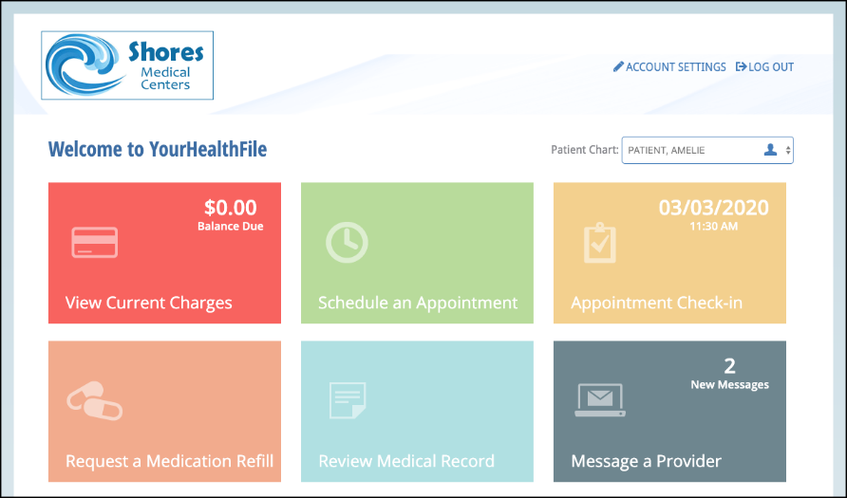
You can complete intake information before joining an e-visit. You can use the navigation menu at the top of the page to review and fill out each form. You can also click a check-in process form link.
2.Click NEXT at the top of the page to continue to navigate the check-in process until it is complete. You can also use the navigation menu to select a form to fill out.
You do not have to complete all forms to complete the check-in process. When you complete a form, a green checkmark appears next to the step.
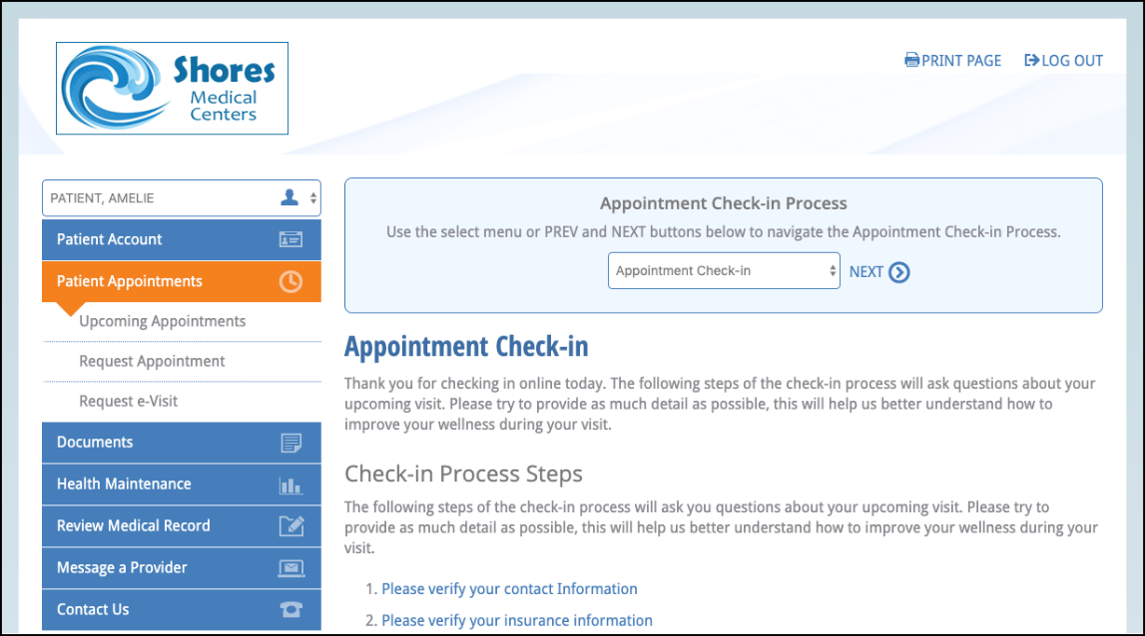

- When you are done filling out the intake forms, you can click Complete Check-in Process.
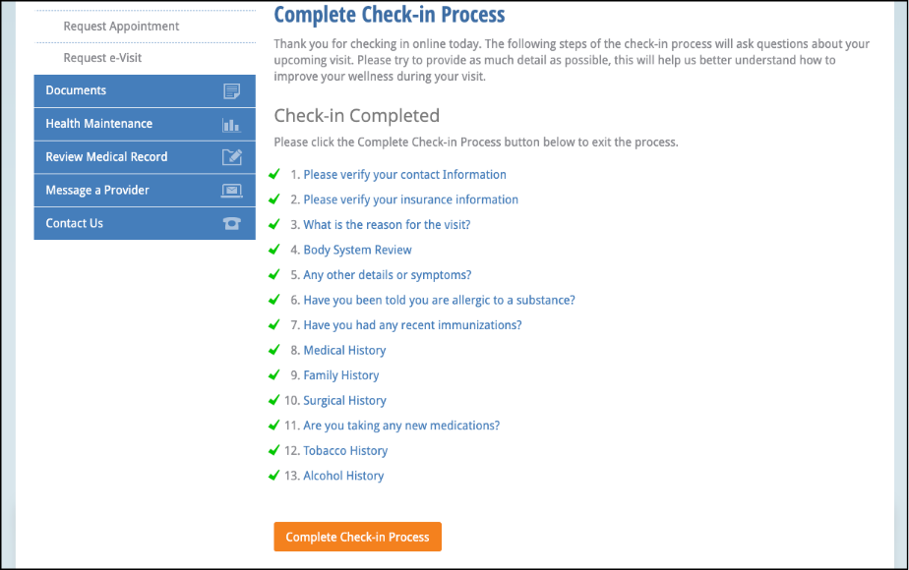
If you complete the intake forms and it isn’t time for your E-Visit you can log out.
At the time of your appointment log back in to your portal and click on Appointment Check In.
You will see the Appointment Check-In Process box again. Click on the dropdown arrow and scroll down to the bottom and click on COMPLETE CHECK IN PROCESS.
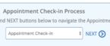
The e-Visit window opens.
You will appear on the left side of the screen and the provider appears on the right side.
You can communicate by:
Phone: patient provides the preferred phone number when they request an E-Visit or
Video chat: Patients and providers use the on-screen microphone. The browser may prompt the patient to allow access to their computer's camera and microphone. Patients must allow access.
- Patients can end their e-visit by clicking End e-Visit.
