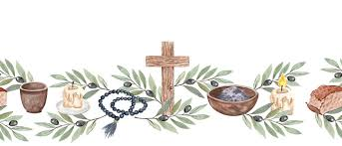
GOD’S BLESSINGS TO OUR CONFIRMATION
&
FIRST HOLY COMMUNION STUDENTS
CONFIRMATION – APRIL 24, 2026
American Martyrs Parish
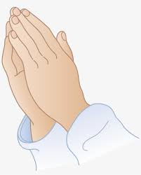
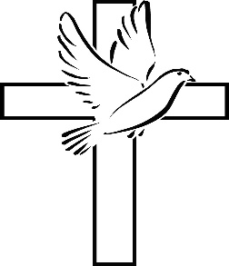
Jett Buckley
Lychele DeGroot
Lawson Lutz
Tyler Phelps
Heather Harris – 11th Grade Instructor
FIRST HOLY COMMUNION – MAY 3, 2026
American Martyrs Parish
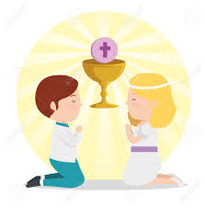
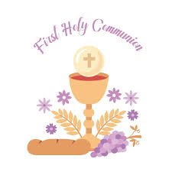
Luka Lutz
Theo Milinski
Sawyer Poquette
Hazel Sikora
Ann VanGuyse
Amy Giesen – 2nd Grade Instructor

