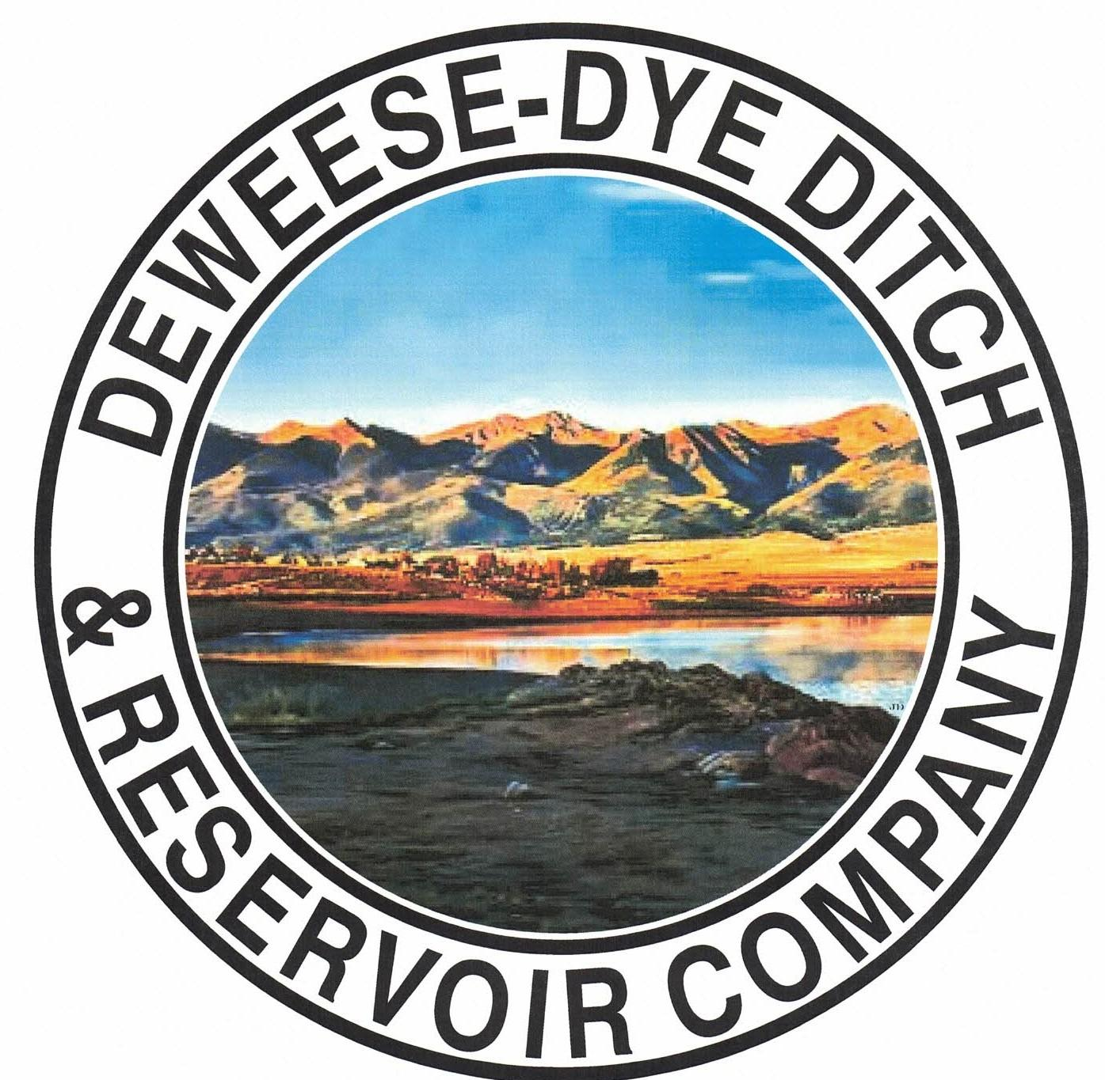
DeWeese-Dye Ditch & Reservoir Company
Board Meeting
PO Box 759
Cañon City, CO 81215

July 6, 2026

Call to Order: President Bolkema called the meeting to order at 7:00 p.m.

Board Directors Present: Board Directors Absent:
Arlin Bolkema Leo French
Kenn Estes
Bill Brogoitti
Marc Thompson

Others Present: Absent
Annette Reed-Pugh, Secretary/Treasurer
7 Shareholders

Minutes:
The minutes from the June 1, 2026 meeting were e-mailed prior to the meeting. All Board Directors indicated they had read the minutes. President Bolkema called for a motion to approve the minutes as written, Director Brogoitti moved to accept the minutes, Director Thompson seconded, all voted in favor.

Financial Report:
- Presentation of the bills:
The list of June bills was provided to the Board for review, with one addition for reimbursement to Bill for the oil change for the truck. President Bolkema called for a motion to approve payment of the bills. Director Thompson moved to pay the bills, Vice President seconded, and all voted in favor of the motion.

- Balance Sheet and Income Summary:
The financial reports were provided to the Board to review prior to the meeting, and anyone with questions were directed to speak with Secretary/Treasurer Reed-Pugh.

Old Business:
- Reservoir Extension Update:
Previous discussion for historical information: UAWCD will be applying and administering grant funding for the various studies and future expansion. Upper Ark has been approved for our CWCB grant for Phase 2 of the Enlargement feasibility study. They will continue to partner with GEI, the same engineering company from Phase 1, to handle these next steps. The proposal from GEI was provided to the Board previously, which outlines the specific tasks and scope of work for Phase 2. GEI will attend Upper Ark’s Board at our May 14th meeting. President Bolkema asked for the Board’s input, questions, and comments of the GEI study, and if the Board had any issues with the proposal. Discussion ensued. The Board indicated no issues and to move forward. President Bolkema called for a motion to move forward with the scope of work for the grant from GEI. Director Brogoitti moved to approve the scope of work, Vice President Estes seconded, and all voted in favor of moving forward.

- BLM Grant Update (outlet pipe repair):
Previous discussion for historical information: Discussion ensued on scope of work provided by RJH, which was provided to the Board previously for review. RJH provided the options/alternative for the outlet pipe repair. The option that was desired by the Board when discussion first took place is now the most costly. After discussion and consideration of the best option for repair, President Bolkema called for a motion to approve the scope of work for Option #1 of the traditional slip line in the amount of $470,000.00. Director French motioned to approve to move forward with Option #1, Director Brogoitti seconded, and all voted in favor. President Bolkema will contact Bob with RJH to let him know of the Boards decision. RJH will be at the dam Friday June 6, 2026 to take some measurements of the inside dimensions of the pipe, as well as pictures. President Bolkema stated there are ¾’ to 1’ thick sidewalls, and that grouting would be best to seal the pipe rather than crawling inside of it.

New Business:
.
- Secretary/Treasurer Business Items: Secretary/Treasurer Reed-Pugh discussed business items and issues, and provided an update on receivables and transfers processed. Properties that have been sold and did not contact the Ditch for transfer have been contacted via letter to transfer the shares.

- Major Ditch Repairs:
Superintendents Brogoitti and Thompson and President Bolkema provided an update.
* Inland Marine divers repaired the stem on the north 16” valve, but it broke again. Vibration is causing the leaks and the repair will need to be more substantial. RJH will need to contact Inland Marine to discuss repairs and how they will align with the outlet pipe repairs. President Bolkema will contact Inland Marine about the failed repair, as well. We would like to have all new fixtures and Bruce with Hydrologik will be contacted about raising the stem to get the nuts replaced. After discussion, President Bolkema called for a motion to approve Inland Marine to come back out to make the needed repairs, which was not budgeted for, but the repairs must be made. Director Thompson motioned to approve the expense for Inland Marine to come back out to repair, and Director Brogoitti seconded. All voted in favor.
* Outlet pipe repair: A virtual meeting was held on June 29, 2026. The design kick off was held with Bob Huzjak, P.E. of RJH Consultants, Inc. Discussion ensued and information was provided to the Board for review of the scope of work and proposal from RJH Consultants.
* We have scheduled a meeting with Upper Ark for July 17, 2026 to discuss the stakeholder kick off meeting for the next phase of the expansion for by GEI.
- Ditch Superintendent Update:
  - Superintendent Brogoitti found a 1 -2 cfs leak in the sand trap. Discussion ensued on needing to keep the pipeline clear and how best to accomplish that. President Bolkema will speak with Avalanche. There is also a leak at the power pole on Capitol Hill that will need to be repaired.
  - Locks have been added to the gates and bulkheads to keep people from stealing water. Superintendent Brogoitti made some repairs to the valves prevent theft of water, as well.
  - Superintendent Thompson provided inflow and water amounts and suggested constructing some shade for the control boxes, as the heat is not good for the boxes. We are letting out about 25 cfs and lose 5 cfs to transit loss at this time.

- Shareholder Questions:
The floor was opened to shareholders questions and/or comments.
- Property owners: at 1325 Cedar inquired of water at that location. We do not service 1325 Cedar. When the property was subdivided years ago, shares were not given to 1325 Cedar, as they stayed with 1335 Cedar. The property owners will research further, but we do not have record of 1325 Cedar having water shares, nor can we guarantee water shares to that property if they were not provided to the property when the land was divided.
- Shareholder Madone: inquired about tail water. We do not take a position on the matter, as it is between the County, the neighboring property owners, and the shareholders. The bylaws will need to be referred to and followed with any water use from our delivery system.
- Shareholder Toteno: Inquired about a possible change to a headgate a neighbor mentioned to her. All changes/repairs/use of headgates and all infrastructure owned by DeWeese Dye Ditch & Reservoir Company will need Board approval prior to making any changes, in accordance with our Bylaws!

REMINDERS:
- The Board will not tolerate any receipt of too much water. If any Shareholder is determined to be taking more than their rightful amount, they will be immediately terminated from water for the entire season, no exceptions. Water is going to be scarce this year, and we have to be extra mindful of our resource.

- Shareholders are expected to clean and maintain their laterals, as per our governing By-laws. Violations will be issued to Shareholders for non-compliance with our by-laws; up to and including termination of water delivery.

- Other Business:
The floor was opened to other business.
Discussion ensued with regard to when Shareholders should be terminated from water delivery, rather than giving warnings when they are tampering with water. After discussion, it was recommended that we make a change to the bylaws to read if a Shareholder is in violation of the bylaws, they will be IMMEDIATELY terminated from access to water, no warnings. We will add this proposed change to our bylaws on our annual Shareholder meeting agenda.

Adjournment: With no other business to consider, President Bolkema called for a motion to adjourn. The meeting was adjourned at 8:25 p.m., via a motion by Vice President Estes, and seconded by Director Brogoitti, and a unanimous vote in favor.

Respectfully submitted,

Annette Reed-Pugh
Secretary/Treasurer

