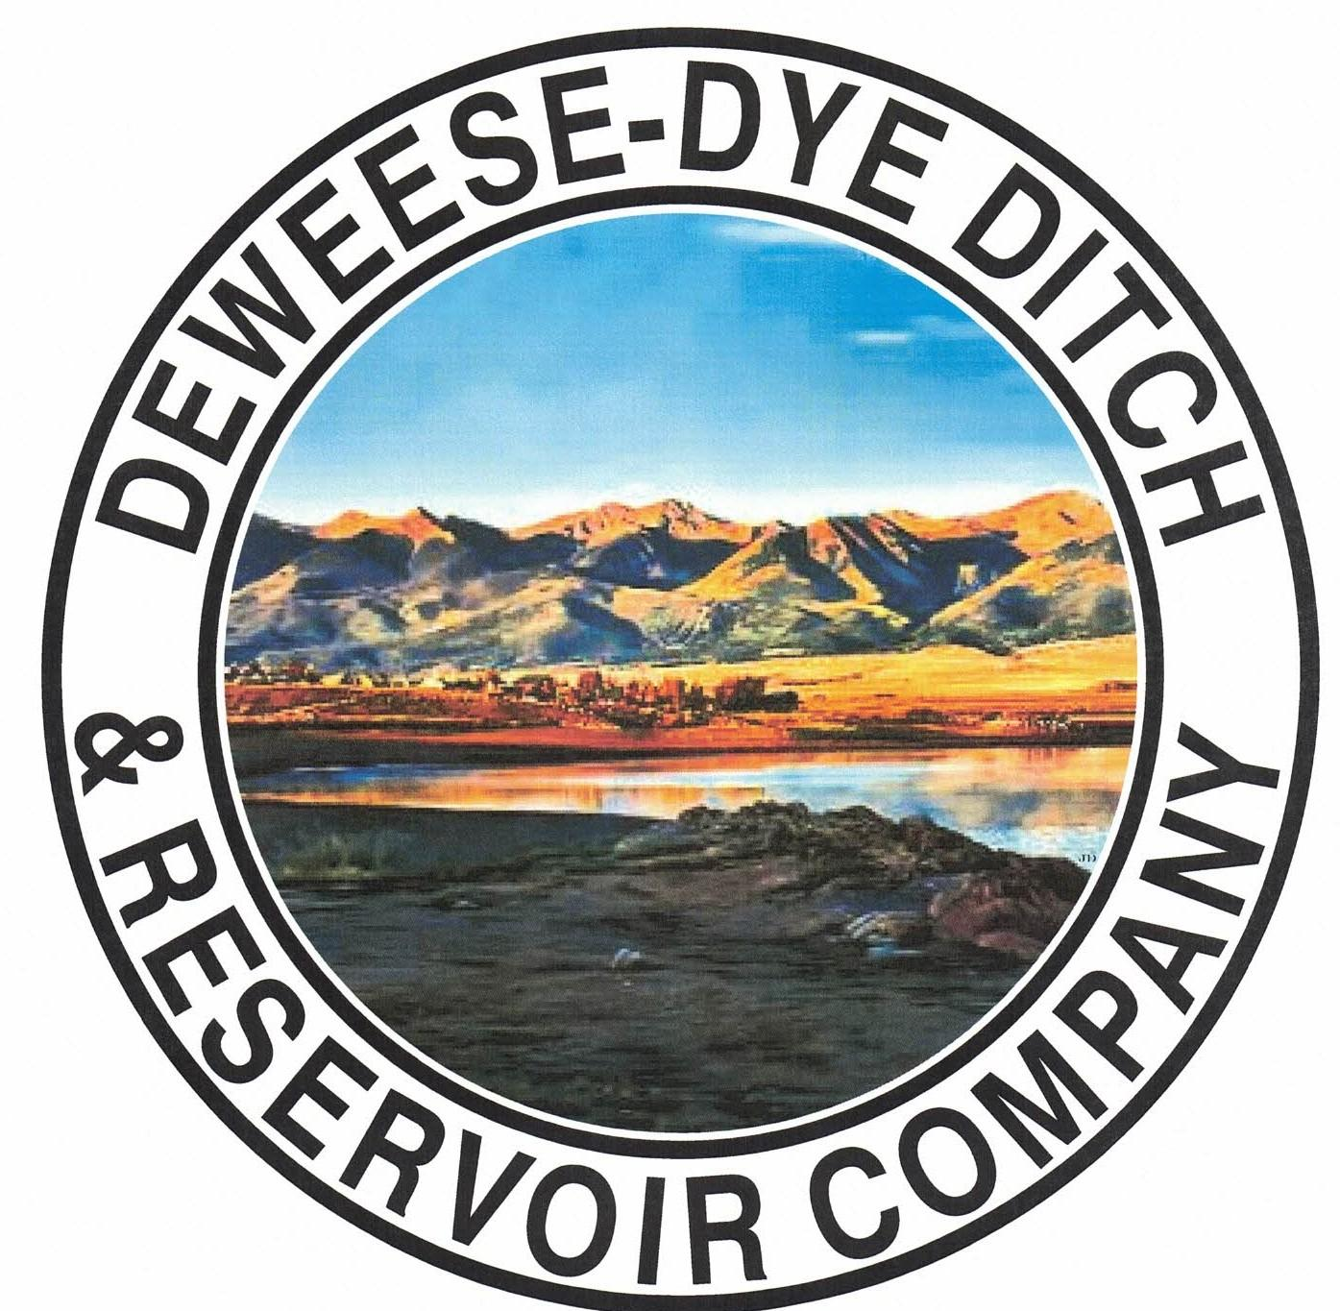
DeWeese-Dye Ditch & Reservoir Company
Board Meeting
PO Box 759
Cañon City, CO 81215

September 7, 2026

Call to Order: President Bolkema called the meeting to order at 5:00 p.m.

Board Directors Present: Board Directors Absent:
Arlin Bolkema Bill Brogoitti
Kenn Estes
Leo French
Marc Thompson

Others Present: Absent
Annette Reed-Pugh, Secretary/Treasurer
2 Shareholders

Minutes:
The minutes from the August 3, 2026 meeting were e-mailed prior to the meeting. All Board Directors indicated they had read the minutes. President Bolkema called for a motion to approve the minutes as written, Vice President Estes moved to accept the minutes, Director Thompson seconded, all voted in favor.

Financial Report:
- Presentation of the bills:
The updated list of August bills was provided to the Board for review. President Bolkema called for a motion to approve payment of the bills. Director French moved to pay the bills, Vice President Estes seconded, and all voted in favor of the motion.

- Balance Sheet and Income Summary:
The financial reports were provided to the Board to review prior to the meeting, and anyone with questions were directed to speak with Secretary/Treasurer Reed-Pugh.

Old Business:
- Reservoir Extension Update:
Previous discussion for historical information: UAWCD will be applying and administering grant funding for the various studies and future expansion. Upper Ark has been approved for our CWCB grant for Phase 2 of the Enlargement feasibility study. They will continue to partner with GEI, the same engineering company from Phase 1, to handle these next steps. The proposal from GEI was provided to the Board previously, which outlines the specific tasks and scope of work for Phase 2. GEI will attend Upper Ark’s Board at our May 14th meeting. President Bolkema asked for the Board’s input, questions, and comments of the GEI study, and if the Board had any issues with the proposal. Discussion ensued. The Board indicated no issues and to move forward. President Bolkema called for a motion to move forward with the scope of work for the grant from GEI. Director Brogoitti moved to approve the scope of work, Vice President Estes seconded, and all voted in favor of moving forward.

- BLM Grant Update (outlet pipe repair):
Previous discussion for historical information: Discussion ensued on scope of work provided by RJH, which was provided to the Board previously for review. RJH provided the options/alternative for the outlet pipe repair. The option that was desired by the Board when discussion first took place is now the most costly. After discussion and consideration of the best option for repair, President Bolkema called for a motion to approve the scope of work for Option #1 of the traditional slip line in the amount of $470,000.00. Director French motioned to approve to move forward with Option #1, Director Brogoitti seconded, and all voted in favor. President Bolkema will contact Bob with RJH to let him know of the Boards decision. RJH will be at the dam Friday June 6, 2026 to take some measurements of the inside dimensions of the pipe, as well as pictures. President Bolkema stated there are ¾’ to 1’ thick sidewalls, and that grouting would be best to seal the pipe rather than crawling inside of it.

New Business:
.
- Secretary/Treasurer Business Items: Secretary/Treasurer Reed-Pugh discussed business items and issues, and provided an update on receivables and transfers processed.

- Major Ditch Repairs:
Superintendent Thompson and President Bolkema provided an update.
  - Inland Marine divers took another look at the issues for the hardware and gears on the dam. It will take a bigger repair than what we initially thought, as the stem is not centered. Divers will return to conduct the repair to a more suitable level.
  - From item B under old business: President Bolkema received information from RJH and will speak with Andy Kagan about removing parts of the rock to gain straight access to the outlet pipe.

- Ditch Superintendent Update:
  - Superintendent Thompson discussed what is being done and what needs to be done. We finished draining the little reservoir. The valve on the back did not close all the way and let out water. This will be on the repair list for the winter projects.
  - We ended the season with 76 af of winter water, and 300 af of native water.
  - Focus on repairs and a way to institute a slow-down of the main ditch in an effort to mitigate too much water that causes flooding.
  - Debris removal was discussed and how best to mitigate flooding from the debris.
  - Discussion ensued with regard to the Lakeside Cemetery water, repairs, and water calculations.

- Core Drilling for dam expansion (from item A under old business):
  - President Bolkema met with Jeremy Franz and Mark Perry about the expansion of the dam and provided a summary on what will need to be done in order to allow expansion of the dam. On the north side up the hill there is a 25% grade. Two 50’ core holes will need to be drilled on the north side, and 15’ angle core holes drilled on the spillway at the base of the dam. The core drilling will be conducted in October and will be a two-day process. If the core results are good, then we can move forward.

- Shareholder Questions:
The floor was opened to shareholders questions and/or comments.
  - Shareholder Bosco: There are plugs in the headgate and he cannot find where it is plugged. He asked about running a camera thru the pipe. Discussion ensued with regard to possible solutions, and the issue will be reviewed to see how best to fix.
  - Shareholder Bunch: brought pictures of the issues with the lateral he is having. The neighbor is placing a screen across the opening in an effort to mitigate debris from clogging the pipe, but it is causing a build up of debris on the screen, thereby causing flooding. He wanted to show the Board so that he is not blamed for placing anything in the ditch.
REMINDERS:
- The Board will not tolerate any receipt of too much water. If any Shareholder is determined to be taking more than their rightful amount, they will be immediately terminated from water for the entire season, no exceptions. Water is going to be scarce this year, and we have to be extra mindful of our resource.

- Shareholders are expected to clean and maintain their laterals, as per our governing By-laws. Violations will be issued to Shareholders for non-compliance with our by-laws; up to and including termination of water delivery.

- Other Business:
The floor was opened to other business.
There was no other business brought before the Board.

Adjournment: With no other business to consider, President Bolkema called for a motion to adjourn. The meeting was adjourned at 5:54 p.m., via a motion by Director Thompson, and seconded by Vice President Estes, and a unanimous vote in favor.

Respectfully submitted,

Annette Reed-Pugh
Secretary/Treasurer

