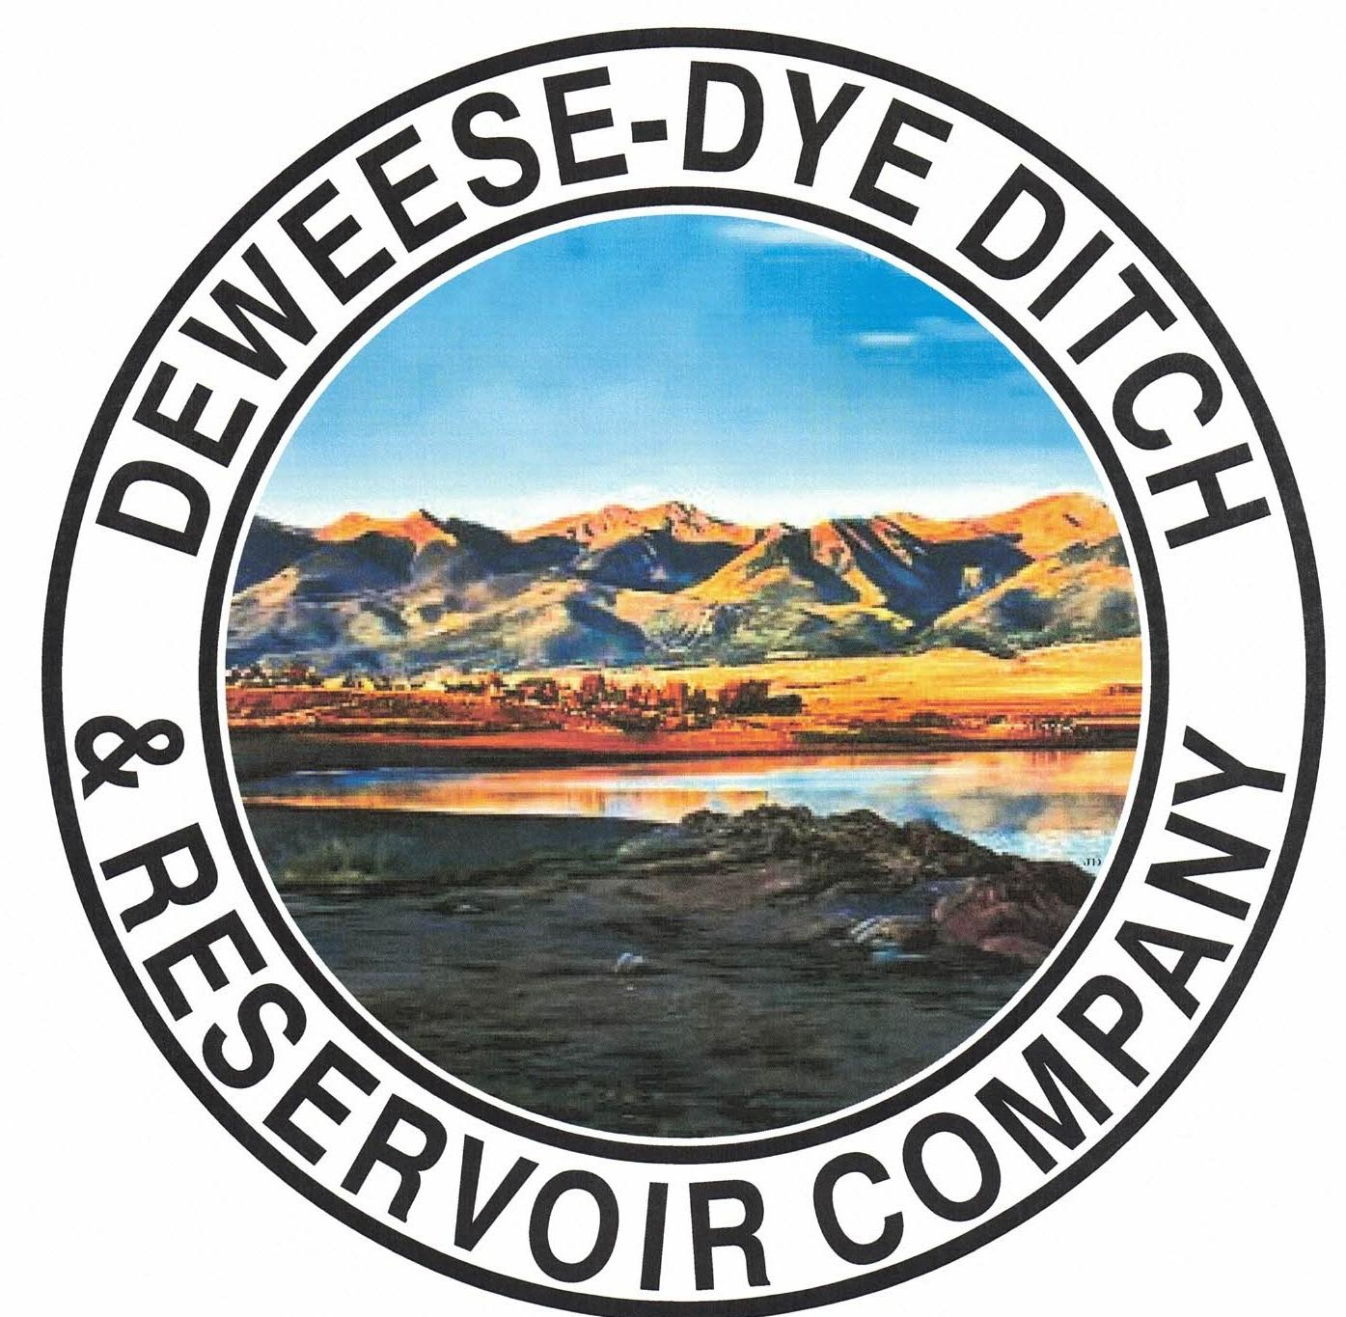
DeWeese-Dye Ditch & Reservoir Company
Board Meeting
PO Box 759
Cañon City, CO 81215

January 5, 2026

Call to Order: President Bolkema called the meeting to order at 5:00 p.m.

Board Directors Present: Board Directors Absent:
Arlin Bolkema
Kenn Estes
Marc Thompson
Bill Brogoitti
Leo French

Others Present: Absent
Annette Reed-Pugh, Secretary/Treasurer
2 Shareholders

Minutes:
The minutes from the December 1, 2025 meeting were e-mailed prior to the meeting. All Board Directors indicated they had read the minutes. President Bolkema called for a motion to approve the minutes as written, Vice President Estes moved to accept the minutes, Director Brogoitti seconded, all voted in favor.

Financial Report:
- Presentation of the bills:
The list of December bills was provided to the Board for review. Discussion ensued. President Bolkema called for a motion to approve payment of the bills. Director Thompson moved to pay the bills, Director French seconded, and all voted in favor of the motion.

- Balance Sheet and Income Summary:
The financial reports were provided to the Board to review prior to the meeting, and anyone with questions were directed to speak with Secretary/Treasurer Reed-Pugh.

Old Business:
- Reservoir Extension Update:
UAWCD will be applying and administering the grant funding for the various studies and future expansion.

- BLM Grant Update:
Discussion ensued on scope of work. Work will begin on the engineering tasks.

New Business:
- Secretary/Treasurer Business Items: Secretary/Treasurer Reed-Pugh discussed business items and issues, and provided an update on receivables for 2025.
- Resolution 2026-1: To ratify signatures from previous approval to contract RJH Consultants for the outlet pipe repairs, previously voted on via email dated December 25, 2025-unanimous vote in favor. Discussion ensued, and with majority vote via December 25, 2025 email, all Board Directors signed the resolution to contract RJH Consultants to compete the repairs to the outlet pipe. Task 1 of 3 of the engineering services will begin soon.
- Attended NRCS Irrigation Entities Workshop Series #1 on December 19, 2025. Provided informational handouts to the Board and invited everyone to attend the next meeting to be held on January 16, 2026.
- The new website is ready to go live, just need to fix some links
- Working to prepare for Annual meeting, completing power point
- Working with software program to close the year
- Will be meeting with Lauren of the CWCB to discuss grant funding opportunities and projects on Friday January 9, 2026.

- Major Ditch Repairs:
- Avalanche completed repairs on Cedar
- Hydrologik will begin work at the dam for the scata system
- Kagan & Son will begin access roadway work in the spring
- Major repairs will be prioritized as time permits

- Ditch Superintendent Update:
- Concrete “V” ditch on Pine needs to be repaired
- Will be reviewing smaller projects for completion

- Shareholder Questions:
The floor was opened to shareholders questions and/or comments. There were no issues or comments brought before the Board.
NOTE: Reminder to Shareholders: Shareholders are expected to clean and maintain their laterals, as per our governing By-laws. Violations will be issued to Shareholders for non-compliance with our by-laws; up to and including termination of water delivery.

- Other Business:
The floor was opened to other business. No other business was brought before the Board. Secretary Reed-Pugh asked clarifying questions for annual meeting.

Adjournment: With no other business to consider, President Bolkema called for a motion to adjourn. The meeting was adjourned at 5:52 p.m., via a motion by Vice President Estes, and seconded by Director Brogoitti, and a unanimous vote in favor.

Respectfully submitted,

Annette Reed-Pugh
Secretary/Treasurer

