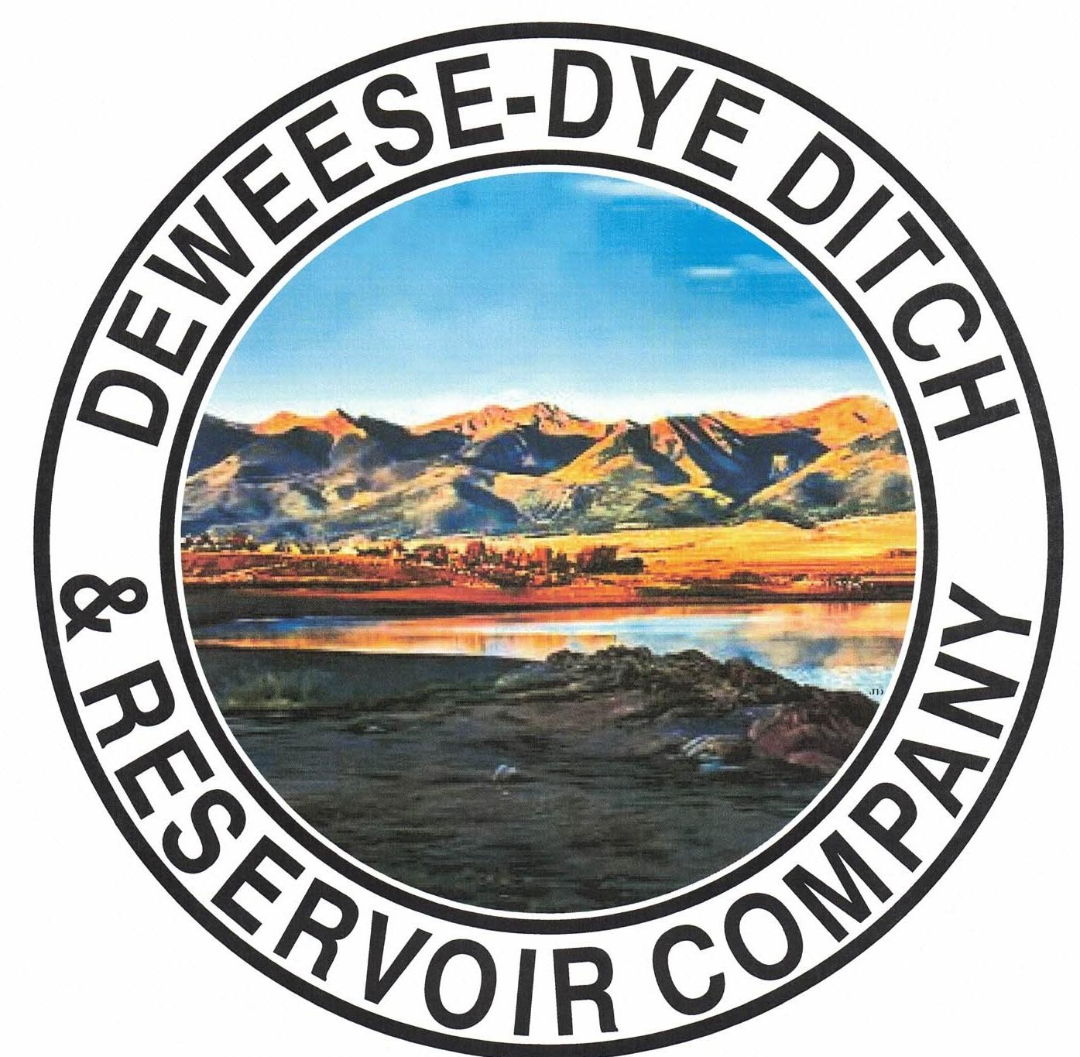
DeWeese-Dye Ditch & Reservoir Company
Board Meeting
PO Box 759
Cañon City, CO 81215

February 2, 2026

Call to Order: President Bolkema called the meeting to order at 5:00 p.m.

Board Directors Present: Board Directors Absent:
Arlin Bolkema
Kenn Estes
Marc Thompson
Bill Brogoitti
Leo French

Others Present: Absent
Annette Reed-Pugh, Secretary/Treasurer
6 Shareholders

Minutes:
The minutes from the January 5, 2026 meeting and the January 10, 2026 Special meeting were e-mailed prior to the meeting. All Board Directors indicated they had read the minutes. President Bolkema called for a motion to approve the minutes as written, Vice President Estes moved to accept the minutes, Director French seconded, all voted in favor.

Financial Report:
- Presentation of the bills:
The list of January bills was provided to the Board for review. Discussion ensued, and a revised amount was provided to the Board for approval, to include last minute expenses from Director Thompson for the truck. President Bolkema called for a motion to approve payment of the bills. Director French moved to pay the bills, Director Brogoitti seconded, and all voted in favor of the motion.

- Balance Sheet and Income Summary:
The financial reports were provided to the Board to review prior to the meeting, and anyone with questions were directed to speak with Secretary/Treasurer Reed-Pugh.

Old Business:
- Reservoir Extension Update:
UAWCD will be applying and administering the grant funding for the various studies and future expansion.

- BLM Grant Update:
Discussion ensued on scope of work. Work will begin on the engineering tasks.

New Business:
- Jonathan Haas, Trout Unlimited:
Discussion ensued on the launch of the new Trout Unlimited Chapter in this area. Previous discussions took place with the CPW and BLM, as well as DeWeese Directors. They are looking at mitigating fish loss at the Grape Creek location, and possibly obtaining a stream gage. Director Brogoitti explained to Mr. Haas that some of the work described will affect our stream flows by creating pools. We would need to find a solution that will not affect our stream flows. Discussion ensued about bank establishment and dredging. Mr. Haas expressed interest in being included on other projects DeWeese may have and would also like a letter of support. Discussion also included possible grant funding from NRCS. The Board will consider and follow up.

- Secretary/Treasurer Business Items: Secretary/Treasurer Reed-Pugh discussed business items and issues, and provided an update on receivables for 2025, as well as 2026. Assessment invoices were sent out on January 16, 2026. Discussion ensued on various year end tasks completed.

- Major Ditch Repairs:
- Hydrologik site meeting: President Bolkema, Director Brogoitti, Director Thompson and Riley met with Bruce Bacon on Thursday January 29, 2026 to finalize specs for headgates, reviewed the project, and explained the process and automation. Director Brogoitti spoke with a machine shop about fabricating gates to work with the parts from Hyrologik. The dam was full and frozen at the time, and spilling.
- Director Brogoitti spoke with Jord with Upper Ark to discuss the installation of another telementry system, in which Jord will be installing this coming Thursday, February 5, 2026.

- Ditch Superintendent Update:
- Superintendent Thompson discussed the repair needing completed on W 1st Street. He will need a sheet of screen 70x42 to cover the hole.
- 917 Grand needs 13’ of 12” smooth pipe to complete that repair. President Bolkema will look at the pipe he has to see if we have the pipe or if we need to purchase it.
- The headwall at the little reservoir needs replaced. Discussion ensued. Repairs will be addressed.
- We are losing water to beaver dams. The State can issue an order to remove.

- Shareholder Questions:
The floor was opened to shareholders questions and/or comments. There were no issues or comments brought before the Board.
- Shareholder Bosco inquired about who controls the water flow, to which the Board responded the State adjusts it and monitors it. The system on Grape Creek is controlled and monitored by DeWeese.

NOTE: Reminder to Shareholders: Shareholders are expected to clean and maintain their laterals, as per our governing By-laws. Violations will be issued to Shareholders for non-compliance with our by-laws; up to and including termination of water delivery.

- Other Business:
The floor was opened to other business. No other business was brought before the Board.

Adjournment: With no other business to consider, President Bolkema called for a motion to adjourn. The meeting was adjourned at 5:57 p.m., via a motion by Director Brogoitti, and seconded by Director Thompson, and a unanimous vote in favor.

Respectfully submitted,

Annette Reed-Pugh
Secretary/Treasurer

