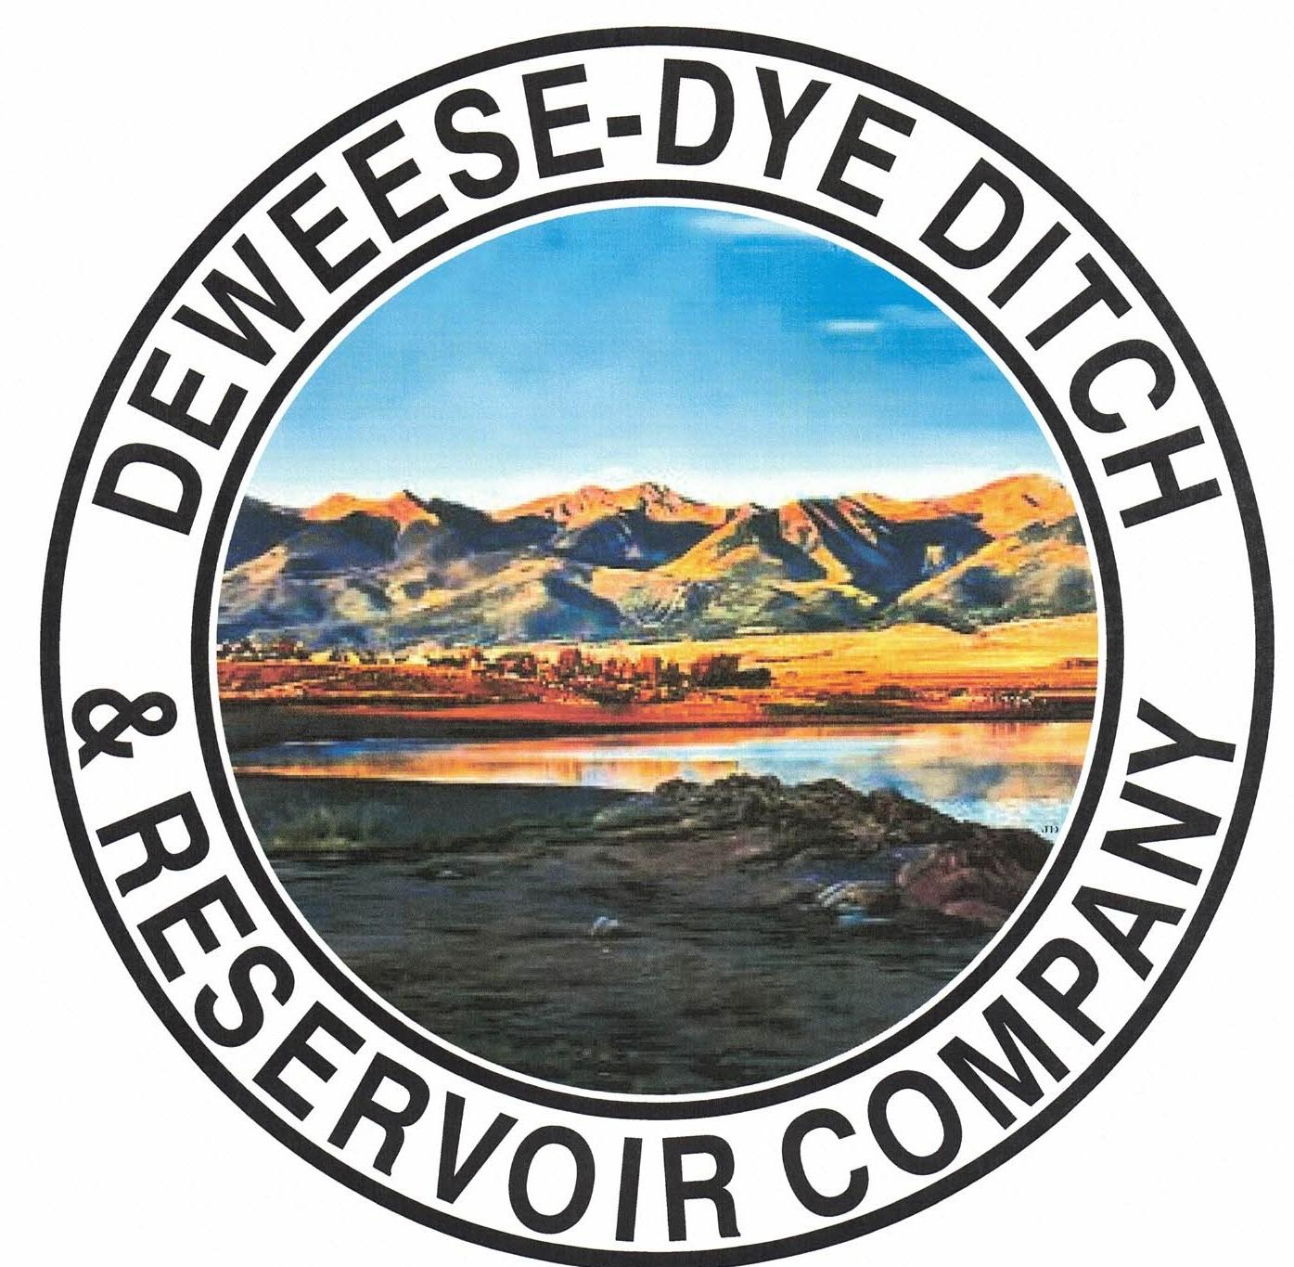
DeWeese-Dye Ditch & Reservoir Company
Board Meeting
PO Box 759
Cañon City, CO 81215

April 6, 2026

Call to Order: President Bolkema called the meeting to order at 5:00 p.m.

Board Directors Present: Board Directors Absent:
Arlin Bolkema
Kenn Estes
Bill Brogoitti
Leo French
Marc Thompson

Others Present: Absent
Justin Krall - CPW
Annette Reed-Pugh, Secretary/Treasurer
9 Shareholders

Minutes:
The minutes from the March 2, 2026 meeting were e-mailed prior to the meeting. All Board Directors indicated they had read the minutes. President Bolkema called for a motion to approve the minutes as written, Vice President Estes moved to accept the minutes, Director Brogoitti seconded, all voted in favor.

Financial Report:
- Presentation of the bills:
The list of March bills was provided to the Board for review. Discussion ensued with regard to the Inland Marine invoice and work. Inland Marine dove to fix the eroded washer and tightened up all other washers/bolts. President Bolkema called for a motion to approve payment of the bills. Director French moved to pay the bills, Director Thompson seconded, and all voted in favor of the motion.

- Balance Sheet and Income Summary:
The financial reports were provided to the Board to review prior to the meeting, and anyone with questions were directed to speak with Secretary/Treasurer Reed-Pugh.

Old Business:
- Reservoir Extension Update:
UAWCD will be applying and administering the grant funding for the various studies and future expansion. Upper Ark is moving ahead with the steps to the expansion.

- BLM Grant Update:
Discussion ensued on scope of work. Work will begin on the engineering tasks by RJH. There are 3 tasks in the scope of work. RJH has not begun work as of yet, but are working toward getting thru previous scheduled work.

New Business:
- Justin Krall, CPW:
Justin spoke about the proposed operational agreement they received from Sport Fish Colorado, LLC. This was the first entity that requested permission to conduct fishing guide services on DeWeese Lake. Justin said he submitted the proposed plan to AG and is waiting to hear back from them. He explained further about the proposed use and what CPW is held by in determining permission. The CPW looks at whether or not there is a need for the service, and what justification there is to say no. The question was asked about if the operations would be catch and release, or just catch. Justin stated it would be both, and the company is both licensed and insured. President Bolkema expressed concerns on behalf of the Board about liability issues stemming from the proposed operations, and if there is a limit on the amount of fishing guide businesses that would be allowed on the lake. After more discussion, the Board decided to table the matter until Justin hears back from AG. The matter was tabled via motion by Director Thompson, seconded by Director Brogoitti, and all aye. Once he hears back, he will follow up with us and we will review and determine our response.
- Meeting with DNR:
Board Directors and President Bolkema met with the DNR to discuss water plans for irrigation and fish for this year. There are concerns about the ability to keep enough water in the lake to support the fish habitat, while still delivery sufficient water to our Shareholders, as water projections look bleak due to the lack of moisture. DNR would like to take what is in priority and then store anything over that. This will also affect our water delivery schedule this year, which will be discussed in item “e”
.
- Secretary/Treasurer Business Items: Secretary/Treasurer Reed-Pugh discussed business items and issues, and provided an update on receivables for 2025 (late lists were previously provided to Supers), as well as 2026 receivables. Discussion ensued with regard to various business items and activities of the month.

- Major Ditch Repairs:
- Superintendents Brogoitti and Thompson provided an update. Most of the major work has been accomplished. The headgate will ship April 10, 2026 from Hydrologik, and is at the top of their list. We hope to have it installed prior to irrigation start date.
- The State is very pleased with the automation at the dam. Upper Ark installed a new system, as well, and all systems are operating well.

- Ditch Superintendent Update:
- Superintendents Brogoitti and Thompson discussed repairs still needing completion, but we are almost ready to run.
- The sand trap location is 90% complete.
- Cleaning debris and clearing ditches will be done prior to start date.
- Need to do a couple of concrete pours.
- The take out on Poplar needs some work still.
- There is a learning curve on the operation of the automated equipment, so flows will not be consistent to start until Supers better understand how to refine the inputs.
- Arlin took out the large beaver dam that was blocking a lot of the water, and is flowing well now.

- Water Start-up schedule:
Discussion ensued about the irrigation schedule. The DNR wanted a water plan from DeWeese to ensure the viability and health of the fish as well as our irrigation water. We need to make sure levels in the dam will support the fish, and ensure irrigation water delivery to Shareholders. After much discussion, the best plan is to run our regular 2x a week schedule for 12-hour days for the month of May. After that, we will review, but are looking to run shorter days of 8 hours 2x a week after May. Instead of running the full 12 hours per day 2x a week, we will cut back to 8 hours per day 2x a week. By cutting back of the hours per day we irrigate, the ground receives water twice a week without having to cut back to one day a week. The Board felt this would provide the water needed without compromising Shareholder operations the way one day a week runs would.

President Bolkema called for a motion to approve water start-up date of May 8, 2026, to run 2x a week at 12 hours per day for the month of May, then cut back to 8 hours a day 2x a week. Director Thompson moved to approve the plan, Director Brogoitti seconded, and all voted in favor. This schedule will be subject to change according to conditions.

- Shareholder Questions:
The floor was opened to shareholders questions and/or comments.
- Shareholder Toteno inquired about morning runs vs afternoon runs and if one is better over the other. President Bolkema stated morning runs are better due to heat during the day.
- Shareholder Bosco: Said Carochi Brothers is going out of business and the Ditch might be interested in some of the equipment for sale, which can be viewed online.

NOTE: Reminder to Shareholders: Shareholders are expected to clean and maintain their laterals, as per our governing By-laws. Violations will be issued to Shareholders for non-compliance with our by-laws; up to and including termination of water delivery.

- Other Business:
The floor was opened to other business.
- President Bolkema and the Board discussed the use of personal tools while completing tasks for the Ditch. Director Thompson found a bundle sale at Home Depot that included many tools that our guys currently are using of their own. The cost of the tool bundle is $2,428.00, and with Director Thompson’s military discount, it is a good deal. Purchasing constantly utilized tools for the Ditch will be a benefit to the company and the guys will not have to use their own tools. President Bolkema called for a motion to purchase the tools, as the costs were not included on the bill approval list. Vice President Estes motioned to approve the purchase, Director French seconded, and all vote aye.
- Discussion ensued about shareholders taking too much water, especially in this dry season. The Board will not tolerate any receipt of too much water. If any Shareholder is determined to be taking more than their rightful amount, they will be immediately terminated from water for the entire season, no exceptions. Water is going to be scarce this year, and we have to be extra mindful of our resource.

Adjournment: With no other business to consider, President Bolkema called for a motion to adjourn. The meeting was adjourned at 6:29 p.m., via a motion by Vice President Estes, and seconded by Director Thompson, and a unanimous vote in favor.

Respectfully submitted,

Annette Reed-Pugh
Secretary/Treasurer

