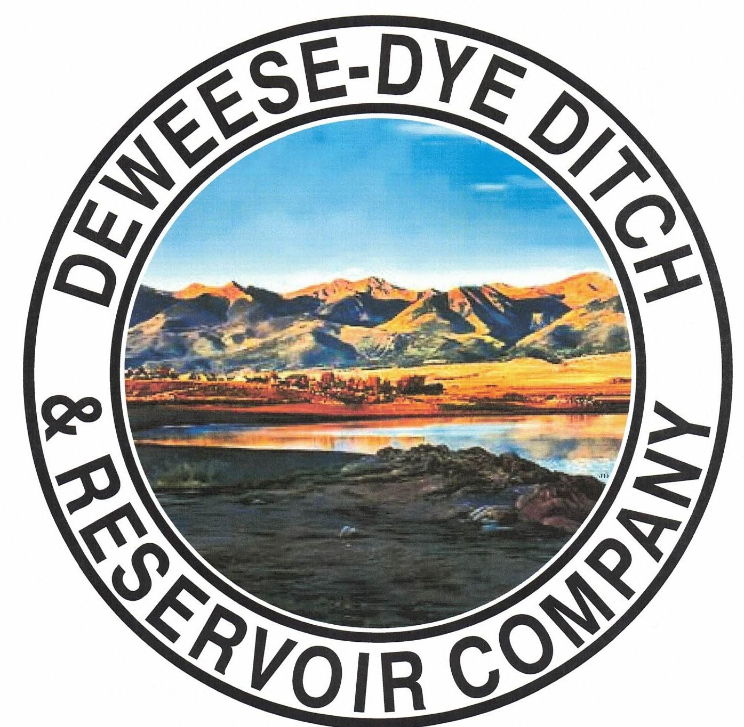
DeWeese-Dye Ditch & Reservoir Company
Board Meeting
PO Box 759
Cañon City, CO 81215

March 2, 2026

Call to Order: President Bolkema called the meeting to order at 5:00 p.m.

Board Directors Present: Board Directors Absent:
Arlin Bolkema Marc Thompson
Kenn Estes
Bill Brogoitti
Leo French

Others Present: Absent
Brian Shepherd – Visionary Communications
Annette Reed-Pugh, Secretary/Treasurer
5 Shareholders

Minutes:
The minutes from the February 2, 2026 meeting and the January 10, 2026 Special meeting were e-mailed prior to the meeting. All Board Directors indicated they had read the minutes. President Bolkema called for a motion to approve the minutes as written, Director Brogoitti moved to accept the minutes, Vice President Estes seconded, all voted in favor.

Financial Report:
- Presentation of the bills:
The list of February bills was provided to the Board for review. Discussion ensued, and a revised bill list was provided to the Board for approval. President Bolkema called for a motion to approve payment of the bills. Director French moved to pay the bills, Director Brogoitti seconded, and all voted in favor of the motion.

- Balance Sheet and Income Summary:
The financial reports were provided to the Board to review prior to the meeting, and anyone with questions were directed to speak with Secretary/Treasurer Reed-Pugh.

Old Business:
- Reservoir Extension Update:
UAWCD will be applying and administering the grant funding for the various studies and future expansion. A Teams meeting was held on Wednesday February 24, 2026 with Jacobs Engineering to discuss the latest study. Upper Ark is moving ahead with the steps to the expansion.

- BLM Grant Update:
Discussion ensued on scope of work. Work will begin on the engineering tasks by RJH. There are 3 tasks in the scope of work.

New Business:
- Brian Shepherd, Visionary Broadband:
Mr. Shepherd spoke about the scope of work Visionary Broadband is conducting to get internet communications to area businesses and residents. Their infrastructure placement interferes with our water delivery system, so they are seeking to enter into a Ditch crossing agreement. Brian provided a draft, which was emailed to the Board previously for review and comment. Discussion ensued. DeWeese wants to protect our easement and infrastructure, first and foremost. President Bolkema would like to see language in the agreement that further protects DeWeese from any negative issues that may arise from the agreement. Mr. Shepherd will revise the agreement to include the necessary requested language. We want 10’ minimum under the bottom of the pipe, maps to us in 14 days prior to digging, 7-day response time, and for the agreement to be recorded at the Clerk’s office. President Bolkema called for a motion to approve the agreement with the revised language placed into the draft agreement. Director French motioned to approve the ditch crossing agreement with changes, Director Brogoitti seconded, and all voted in favor. Once the revised agreement is received, we will review once more and sign if in agreement.

- Secretary/Treasurer Business Items: Secretary/Treasurer Reed-Pugh discussed business items and issues, and provided an update on receivables for 2025 (forfeit lists were provided to Supers), as well as 2026 receivables. Discussion ensued with regard to various business items, to include the If/When agreement with Upper Ark, the Inland Marine gate repairs coming up, letter of support for Trout Unlimited (will wait until we hear more about the plan), and an issue between Shareholders that is on-going….. to which DeWeese will take no action as it deals with Shareholder laterals.

- Major Ditch Repairs:
- Kagan will conduct clearing task at the dam in April to make room for the outlet pipe repairs.
- Repairs to the fastening nuts/bolts need to be completed at the dam. Discussion ensued about the repair and what needs to happen. Inland Marine has completed previous repairs, and President Bolkema would like to hire them to conduct this repair and to check for any other issues that may be occurring. The quote received is for $3,550.00 per day. Director Brogoitti also explained the stem is turning and is not supposed to. President Bolkema called for a motion to approve obtaining Inland Marine to conduct said repairs and to repair any other issues detected while there. Vice President Estes moved to accept obtaining Inland Marine to conduct the needed repairs, Director Brogoitti seconded, and all voted in favor.
- President Bolkema removed a very large beaver dam, and built up the roadway while there. We rented an excavator to accomplish the task. Water was 4-5 feet deep behind the dam. We are checking the area once a week, and there are still 2 other beaver dams above that location, but aren’t as critical.
- The automated equipment has been installed and tested by Hydrologik. Bruce and his team fine-tuned the equipment and it is working well. Hydrologik still has to finish up, but so far things are looking good.

- Ditch Superintendent Update:
- Superintendent Brogoitti discussed repairs still needing completion. The V-Ditch still needs to be repaired, a repair is needed on Ash, clean up and burning will still need to take place prior to start up.
- DeWeese will now need to make our own releases instead of the State. By automating the flows, the task will be much easier, quicker, and more productive. Reporting will be accurate and quick, as well.
- We need to get a good location for a stream gage for Grape Creek, as the second telemetry system has been received. There are 2 possible locations, and we will research further. Would like to get the installation done prior to Hyrologik returning to complete the work. Two mounting brackets are needed, and Director Brogiitti would like to change the sim cards on the data logger and have the information sent to the Hyrologik website.
- The Quinlan location is in needs of repairs.
- Projects are set to start in 2 weeks.

- Shareholder Questions:
The floor was opened to shareholders questions and/or comments.
- Shareholder Toteno inquired about how wide the ditch easement is, as she is still having issues with her neighbor. She will maintain as best she can.

NOTE: Reminder to Shareholders: Shareholders are expected to clean and maintain their laterals, as per our governing By-laws. Violations will be issued to Shareholders for non-compliance with our by-laws; up to and including termination of water delivery.

- Other Business:
The floor was opened to other business. No other business was brought before the Board.

Adjournment: With no other business to consider, President Bolkema called for a motion to adjourn. The meeting was adjourned at 6:03 p.m., via a motion by Director Brogoitti, and seconded by Vice President Estes, and a unanimous vote in favor.

Respectfully submitted,

Annette Reed-Pugh
Secretary/Treasurer

