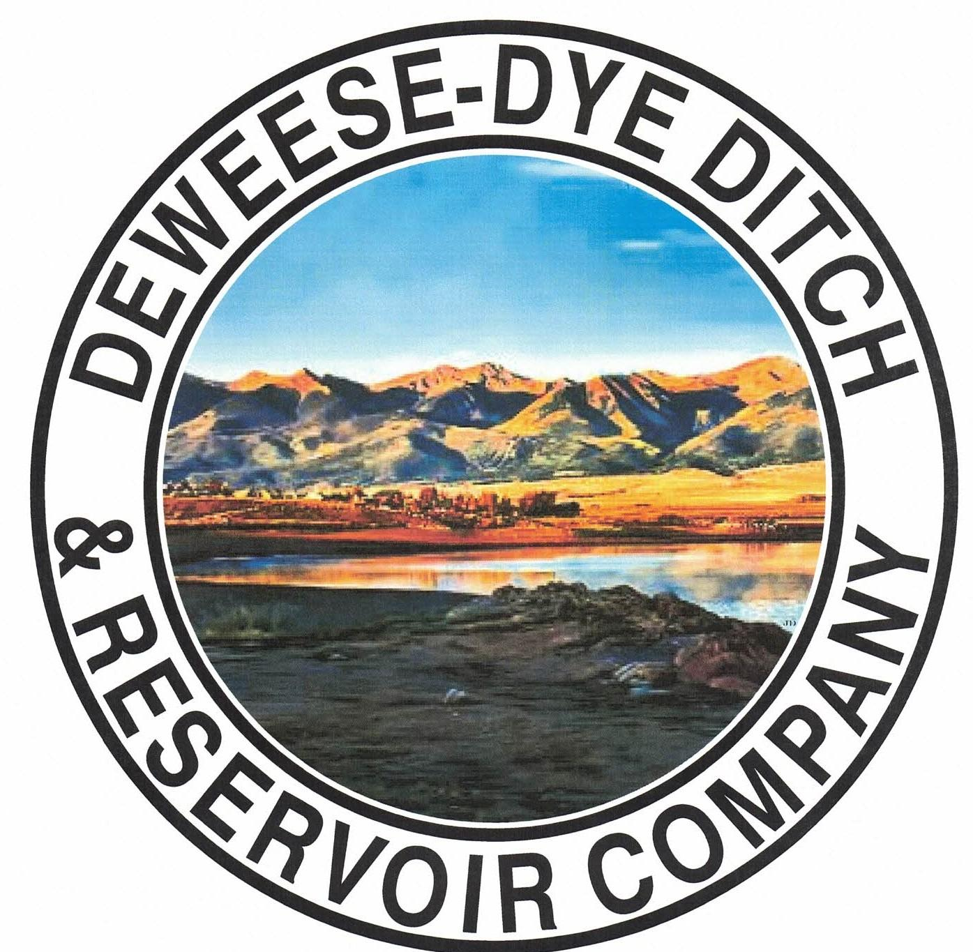
DeWeese-Dye Ditch & Reservoir Company
Board Meeting
PO Box 759
Cañon City, CO 81215

August 3, 2026

Call to Order: President Bolkema called the meeting to order at 7:00 p.m.

Board Directors Present: Board Directors Absent:
Arlin Bolkema Leo French
Kenn Estes
Bill Brogoitti
Marc Thompson

Others Present: Absent
Annette Reed-Pugh, Secretary/Treasurer
4 Shareholders

Minutes:
The minutes from the July 6, 2026 meeting were e-mailed prior to the meeting. All Board Directors indicated they had read the minutes. President Bolkema called for a motion to approve the minutes as written, Director Thompson moved to accept the minutes, Director Brogoitti seconded, all voted in favor.

Financial Report:
- Presentation of the bills:
The updated list of July bills was provided to the Board for review. President Bolkema called for a motion to approve payment of the bills. Vice President Estes moved to pay the bills, Director Brogoitti seconded, and all voted in favor of the motion.

- Balance Sheet and Income Summary:
The financial reports were provided to the Board to review prior to the meeting, and anyone with questions were directed to speak with Secretary/Treasurer Reed-Pugh.

Old Business:
- Reservoir Extension Update:
Previous discussion for historical information: UAWCD will be applying and administering grant funding for the various studies and future expansion. Upper Ark has been approved for our CWCB grant for Phase 2 of the Enlargement feasibility study. They will continue to partner with GEI, the same engineering company from Phase 1, to handle these next steps. The proposal from GEI was provided to the Board previously, which outlines the specific tasks and scope of work for Phase 2. GEI will attend Upper Ark’s Board at our May 14th meeting. President Bolkema asked for the Board’s input, questions, and comments of the GEI study, and if the Board had any issues with the proposal. Discussion ensued. The Board indicated no issues and to move forward. President Bolkema called for a motion to move forward with the scope of work for the grant from GEI. Director Brogoitti moved to approve the scope of work, Vice President Estes seconded, and all voted in favor of moving forward.

- BLM Grant Update (outlet pipe repair):
Previous discussion for historical information: Discussion ensued on scope of work provided by RJH, which was provided to the Board previously for review. RJH provided the options/alternative for the outlet pipe repair. The option that was desired by the Board when discussion first took place is now the most costly. After discussion and consideration of the best option for repair, President Bolkema called for a motion to approve the scope of work for Option #1 of the traditional slip line in the amount of $470,000.00. Director French motioned to approve to move forward with Option #1, Director Brogoitti seconded, and all voted in favor. President Bolkema will contact Bob with RJH to let him know of the Boards decision. RJH will be at the dam Friday June 6, 2026 to take some measurements of the inside dimensions of the pipe, as well as pictures. President Bolkema stated there are ¾’ to 1’ thick sidewalls, and that grouting would be best to seal the pipe rather than crawling inside of it.

New Business:
.
- Secretary/Treasurer Business Items: Secretary/Treasurer Reed-Pugh discussed business items and issues, and provided an update on receivables and transfers processed.

- Major Ditch Repairs:
Superintendents Brogoitti and Thompson and President Bolkema provided an update.
* Inland Marine divers are scheduled to come back to make repairs on Tuesday August 11, 2026. President Bolkema called Mark Perry from the State Engineers’ office to let him know so he could be there.
* We attended a meeting with Upper Ark and Nick with GEI on July 17, 2026 to discuss the stakeholder kick off meeting for the next phase of the expansion for by GEI. A PowerPoint was provided via Webex and discussion ensued with regard to what has been accomplished and the next steps. The next steps will determine whether or not the dam is able to accommodate the increased storage.

- Ditch Superintendent Update:
  - Superintendent Brogoitti located the leak along Grape Creek. It is underneath a rock pile down stream from the sand trap. The location will be difficult to get to for repairs. Further review of the site will need to take place to determine the best way to make the needed repair.
  - Water operations were discussed. We need to move 10 af from the evaporation account. Director Brogoitti will contact Dan Henrich and Allen Keeling.
  - Shareholders are again reminded to clean their laterals. Water cannot flow thru laterals that are full of debris.

- Irrigation Season End Date:
  - Discussion ensued with regard to water flows, operations, weather conditions, and priority. We need to account for our current flows and for evaporation, along with water that needs to remain in the lake for aquatic life. Options were discussed and careful consideration given to water levels and weather conditions, along with river call possibilities. After consideration of end dates, the best option would be to set a TENTATIVE date of Wednesday September 2, 2026 being the last day to run water. This date would be subject to change in accordance with weather conditions. President Bolkema called for a motion to approve Wednesday September 2, 2026 as the TENTATIVE last day to run water for the season. Vice President Estes motioned to accept Wednesday September 2, 2026 as the TENTATIVE last day to run water, subject to change, Director Thompson seconded, and all voted in favor. Should this date change, we will notify Shareholders via website posting and email campaign.

- Shareholder Questions:
The floor was opened to shareholders questions and/or comments. There were no questions from the Shareholders.

REMINDERS:
- The Board will not tolerate any receipt of too much water. If any Shareholder is determined to be taking more than their rightful amount, they will be immediately terminated from water for the entire season, no exceptions. Water is going to be scarce this year, and we have to be extra mindful of our resource.

- Shareholders are expected to clean and maintain their laterals, as per our governing By-laws. Violations will be issued to Shareholders for non-compliance with our by-laws; up to and including termination of water delivery.

- Other Business:
The floor was opened to other business.
There was no other business brought before the Board.

Adjournment: With no other business to consider, President Bolkema called for a motion to adjourn. The meeting was adjourned at 7:34 p.m., via a motion by Vice President Estes, and seconded by Director Brogoitti, and a unanimous vote in favor.

Respectfully submitted,

Annette Reed-Pugh
Secretary/Treasurer

