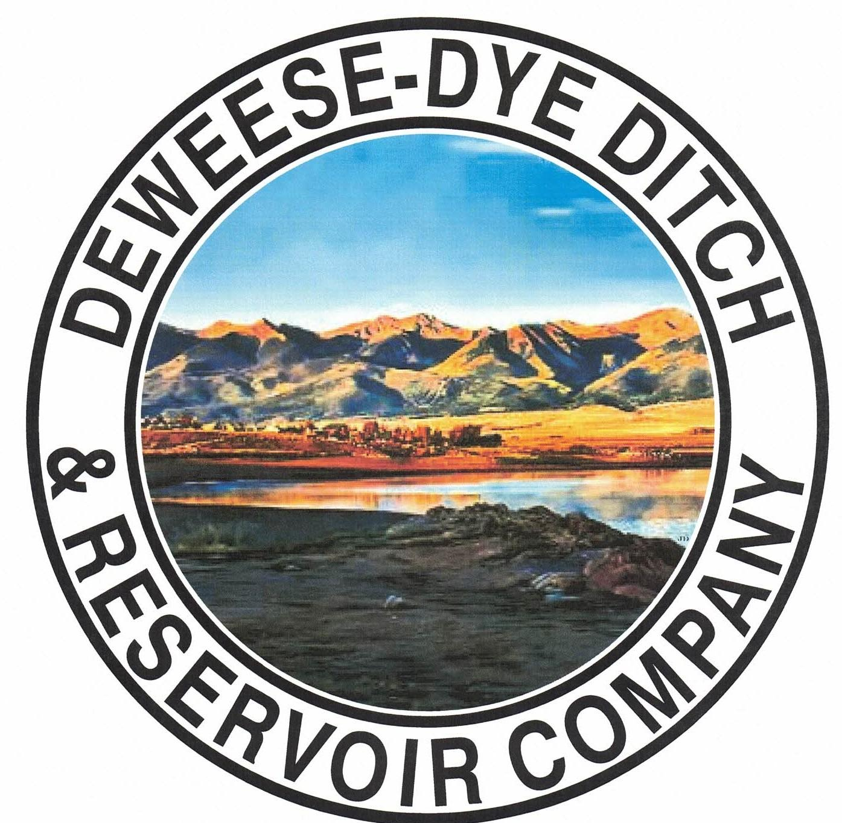
DeWeese-Dye Ditch & Reservoir Company
Board Meeting
PO Box 759
Cañon City, CO 81215

June 1, 2026

Call to Order: President Bolkema called the meeting to order at 7:00 p.m.

Board Directors Present: Board Directors Absent:
Arlin Bolkema
Kenn Estes
Bill Brogoitti
Leo French
Marc Thompson

Others Present: Absent
Annette Reed-Pugh, Secretary/Treasurer
8 Shareholders

Minutes:
The minutes from the May 4, 2026 meeting were e-mailed prior to the meeting. All Board Directors indicated they had read the minutes. President Bolkema called for a motion to approve the minutes as written, Director French moved to accept the minutes, Director Brogoitti seconded, all voted in favor.

Financial Report:
- Presentation of the bills:
The list of May bills was provided to the Board for review. President Bolkema called for a motion to approve payment of the bills. Vice President Estes moved to pay the bills, Director Thompson seconded, and all voted in favor of the motion.

- Balance Sheet and Income Summary:
The financial reports were provided to the Board to review prior to the meeting, and anyone with questions were directed to speak with Secretary/Treasurer Reed-Pugh.

Old Business:
- Reservoir Extension Update:
Nothing new to report. Previous discussion for historical information: UAWCD will be applying and administering grant funding for the various studies and future expansion. Upper Ark has been approved for our CWCB grant for Phase 2 of the Enlargement feasibility study. They will continue to partner with GEI, the same engineering company from Phase 1, to handle these next steps. The proposal from GEI was provided to the Board previously, which outlines the specific tasks and scope of work for Phase 2. GEI will attend Upper Ark’s Board at our May 14th meeting. President Bolkema asked for the Board’s input, questions, and comments of the GEI study, and if the Board had any issues with the proposal. Discussion ensued. The Board indicated no issues and to move forward. President Bolkema called for a motion to move forward with the scope of work for the grant from GEI. Director Brogoitti moved to approve the scope of work, Vice President Estes seconded, and all voted in favor of moving forward. Secretary/Treasurer Reed-Pugh will contact Upper Ark to let them know of the discussion and the Boards agreement.

- BLM Grant Update (outlet pipe repair):
Previous discussion for historical information: Discussion ensued on scope of work provided by RJH, which was provided to the Board previously for review. RJH provided the options/alternative for the outlet pipe repair. The option that was desired by the Board when discussion first took place is now the most costly. After discussion and consideration of the best option for repair, President Bolkema called for a motion to approve the scope of work for Option #1 of the traditional slip line in the amount of $470,000.00. Director French motioned to approve to move forward with Option #1, Director Brogoitti seconded, and all voted in favor. President Bolkema will contact Bob with RJH to let him know of the Boards decision.
RJH will be at the dam Friday June 6, 2026 to take some measurements of the inside dimensions of the pipe, as well as pictures. President Bolkema stated there are ¾’ to 1’ thick sidewalls, and that grouting would be best to seal the pipe rather than crawling inside of it.

New Business:
.
- Secretary/Treasurer Business Items: Secretary/Treasurer Reed-Pugh discussed business items and issues, and provided an update on receivables and transfers processed. Just a reminder that there are issues with email sending limits, so email will no longer be used in notifying Shareholders. All notifications will be provided via website, auto-rely on company email, and voicemail messages. Shareholders will be directed to the website going forward for all notifications. Some discussion ensued about the Lakeside Water questions brought to the Board via email from Leo Evans. We will determine a time to meet to answer the questions.

- Major Ditch Repairs:
- Superintendents Brogoitti and Thompson provided an update. The ground is very dry posing issues trying to fill in the first month. The reservoirs are starting to come around now that there is some water on the ground. Supers are working hard to monitor and deliver the water to our Shareholders.

- Ditch Superintendent Update:
- Some of the Shareholders have not been cleaning their laterals, in accordance with our bylaws. Said Shareholders have been told repeatedly to clean their laterals, as they are affecting all of Shareholders by not doing so.
- Superintendent Thompson provided a quote on higher quality decals for the ditch trucks, and he will look further into the matter to get better quality decals using a new logo.

- Irrigation schedule changes:
Discussion ensued about the irrigation schedule. Several options were discussed and considered due to the drought conditions and water levels. The lack of moisture continues to pose issues for water across the state, including our water. Superintendents Brogoitti and Thompson are doing their best to monitor and deliver water under the current conditions, but it is at the point the schedule needs to be cut back. We are held by river call and have to run according to river call and water levels.

President Bolkema called for a motion to approve a water delivery schedule change to begin delivering one run per week, Monday, Tuesday, and Wednesday only-effective immediately and until further notice. Director Thompson motioned to approve the change to one run per week consisting of Mondays, Tuesdays and Wednesdays only, until further notice. Directory Brogoitti seconded, and all voted in favor of the motion. Secretary/Treasurer will post the notice to the website, generate an auto-reply on company email for those emailing us, and set a voicemail message to this effect.
This schedule will be subject to change according to conditions until further notice.

- Shareholder Questions:
The floor was opened to shareholders questions and/or comments.
There were no concerns brought before the Board.

REMINDERS:
- All Shareholder notices will now be posted to the website. We are no longer using email notifications due to email limits.

- The Board will not tolerate any receipt of too much water. If any Shareholder is determined to be taking more than their rightful amount, they will be immediately terminated from water for the entire season, no exceptions. Water is going to be scarce this year, and we have to be extra mindful of our resource.

- Shareholders are expected to clean and maintain their laterals, as per our governing By-laws. Violations will be issued to Shareholders for non-compliance with our by-laws; up to and including termination of water delivery.

- Other Business:
The floor was opened to other business.
There was no other business brought before the Board.

Adjournment: With no other business to consider, President Bolkema called for a motion to adjourn. The meeting was adjourned at 7:41 p.m., via a motion by Vice President Estes, and seconded by Director Brogoitti, and a unanimous vote in favor.

Respectfully submitted,

Annette Reed-Pugh
Secretary/Treasurer

