**1st Annual South Jersey Gem,**

**Jewelry, Mineral, & Fossil Show**

Date: October 13 & 14, 2018

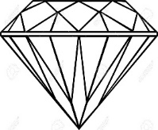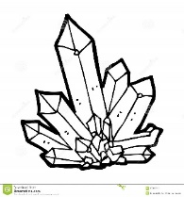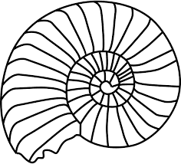

The Jewish Federation of Southern New Jersey Annex Building

*(1721 Springdale Road Cherry Hill, NJ 08003)*

**Show Hours:**

Saturday: 10:00 am – 6:00 pm

Sunday: 10:00 am – 5:00 pm

~ 16 Dealers ~ Door Prizes ~ Refreshments ~

Admission:

Adult: $5.00; Seniors: $4.00; Children (12-16): $3.00;

Children under 12 & Scouts in uniform: Free

*Receive $1 off any adult admission ticket with this flyer.

sjmineralshow.com * sjmineralshow@gmail.com