3rd Annual South Jersey Gem, Jewelry, Mineral,
& Fossil Outdoor Show
~~~~~~~~~~~~~~~~~~~~~~~~~~~~~~~~~~~~~~~~~~~

Date: October 17, 2020
(Rain Date: October 18, 2020)

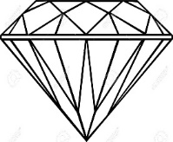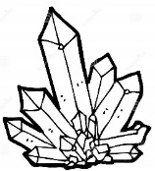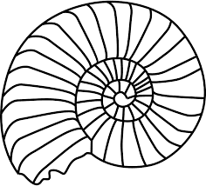

The Jewish Federation of Southern New Jersey Annex Building
(1721 Springdale Road Cherry Hill, NJ 08003)

Show Hours:

Saturday: 10:00 am – 5:00 pm

~ 13 Dealers ~ Free Admission ~ Face Coverings Required ~

sjmineralshow.com * sjmineralshow@gmail.com

