**4th Annual South Jersey INDOOR Gem, Jewelry,**

**Mineral & Fossil Show ~~~~~~~~~~~~~~~~~~~~~~~~~~~~~~~~~~~~~~~~~~~**

Date: April 29, 2023

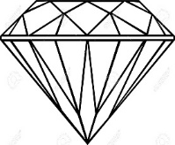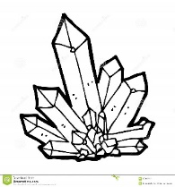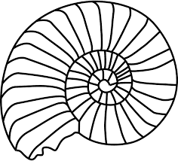

The Jewish Federation of Southern New Jersey Annex Building

*(1721 Springdale Road Cherry Hill, NJ 08003)*

**\*Edited Show Hours:**

SATURDAY ONLY: 10:00 am – *4:00 pm

~ 16 Dealers ~ Door Prizes ~ Refreshments

Admission:

Adult: $4.00; Children (6-17): $3.00;

Children under 5 & Scouts in uniform: Free

*Receive $1 off any adult admission ticket with this flyer.

sjmineralshow.com * sjmineralshow@gmail.com