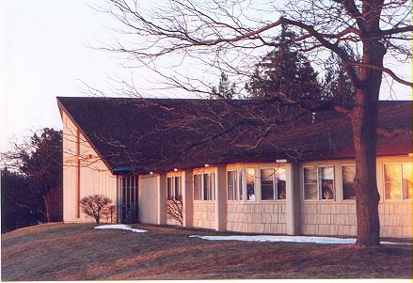

**September/October 2025 Communiqué**

John Calvin Presbyterian Church

50 Ward Hill, Henrietta, NY 14467

Office Phone: 585-334-2130

Gratitude for Life is Caring for Our Health

“Love all God’s creation, the whole of it and every grain of sand. Love every leaf, every ray of God’s light! Love the animals, love the plants, love everything. If you love everything, you will perceive the divine mystery in things. And once you have perceived it, you will begin to comprehend it ceaselessly, more and more every day. And you will at last come to love the whole world with an abiding universal love.”

Fyodor Mikhail Dostoevsky

For several months, I have been contemplating and, perhaps, brooding over my physical, cognitive, and spiritual health, because of an upcoming routine, every five-year medical test. What struck me in Dostoevsky’s comment is that loving ourselves means good stewardship of all aspects of our health. Are we eating a balanced diet of proteins, carbs, and fiber, vitamins, and minerals we need each day? Are we sleeping seven to eight hours a night and getting a restful sleep that will heal our minds and bodies, as sleep is designed to do? Are we exercising enough based upon our ability to stretch, to move, to lift weights, and to do so without getting injured? Are we seeing our health care professionals at the appropriate time and being vaccinated? Yes, I do get vaccinated for the flu every year. How is our prayer life and our bible study, either at home or with other people? Do we look for God’s presence in the world around us as Dostoevsky recommends? How is our memory? Do we do puzzles that challenge us to think? Do we read and reflect on what we have read?

I am sure the list could continue, but I want us to consider how we can express our gratitude to God for the life given to us as a gift by being good caretakers of our health. Can we take Dostoevsky’s suggestion to “love everything” as the path to the stewardship of our health and well-being that will move us closer to God’s image and God’s purpose for our lives?

May you all be blessed with good health in body, mind, and spirit,

Pastor Carson



*Preparing for Fall Worship*

Season of Creation

September 7 to September 28, 2025

Season of Pentecost 2

October 5 to November 23, 2025

Through the focus passages for the Season of Creation and Season of Pentecost 2, we are invited to see Chaos as the given from which the Creator brings forth life to materialize possibility. Job 38, the focus passage that begins the Season of Creation, makes the claim that the wisdom of God is found within the creative chaos out of which the world is born.

God’s voice is heard in the whirlwind; that is, God’s voice is heard in the chaos. “Where were you when I laid the foundation of the earth?” God asks Job. “I was there,” answers Wisdom in the final week of the season. During the four weeks of the Season of Creation, we study and worship with the sacred text of creation as we explore divine wisdom in oceans, flora and fauna, storms, and the cosmos. Aqua – the blue-green color of planet Earth when viewed from outer space – moves to the green growing color of the Season of Pentecost, which began June 8. We return to the Season of Pentecost with a letter to a young Timothy that celebrates faith handed down from one generation to the next generation.

During this period, we observe individuals facing adversity and recognize that healing arises when liberation from oppressive social systems is achieved. In stories from the gospel of Luke, we encounter one who is freed from a skin disease, freed from all restriction, free to be fully grateful, free to offer full praise. A widow refuses to give up seeking justice, and we are encouraged to challenge injustice, too. When a religious leader contrasts himself with another, we join a dance of pride and humility. Zacchaeus climbs a tree, and we all see more clearly; no one is left out of God’s plan for right relationship, shared blessing, and participation in community. In the final weeks of the

Season of Pentecost and the church year, we hear a psalmist spell out the greatness and goodness of God who is near to all, and we imagine, with the prophet Isaiah, a world filled with love and peace.

On Reign of Christ/Christ the King Sunday, we find ourselves in the middle of the heart-felt prayer of a loving leader of the Christian band at Colossae, and we are carried into a lofty, Christological reflection on what God has done and what God has offered to the world in Christ.

September 7 - Ocean Sunday

Job 38:1–18 Psalm 104:1–9, 24–26 Ephesians 1:3–10 Luke 5:1–11

God created a world that is interconnected, joined together in a complex web of related parts. God holds all these things together – and expects us to help. The complexity and expanse of creation are bigger than we can understand. God laid the foundation of Earth. God said to the ocean, “thus far shall you come, and no farther, and here shall your proud waves be stopped” (Job 38:11). That is one powerful God.

September 14 – Fauna and Flora Sunday

Psalm 104:14–23 Job 39:1–8, 26–30 1 Corinthians 1:10–23 Luke 12:22–31

“You cause the grass to grow for the cattle, and plants for people to use, to bring forth food from the earth” (Psalm 104:14). The Season of Creation readings invite us into a relationship with the natural elements that surround us. We have an intimate relationship with the plants and animals that feed and nourish us. Our food comes from all parts of creation – plants growing in the ground, fish and seafood living in rivers and oceans. We depend upon creation to keep us alive. When we grow, harvest, and consume responsibly, we care for creation and preserve the balance of nature for the generations that follow us.

September 21 – Storm Sunday

Psalm 29 Job 28:20–27 1 Corinthians 1:21–31 Luke 8:22–25

“God sits enthroned over the flood; God sits enthroned as ruler forever. May God give strength to God’s people! May God bless God’s people with peace!” (Psalm 29:10–11) Creator God is not the only role that God plays in our lives. As these verses explain, God is a God of storm and God strengthens and calms us. While we might struggle with the different roles God plays in our lives, we can be assured that God is present in times of storm. We can tell God we are afraid, and God hears.

September 28 – Cosmos Sunday

Proverbs 8:22–31 Psalm 148 Colossians 1:15–20 John 6:41–51

We take for granted God’s divine wisdom in creation – the elements of creation that work perfectly together to sustain all life. In Proverbs, Wisdom speaks about the creation of the cosmos at the beginning of time, long ago, “before the beginning of the earth” (Proverbs 8:23). Wisdom was there alongside God as God crafted the world and all creation. Today, we are working alongside God – conserving and protecting creation – sharing in God’s delight. We cannot forget our role in maintaining the health of all creation – it will undoubtedly affect our own.

October 5 – Living Love Letter - World Communion Sunday

Lamentations 3:19–26 Psalm 137 2 Timothy 1:1–14 Luke 17:5–10

“I am reminded of your sincere faith, faith that lived first in your grandmother Lois and in your mother Eunice, and now, I am sure, lives in you.” The church community grows because of the wisdom and nurture provided by members of the community. Each one of us can point to someone – and probably several people – who inspire and challenge us on our faith journey. In this week’s scripture, Paul points out that Timothy’s faith reminds him of the faith of Timothy’s mother and grandmother. We are heirs to a faith tradition that can strengthen us in our own walks with God.

October 14 – The Voice of Healing

Jeremiah 29:1, 4–7 Psalm 66:1–12 2 Timothy 2:8–15 Luke 17:11–19

“Keeping their distance, they called out, saying, ‘Jesus, have mercy on us!’” Jesus’ healing of the 10 with leprosy shows us God’s endurance during the most difficult and painful times through to healing on the other side. It is in the actions of the 10 that they are made well – Jesus invites them to go and return to the community so they might be a part of it again. Our daily actions reveal faith's role in our lives. Although we might not experience dramatic physical healing, we can step out in faith and allow God to heal relationships or personal wounds that make us unwell.

October 19 – A Voice for Justice

Jeremiah 31:27–34 Psalm 119:97–104 2 Timothy 3:14—4:5 Luke 18:1–8

“Then Jesus told them a parable about their need to pray always and not to lose heart.” The persistent widow in this scripture did not give up. She continually demanded justice from the unjust judge. And despite the judge’s hardened heart, the widow “wore him out”; she endured. We don’t know the specific situation of the widow’s case for justice, but we can all probably quickly cite examples of injustice that we see in the world around us. But we can’t forget: God’s justice is always with us.

October 26 – Dance of Pride and Humility

Joel 2:23–32 Psalm 65 2 Timothy 4:6–8, 16–18 Luke 18:9–14

“All who exalt themselves will be humbled, but all who humble themselves will be exalted.” We can easily fall into the trap of the Pharisee in this passage – thanking God that we are not like so-and-so. Because of society’s emphasis on image and self-promotion (think about social media sites like Facebook, Twitter, and Instagram), we can quickly pass judgment on what people say, do, and on their appearance. Jesus reminds us that in the reign of God, “all who exalt themselves will be humbled, but all who humble themselves will be exalted.”

November 2 – Salvation for All

Habakkuk 1:1–4, 2:1–4 Psalm 119:137–144 Luke 19:1–10 2 Thessalonians1:1–4, 11–12

“Zacchaeus, hurry and come down; for I must stay at your house today.’ So Zacchaeus hurried down and was happy to welcome to Jesus.” Jesus’ visit to Zacchaeus’ house shows us how important it is to share how much God’s love really means to us – with our hospitality and sacrifice. Zacchaeus was viewed by many as a sinner, and even unclean because of his interactions with the Romans. Jesus called Zacchaeus by name – knowing what was in his heart, even as the crowd grumbled. Jesus said, “For the Son of God came to seek out and to save the lost.”

November 9 – God Is Near to All

Haggai 1:15b—2:9 Psalm 145:1–5, 17–21 2 Thessalonians 2:1–5, 13–17 Luke 20:27–38

“God is near to all who call.” The psalmist reminds us that God is always close to us – “God is near to all who call on God.” This is important to remember during times of trial, and also when things in our lives are going just fine. God’s glorious splendor and wondrous works are to be praised daily, forever and ever.

November 16 – Joy Begins Now

Isaiah 65:17–25 Isaiah 12 2Thessalonians 3:6–13 Luke 21:5–19

“The wolf and the lamb shall feed together; the lion shall eat straw like the ox.” God sees reconciliation where there is misunderstanding and hostility. Things are going to be transformed – there will be life and new homes where there was once death and despair. Everything will live in harmony – creation, too.

November 23 – Christ over Chaos

Jeremiah 23:1–6 Luke 1:68–79 Colossians 1:11–20 Luke 23:33–43

“Christ is the image of the invisible God.” Christ holds all things together – a way for God to also hold us close. We have a hard time imagining the complete glory of the Reign of Christ. God’s ways are grander than we can imagine. We can know that through Christ, we can learn more about God’s wisdom and what we need to do to become the loving church community that God wants us to be.

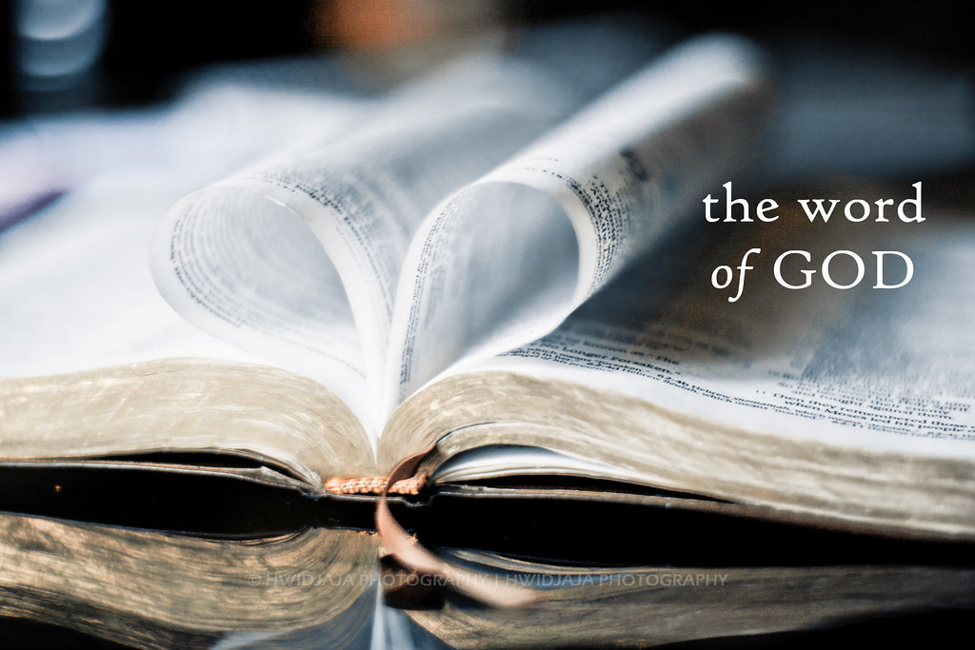

**Presbytery in Brief**

By Rev. Dr. John Odom, Executive Presbyter  
  
Martin Luther did not show up with a nail, hammer, and 95 Theses, but 104 Presbyterians did—either in person at the Batavia, First Presbyterian Church, or online via Zoom. And the Presbytery of Genesee Valley lived up to our Presbyterian motto: “The Church reformed and always being reformed according to God’s Word.” The following are some of our reformations as we seek to change and become the people and the presbytery that Christ is calling us to be:

**Glorified**God through worship with an inspired sermon by outgoing Moderator Mindy Shaffer and received an offering to help establish a warming center for Batavia.

**Reformed**the presbytery’s structure with these actions:  
  
**Established a Mission Commission (MC)** to put mission at the center of the presbytery’s life. The MC will coordinate the life of the presbytery between meetings, oversee and approve the work of its Working Groups, and provide a communication and shared vision within the presbytery. The MC replaces the Transitional Leadership Council.  
  
**Established**the following commissions to assume most of the work of the Committee on Ministry, which was dissolved at the presbytery’s May meeting:

* **Congregation Relations Commission (CRC)** to build strong relationships with sessions and pastors—encouraging faithfulness, assisting transformation, providing accountability, and mediating conflict.
* **Pastoral Transitions Commission (PTC)** to accompany congregations from the moment a pastor announces that they are leaving until a new pastoral leader is on the field. The PTC also has the delegated power of the presbytery to examine ministers for membership in the presbytery, approve, modify and dissolve pastoral calls and relations.
* **Established**the Budget Development and Oversight Committee as a sub-committee of the Board of Trustees.

**Highlights from Session**

* A huge thank you to all of those who helped figure out and secure the needed roof repair and replacement. We are especially appreciative of the time and effort that Carl S., Randy H. and John S. put in to make this happen.
* By the time of this reading, the roof repair/replacement should be completed. Session and the Congregation approved the Nordic bid
* New Boiler work is progressing.
* Windows and rugs have been cleaned, floors mopped cleaned and waxed
* Extension of gutters for downspouts to direct water away from the building has been completed
* Mission donations to: Presbyterian Home -- $300
* Accepted resignation of Shaya G., Music Director who will be moving to South Carolina to be near family.
* Search is ongoing for a new Music Director.
* Approved Clarinet Connection use of sanctuary rehearsal space on Tuesday evening.
* “Gratitude in Action” stewardship campaign agreed on to help replenish stock market funds used for roof repair and replacement.
* Potluck Sept. 7 and Christmas Potluck December 14

**Presbytery Meeting Highlights** from July 29th have been included separately from Rev. John Odom’s article in the Valley Vibes (Genesee Valley Presbyterian newsletter). The new leadership model for Presbytery can also be found as this signals a big change in how Presbytery will be operating. The meeting at Dansville was a hybrid meeting—well attended by in person as well as online participants.



**Gratitude In Action**

Carl DF

Every morning, I start my day with a gratitude prayer. It starts out something like this…Thank you Lord for all that I am, all that I have and all that I will ever be. This is how I prepare myself for whatever challenges the day may bring. Living with gratitude helps me to recognize God’s daily abundance in my life and in the world.

One of the things I am most grateful for is the faith community at John Calvin. In the Celtic tradition there are the “thin places”. These are where Heaven and Earth are so close together that you can almost step from one to the other. You may not realize it, but John Calvin Presbyterian Church is one of those places.

It’s also an important piece of the Rush-Henrietta community, providing support to a wide variety of local groups. Continuing our mission and ministry work is vitally important. This is why your church Session decided to move forward with the recently completed roof replacement so we can effectively move into a leak-free future.

This did require the expenditure of about $91,000 from our Investment Reserve funds, leaving us with about $29,000 as a remaining prudent reserve. Considering our yearly budget, this is not sufficient to meet any unforeseen financial needs of the church.

So, on behalf of your church’s Session, I am here to announce the start of John Calvin’s **GRATITUDE IN ACTION** program. For the next six weeks you and I have an opportunity to fund the future of this church and this congregation by adding $30,000 back into our reserve investment account fund.

The estate of Pat Plasse has already donated $5,000 to the program and **GRATITUDE** **GIFTS** of any size are vitally important because the next $5,000 in contributions is being matched, dollar for dollar, by an anonymous member of this congregation. **THESE SERVANTS HAVE PUT THEIR GRATITUDE INTO ACTION….AND SO CAN EACH AND EVERY ONE OF US!!** Contributions are easy and can be made in all the same ways as pledges and be sure to earmark them as **GRATITUDE** to ensure that the matching funds are applied.

You will hear much more regarding the **GRATITUDE IN ACTION** program over the next several weeks. **TOGETHER,** we have an amazing opportunity to ensure that this church continues to be a sanctuary for all of God’s children…. not just for today, but into the future as well. Thank you and may God bless us all.

Have you ever thought of providing fellowship snacks after Church Services on Sunday, but didn’t know where to start or how to do it? If the spirit moves you to bake or buy snacks for fellowship hour, please see one of the deacons: Nancy M, Janice S or Mark S. We can help you with determining how much coffee to make, what to buy or bake, and how much to make, among other things. Please don’t be shy, we are here to help.

The Deacons of 2025

The Walk to End Alzheimer’s is Coming

Get ready for the Annual Walk to End Alzheimer’s on October 4, 2025. JCPC will once again be participating in this important endeavor. Whether you want to walk with the team, donate to the cause, or be with us in spirit, everyone is welcome. More details will be coming soon!

For those of you who want to walk, we will meet at 10:00 am at the church on Saturday, October 4, and walk in the neighborhood for the cause. Our walking team name is John Calvin Presbyterian Church, and you can donate online at act.alz.org. Please find the Rochester Walk and our walking team name to donate to this year’s walk. Many thanks for all of your generosity in the past. We are looking forward to your support again this year in whatever capacity you choose.

Ellen B, Team Leader

**New Presbytery Structure**

A new structure for the presbytery was approved by the presbytery at its July 29, 2025, meeting. The following is a portion of an article sent out before the vote to explain the new structure and how it came about. The article has been edited for length, so it fits into the Communiquè. I do believe reading the following article will be helpful for all of us to understand the new structure.

Peace,

Pastor Carson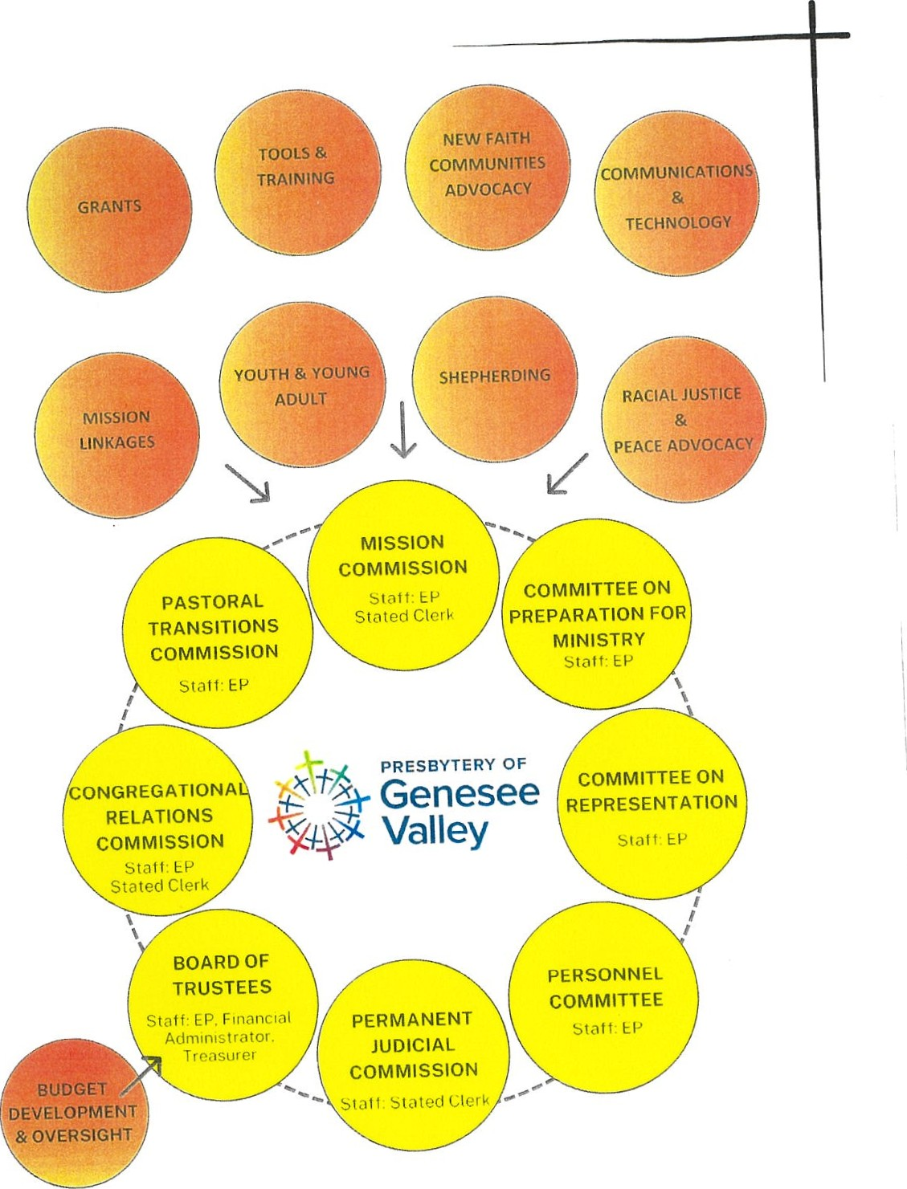

**Mission First: Introducing the Mission Commission**

*Rev. Evan Wildhack, Convener of the Transitional Leadership Council*

The apostle Paul writes in 1 Corinthians 12:

*Now there are varieties of gifts but the same Spirit, and there are varieties of services but the same Lord, and there are varieties of activities, but it is the same God who activates all of them in everyone. To each is given the manifestation of the Spirit for the common good.*

  That’s the framework for this introductory report. As we consider this new structure, our goal is not eﬃciency for its own sake – but to create space where every gift can be activated, and where every congregation, leader, and ministry can remain healthy, vital, and sustainable, and can ﬂourish for the common good.

 As our Book of Order reminds us in F-1.01:

*“Human beings have no higher goal in life than to glorify and enjoy God now and forever, living in covenant fellowship with God and participating in God’s mission.”*

This isn’t about rebranding. It’s about realigning.

**So, what is the Mission Commission?**

The Mission Commission, as proposed, is designed to serve as a coordinating body that supports the Presbytery between stated meetings, with a strong emphasis on mission-ﬁrst alignment, coordinating the mission and vision of the presbytery through active support of all the Working Groups. As a commission, it will have the authority to act on behalf of the Presbytery in between stated meetings in certain administrative and mission-related matters, while remaining accountable to the whole body.

The goal is to strengthen and streamline communication, improve coordination and reduce redundancy, and most importantly, put mission – not maintenance – at the center of our common life.

But why call it the “Mission Commission?” Why not call it the “Coordinating Commission”? We thought it was cute and catchy, and it was the name that stuck as TLC worked through putting this proposal together.

But in all seriousness, the name does more than sound catchy – it names our purpose. It reﬂects a deliberate and faithful re-centering of our Presbytery’s work around our stated Mission: Know Christ, Live Christ, Share Christ.

Whether we realize it or not, that mission shapes the way we gather, the way we serve, and the way we discern what matters most. Naming this body the *Mission Commission* signals that the work it does is ultimately about strengthening the ways we know, live, and share Christ.

It also aligns with our Presbytery’s vision, which reminds us that our focus is not self-preservation but the landscape of possibilities and challenges facing our congregations, with the primary goal of encouraging and empowering healthy, vital, and sustainable congregations and leaders.

The Mission Commission, then, is not just about procedure. It’s about purpose – about keeping us oriented toward what God is doing in our midst, and oﬀering the kind of support and structure that lets mission ﬂourish.

**Who Serves on the Mission Commission?**

The Commission will consist of 9 voting members. Why 9? Any more than that and you risk having seats that remain unﬁlled, as was experienced on the Big Picture Team. Also, it lines up with the number of folks on both the new Pastoral Transitions and Congregational Relations Commissions, so there was a desire for consistency. Included in the nine are:

* The **Immediate Past Moderator of the Presbytery**, who moderates the Commission;
* The current Presbytery **Moderator and Moderator-Elect**;
* Conveners of the **Pastoral Transitions Commission**, **Congregational Relations Commission**, and **Committee on Representation**;
* And **three at-large members**, nominated by the Committee on Representation and elected by the Presbytery
* Both the **Executive Presbyter** and **Stated Clerk** will serve as ex-oﬃcio members.
* Other committee and/or working group representatives will be invited to report to the Mission Commission as needed for updates and support and encouragement, or upon their request

A word about those three at-large members and their importance: in the past, we tried to achieve broad representation through the neighborhood model.

The Big Picture Team was to have representatives from each of the “neighborhoods.” I originally joined BPT as the representative from the Country neighborhood. However, that model was never eﬀectively implemented, and over time it has broken down completely. I believe there was a neighborhood or two that never had a representative on BPT, and at the end of BPT’s life, as convener, I resisted bringing anyone new in so that they didn’t have to join a sinking ship.

However, we still believe in broad participation and diverse voices. That’s why the inclusion of three at-large members is so important. It’s not about geography – it’s about participatory discernment – ensuring that the work of the Presbytery is shaped not only by positional leaders, but also by the insight and experience of the wider Presbytery.

**Mission Working Groups**

Let’s now talk about the working groups, or what will soon be known as Mission Working Groups, if the Mission Commission is approved, because these groups are where much of the Presbytery’s real ministry and impact happen. If the way is clear, all current and future working groups would report to the presbytery through the Mission Commission.

That said, it is essential to make clear: all existing working groups will remain unchanged as the Mission Commission takes shape. That is intentional. The Mission Commission is not being formed to interfere, dismantle, or micromanage. Instead, it will come alongside each working group to meet with them, to listen carefully, to support, and to evaluate together how best to move forward in this next chapter in the life of the presbytery.

Some working groups may ﬁnd that they’re thriving. Others may discover that they’re duplicating eﬀorts of another working group or there are areas of overlap. Some may discover that they have completed their original purpose and/or are at the end of their life. Some may need revitalization. All in all, the goal is not control – it’s clarity, collaboration, and care.

And here’s something essential: communication is a two-way street. Working Groups don’t need to wait for the Mission Commission to reach out to them. If there’s something a Working Group needs feedback on, or if there’s an issue that would beneﬁt from broader discernment, they are always encouraged to initiate contact. The Mission Commission is there to be a partner for our Working Groups – to encourage, support, and advocate for the ministry taking place across our Presbytery. We want Working Groups to know they are heard, seen, and valued.

To allow for a healthy and supported transition, it is hoped that by next July, Working Groups will take on a slightly more formal structure:

* **Six elected members** in staggered three-year terms, and not limited to being ordained as either a minister or a ruling elder. If you’re a regular member of one of our congregations or worshiping communities, then you can be on a working group. Of those six, the working groups would then elect a convener and a recording secretary.
* The ﬂexibility to invite others to participate with voice but not vote
* And no assumption of permanent appointment – just faithful participation for a season.

This opens the door for new leadership, new energy, and deeper engagement across the Presbytery.

**Why do working groups and other committees not have formal representation on the Mission Commission?**

That’s a fair and essential question. And the answer is grounded in what we’ve learned from past structures—especially from our experience with the Big Picture Team. As alluded to earlier, there was an eﬀort to include broad representation from across the Presbytery, including formal slots for neighborhood reps and some committee chairs.

But in practice, it often didn’t work. The problem wasn’t necessarily that the table got too full—it was that it became increasingly diﬃcult to ﬁll the seats at all. Many roles sat vacant, not because people didn’t care, but because the structure itself didn’t invite meaningful engagement. Some folks were there simply because no one else from their group wanted the job. And when people don’t want to be in the room, it becomes nearly impossible to do good, forward-looking work together. And the fact that folks didn’t want to be there also led to a lack of consistency in meeting attendance.

So, in designing the Mission Commission, we’ve taken a diﬀerent approach. Rather than assigning formal seats to every group, we’ve created a smaller structure that remains relationally accessible. Mission Working Groups (and other Presbytery committees) don’t need formal representation to have a voice. The Commission is charged with actively coordinating and supporting the work of the working groups—and that means regular communication, listening, and collaboration.

Just as importantly, Working Groups (as well as other Presbytery committees) can always request time with the Commission. They don’t have to wait for an invitation. If there’s a question, a concern, or a discernment moment that requires input from the Commission is needed or desired, they are encouraged to bring it forward.

This structure emphasizes relationship over representation, and ﬂexibility over formality. It’s not about leaving anyone out—it’s about building in the kind of access, trust, and accountability that we hope will encourage greater participation, not less.

**How This Supports Our Mission and Vision**

Everything we’re proposing, every change and every structure, serves a purpose: to live into both our stated mission – **know Christ, live Christ, share Christ** – and our shared vision of **healthy, vital, and sustainable congregations and leaders.**

This new structure:

* Focuses mission over maintenance
* Encourages relationship, not just representation, by fostering mutual trust and accountability
* Strengthens and supports Working Groups by oﬀering encouragement, ﬂexibility, and accompaniment
* Reduces burnout and increases clarity to make the work more sustainable and help avoid the exhaustion that plagued previous structures
* Builds on what has already worked in the past, bringing stability and focus to what has already been happening.
* And most importantly, it returns our focus to what matters most: participating in God’s mission together.

Finally, the new presbytery structure is ultimately about becoming more faithful to the mission God has placed before us. It is about organizing ourselves in a way that supports **fruitful ministry**, honors the gifts among us, and frees us to respond with agility, clarity, and care.

We recognize: change is not always easy.

  If the Mission Commission is a first step into a new chapter in the life of the Presbytery, one that builds on the work we’ve already done and gives shape to where we believe God is leading us next. That will require **trust**—trust in one another, trust in our leaders, and most importantly, trust in the guidance of the Spirit. It will also require **grace**—grace when things don’t unfold perfectly, grace when we need to adjust or adapt, and grace as we learn together what this new structure will look like in practice.

We are not aiming for perfection. We are striving for faithfulness.