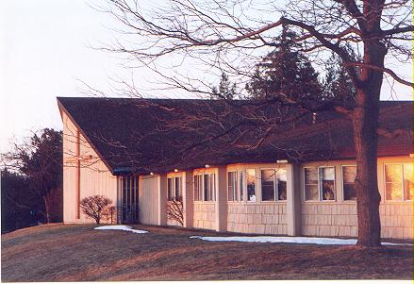
November/December 2025 Communiqué
John Calvin Presbyterian Church
50 Ward Hill, Henrietta, NY 14467
Office Phone: 585-334-2130

____________________________________

Waiting and Preparing for the Shoot to Emerge from the Stump

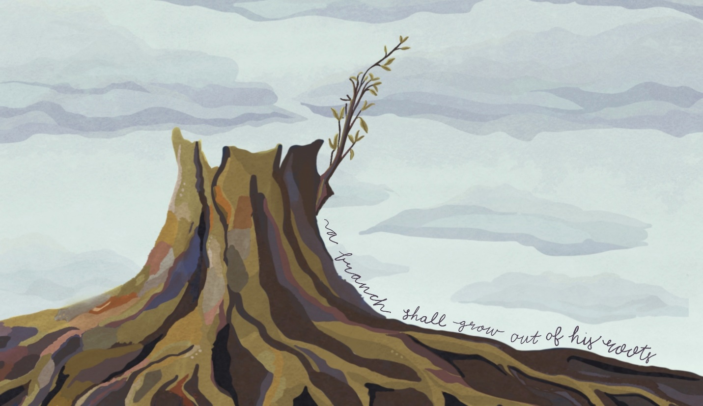
“400 years of silence. That was the number of years between the last words of the prophet Malachi and the miraculous announcements that the Messiah was to be born to a young, unwed woman. 400 years during which time it seemed that God was silent as God’s people experienced ongoing political upheaval making life difficult. 400 years of waiting, wondering. Were any of the prophecies true? Was there to be a Messiah, someone who will save them from the tyranny of being ruled by foreign powers? For those who were looking, little hope was to be found,” according to the writer of Reformed Worship’s Advent series.
“Some may wonder where God is today? Is there any hope to be found in our world? But all wasn’t lost then, nor is it now. Hope was not dead. Hope is not dead,” the writer continues. Just as the prophet Isaiah had foretold, “A shoot shall come out from the stump of Jesse, and a branch shall grow out of his roots.”
Are we waiting and preparing for the shoot that is Jesus to emerge into our lives and the lives of all people in the world? What do we do in our waiting? Do we sit and look out a window? Do we sit by the fire in our fireplaces wishing the world around us would be transformed from wars in Ukraine, Gaza, Israel, and South Sudan, from the ongoing droughts creating more hunger, from the food deserts in our larger Rochester community, from the polarizing conversations about justice, respect, race, and immigration as well as from the concerns of violence and fear.
No. Our waiting is not passive because we are expecting a guest to arrive, expecting Jesus the Christ to come and there is work to be done. Just as we clean our homes, dusting and vacuuming, washing the windows, cleaning the house and getting everything in our homes in order when we are expecting guests to come into our homes, so we are called to prepare for the coming of Jesus and the celebration of his birth by looking at our lives to see the housecleaning of our lives that need to be done. Do we need to re-orient our lives to how Jesus taught us to live by loving God and loving our neighbors in new ways? Perhaps, we need to hear John the Baptist’s call to repent as a call for us to change the direction of our lives. How have we turned away from God and now need to turn toward God? How have we veered off God’s path for life and need to find that path again? What relationships need mending? What foundations of our lives are shaking and coming undone? Where do we need joy to emerge in our lives?
We begin answering these questions in Advent then continue in Christmastide and Epiphany as we ground our lives in God’s love and grow in our hope of God’s transforming power to change the world into a place where all people live together in communities of loving kindness and peace. A place of joy where all people are valued as images of God who have been given gifts to share with the community, bringing wholeness to the community.
Peace and joy,
Pastor Carson


Worship Leaders for 2025 – November and December

Nov 2 Rev. Dr. Carson Mouser Dec 7 Rev. Dr. Carson Mouser
Nov 9 Rev. Dr. Carson Mouser Dec 14 Rev. Dr. Carson Mouser
Nov 16 Rev. Jim Renfrew Dec 21 Rev. Dr. Carson Mouser
Nov 23 Rev. Dr. Carson Mouser Dec 28 Rev. Deborah Fae Swift
Nov 30 Rev. Dr. Carson Mouser



November 2 – Congregational meeting following worship for election of

2026 Officers

November 22 – Joint Training for Elders and Deacons 9 am –11 am on Zoom

November 23 – Installation of 2026 Officers during worship

December 14 – Church Christmas Potluck directly after worship

Jan 25, 2026 – Annual Meeting of the Congregation and Corporation of JCPC

Highlights from Session

Gratitude in Action campaign going well—Donations currently total $35,236
New Music Director, Ciara Cornelius hired and will begin January 2026.
Vera Forster will lead the choir in November and December
Caroling at Addison Erie Station December 7th at noon
Donations from Mission as follows:
Presbyterian Home--$300
Sheen Housing -- $200
Kirkhaven Christmas Items --$200
Friendship Children’s Center Christmas -- $200
Building and Grounds report that the new boiler is installed
Ongoing care of doors, RNS rooms and floors
Election for new 2026 Officers will take place following worship on Nov 2nd
Presbytery Meeting November 8th
Joint Training of Elders and Deacons November 22 nd 9-11 am on Zoom
Installation of 2026 Officers November 23rd during worship
Decorating church for Advent/Christmas November 23rd following worship
Pulpit supply November 16th Rev. Jim Renfrew
December 28th Rev. Deborah Swift
Christmas Potluck December 14 th
Christmas Eve service 4:00 pm December 24th
Annual Meeting of the Corporation and Congregation January 25, 2026
Review of Emergency closing plan

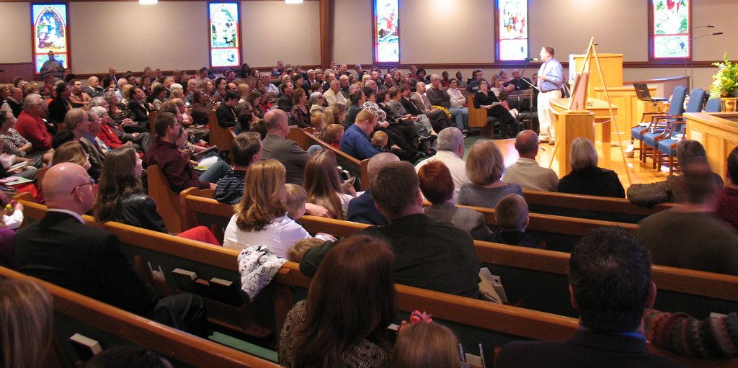

Our Christmas Giving Organizations

Friendship Children’s Center

Friendship CC provides childcare for children 18 months through 4 years, as well as before and after-school care for children up to 12 years old. They serve approximately 100 children. Breakfast, lunch, and snacks are served daily for the children. This is a non-denominational, not-for-profit organization that provides a wide range of family and childcare support services in the Rochester area. JCPC members donate toys for the children at Christmas. Barb and Jody will be delivering these shortly after November 30th.

Kirkhaven Senior Living

Kirkhaven began in 1984 and is located in the Park Avenue section of the city. When it was first constructed, Kirkhaven was known as the Presbyterian Home. They provide care for people needing short-term rehabilitation, residential skilled nursing care, respite care, and memory care. Each year, Barb and Jody bring our Christmas donations and gifts to the residents of the senior center.

Operation Christmas Child (a part of Samaritan’s Purse)

Churches in more than 100 countries distribute gift-filled shoeboxes to boys and girls during outreach events that focus on Jesus Christ, God’s greatest gift. The Greatest Gift booklet is available in 118 languages, and a story booklet about Jesus’ life is given to each child receiving a shoebox. Last year, 11.9 million shoeboxes were collected from 11 nations. Last year, JCPC shoeboxes were sent to children in Botswana. This year, our shoeboxes will be collected on November 16th; Jan will register them so they can be tracked, and the Deacon’s mission funds will cover the mailing costs.

What can YOU do?
Lists of potential gift items for each of the organizations we support during Christmas time are on the table in the back of the sanctuary. Each contribution is a blessing to those who struggle financially and reflects Jesus’ love to all. Monetary gifts, including checks and cash, are also welcome. Make your checks payable to John Calvin Presbyterian Church, with a note stating which organization you would like your donation to support.

Thank you for all your contributions, both big and small!

SEASON OF Advent, Christmas and Epiphany
Nov. 30, 2025 – Feb.15, 2026

The prophet Isaiah leads us into the Season of Advent, offering visions of a world of peace and harmony, and a vulnerable child leading the way forward. With Mary, we will sing a song of joy and justice, and Joseph’s courageous choice will encourage us to ground our lives in faithful obedience and righteous action.
The blue/purple color of Advent swirls into the white/gold of Christmas, and we begin the 12 days of Christmas with a psalm of praise for God’s extraordinary accomplishments, before another psalmist summons all creation to praise.
The Season after the Epiphany begins and ends in mystical encounters and words of affirmation: “You are my beloved.” A dove becomes a symbol of Spirit-nurtured growth, and the call of Isaiah and the call of disciples prompts us to reflect on our own call, decision points, and the clarifying light. We spend four weeks savoring a collection of Jesus’ sayings presented as the Sermon on the Mount. The Beatitudes bend our understanding of the world around us and turn our worldview upside down as we glimpse a re-imagined realm where the meek inherit the earth and the merciful receive mercy; we are reminded that we are salt and light in a world in need of both, and we are taken into the heart of God’s Torah and the gospel. What do these visions mean for us today and how might we live into them?

Advent

Advent is about actively preparing for and anticipating God coming into our lives – not only preparing for the celebration of Christ’s birth in a few weeks but actively preparing for God to come into our lives EVERY DAY! God’s presence with us – and our presence with those who are precious to God – brings us closer to God. We grow spiritually, love deeply, and work for peace and justice for all God’s people. During this Advent season we hear God’s message of love, peace, and justice from the Prophet Isaiah. Isaiah challenges us with a message of peace that demands us to work for the well-being of everyone, not simply to set aside our weapons (Isaiah 2:1–5).
God’s peace requires our participation and energy – just as much energy as we might have used in fighting other peoples. Isaiah also shares a vision of power that’s up-ended, reversed – “And a little child shall lead them” (Isaiah 11:6). But how can this be? What is it God is trying to tell us about vulnerability and hierarchies of power? The prophet is telling us about the hope-filled vision of a new world, a world of peace and harmony. A world we’d like to live in today.
Mary herself becomes a prophet – proclaiming a message of liberation to the poor and marginalized (Luke 1:47–55). She carries the great Liberator in her womb and following God’s will she’ll nurture and protect that hope for us all. Along with Mary, Joseph responds to God’s message, received in a dream, to welcome and care for Jesus (Matthew 1:18–25). The example of Mary and Joseph helps us lean into God’s will for us in today’s world.

November 30 - God’s Path of Peace Sunday

Isaiah 2:1–5, Psalm 122, Romans 13:11-14, Matthew 24:36-44

Isaiah’s message for the people of Judah – a message that can still teach us today – proclaims peace to a people who were surrounded by war and conflict. Isaiah explains that peace is not just an absence of fighting, but peace is working together with our enemies. It’s the kind of peace that requires our participation and attention. It is a peace made of restorative justice and the well-being of all people not just for some people. Just as Advent is a time when we wait expectantly for the coming of Christ in the world, peace requires the same watchfulness and involvement.

December 7 – Growing Together

Isaiah 11:1–10, Psalm 72:1-7, 18-19, Romans 15:4-13, Matthew 3:1-12

The prophet shares a hope-filled vision with us – a vision of harmony and understanding – and presents an unlikely subject for leading us toward this vision – “a little child.” Even more unlikely, Isaiah explains that animals who are enemies will lie down together. They will reconcile and be adversaries no more. These verses seem unbelievable, but longing for their fulfillment is the stuff of hope. Isaiah’s vision pushes us to re-think the way we understand power dynamics today and show us that no matter what we think is possible, peace inside ourselves and in the world is possible.

December 14 – Song of Joy and Justice

Luke 1:47–55, Isaiah 35:1-10, Psalm 146:5-10, James 5:7-10

Mary proclaims her devotion to God and God’s liberation in her Magnificat. She’s carrying the very one who will continue the work of liberation in the lives of the poor and marginalized. Mary herself becomes a prophet, declaring God’s vision of a world where God has “brought down the powerful from their thrones, and lifted up the lowly…filled the hungry with good things, and sent the rich away empty.” Mary turns toward God in faith and follows the path before her. She takes on the role of bringing liberation to the world. Will we follow her example of faithfulness to God?

December 21 – Faithful Response

Matthew 1:18–25, Isaiah 7:10-16, Psalm 80:1-7, 17-19, Romans 1: 1-7

As Advent draws to a close, we focus on the birth of Jesus. Joseph’s role in the birth and life of Jesus is often speculated, but one thing is sure – he trusted God’s will and stood by Mary during a difficult time in her life. Joseph provides a home and family for Jesus, an example that all of us can learn from today. And Joseph’s trust in God’s message from a dream shows us how God can communicate with us and give us direction and guidance. As we welcome our Savior into the world, may we also welcome God’s guidance in our lives.

December 24 – Christmas Eve 4 pm

Christmas

It’s Christmas – what we’ve spent all of Advent preparing and waiting for – and as we look around, much of the secular world has stopped celebrating. Gifts were given, exchanged, and returned. The world sighs after all the bustle and celebration. But what some celebrate in one day is so much more.
The Christmas season is actually 12 days, not just one. We are reminded of God’s gifts during this season. First – the gift of praise for all that God has created. The psalmist summons all creation to praise God in Psalm 148. Cries of “Hallelujah!” add to the joy of the season. This call to praise orients us toward God and the gift of God’s love to the world, God’s son. And it’s that son, Jesus, who awed explorers and wise ones in a faraway land to the point that they journeyed to see him. Realizing like the psalmist the greatness of the one they seek, they bring gifts to the child.
While we need to guard against an emphasis on material gifts and commercialism at Christmas, we are at a disadvantage if we do not celebrate the gift from God that came and lived among us. God’s gift to all creation of God’s son is an example of selfless and sacrificial giving. God gifts us with God’s greatness. And in return, we can live out that same selflessness and sacrifice in our own lives. These are not only gifts for the Christmas season, but the whole year.

Dec. 28 – Let All Creation Praise God

Psalm 148, Isaiah 63:7-9, Hebrews 2:10, Matthew 2:1-3-23

In the days after Christmas – when much of the commercial hype related to the season has passed – we can exhale a “We made it” sigh. What we’ve been waiting and preparing for – both the spiritual and the practical – has arrived. As we enjoy the respite from some of the hustle and bustle of the past four weeks, the focus scripture summons us to praise. We are reminded of the greatness of God’s creation. And no matter how overwhelmed we may have felt with Christmas details, God is bigger than all of that. And now in the Season of Christmas we can celebrate God’s great gift to the world – God’s son. Christmas might be “over” in the secular sense, but we’ve only just begun to celebrate

Epiphany

A magician’s trick or the famous man behind the curtain scene in the movie “The Wizard of Oz” reminds us there can be more to something than what meets the eye. The Season of Epiphany truly pulls back the curtain on the son of God as he’s grown to be a man. We become intimate with how Jesus lives, how he loves, and how he wants us to be in today’s world. God wants us to see – through the life of Jesus – the depth of a relationship with God.
We watch Jesus’ baptism, the call of his first disciples, his Sermon on the Mount, and Transfiguration unfold before our eyes. These stories are rich in meaning and teaching about God’s law, God’s commandments, and God’s desire for us to live together in community and peace with one another. Jesus shows God’s love and hope to the world. Throughout the gospel of Matthew, Jesus turns our ideas about the accepted order of the world on their heads. We can’t continue to live the way we’ve always known because God calls us to a better life.
Beginning with his baptism, Jesus reveals his place among God’s people. He is baptized by John the baptizer, not the other way around, to emphasize that it’s precisely in the midst of God’s people that Jesus will live out his ministry.
The Sermon on the Mount exemplifies reconciliation, restorative justice, giving, peacemaking, integrity, truth speaking, and honor. Jesus calls on all of us to examine our hearts and lives and follow his example to practice a more perfect love. This love will strengthen us individually and strengthen the communities we live in. When you pull back the curtain on your congregation today, may you see a community striving to reveal the light of Jesus in our lives today.

January 4 – Christmastide

Jeremiah 31:7-14, Psalm 147:12-20, Ephesians 1:3-14, John 1: 1-18

The prophet Jeremiah speaks God’s vision of homecoming for the exiled Israelites with images of abundance and an easy walk along life giving waters of a brook that will lead them back to their homeland. No obstacles will be in their way. The psalmist in Psalm 147 encourages the worshippers to praise God for the blessings of life they have received out of God’s steadfast love and commitment to Israel. How does God give life? The founding of life in Christ the eternal Logos, is poetic as the opening of the Gospel according to John mirrors Genesis 1 and reminds us that God gives “light to the world” by speaking creation into being. The letter to the Ephesians is a strong celebration of the life of the church, a unique community established by God through the work of Jesus Christ, who is its head and also head of the whole of creation.

January 11 – Baptism of the Lord-See How God Sees

Matthew 3:13–17, Isaiah 42:1-9, Psalm 29, Acts 10:34-43

In this focus scripture, Jesus is baptized by John the baptizer, not the other way around as scripture tells us John would prefer. Jesus’ ministry begins by turning our ideas about him and how God works upside down. God calls us to a deeper relationship with God, a deeper understanding of God, in our baptism. We are called beyond the things we know and understand in the world around us. We are called to imagine how God wants the world to be – how God sees the world. In our own baptism we bathe in waters of Kingdom understanding and truths.

January 18 – Big Call

Isaiah 49:1–7, Psalm 40:1-11, 1 Corinthians 1:1-9, John 1:29-42

The prophet speaks a message of hope to a community in exile. Being separated from all that they know, the people of Judah are defeated and depressed. They are waiting for better tomorrows. The prophet shares God’s message of reassurance and affirmation that not only will their lives be restored – they will be a “light to all nations.” Given their current situation, that seems pretty unbelievable, but God’s vision for the people of Judah is more than they can see and understand on their own. God continues to work in these ways in our lives today.

January 25 – A Call to Follow

Matthew 4:12–23, Isaiah 9:1-4, Psalm 27:1, 4-9, 1 Corinthians 1:10-18

Jesus calls his first disciples. They set aside their lives and livelihoods and follow Jesus. Jesus calls Peter, Andrew, James, and John to follow him, giving them a new purpose for their lives. In this way, not only is answering Jesus’ call to discipleship a gift for God, it is a gift to the disciples who have chosen a new course and direction for their lives. Coming together in a new community, the disciples follow Jesus and God’s will for their lives.
February 1 – Re-Imagined Realm

Matthew 5:1–12, Micah 6:1-8, Psalm 15, 1 Corinthians 1:18-31

The Beatitudes – the blessed and the not so blessed. In these verses Jesus asks us to re-think, to re-imagine, what the world has taught us about the rich and the poor, the haves and the have-nots, the powerful and the powerless. No small feat given the way we see the wealthy and the powerful portrayed in today’s society where we measure being “blessed” by what we accumulate and acquire. And it’s up to us to be sure that Jesus’ teachings are realized in the here and now. It’s our job to be the liberators for those oppressed by society’s notions of “blessed.”

February 8 – Letting the Light Through

Matthew 5:13–20, Isaiah 58:1-12, Psalm 112:1-10, 1 Corinthians 2:1-16

In today’s focus scripture Jesus says that the disciples are salt and light in the world. These symbols of life (salt – preserving and even seasoning life; light – nurturing and sustaining life) are meant to call us to remember the importance of God’s covenant with God’s people. God wants us to remember God’s law as it will preserve our community (like salt), and God wants us to show the message of God’s love to the world (like light). The use of two familiar substances that we encounter daily reminds us our of role as Jesus’ disciples in today’s world.

February 15 - Glorious Mystery – Transfiguration Sunday

Matthew 17:1–9, Exodus 24:12-18, Psalm 2, 2 Peter 1:16-21

The Transfiguration is an awesome moment in scripture. Jesus is transformed in a bright cloud; Moses and Elijah appear alongside him. Jesus is revealed again as God’s son as God speaks to Peter, James, and John saying, “This is my Son, the Beloved; with him I am well pleased.” With the disciples, we are witnesses to Jesus’ light. We are overcome with the mystery of God’s son dwelling among us. In the Season after the Epiphany, we’ve journeyed with Jesus as he’s taught us about God’s love and lived the light of that love among us. As this season draws to a close, we’re challenged to carry that light forward and be a witness to God’s love in the world.

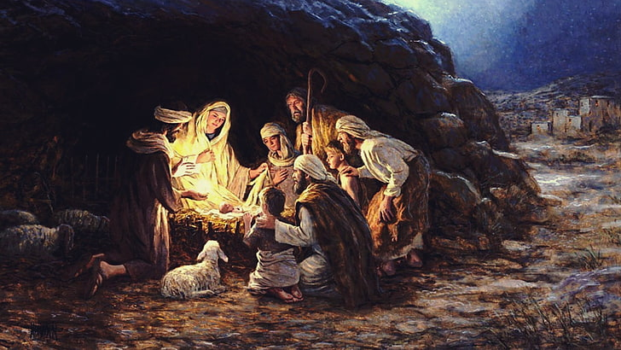
You Are Appreciated!

For several years our congregation has been collecting Christmas gifts for many families and organizations. Our parishioners have always been very generous in their giving. Your kindness has been appreciated by so many adults and children. This year, we have the opportunity to again make Christmas special for the residents at the Kirkhaven Nursing Facility and the children at the Friendship Children’s Center. Gifts will be accepted at church until November 30th. Monetary donations are always accepted. Thank you for being a blessing this holiday season.
Joy to all!
The Mission Team

Welcome To Ciara Cornelius

As most of you know we have hired our new Music Director, Ciara Cornelius. She comes to us the with a myriad of education and experience in the music world. She is a graduate of Nazareth University with a Master of Science in Music Education. Ciara now teaches at North Street Elementary School in the Geneva City School District grades 3 – 5 in general music. Ciara is their chorus teacher and all-county advisor that selects and prepares vocal students to participate in the Elementary All-County East Festival. She will start the first Sunday in January, so please introduce yourself to Ciara. We are blessed to have her as our Music Director.



Thank you!

We want to thank Vera for stepping up to be our Music Director for November and December. The congregation is grateful to you for doing this at an important time on our church calendar. Under Vera’s leadership, we will have wonderful music to go along with our Advent and Christmas Eve services. Again, Vera, a heartfelt thank you from all of us here at John Calvin.

Emergency Closing Procedure

As winter approaches, here is a reminder of our emergency closing procedure. We hope not to have to use it but want to be prepared just in case.

The Pastor, Music Director and Clerk of Session will determine as early as possible if an emergency closing will be necessary. The Music Director will notify the church organist/pianist and all choir members. The Pastor will notify the Deacon Moderator who will then notify the deacons. They will let everyone on their shepherding lists know of the closing. The pastor will also send out a group email, when possible and the closing will be posted on the church website.

Thanks again everyone for helping keep our congregation and friends safe!



Sing and Rejoice! Come Caroling at the Addison

On December 7th the JCPC Choir will be presenting a Christmas program at the Addison – Erie Station with familiar Christmas songs and carols. The program will begin at noon and we will be finished by 12:45. Please come join us! Sandi is putting together a booklet with the words to the songs and carols we will be using during the sing-along portion of the program. It will be easy to follow and fun to join together in song!



Hymn and Carol Favorites—we want your input!

At our last Worship committee meeting we discussed the possibility of having a worship service featuring a hymn sing-along and a service with lots of Christmas carols. Both of these suggestions came from members and friends of the congregation. We would like your input as to which hymns and carols to include. Please use the following form to note your top three favorites of each. There will be hard copies on the table in the back of the sanctuary for you to use. We would appreciate if you would fill them out and return them in the folder there. We look forward to your input and if you have other ideas for special services, please let us know!

Many thanks from your Worship Committee,
Ellen, Carol, Janet, Carolyn and Anne

JCPC Friends

We are interested in your input for upcoming services. Please indicate your top three choices for inclusion in services which focus on these types of music.

My favorite hymns are:

- ____________________________________________
- ____________________________________________
- ____________________________________________

My favorite Christmas carols are:

- __________________________________________
- __________________________________________
- __________________________________________

Thank you from the Worship Committee!

THANK YOU from the Walk to End Alzheimer’s JCPC Team!

Our Walk to End Alzheimer’s team raised $855 towards this important cause. Many
thanks for your continued generosity and support. Also, a big thank you to Carol and Allison who walked on Saturday October 4th. It was a beautiful day, and we all appreciate your representation of our John Calvin Presbyterian Church team.

