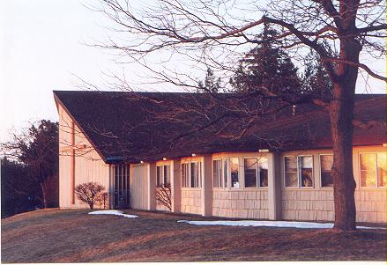
January/February 2026 Communiqué
John Calvin Presbyterian Church
50 Ward Hill, Henrietta, NY 14467
Office Phone: 585-334-2130

_________________________________________



God’s Emphatic Now

Now the kneeling
Now the plea
Now the Father’s arms in welcome
Now the hearing
Now the power
Now the vessel brimmed for pouring
Now the body
Now the blood
Now the joyful celebration
Now the wedding
Now the songs
Now the heart forgiven leaping
Now the Spirit’s visitation
Now the Son’s epiphany
Now the Father’s blessing
Now Now Now
Jaroslav J. Vajda , “Now the Silence,” The United Methodist Hymnal
This communion hymn written by Jaroslav Vajda pushes us to hear the imperative exclamation of the immediacy of Christ’s presence not only in the sacrament, but also in our lives. The twenty-one times the word “Now” is repeated in short bursts combines with the lack of punctuation to produce the experience of moving forward without waiting, without dilly dallying, without seeking some stop over until Christ is present and God’s call to new life is heard. While the tune, as one commentator notes, “ends on a dominant Chord, creating a kind of musical cliffhanger that suggests more is to come” God’s inbreaking into our lives is not a cliffhanger keeping us in suspense of what will happen next like in old time serials or soap operas. This is not God’s teaser for the next season. Rather, the incarnation of Christ is God’s emphatic “Now!” Now the messiah has come. Now the mercy will flow! Now the restorative justice is here! Now God is here with us! Now God is bringing newness and transformation! Now is the blossoming of grace into full bloom! Now the new heaven and new earth are one! There is nothing more to wait for to happen because the clarity of God’s vision of living together as God’s people is made clear and the belonging to God as God’s people is brought to reality.
The only question before us is how will we, as a community of faith following Christ, embody God’s emphatic “Now!” How will we bring our actions into alignment with God’s emphatic “Now!”
Answering these questions now will be part of each worship, each Bible Study, each mission project, each fellowship and each celebration until we find ourselves moving forward with God, and not waiting around for transformation, not waiting until society gets around to restorative justice, mercy, and grace.
Christ’s Peace is with you, “Now!”
Pastor Carson
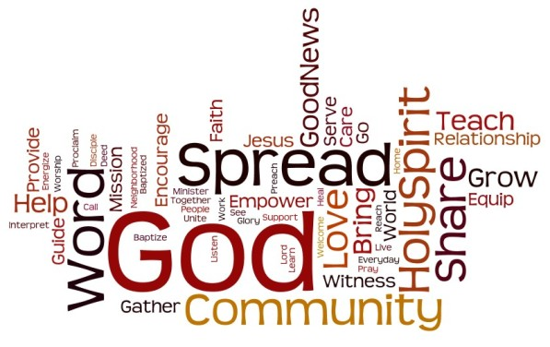



A VERY HAPPY, HEALTHY, SAFE AND BLESSED NEW YEAR IS WISHED FOR OUR FAITH COMMUNITY


Worship Leaders for 2026 – January and February

Jan 4 Rev. Dr. Carson Mouser Feb 1 Rev. Dr. Carson Mouser
Jan 11 Rev. Dr. Carson Mouser Feb 8 Rev. Dr. Carson Mouser
Jan 18 Rev. Jim Renfrew Feb 15 Rev. Penni Farrington
Jan 25 Rev. Dr. Carson Mouser Feb 18 (Ash Wed) Rev. Penni Farrington
Feb 22 Rev. Penni Farrington



Jan 25, 2026 – Annual Meeting of the Congregation and Corporation of JCPC

Feb 15, 2026 – Worship with Music provided by The Clarinet Collection
Followed by a Spaghetti Pot Luck Dinner

Preparing for Lent 2026

Introduction

It seems God is always looking for us even as we search for God or hide from God. As J.J. Heller has written, “I don’t know where I’m headed but I know where I’m from,” to describe the experience of displacement she felt as college freshman who didn’t speak to her roommate, sprained her ankle on the first day of new student welcome event, and her basketball skills were going south on her. She felt alienated from meaningful community and yet she never lost the sense of home as the lifeline she needed and as the “safe haven” where she was known and wanted and brought back to life. Coming home helped her to locate herself. The person she was and is.
In many ways Lent reminds us of the same experience. Lent invites to answer the question “Where are you?” both spatially and in the inner wilderness of our soul with its feelings of exile and return, ascent and descent, hiding and seeking. Where are you, asks us to locate ourselves within God’s presence and to understand that every moment where we are and every place where we are is filled with divine purpose and call. Whether from the call to return in Joel to the breath of life in Ezekiel the journey of return, recognition, renewal, and resurrection always has God meeting us where we are because God is always seeking us first, even when we don’t where we are ourselves.
Lent begins with Jesus in the wilderness, and then we travel with him to Jerusalem and beyond. The gospel of John is our primary gospel companion for most of this Season of Lent. Here we will encounter Nicodemus and through his conversation with Jesus we, too, are assured of God’s care in the winds of change and new birth. We will sit on the edges with a Samaritan woman as she draws from the well of life-giving waters, see the movement of God in our lives and the world around in the story of one who is born blind, experience the pain of a community in the death of Lazarus, and join the conversation that unbinds and brings forth life.
On Palm/Passion Sunday, we enter Jerusalem on a path paved with cloaks and branches. It is a path that leads to betrayal, abandonment, prayer, violence. The story seems to come to an end in the closing of the tomb.
Instead, it is a beginning. Easter arrives dressed in white and gold and a flurry of Alleluias. Mary is the first to witness the resurrection of Jesus and Thomas follows with his proclamation of faith. Two who travel home believing all has come to an end meet the risen Christ when bread is broken and shared.
The Season of Easter ends with words of farewell and commission. John’s narrative of the Spirit’s promised coming finds abundant fulfillment in the Acts of the Apostles’ testimony on Pentecost. The Spirit restores, unites, and empowers the community to witness by moving from Jerusalem outward to the rest of the world. Alleluia!

February 18 - Ash Wednesday

This is the beginning of Lent as we gather together to commit ourselves to walking with Jesus along the stony path leading to Jerusalem, the cross and the tomb. This is the timeless journey toward a deepening of our spiritual lives that will nourish our entire lives. The ashes symbolize the death of the sins in a past we cannot change as we prepare ourselves for the new future God promises is ours in Christ. The simplicity of this prayer worship is a call to the Lenten path. Yet, through the noise of judgment and exile comes the divine call to return home to God that is a restoration of relationship and reorientation of our life toward God, who is our true home.

February 22 – First Sunday of Lent – Where are you hiding?

Genesis 2:15–17, 3:1–7 Psalm 32 Romans 5:12–19 Matthew 4:1–11

Scripture is a mirror that reflects our true identity. In this week’s lectionary texts, we see the power of an individual to heal or destroy. We learn about the impact of a single choice or a single person. This week, we are invited to see our fears and selfish desires as forces against the courage and generosity we have been given by God. We may identify ourselves by our age, race, roles or many other unique characteristics but we are always, first and foremost, children of God. Ponder the following questions:

How does Jesus’ response to Satan show self-awareness, compassion, and faith?

What kinds of physical challenges foster spiritual growth?

When have you wanted God to be like God, but discover the choice causes more confusion and fear. How might the power of choice send us on a journey away.

This is but the beginning of our journey through the wilderness to our home. We will in the March-April Communique discuss the rest of our journey home and the question, “Where are you?”


The Clarinet Collection
By Gail M. Seigel
Music Director

The Clarinet Collection, a local clarinet choir, was established in 1982 as a spin-off of the clarinet section of the Perinton Concert Band. Our group plays for senior living centers, festivals, parties, and other special events. We have enjoyed a mutually beneficial relationship with John Calvin Presbyterian Church for over 30 years. We were first introduced to JCPC by Don Coley, a church congregant (and my clarinet teacher) who asked if we would be willing to play for a spaghetti supper and the rest is history. We performed at JCPC spaghetti suppers from the mid-1990's until the pandemic hit in 2020, when we all temporarily suspended operations. Eventually, when we were ready to rehearse again, I realized that the small music room in my house was not sufficient for a group of our size. I approached the leadership of JCPC to see if we could possibly rehearse in the sanctuary on Tuesday evenings and we were thrilled to get the OK. The sanctuary is set up perfectly for our rehearsals with plenty of space, lots of comfy chairs, and even kids' toys to brighten our surroundings. We continue to be "the house band" for some JCPC special events and even occasional church services. We are grateful for your continuing generosity. The active members of the Clarinet Collection include: Linda Knight (a charter member), Susan Brownell, Wendy Matthews, Ulrich Bobitz, David Van Lare, Craig Hanson, Kojun Hatta, and Gail Seigel. When we need an announcer or percussion player, we call on Janice Hanson (Craig's wife). We love playing JCPC events and look forward to more exciting performances ahead. Thank you!

Photo caption: The Clarinet Collection rehearses in the JCPC sanctuary

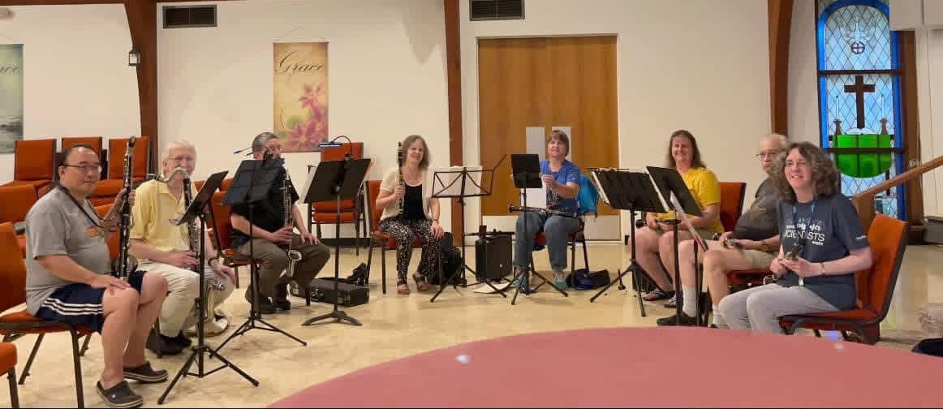
SAVE THE DATE …
SUNDAY FEBRUARY 15, 2026

Sunday Morning Worship
and
Spaghetti Dinner Pot Luck

What: Sunday Morning Worship

with Special Music provided by The Clarinet Collection
AND
Spaghetti Dinner Pot Luck following Worship

When: Sunday February 15, 2026

Our Sunday begins with Worship that will include special music performed by The Clarinet Collection. Following Worship, stay for one of our enjoyable Pot Luck Dinners featuring a delicious Spaghetti with Meatballs main course prepared by our own 'Chef' Mark Sundman. But, everybody can help. Sign up to attend. Bring a side dish to pass (salad, bread, or dessert). Help set up tables or supply some decorations.

We are also encouraging everyone to invite a friend to join us. Meet the musicians from the Clarinet Collection. Invite your neighbors. This is a Fellowship event, NOT a fundraiser. If you have any questions, ask Mark Sundman or Ellen Best.

Yours in Christ,
Mark

“The JCPC Coffee and/or Brunch Gathering.”

A NEW SOCIAL HOUR GET-TOGETHER!

Ladies and Gentlemen of John Calvin Presbyterian Church. How would you like to meet at Peppermints Restaurant, 4870 West Henrietta Rd., for “Brunch” once a
month on a Wednesday at 10 am? Let me know if you would be interested in attending this informal group. I’ve included the Peppermints’ website below. If you are unable to drive to the gathering, please let me know, and we will arrange transportation. If I get enough people interested in this brunch, at least me and one other person, I will plan the first one for January 21st, 2026, 10 am. You may invite a friend who is not an attendee of JCPC.

See me in church or email nmilizia@rochester.rr.com to share your interest in this monthly get-together.

Nancy M

https://www.peppermintshenrietta.com/



