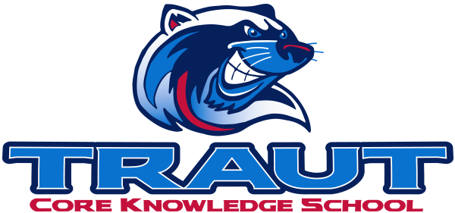
Parent Advisory Board (PAB)
Wednesday, September 10, 2025
7:30-8:30; TCKS Media Center
Chair: Miranda Rogers
“A partnership is defined as a collaborative effort between parents and staff as equals”
- TCKS Charter

Agenda:

- Opportunity for Community Comment

- Board Member Comment

- Approval of 5/8/25 Minutes

- Reorder Agenda

- Discussion:
  - Committee Liaison Assignments
  - Fall Fest and Pumpkin Run Update
  - Stay and Play
  - Glow Dance
  - PAB SOP
    - Initial conversation
  - Grade Level Social Media Highlights
  - Committee Kickoff
  - Review PAB Calendar

- Action Items

- Adjournment

Next Meeting Date and Time: November 12, 2025 7:30-8:30PM Chair:

