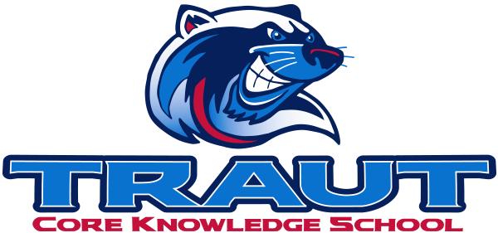
Parent Advisory Board (PAB)
Thursday Nov 21, 2024
7:00-8:00; TCKS Media Center
Chair: Aida Yvari
“A partnership is defined as a collaborative effort between parents and staff as equals”
- TCKS Charter

Agenda:

- Opportunity for Community Comment

- Board Member Comment

- Approval of 10/24/24 Minutes

- Reorder Agenda

- Discussion:

  - PSD Mill Levy Update - De-Brief
  - Pumpkin Run/Fall Festival - De-Brief
    - Food Trucks
    - Activities
    - Drink sales
  - Spring Book Fair
  - Committee Liaison assignments
  - PAB Calendar
  - Parent Pulse Survey - To do or not to do
  - Spring Fling - How can we help enhance fund raising? (Jen)
  - Committee Kick-off September 2025
  - Parking lot concerns
  - Parenting Series

- Action Items

- Adjournment

Next Meeting Date and Time: December 12, 2024 7-8 PM Chair:

