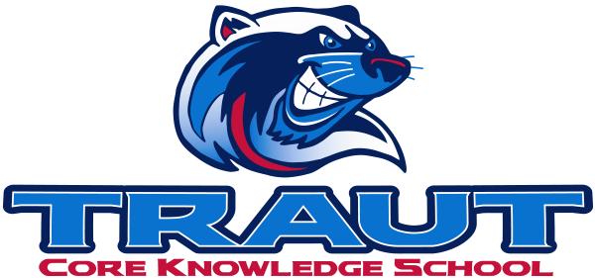
Parent Advisory Board (PAB)
Thursday September 26, 2024
7:00-8:00; TCKS Media Center
Chair: Miranda Rogers, PAB Vice President
“A partnership is defined as a collaborative effort between parents and staff as equals”
- TCKS Charter

Agenda:

- Opportunity for Community Comment

- Board Member Comment

- Approval of 9/5/24 Minutes

- Reorder Agenda

- Discussion:

  - PSD Mill Levy Update
  - Pumpkin Run/Fall Festival- October 25, 2024
    - Food Trucks
    - Activities
    - Drink sales
  - Committee Liason assignments
  - PAB Calendar

- Action Items

- Adjournment

Next Meeting Date and Time: October 10, 2024 7-8PM Chair:

