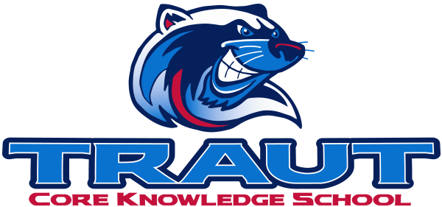
Parent Advisory Board (PAB)
Wednesday, January 14th 2026
7:30-8:30; TCKS Media Center
Chair: Katie Lowry
“A partnership is defined as a collaborative effort between parents and staff as equals”
- TCKS Charter
Attending: Miranda Rogers, Courtney Elder, Katie Lowry, Kristen Dodder, Roxanna Costello, Molly Stong
Absent: Danny Mistry
Community Members: Gavin Roy

Called to order at 6:35

- Opportunity for Community Comment
  - Gavin: Facebook Banner - potential to update to make it more Traut specific
  - Gavin: Appreciation of the transparency but would appreciate more info on fundraising and Wolverine Fund

- Board Member Comment
  - Miranda: VIPS update

- Approval of 12/10/25 Minutes
  - Motion to approve: Kristen
  - 2nd: Miranda
  - Approved: All

- Reorder Agenda

- Discussion:

  - Communication Chair Description Revisement
  - Glow Dance
  - Future Open Board Positions
    - Danny and Miranda will all be stepping off.
    - Courtney’s 2 year term is up and will have to re-run if she decides to.
  - Principal Survey
  - Art Show
  - Spring Fling
    - Same sponsorship structure as last year
  - Bingo Night
    - May 1st if approved by SBMC
  - Committee Updates

- Action Items
  - Move meeting to Feb 25, 2026
    - Motion Kristen
    - 2nd: Miranda
    - Approved by all

- Adjournment
  - 8:11

Next Meeting Date and Time: February 25th, 2026 7:30-8:30PM Chair: Courtney

