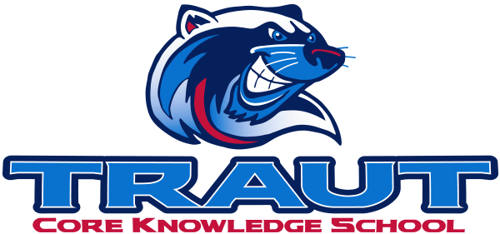
Parent Advisory Board (PAB)
Wednesday, September 10, 2025
7:30-8:30; TCKS Media Center
Chair: Miranda Rogers
“A partnership is defined as a collaborative effort between parents and staff as equals”
- TCKS Charter

Attending: Miranda Rogers, Courtney Elder, Danny Mistry, Katie Lowry, Kristen Dodder, Molly Stong, Roxanna Costello
Community Member: Gavin Roy
Absent: N/A

Meeting Called to order at 7:39PM

Agenda:

- Opportunity for Community Comment
  - Gavin Roy
- Board Member Comment
  - Parent concerns with tech use especially for younger students
- Approval of 5/8/25 Minutes
  - Moved: Miranda
  - Second: Courtney
  - Aye: all
  - Nay: none
- Reorder Agenda
  - Move Committee Kickoff to Discussions after Committee
- Discussion:
  - Committee Liaison Assignments
    - Assessment & VIPS - Miranda
    - Fundraising & Grants - Katie
    - Character Ed & Education - Kristen
    - Tech & Outdoor Classroom - Danny
    - Parent Ed & Mentors - Courtney
    - Hiring - Molly
    - Library & Wellness - Roxanna
      - Add Amber Lillestolen to library

    - PAB liaison needs to have good communications with the chairs on the committees to see what help is needed. Liaison will take a more active role to see what’s going on and what needs to be done within the committee.
  - Committee Kickoff
      - Friday September 26th at the Outdoor classroom from 8:30- roughly 9:30. Packaged Breakfast items
  - Fall Fest and Pumpkin Run Update
    - Fall Fest
      - 3 food vendors have been booked
        - Maria’s Food Truck
        - Glacier Ice Cream
        - Chickfila
      - Needing outdoor games
    - Pumpkin Run
      - No big updates from Gavin at this point, but will be meeting Mike to find out what needs to be done to help
  - Stay and Play
    - No school the first Friday of October. October’s will be during the Pumpkin Run
    - Nov will be TBD. Weather permitting
  - Glow Dance
    - Nail Down a date with Jenn.
  - PAB SOP
    - Initial conversation
      - Will address during November Meeting
  - Grade Level Social Media Highlights
    - Oct - 5th especially with SAB, Eco-week, and book buddies
    - Nov- 4th
    - Dec - Kinder
    - Jan - Music & PreK
    - Feb - 2nd & Art
    - March - 3rd
    - April - 1st
    - May - PE (Field Day)
  - Review PAB Calendar
    - SAC on Oct 15
    - Parent Pulse survey
      - Reimplement but with revisions that will be revisited.
- Action Items
  - Invite for Family Fall Fest - Kristen will create it
  - Look for any outdoor games that we might have for Fall Fest
- Adjournment
  - 8:38 PM

Next Meeting Date and Time: November 12, 2025 7:30-8:30PM Chair: Danny

