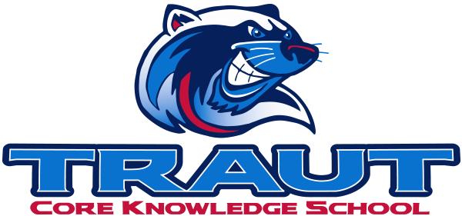
Parent Advisory Board (PAB)
Thursday, January 16, 2025
7:00-8:00; TCKS Media Center
Chair: Miranda Rogers
“A partnership is defined as a collaborative effort between parents and staff as equals”
- TCKS Charter

Agenda:

- Opportunity for Community Comment

- Board Member Comment

- Approval of 12/12/24 Minutes

- Reorder Agenda

- Discussion:

  - Spring Fling Update/Planning
  - Principal Survey
  - Bingo Night
  - Eco Week Fundraiser
  - Committee updates

- Action Items

- Adjournment

Next Meeting Date and Time: January 30, 2025 7-8PM Chair:

