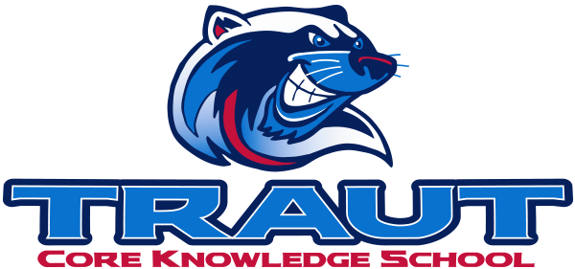
Parent Advisory Board (PAB)
Wednesday, May 13, 2026
7:30-8:30; TCKS Media Center
Chair: Miranda Rogers
“A partnership is defined as a collaborative effort between parents and staff as equals”
- TCKS Charter

Agenda:

- Opportunity for Community Comment

- Board Member Comment

- Approval of 4/8/26 minutes

- Reorder Agenda

- Discussion:
  - Field Day
  - 5th Grade Promotion/Legacy Projects
  - New Board Members
  - PAB 2026-2027

- Adjournment

Next Meeting Date and Time: Fall 2026 Chair: TBD

