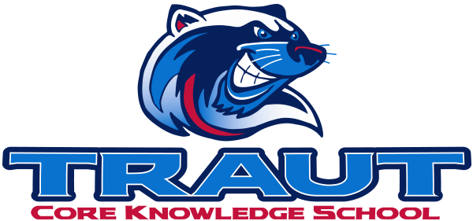
Traut Core Knowledge School
School Accountability Advisory Committee (SAAC)
Wednesday, May 13, 2025
6:30-7:30PM; TCKS Media Center
Miranda Rogers, PAB President
“A partnership is defined as a collaborative effort between parents and staff as equals”
- TCKS Charter

Agenda:

- Opportunity for Community Comment

- Board Member Comment

- Approval of SAAC 10-15-2025

- Review and Discussion:
  - Definition and Purpose of SAAC

  - Standing Committees:
    - Assessment, Curriculum, Communications, Character Ed, Fundraising, Grants, Hiring, Library, Parent Ed, Technology, VIPS

      - Charges for 2025-2026
      - Action Steps

  - Ad Hoc Committees:
    - Outdoor Classroom, Wellness

      - Charges for 2025-2026
      - Action Steps

- Action Items

- Adjournment

Next SAAC Meeting: FALL 2026 TBD Chair: PAB President

