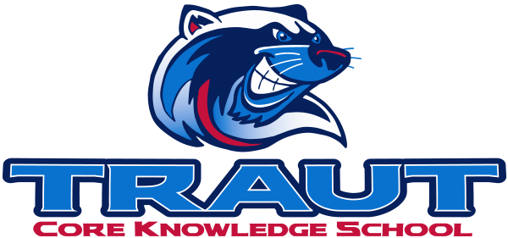
Parent Advisory Board (PAB)
Thursday Oct 24, 2024
7:00-8:00; TCKS Media Center
Chair: Danny Mistry
“A partnership is defined as a collaborative effort between parents and staff as equals”
- TCKS Charter

Agenda:

- Opportunity for Community Comment

- Board Member Comment

- Approval of 9/26/24 Minutes

- Reorder Agenda

- Discussion:

  - PSD Mill Levy Update - Connor Duffy Review / Next steps
  - Pumpkin Run/Fall Festival- October 25, 2024
    - Food Trucks
    - Activities
    - Drink sales
  - Committee Liaison assignments
  - PAB Calendar
  - Parent Pulse Survey
  - PAB Mission - Revisit 3 goals (Community Building, Communication, Fund Raising)
  - Committee Kick-off September 2025

- Action Items

- Adjournment

Next Meeting Date and Time: November 7, 2024 7-8PM Chair:

