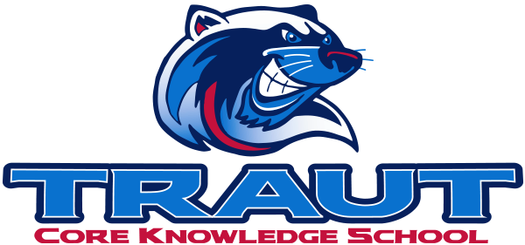
Traut Core Knowledge School
School Accountability Advisory Committee (SAAC)
Thursday, September 10th, 2026
5-6PM; TCKS Media Center
Courtney Elder, PAB President
“A partnership is defined as a collaborative effort between parents and staff as equals”
- TCKS Charter

Agenda:

- Opportunity for Community Comment

- Board Member Comment

- Approval of SAAC Minutes 5/13/2026

- Review and Discussion:
  - Definition and Purpose of SAAC

  - Standing Committees:
    - Assessment, Curriculum, Communications, Character Ed, Fundraising, Grants, Hiring, Library, Parent Ed, Technology, VIPS

      - Charges for 2026-2027
      - Action Steps

  - Ad Hoc Committees:
    - Outdoor Classroom, Wellness, Art Show

      - Charges for 2026-2027
      - Action Steps

- Action Items

- Adjournment

Next SAAC Meeting: May 13th, 2027 5-6PM Chair: Courtney Elder, PAB President

