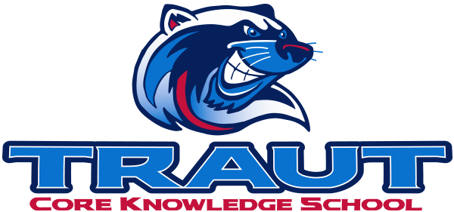
Parent Advisory Board (PAB)
Wednesday, December 10th, 2025
7:30-8:30; TCKS Media Center
Chair: Molly Stong
“A partnership is defined as a collaborative effort between parents and staff as equals”
- TCKS Charter

Agenda:

- Opportunity for Community Comment

- Board Member Comment

- Approval of 11/12/25 Minutes

- Reorder Agenda

- Discussion:
  - Parent Pulse Survey Results
  - Instructional Minutes
  - Glow Dance
  - Art Show Prep
  - Bingo Night
  - Spring Fling

- Action Items
- Survey results

- Adjournment

Next Meeting Date and Time: January 14, 2025 7:30-8:30PM Chair:

