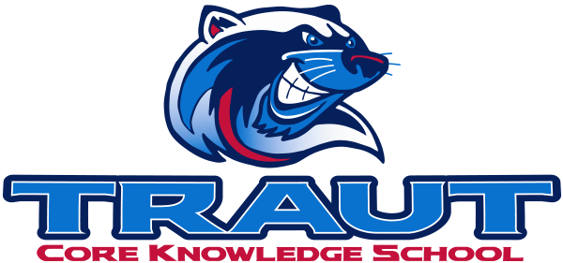
Parent Advisory Board (PAB)
Wednesday, January 14th 2026
7:30-8:30; TCKS Media Center
Chair: Katie Lowry
“A partnership is defined as a collaborative effort between parents and staff as equals”
- TCKS Charter

Agenda:

- Opportunity for Community Comment

- Board Member Comment

- Approval of 12/10/25 Minutes

- Reorder Agenda

- Discussion:

  - Communication Chair Description Revisement
  - Glow Dance
  - Future Open Board Positions
  - Principal Survey
  - Art Show
  - Spring Fling
  - Bingo Night
  - Committee Updates

- Action Items
- Communication Chair Description Revisement

- Adjournment

Next Meeting Date and Time: February 25th, 2026 7:30-8:30PM Chair:

