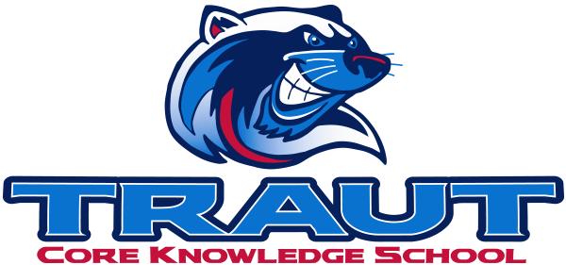
Traut Core Knowledge School
School Accountability Advisory Committee (SAAC)
Thursday October 10th, 2024
5:30-6:30PM; TCKS Media Center
Sara Merrill, PAB President
“A partnership is defined as a collaborative effort between parents and staff as equals”
- TCKS Charter

Agenda:

- Opportunity for Community Comment

- Board Member Comment

- Approval of SAAC Minutes 5/2/2024

- Review and Discussion:
  - Definition and Purpose of SAAC

  - Standing Committees:
    - Assessment, Curriculum, Communications, Character Ed, Fundraising, Grants, Hiring, Library, Parent Ed, Technology, VIPS

      - Charges for 2024-2025
      - Proposed Goals
      - Action Steps

  - Ad Hoc Committees:
    - Outdoor Classroom, Building Refresh, Wellness

      - Charges for 2024-2025
      - Proposed Goals
      - Action Steps

  - Next Steps:

Next SAAC Meeting: May 8th, 2025 5:30-6:30PM Chair: Sara Merrill PAB President

