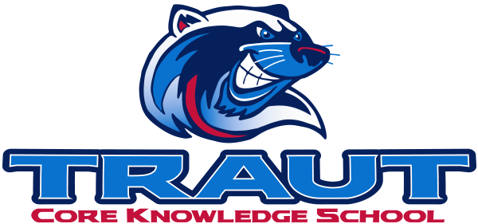
Parent Advisory Board (PAB)
Wednesday, December 10th, 2025
7:30-8:30; TCKS Media Center
Chair: Molly Stong
“A partnership is defined as a collaborative effort between parents and staff as equals”
- TCKS Charter

Attending: Miranda Rogers, Courtney Elder, Danny Mistry, Katie Lowry, Kristen Dodder, Roxanna Costello, Molly Stong
Community Members:
Absent:
7:09PM

Agenda:

- Opportunity for Community Comment

- Board Member Comment

- Approval of 11/12/25 Minutes
  - Motion Roxanna
  - 2nd Katie
  - Approved by all

- Reorder Agenda

- Discussion:
  - Parent Pulse Survey Results
  - Instructional Minutes
  - Glow Dance
    - Jan 22nd
  - Art Show Prep
    - Feb 10th
  - Bingo Night
    - Date TBD
  - Spring Fling
    - April 10th

- Action Items
- Survey results

- Adjournment
  - 8:35
Next Meeting Date and Time: January 14, 2025 7:30-8:30PM Chair: Katie

