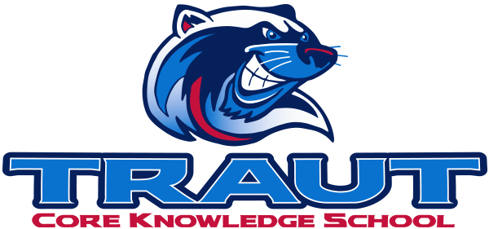
Parent Advisory Board (PAB)
Wednesday, November 12, 2025
7:30-8:30; TCKS Media Center
Chair: Courtney Elder
“A partnership is defined as a collaborative effort between parents and staff as equals”
- TCKS Charter

Attending: Miranda Rogers, Courtney Elder, Katie Lowry, Kristen Dodder, Molly Stong, Roxanna Costello
Community Member: N/A
Absent: Danny Mistry
7:13PM

Agenda:

- Opportunity for Community Comment

- Board Member Comment
Discussion of meeting schedules

- Approval of 9/10/25 Minutes
Motion to approve: Roxanna
2nd: Molly
Approved: All
Opposed: None

- Reorder Agenda

- Discussion:
  - PAB SOP- proposed edits
    - Discussion of amendments to SOP
  - Review PAB Calendar
    - Addition of sending out PAB position openings in January
  - Parent Pulse Survey
  - Traut’s Got Talent 11/20
  - Ideas for increased communication on TCKS event outcomes
  - Stay and Play planning
    - We will cancel the month’s Stay & Play if:
      - Temperatures with windchills at 45 or lower
      - Actively raining or snowing
  - Committee check-ins

- Action Items
  - PAB SOP
    - Tabled until amended further

- Adjournment
  - 8:18PM

Next Meeting Date and Time: December 10, 2025 7:30-8:30PM Chair: Molly

