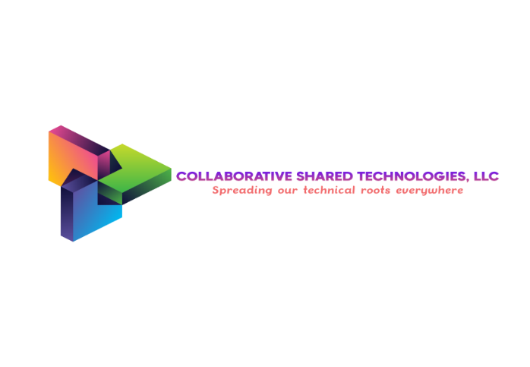

CAPABILITY STATEMENT

Address: 6401 Golden Triangle Drive, Suite 201 #107 Greenbelt, MD
POC: Asha A. Peterson, Founder & CEO
Phone: (786) 512-4783
Email: ceo@collaborativesharedtech.net
Website: https://collaborativesharedtech.net
eMMA Vendor: Active Supplier# 1089551
UEI: HU1GCCXCKN81 | CAGE Code: 174U2 | DUNS Number: 110096910
Business Type: SBA-Certified Small Business | Service-Disabled Veteran-Owned (SDVOSB) | Woman-Owned Small Business (WOSB) | Veteran-Owned Small Business (VOSB) | Veteran Small Business Enterprise (VSBE)

CORE COMPETENCIES
Enterprise Knowledge Management (KM)
- Developing and implementing enterprise-wide KM strategies and maturity models.
- Architecting and deploying structured knowledge capture, retention, and transfer programs for both tacit and explicit knowledge.
- Designing enterprise taxonomies, metadata schemas, and knowledge architectures to enable discovery.
- Establishing organizational learning and cross-functional knowledge-sharing frameworks.
Artiﬁcial Intelligence & Digital Transformation
- Providing AI strategy, governance, and implementation roadmaps aligned to mission objectives.
- Engineering AI-enabled solutions for intelligent search, knowledge discovery, and predictive decision support.
- Delivering predictive analytics platforms that convert data into actionable operational insights.
- Implementing intelligent process automation and workﬂow optimization.
Enterprise Content & Process Management
- Designing and implementing Enterprise Content Management (ECM) systems as authoritative sources of truth.
- Automating document classiﬁcation, tagging, and retrieval using AI to ensure compliance and accessibility.
- Redesigning and optimizing core business processes by embedding intelligent knowledge ﬂows.
- Establishing information governance frameworks for regulated environments.
Business & Organizational Transformation
- Leading process improvement and redesign initiatives using Lean and Agile methodologies.
- Managing complex changes and driving user adoption for technology and analytics programs.
- Implementing performance measurement systems to track outcomes and enable continuous improvement.
- Facilitating cross-functional stakeholder engagement to ensure solution alignment and buy-in.

VALUE PROPOSITION
Collaborative Shared Technologies LLC transforms information into a strategic asset through integrated Knowledge Management and Artiﬁcial Intelligence solutions. We enable federal and state agencies to make faster, data-driven decisions, ensure regulatory compliance, and achieve mission success by embedding intelligence directly into workﬂows and knowledge systems. Our methodology delivers tangible operational outcomes, including reduced process cycle times, increased knowledge worker productivity, and enhanced governance.

DIFFERENTIATORS
- Integrated KM + AI Execution: We uniquely combine deep KM discipline with practical AI application. Unlike pure AI vendors or traditional consultants, we architect systems where AI enhances human expertise—evidenced by our founder’s dual expertise as a KM subject matter expert and AI strategist, directly addressing complex challenges in federal healthcare and defense.
- Full-Lifecycle Delivery from Strategy to Adoption: We own the outcome from initial strategy through implementation, change management, and sustainment. Our proven engagement model, which pairs strategic advisory with hands-on technical delivery, ensures solutions are adopted and deliver lasting value.
- Mission-Critical Governance by Design: We specialize in solutions for highly regulated environments. Our frameworks for records management, information governance, and ethical AI are built into solutions from the start, mitigating risk for clients in public health, defense, and government services.
- Outcome-Obsessed, Business-First Approach: We align every technological solution to a speciﬁc mission outcome and user need. Our work is guided by the principle that technology must serve the mission, resulting in high-user-adoption rates and measurable ROI for our clients.
- Proven Transformation Leadership with Credentials: Our leadership has a documented track record of leading enterprise-scale digital transformations. This is supported by founder credentials including a Master’s in KM, status as a PMP and Scrum Master, and direct experience supporting high-visibility initiatives at agencies like the Defense Health Agency.

CERTIFICATIONS
Federal Certiﬁcations (Active in SAM.gov)
- Service-Disabled Veteran-Owned Small Business (SDVOSB)
- Woman-Owned Small Business (WOSB)
- Veteran-Owned Small Business (VOSB)
State of Maryland Certiﬁcations (Active in eMMA)
- Veteran-Owned Small Business Enterprise (VSBE)
- Certiﬁed Small Business (CSB) / Small Business Reserve (SBR) Eligible

REPRESENTATIVE EXPERIENCE
Client: Defense Intelligence Community (DoD)
Contract Type: Prime Contractor Support (Subcontracted SME Support)
Role: Enterprise Chief Knowledge Officer / KM Strategy Lead
Environment: TS/SCI – Classified & Unclassified Enterprise IT
Scale: 6,000+ Personnel | Two IT Service Units
Scope:
- Directed enterprise Knowledge Management modernization supporting intelligence mission operations.
- Conducted As-Is capability assessments and designed To-Be enterprise KM architecture aligned to operational mission objectives.
- Established governance, taxonomy, metadata standards, and lifecycle controls across directorates.
- Gathered and documented business requirements; developed workflow and process models to improve information sharing and traceability.
- Led enterprise SharePoint Online adoption initiative.
Results:
- Achieved $6.5M cost savings through enterprise training modernization.
- Increased knowledge accessibility and collaboration across 6,000+ personnel.
- Improved lifecycle governance and reduced redundancy across enterprise systems.
- Strengthened compliance posture within classified operational environments.

Client: U.S. Air Force Communications Enterprise
Contract Type: Government Direct (Active Duty Leadership Role)
Role: Enterprise Chief Knowledge Officer
Environment: Classified & Unclassified Systems | Secure Communications Infrastructure
Scale: 22,000+ Customers Supported
Scope:
- Led enterprise KM governance and digital transformation initiatives across communications squadron operations.
- Managed policy development for records management, information governance, and knowledge lifecycle management.
- Administered collaboration platforms and secure enterprise systems.
- Oversaw IT service management processes supporting both classified and unclassified environments.
- Developed structured training programs to drive workforce adoption.
Results:
- Supported operational continuity across 997 unclassified and 689 classified systems.
- Managed approximately 3,000 annual IT service tickets, maintaining high service reliability.
- Increased user adoption and cross-functional collaboration across 22K enterprise users.
- Embedded governance controls reducing operational and compliance risk.

Client: Air Force Special Operations / Global Network Operations
Contract Type: Government Direct (Enterprise Support Role)
Role: Senior Enterprise Knowledge Manager / IT Systems Support
Environment: Global IT Infrastructure | High-Security Operational Environments
Scale: 15,000+ Personnel | 184 International Locations
Scope:
- Supported global technology network spanning U.S. Embassy locations worldwide.
- Configured and documented 600+ IT systems to ensure operational readiness.
- Conducted vulnerability assessments and security scans to mitigate enterprise risk.
- Implemented disaster recovery planning and business continuity procedures.
- Managed records lifecycle and documentation compliance processes.
Results:
- Enhanced system reliability and documentation traceability across 184 global locations.
- Strengthened cybersecurity posture through proactive vulnerability mitigation.
- Improved lifecycle governance and continuity planning for mission-critical systems.

Client: DoD Enterprise Collaboration & Workflow Modernization Programs
Contract Type: Prime Contractor Support (Subcontracted SME Support)
Role: Enterprise Senior Knowledge Manager / AI-Enabled KM Engineer
Environment: Secure DoD Enterprise Collaboration Platforms
Scale: 250+ SharePoint Site Collections | 70+ Automated Workflows
Scope:
- Designed enterprise taxonomies, ontology structures, and metadata frameworks.
- Administered and governed 250+ SharePoint site collections supporting mission collaboration.
- Engineered 70+ automated workflows for document lifecycle and process management.
- Implemented AI-enabled retrieval and knowledge automation solutions.
- Integrated ServiceNow KM and collaboration platforms into structured governance models.
Results:
- Reduced manual processing time by 40% through AI-enabled automation.
- Decreased research timelines from days to hours via intelligent retrieval architecture.
- Improved document discoverability and operational efficiency across enterprise systems.
- Increased standardization and governance maturity within regulated environments.

NAICS CODES
- 541611 — Administrative Management and General Management Consulting
- 541690 — Other Scientiﬁc and Technical Consulting Services
- 541512 — Computer Systems Design Services
- 541511 — Custom Computer Programming Services
- 518715 — Research and Development

COMPANY INFORMATION
- Founded: 2022
- Ownership: 100% Woman-Owned & Service-Disabled Veteran-Owned
- Primary Markets: Federal Government (Prime & Subcontractor), State of Maryland, Commercial Enterprises in regulated industries.
- Work Model: Remote, Hybrid, and On-Site delivery to meet client requirements.

Sincerely,
Asha A. Peterson
Founder & CEO
Collaborative Shared Technologies LLC

