

**JobsGuide Job Fair**

**Comfort Inn & Suites-7007 Grover St. Omaha**

**First Wednesday of most months.**

**Are you looking for a job? Are you happy with your current job?    
Do you need benefits? Vacations? Paid time-off?    
Are you wanting to change your life for the better?   
ATTEND the next job fair! Find the job you are looking for!**

**Jobs Guide Job Fairs**

Job Fairs are on the **first Wednesday** of most months (excluding January and July)   
from **1:00-4:00 PM.**  The amazing events have been taking place at the same location for the   
past 14 years: **Comfort Inn & Suites at 72nd and Grover**. This prime location is right off the interstate, which makes it easily accessible for all. Not only that, there is plenty of **FREE** parking and it’s right **on the bus route**.

**Where else can you go and speak with around 20+ employers,**

**all under one roof, all ready to hire YOU?**

**Meet FACE-TO-FACE WITH EMPLOYERS**Many employers are offering jobs with great benefits and sign-on bonuses.   
Get paid for holidays, vacation time and medical time off.   
There are jobs available in all industries and all skill levels.   
**Improve your LIFE!  Find your dream job NOW**!!  
  
**Check out our website:** [**www.jobfairsNebraska.com**](http://www.jobfairsnebraska.com/)  
**Click on “Jobs” then on the Company logo.   
View the opportunities, then come meet with all the employers, face-to-face   
and leave with a new job.   
Plan ahead…update your resume, research the employers.**

**Heartland Workforce Solutions** will be there to help connect people to opportunities.

**Creighton University** will be there assisting individuals with their resumes.

**Childhood Resource and Referral of the Nebraska Department of Education** will be present and available to assist individuals looking to find day care for their children.



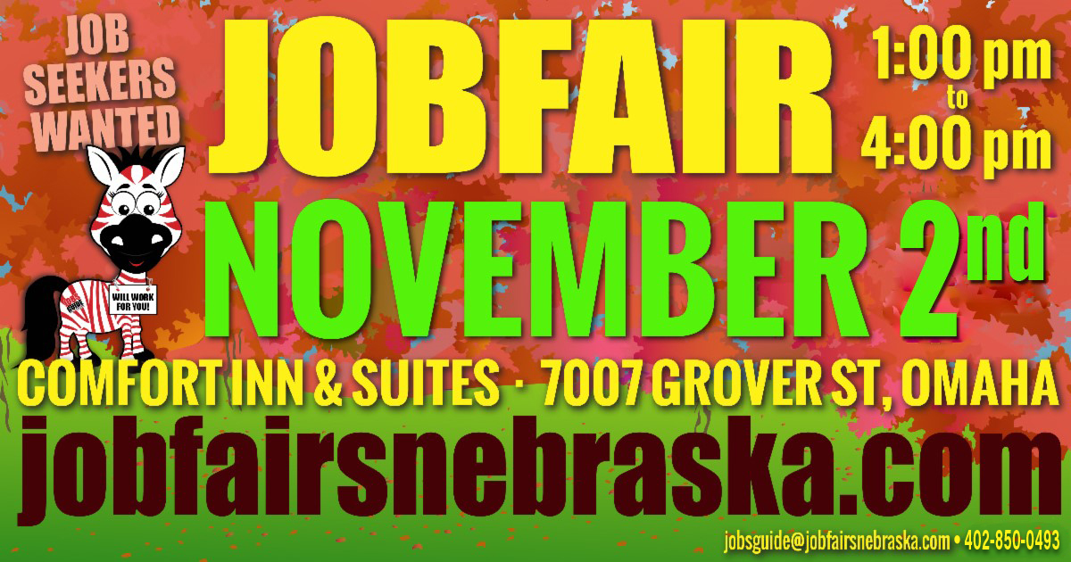Top of FormBottom of Form