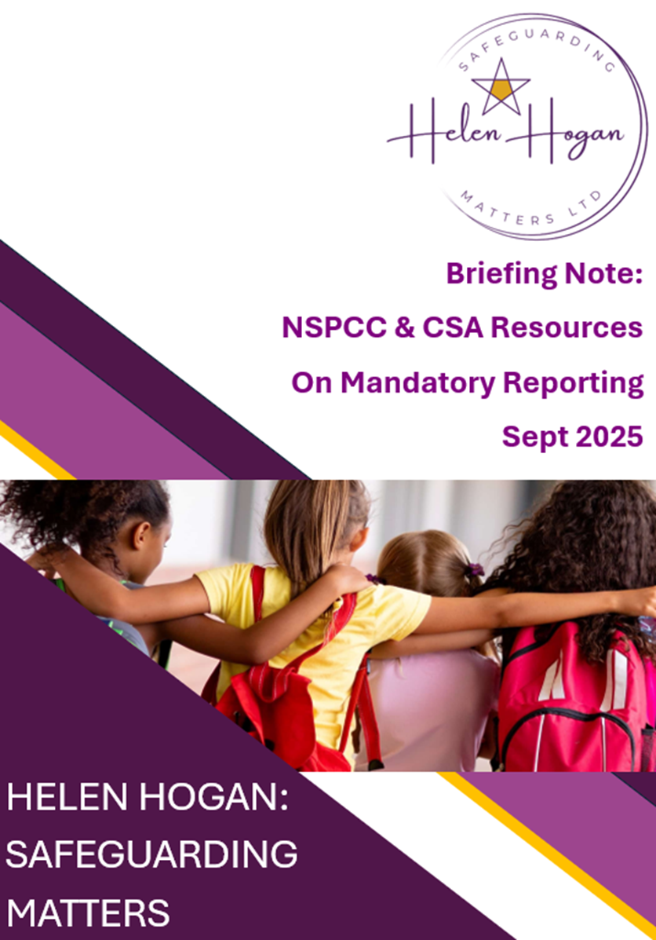

HELEN HOGAN:
SAFEGUARDING MATTERS

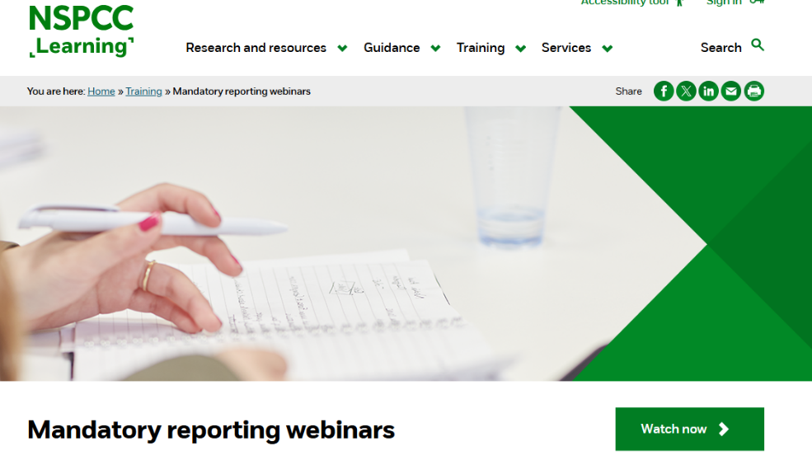
Ahead of the NEW PROPOSED mandatory reporting duty on Child Sexual Abuse the NSPCC has produced some free training for schools, sports and other voluntary sectors.

Please access the free videos via this link
Mandatory reporting webinars | NSPCC Learning
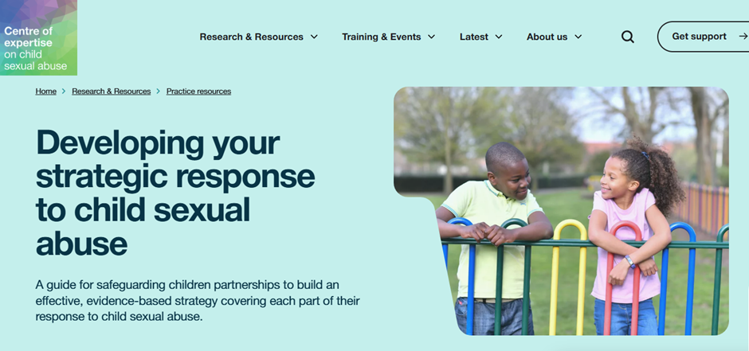
The Centre of expertise on Child Sexual Abuse have also created a new guide on developing evidence-based strategies to respond to child sexual abuse. Aimed at professionals working with local and regional safeguarding children partnerships the guide provides advice on developing and improving strategic responses and sets out information on: identifying strategic aims and intended outcomes; key components of a strategic response; and embedding a strategy across local/regional systems.
Please access the guide via this link
Developing your strategic response to child sexual abuse | CSA Centre

