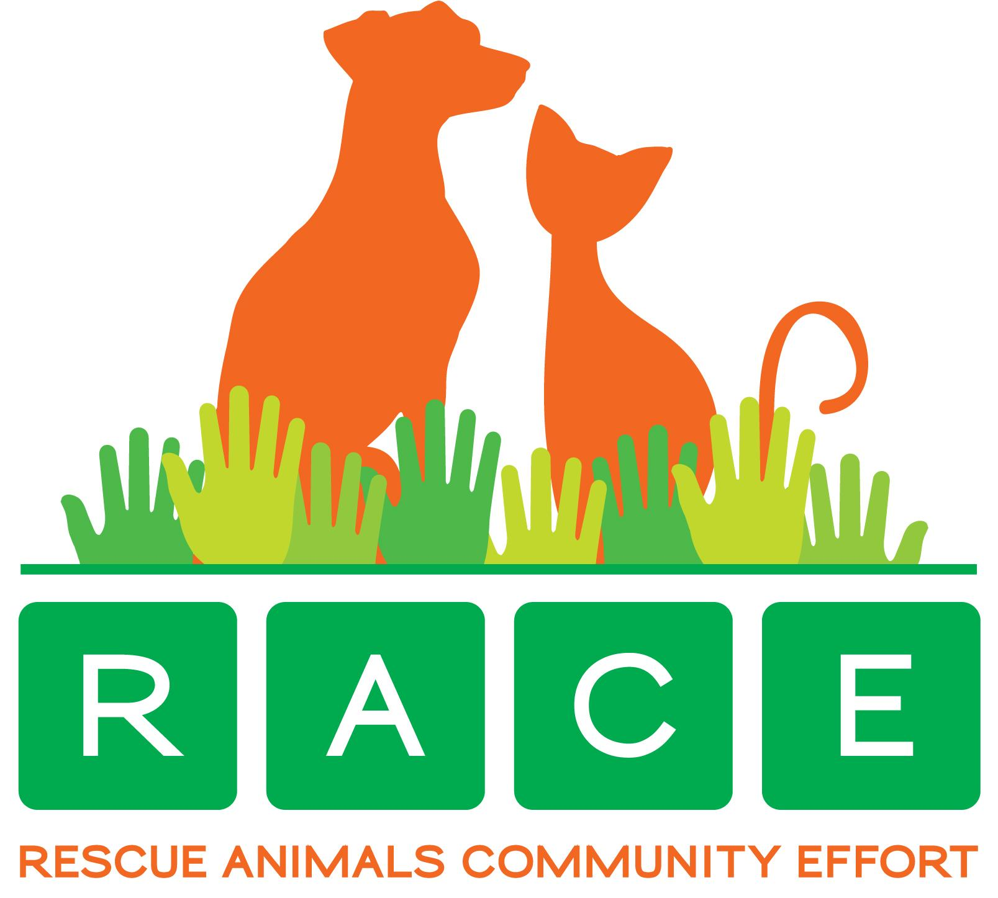
ADOPTION APPLICATION = No application fee
Adoption fees are $250 for dogs and puppies, $150 for senior dogs
Date :

Name of animal ? | Breed | Gender
How did you hear about this animal ? | Facebook | website
Other , please list | Pawprints | Petsmart

Name : | Address: | Unit #
City : | State : | Zip code:
Place of Employment |  | Phone:
Email : | Drivers license # : | State :
Own : | Rent : | Share home:
Development name :
Landlord name if renting or sharing: |  | Phone:
Cell phone: | Work or Home phone:
Names of other adults living in home :
Name & ages of children if any:

Has anyone in home been convicted of animal cruelty or neglect: | Yes | No
Do you have a fenced in yard? | Yes | No
Where will the dog stay when you are not at home? | Crate | Free:
Where will the dog sleep at night ? | Crate: Bed: | Free:
How many hours will the pet be alone every day ?
Nearest relative not living with you: | Phone:
Address: | City : | state:

Names of current pets , or pets owned in last 5 years: | Dogs: | Other:
Name of current Veterinarian: | City | Phone:
Business name of Veterinarian office:
Owner’s name on vet records:
Is your current pet spayed or neutered? | What clinic was it at?
Is your pet current on vaccines & heartworm prevention?
Please initial agreement below this line

I understand I am responsible for protection,care & medical treatment of this pet | Initials:
I agree I am financially able to care for this pet , including accident and illness | Initials:
I understand that at no time will this dog live outside under any circumstances | Initials:
I understand that at no time will this dog be tied or chained outside in any yard | Initials:
I agree to obey all applicable ordinances and laws governing control & custody of pets | initials:
I agree to place place ID tag with name, address & phone # on pet | Initials:
I agree to allow RACE to follow up on pet & take legal action to protect adopted pet | initials:
I understand RACE can’t guarantee health,temperament or behavior of pets & hereby release RACE from claims of liability,injury or damage to persons or property once I adopt | Initials:
I understand I will return pet to RACE if I can no longer care for or house the pet | initials:
I understand RACE has provided me with all records & information pertaining to pet and that it is accurate to the best of their knowledge and I accept the pet based on my judgement of pet’s current condition & personality | initials:
I understand the adoption fee is a donation and is non-refundable | initials:

Signature:

