

SUPPLIES

SERVICE

SELECTION

CUSTOMER SERVICE
___________________________________________________________

Shipping Information


For your convenience, Westan offers a variety of shipping services, depending upon your needs and location. When ordering, ask us to help you choose a courier that will best suit your needs.

Terms



Visa and Mastercard Accepted

All orders are shipped F.O.B. from a Westan branch office. Terms are subject to credit application. Payment is due net 30 days from statement date. Interest on past due balances will be charged at 1.5% per month (18% A.R.P.).

To Place An Order
Phone: (204) 946-5452
Fax: (204) 947-1651

Toll-Free in Canada
1-888-477-9378

TABLE OF CONTENTS
CUSTOMER SERVICE
TABLE OF CONTENTS
MANUFACTURERS’ LISTING
ABRASIVES 1 - 9
ACCESSORIES 105
ACRYLICS 12 - 19
ACRYLICS & MONOMERS 10 - 11
ADHESIVES & ACCELERATORS 21
ALGINATES 82 - 83
ALLOY 22
ARTICULATING PAPER 23
ARTICULATORS 25 - 27
ATTACHMENTS 28
BRUSHES & BUFFS 29 - 33
BUNSEN BURNERS & ACCESSORIES 37 - 38
BURS 39 - 41
CASTING EQUIPMENT 42 - 44
CHEMICALS 45
CLEANERS 97 - 98
DEBUBBLIZERS 46
DENTURE SYSTEMS & ACCESSORIES 49 - 51
DENTURE FLASKS & COMPRESSES 52
DISINFECTANTS 95 - 96
DUPLICATING MATERIALS 109 - 111
EQUIPMENT (MISCELLANEOUS) 62 - 65
GYPSUM ACCESSORIES 77 - 78
HANDPIECES 79 - 80
IMPRESSION MATERIALS 84 - 85
IMPRESSION TRAYS 81
INDICATING PASTES & SPRAYS 24
INSTRUMENTS 87 - 91
INVESTMENTS 74 - 76
LAB PUTTY 86
LATHES 101 - 102
LIGHT CURING TRAY MATERIAL 20
MODEL FABRICATION 53 - 58
MODEL TRIMMERS 103 - 104
OPERATORY 92 - 94
ORTHODONTIC SUNDRIES 106 - 108
PALETTES 34 - 36
POLISHING COMPOUNDS 112 - 113
PORCELAIN 114 - 117
PORCELAIN ACCESSORIES 118 - 119
SEPARATORS 47 - 48
SHIPPING SUPPLIES 59 - 61
SPRUES 99 - 100
STONE 69 - 73
SUCTION UNITS 66 - 68
TEETH 120 - 121
VACUUM FORMING 122 - 126
VACUUM MIXERS 137
VIBRATORS 127
WAXERS 128 - 131
WAXES 132 - 136
INDEX

LISTING OF SOME OF OUR MANUFACTURERS.
___________________________________________________________

A.S.A. INSTRUMENTS
CANDULOR
CMP INTERNATIONAL (VERNON BENSHOFF)
COLTENE/WHALEDENT
DENTSPLY
DREVE
GARRECO INCORPORATED
GC AMERICA
GEORGE TAUB PRODUCTS
HANDLER MANUFACTURING COMPANY
KULZER
IVOCLAR VIVADENT CANADA INC.
KOMET DENTAL
KERR (BELLE DE ST. CLAIR)
LANG DENTAL MANUFACTURING CO.
METRODENT LIMITED
MOYCO INDUSTRIES INC.
NATIONAL KEYSTONE
PACIFIC
PASCAL COMPANY INC.
RAY FOSTER DENTAL EQUIPMENT
RELIABLE
RENFERT
SHOFU
VITA
WELLS DENTAL INC.
WHIP MIX CORPORATION
YATES & BIRD
ZEST LOCATOR
ZHERMACK
ZUBLER

ABRASIVES
___________________________________________________________

ARBOR BANDS CUT OFF DISKS
Available in fine or coarse For Chrome(100 box)
Thin- 38mm x 0.6mm 599515
3/4” Coarse Pkg. of 100 66082 Medium- 38mm x 1mm 599505
3/8” Fine Pkg. of 1000 66093 Thick- 31.8mm x 1.6mm 599510

ARBOR BAND CHUCKS GRINDING WHEELS

3/4” Chuck 51126 - Acrylic wheel “coarse” (red) 65225
Left 50649 for fast, clog-free grinding of
Right 50482 acrylics
Jacobs 50169
- Aluminum oxide wheel “coarse”
MANDRELS (white) knock down wheels
designed for fast removal
1/4” 52306
3/8” 52228 3 x 3/8” Each 65282
Screwhead Each 51910 4 x 3/8” Each 65449
Tapered Each 52074
Large Head Each 51926 - Base plate wheel (green)
3 x ¼” Each 65132
ECONO CUTTER DISKS
- Tooth grinding wheel (green)
1 1/2” 59921 for heatless, chip-free grinding
2 1/2” 59889 of porcelain teeth
Mandrel ¼” 59894
3 x ¼” Soft Each 64640
ABRASIVE WHEELS 3 x 3/8” Hard Each 64677
Excellent for trimming soft liners.
Pre-mounted 10 pack , available in:
Fine K11478
Medium K10456
Coarse K11482

1
ABRASIVES
___________________________________________________________

FELT CONES & WHEELS

Felt Cones

½”x 1” Long Pkg. of 12 57610
¾” x 1 ½” Long Pkg. of 12 57628
1” x 2” Long Pkg. of 12 57636

Felt Wheels

1” x ¼” Soft Pkg. of 100 57420
1” x 3/16” Medium Pkg. of 100 57438
1” x 1/8” Hard Pkg. of 100 57411
1 3/8” x 1/2” Pkg. of 12 N11310

Heatless Wheels
Made of a silicone carbide abrasive for a rapid reduction through final shaping of non-precious, semi-precious, precious alloys, porcelain and acrylic denture teeth without generating excessive heat
Mizzy

No. 5 Reg. Pkg. of 50 (7/8” diameter x 1/8” wide) 60002
No. 5 White Pkg. of 50 (7/8” diameter x 1/8” wide) 60069

Komet
For Porcelain

767A “Thick” 16mm x 3mm Pkg. of 25 K11333

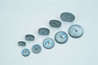

2

ABRASIVES
___________________________________________________________

MOUNTED STONES

For Chrome Cobalt and Non-Precious

PINK (Medium Grit) WHITE (Hard Grit)

Box of 12 or Box of 72 Box of 12 or Box of 72

(226) Barrel Thick 61527 (228) Barrel Thin H10150

(203) Inverted Cone 61505

(230) Tapered Barrel 61493

BROWN (Porcelain to Metal Alloys) GREEN (For Porcelain)

Box of 12 or Box of 72 Box 12 or Box of 72
(300) Inverted Cone H10160 (103) Inverted Cone 62487

(302) Mounting Points H10155 (105) Tapered Barrel H10135

(304) Mounting Stone 62448

(306) Barrel Thick H10495

3

ABRASIVES
___________________________________________________________

MOUNTED POINTS
By Shofu
Duragreen stones are outstanding for finishing porcelain, composites, gold and silver alloys. All shapes are available in HP shanks and are packaged by the dozen.

1C1 62171
1C2 S/O
1C3 62190
1C4 S/O
1C5 62174
1C6 S/O
1C7 62234
1C8 S/O
1C9 S/O

PC1 62164
PC2 62608

TC1 S/O
TC2 62180
TC3 S/O
TC4 62182

WH1 S/O
WH2 S/O
WH3 61903
WH4 61869
WH5 62185
WH6 62188

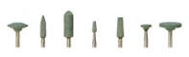

*S/O (Special Order) 4

ABRASIVES
___________________________________________________________

RUBBER WHEELS & POINTS
By Dedeco

Brown (Aluminum Oxide)
Extra long lasting for fast finishing and polishing of chrome cobalt, non-precious, and semi-precious metals. Non-contaminating

Knife Edge Box of 100 S/0
Square Edge Box of 100 55469
Points Box of 100 57135

Black (Silicone Carbide)
“Hard” for finishing and polishing chrome cobalt metals

Knife Edge Box of 100 S/0
Square Edge Box of 100 55612
Points Box of 100 57144

Green (Silicone Carbide)
“Coarse” - the standard for scratch removal and the polishing of chrome cobalt metals

Knife Edge Box of 100 S/0
Square Edge Box of 100 55457
Points Box of 100 57164

Blue (Silicone Carbide)
“Hi Glaze” for polishing non-precious, semi-precious, and chrome cobalt metals

Knife Edge Box of 100 56240
Square Edge Box of 100 55523
Points Box of 100 57123

Red Flexies (Silicone Carbide)
“Fine” - soft and flexible for fine polishing of gold

Box of 100 56227

White Flexies (Aluminum Oxide)
Soft and flexible for ultra fine polishing of porcelain and gold

Box of 100 55846
*S/O (Special Order)* 5
ABRASIVES
___________________________________________________________

SILICONE RUBBER WHEELS & POINTS

Initial Polishing – for precious and semi-precious alloys

G1 Dark Grey 7/8” Square Edge Box of 100 56331
G2 Dark Grey 7/8” Knife Edge Box of 100 56315
G3 Dark Grey Cylinder Box of 100 57230

High Shine – for precious and semi-precious alloys

GF4 Pink 7/8” Square Edge Box of 100 56299
GF5 Pink 7/8” Knife Edge Box of 100 56273
GF6 Pink Cylinder Box of 100 57255

Porcelain & Composite

SG1 Coarse Light Grey 7/8” Square Edge Box of 100 56372
SG1 Coarse Light Grey 7/8” Knife Edge Box of 100 56380
SG3 Medium Light Grey 7/8” Square Edge Box of 100 S/0
SG3 Medium Light Grey 7/8” Knife Edge Box of 100 S/0
SG4 Hi-Glaze Light Grey 7/8” Square Edge Box of 100 56356
SG4 Hi-Glaze Light Grey 7/8” Knife Edge Box of 100 56337

By Komet
Polishes ceramic cleanly, odourlessly, and with a minimum of heat. Square edge.

Box of 10 K10926

*S/O (Special Order)*

6
ABRASIVES
___________________________________________________________

SEPARATING DISKS

NM Slims (Silicone Carbide)
Ultra thin end cutting disk – fastest for porcelain, gold, enamel, and crown and bridge metals

7/8” x .009 Pkg. of 100 59046
Ultra-Thins (Silicone Carbide)
For fine interproximal cutting of porcelain, gold, and plastics

7/8” x .009 Pkg. of 25 58923

Veri-Thins (Silicone Carbide)
Ideal for cutting porcelain, gold, and plastics. Excellent wearing qualities and strength

7/8” x .015 Pkg. of 50 58949

Dura-Thins (Silicone Carbide)
An extremely thin disk for cutting all metals

7/8” x .009 Pkg. of 25 58980

Red Flash (Silicone Carbide)
All purpose disk for gold and chrome

1” x .025 Pkg. of 100 58568

Thins (Silicone Carbide)
For finishing and shaping porcelain margins and interproximals; strong and long wearing

7/8” x .009 Pkg. of 25

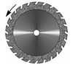

7
ABRASIVES
___________________________________________________________

SANDBLASTERS

Renfert Basic Classic 820224
This compact blasting unit holds two versions of blasting modules. One is for 25 – 70 microns and one is for 70 – 250 microns. Patented mixing chambers guarantee an even flow of material.

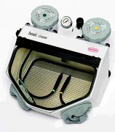

Renfert Variobasic S/O
An all around blasting unit that is a combined recyclable blaster and fine sandblasting unit.
Its compact construction and multi-purpose function is ideal for all labs. This economical unit can carry out all the usual blasting tasks required within dental technology.

Renfert Variojet 850684
The Variojet is the ideal recyclable blaster for rational and intensive sandblasting. It comes complete with a rotating basket, which can be used in automatic or manual mode.

Vaniman Sandstorm Expert 50-100 micron 860522

Renfert Cobra Aluminum Oxide 50 micron 12.5 kg 115253
110 micron 12.5 kg 115255

*S/O (Special Order)*

8

ABRASIVES
___________________________________________________________

Glass Beads

Renfert Rolloblast 50 micron 12.5kg 114980

Walnut Shells 20 – 30 grit 40 lb. 124986

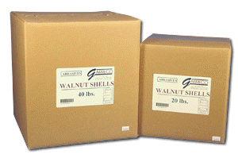

9

ACRYLICS & MONOMERS
___________________________________________________________

HEAT CURE DENTURE BASE RESINS

Lucitone 199
Original shade

630 gram 252208
25 lb pail of acylic w/ 4 quarts liquid. 252205

Monomer

Liquid 1 qt. 252202

Diamond D

Pail 1 lb. 304247
Pail With Liquid 25 lb. 304258
Liquid 1 qt. 304245

Probase Hot

Clear 500 gr. 254065
USL 500 gr. 254075
USP 500 gr. 254077
Monomer 500 ml. 259200

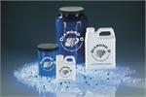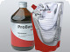

Ivocap Capsules
Encapsulated denture base material with a methyl methacrylate base. When used in conjunction with the SR Ivocap system, you are assured an accurate fit and a secure bond with artificial teeth. Use a cap vibrator for the mixing of capsules.

Preference Case of 50 251839
USL Light Pink 251783
USP Pink 251770
Clear 251809
10

ACRYLICS & MONOMERS
___________________________________________________________

Ivocap Elastomer 251827
A clear, flexible, acrylic resin used to produce positioners, mouthguards, bruxism, and bite splints

Nature-cryl
By GC
Specially formulated for microwave curing. High quality precision dentures can be cured in just three minutes in a household microwave oven.

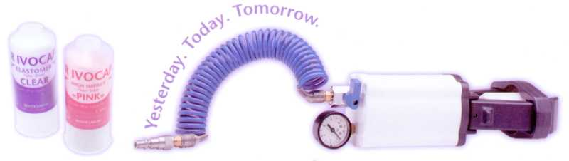

Original 1 lb. Kit 454 gr. Powder & 8 oz. Liquid 251682
Light Fibred 5 lb. Powder 251712
Original 5 lb. Powder 251686
1 qt. Liquid 251688

Nature-cryl Hi 20ET
High Impact heat cured denture base resin. The innovative polymer chemistry allows extended working time and a 20 minute boiling water cure.

Original 1 lb. Kit 454 gr. Powder & 8 oz. Liquid 251715
Original 5 lb. Powder 251672
1 qt. Liquid 251670

Nature-cryl Pour
Self-cured denture base resin. This pour type acrylic can also be used as a reline and repair material.

Original 5 lb. Powder 251679
1 qt. Liquid 251678

11

ACRYLICS
___________________________________________________________

SELF CURE DENTURE BASE RESINS

Lucitone 199 Original

1 lb. 252204
4 lb. 252206
Liquid 1 qt. 252207

Probase Cold

Clear 500 gr. 253946
USL 500 gr. 253978
USP 500 gr. 253969
Monomer 500 ml. 259190
Monomer 1000 ml. 254099

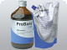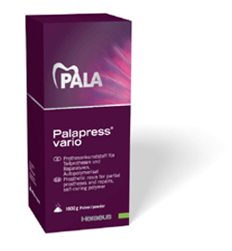

*Also available in standard or lab size kits*

Palapress Vario
By Heraeus Kulzer
A cadmium free denture material that can be used for all denture applications

PinkVeined 1 kg. H10065
Light Pink 1 kg. H10055
Clear 1 kg. H10050
Liquid 500 ml. 254067

12
ACRYLICS
___________________________________________________________

ORTHO ACRYLIC

Lang Orthojet

Clear Kit 1 lb. 304525
Pink Kit 1 lb. 304526
Clear Powder 5 lb. 303000
Clear Monomer 946 ml. 304514
Pink Monomer 946 ml. 304536

Pattern Resins
GC America pattern resin was formulated to provide a perfect fit. Because of its superior strength, a pattern can be made directly on the working model without using a model investment. GC pattern resin is quick setting with minimal shrinkage, has high strength with no distortion, and is easy to manipulate and handle.

Powder and Liquid Kit 100 gr. & 100 ml. 115525

Duralay
By Reliance

Powder and Liquid Kit 8 oz. 115553

Aesthetic Denture Base
By Candulor
Candulors’ denture bases are made from exceptionally high-grade, high-purity polymers and monomers. One of the most striking features of Candulor acrylics is their stunning, natural appearance, due in part to the specially selected particle size distribution.

Heat Cure
Monomer 500 ml. CA10303
Powder 1000 gr.
Available in shades of: Pink V CA10293
34 CA10283

Cold Cure
Monomer 500 ml. CA10333
Available in shades of: Pink V CA10323
34 CA10313

13
ACRYLICS
___________________________________________________________

RELINE MATERIALS

PERMANENT HARD LINERS

Flexacryl Hard
By Lang
A highly cross-linked acrylic that sets hard and strong and resists crazing

1 lb. Kit 304921

Hard Reline
By GC
A methyl methacrylate-free, self-curing reline material 256482

Tokuyama Rebase II 256654
A chairside hard denture reline material that offers excellent polishability and low heat generation for in the mouth curing. Cures in 4 1/2 minutes intraorally.

Kooliner 256480
By GC
A hard chairside reline that has been formulated for reduced exothermic heat. It can completely cure in the patient’s mouth in approximately 10 minutes.

PERMANENT SOFT LINERS

Molloplast B 170 gr. 256485
Molloplast is an industry-leading heat processed silicone material that stays soft permanently and features decades of documented success in denture reline cases.

Lucisoft 7 sheets 256475
A silicone based denture liner system suitable for relining existing and lining new dentures. It has superior durability and excellent bond strength.

Permasoft 120 gr. 256495
Permasoft is the only system offering the durability of a laboratory processed soft liner and the convenience of a compatible chairside soft reline kit.

14
ACRYLICS
_______________________________________________________

Easysoft denture reline:
-Lab pack 255482
-Twin pack(2 cartridges) 255488
-Starter pack 255482
-Easysoft adhesive 10ml 255486

15
ACRYLICS
___________________________________________________________

ACCESSORIES

Primo 260446
Denture Base Adhesive

Lustrol 260461
Paint on polish for sealing and smoothing the bonding area between mollo and the acrylic base

SEPARATING SHEETS

Separating Sheets
By Yates & Bird

5” x 5” .001” 1000 sheets 109946
4” x 4” Elastophane 1000 sheets 109726

ADHESION PRIMERS

Acrylic Primer by Lang

Palabond
An adhesion primer used for highly cross-linked acrylic teeth and denture based resins.

45 ml. 253975

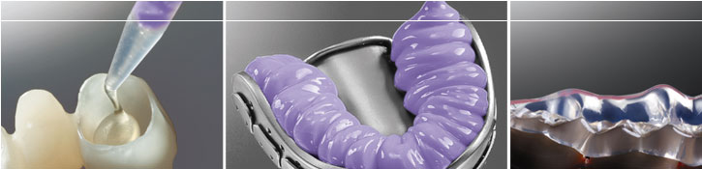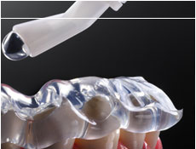
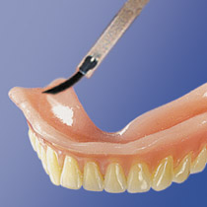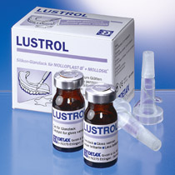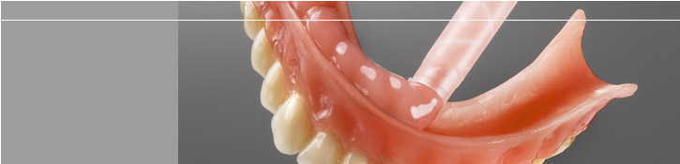

16
ACRYLICS
___________________________________________________________

TEMPORARY SOFT LINERS AND TISSUE CONDITIONERS

Flexacryl Soft
By Lang
A non-irritating chairside reline in less than 15 minutes; remains resilient for nine months
1 lb. Kit 304866

Tempo(Lang)
A temporary cushion treatment reline

1 lb. Kit Pink 304837
1 lb. Kit Clear 304806
Powder 6 lb. Pink 304831
Powder 6 lb. Clear S/O
Liquid 1 qt. Clear 304834
Liquid 1 qt. Pink 304830

Immediate 304815
By Lang
A long lasting, very soft reline; ideal for newly edentulous patients. Stays soft up to six months.

TruSoft 251694
By Bosworth
A plasticized acrylic PEMA that is specifically designed as an intermediate liner for patients requiring prolonged adjustment periods prior to using a hard liner. Remains soft for up to 12 months.

Coe Soft 256701
By GC
A resilient cold cure reline material that polymerizes in or out of the mouth in approximately 15 minutes. Lasts from three to six months.

Coe Comfort 256780
By GC
A self curing chairside edentulous tissue conditioner used to restore sound form and condition to the underlying tissue. Mixes in 30 seconds and can be used as a functional impression material.

17
ACRYLICS
___________________________________________________________

TOOTH ACRYLICS
Lang’s self curing acrylic resins set up in six to nine minutes. It is the most durable crown and bridge material on the market today.

Shade
59/B1 45 gr. 300598 69/C2 45 gr. 300697
60/A1 45 gr. 300600 77/B4 45 gr. 300770
61/B2 45 gr. 300614 81/A3.5 45 gr. 300812
62/A2 45 gr. 300622 87/A4 45 gr. 300879
65/A3 45 gr. 300655 Light Incisal 300928
66/A3 45 gr. 300663 Dark Incisal 300940
67/B3 45 gr. 300671

*Some shades are available in 454 gr.; please ask!

LIGHT CURE OVENS

Procure 300 860110
Rotating glass platform to ensure uniform light. Built in fan to maintain optimum temperature to eliminate warping. Two powerful halogen bulbs to ensure excellent intensity and depth of cure.

EuroCuring Light 860120
Optimal illumination of the polymerization chamber with four compact fluorescent UVA lamps, emitting in the 350 – 40 nm range. Fits up to four models.

Tray Material
Ivolen is a self curing acrylate designed for individual impression trays. The material is also used for base plates in bite registration and try-ins.

Standard Kit

1000 gr. Powder & 500 ml. Liquid 258101
Powder only 258119
Liquid only 259141
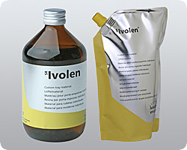
18
ACRYLICS
_______________________________________________________

C Plast Candulor
A cold curing precision tray material in white or pink with high dimensional stability

C Plast – White 1000 gr. CA1073
C Plast - Pink 1000 gr. CA1077
C Plast – White 2500 gr. CA1075
C Plast – Pink 2500 gr. CA1078
C Plast - Monomer 500 ml. CA1074
C Plast - Monomer 1000 ml. CA1076

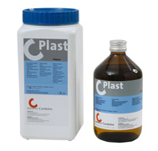

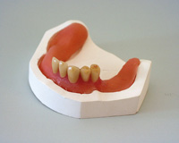
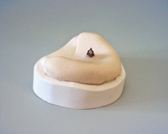

19
LIGHT CURING TRAY MATERIAL
___________________________________________________________

Ultratray by Candulor

Pink 50 Light cure sheets CA1072

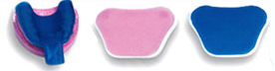

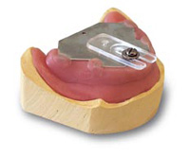
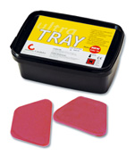

20

ADHESIVES AND ACCELERATORS
___________________________________________________________

Adhesives

Aron Alpha .7 oz. 110724
A thin viscosity cyanoacrylate glue

Permabond 910 oz. 110567
A slightly thicker viscosity cyanoacrylate glue

Tray Adhesives

Coltene Universal 10 ml. 110699
GC Adhesive 7 ml. 110673

Z-Base 1/3 oz.

Accelerator

Z-Base 2 oz.
Z-Base 16 oz.

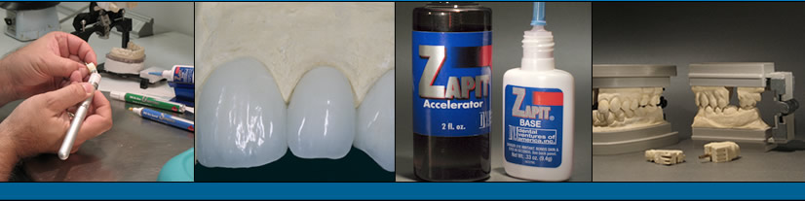

21
ALLOY & SOLDERING
___________________________________________________________

Platinum Foil
.001 1 DWT 200160

FLUX

Ortho Soldering Flux
By RMO
Jar 111201

Borax Casting Flux 1 oz. 111228

Noritake Flux
A pre and post soldering flux for full metal and porcelain fused to metal crowns

N Jar N11338
P Jar N11339

Alloy
By Bego
The ideal partial denture alloy for combination work

Wironit X Hard 1 kg. 205222

22
ARTICULATING PAPER
___________________________________________________________

Horseshoe shaped to provide a one handed method for surveying the whole arch. The problem of patients biting unilaterally favouring one side of the mouth is avoided.

Surgident (Blue/Red) 910404

For overall pressure distribution:
High spots produce a dark colour and therefore should be adjusted.

Bausch Blue 200 Strips (BK09) 911097
Bausch Red 1 Sided Roll 8 micron (BK21) 910724
Bausch Red 2 Sided Roll 8 micron (BK25) 911190

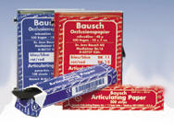

Madame Butterfly Silk Tape
This ribbon is thinner than paper and is ideal for checking crown and bridge work.

Red ¾” wide 910529
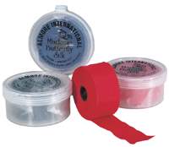

23
INDICATING PASTES & SPRAYS
___________________________________________________________

Hydent
A fast and accurate spray for disclosing high spots. Hydent is easy to clean from the denture and is sanitary – no chance of cross contamination. Mint flavour.

Can 26 gr. 910503

Quickcheck
An excellent aid in seating castings. Quickcheck is accurate; it will pinpoint the location of high spots and will mark any tooth or restorative surface (including gold) wet or dry.

Can 75 gr. Green 910696
Can 75 gr. Red 910702
Can 75 gr. White 910700

*Can also be used for scanning.*

Crown Fit Seating Indicator
By Kerr
This paint clearly marks internal interferences in the casting, permitting accurate adjustments for complete seating of the casting to the die.

Kit 2 x 15 ml. 112403

Precise Pressure Indicator Paste
This is a pure white paste, used for showing high spots on immediate or partial dentures.
Easy clean up.

Jar 3 oz. 940145

24
ARTICULATORS
___________________________________________________________

ASA Semi-Adjustable
This lightweight affordable articulator is made out of aluminum. With the ASA you have easy access and visibility to the lingual surfaces combined with interchangeable mounting plates. It also has an anatomic return to the hinge axis with recall springs.

ASA Articulator 76743
Mounting Plates Each 76768
Magnetic Mounting Plates Each 76755

Ray Foster EE8
This is an accurate and economical articulator, designed with lateral and protrusive movements. Separation of the upper and lower parts is simple.

Brass #8 78160
Chrome #8 79506
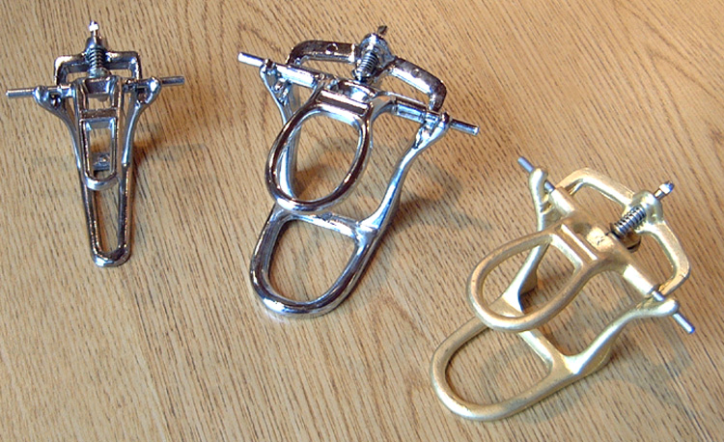

*Hanau and Denar articulators available by special order.*

25
ARTICULATORS
___________________________________________________________

Galetti 79455
A simple, plasterless articulator that saves time and materials. Made completely of metal alloy casting with all anatomical movements possible. Perfect for partial or full denture work, as well as for ortho study models.

Mounting Plates

Hanau 78707
Whip Mix 76770

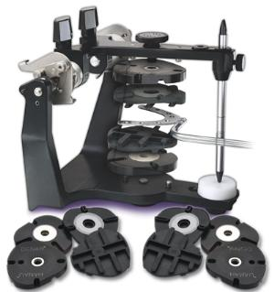

Disposable Articulators
This articulating system is designed to increase productivity by significantly reducing labor at the plaster bench. The system eliminates model trimming after removal of models from base formers, the need to cover dowel pin tips with plaster during mounting, and knocking the model off the articulator. Finished cases are symmetrical and consistent in size.

Slot Back Box of 100 76675
Flat Back Box of 100 76680

Monotrac articulators
A pinless articulating system used for mounting models.
-Full arch
-Anterior
-Straight quad
-Radius quad

Mold Formers

Small Each *Call for prices.*
Medium Each
Large Each
26
ARTICULATORS
___________________________________________________________

Whip-mix Mainstay articulators

Full Arch
Left Quad
Right Quad
Anterior

Deluxe Magnetic Articulator 79552
A lightweight Teflon-coated articulator with interchangeable magnetic mounts. Has a full range of movement, including lateral excursions.

27
ATTACHMENTS
___________________________________________________________

ERA Attachments

ERA RV Complete Kit 162775
ERA RV Black Males 162925
ERA RV Orange Males 162913
ERA RV White Males 162834

ERA RV Micro Kit 162848
ERA RV Metal Housing 162786
ERA RV Processing Jig 162854
ERA RV Micro Processing Jig 162845

Tubelock(plastic for casting) Small 168201
Tubelock(plastic for casting) Large 168227

Keyway(plastic for casting) Small 161040
Keyway(plastic for casting) Large 161024

Expansion Screws
By Dentaurum

*We have many other attachments in stock; please call for availability.*

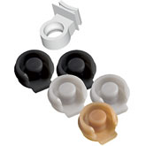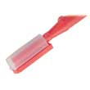

28
BRUSHES & BUFFS
___________________________________________________________

Bristle Brushes
These brushes are time proven for quality and durability. They are available in soft, standard stiff and extra stiff. All of these brushes are mounted for your convenience.

#11 Soft Box of 10 66651
#11 Standard Stiff Box of 10 66702
#11 Extra Stiff Box of 10 66769
#12 Soft Box of 10 66801
#12 Standard Stiff Box of 10 66942

(Also sold by the gross - Box of 144)

Lathe Brushes
By Attenborough

Sold by Each or Box of 10

3” Diameter with Cotton - Green Plastic Centre 74128
3” Diameter no Cotton - Red Plastic Centre 73965

Polishing Brushes

Sold by Each or Pkg. of 12

P12 with Cotton 1 7/8” 74003
P12 without Cotton 1 7/8” 73922
P12 with Cotton 2 1/2” 74015

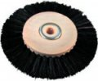

29
BRUSHES & BUFFS
___________________________________________________________

Porcelain Brushes
Takanishi by Renfert
A high quality acrylic bristle brush for optimum porcelain modeling

Size #000 72427 #4 72454
#0 72426 #5 70807
#1 72428 #6 72457
#2 72440 #8 72460
#3 72452

Kolinsky
By Renfert
Natural bristle brush made from red sable – quality and aesthetics combined

#4 72477
#6 72475
#8 72473
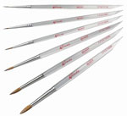
Ceramicus
Exclusively by Renfert
New type brush bristles, with properties superior to natural and synthetic hairs

#4 73450
#6 73456
#8 73452

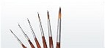

30
BRUSHES & BUFFS
___________________________________________________________

BUFFS

Cotton Buffs
Shellac-hardened centres for easy threading and durability

Sold by the Dozen

1 x 1/4 74667
2 x 16 74755
3 x 30 74784
3 x 35 Ply 74565
4 x 30 Ply 74409
4 x 42 Ply 74243
4 x 50 Ply 74213

Cotton Buffs with Plastic Centre
Unstitched and used to produce a high finish

4 x 28 74760

Chamois Buffs
For a high luster shine. Leather centres assure a firm grip.

1” Each 74748
3” Each 74722

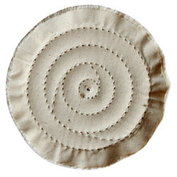

31
BRUSHES & BUFFS
___________________________________________________________

BRUSHES
By BK Medent

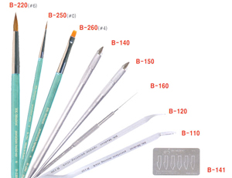
Porcelain Build Up Full Kit B-711

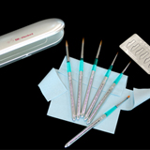
Porcelain Build Up Full Kit B-611

32
BRUSHES & BUFFS
___________________________________________________________

Brushes
By Smile Line

#3/0 Brush 70833

#6 Brush 70795

#8 Brush 70771

#3/0 Tips 70773

#6 Tips 70775

#8 Tips 70778

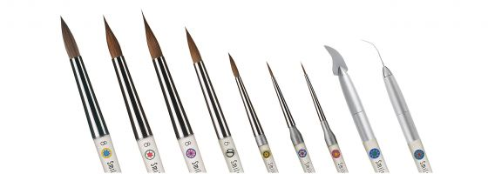

33
PALETTES
___________________________________________________________

MIXING PALETTES FOR STAIN

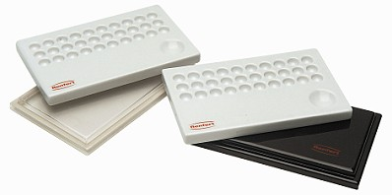
Stain-Mix Palette

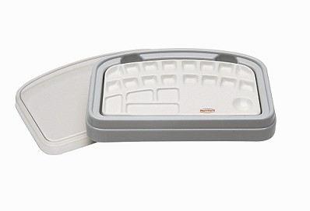
Stain-Mix Palette

By BK Medent
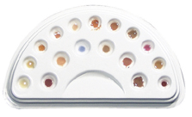
BK Stain Palette B-010

1096
34
PALETTES
___________________________________________________________

INDIVIDUAL PORCELAIN MIXING PALETTES

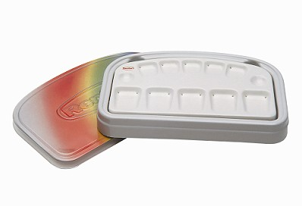
Mixing Palette

MIXING PALETTE WITH WATER-RETENTION FUNCTION

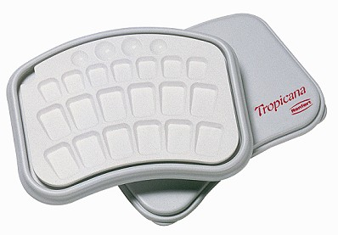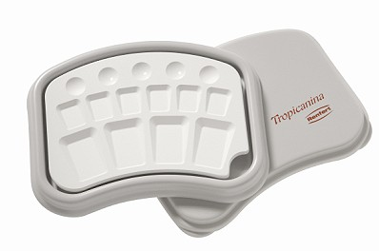

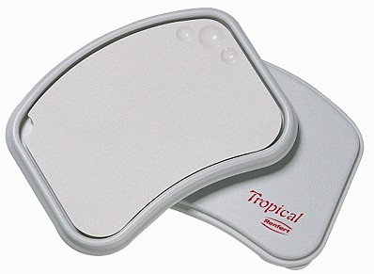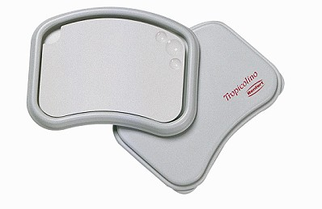

*Please call to inquire about our other available palettes.*
35
PALETTES
___________________________________________________________

Porcelain Mixing Plates
By BK Medent_

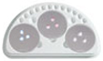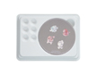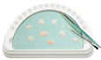

EZ-Master B-007 EZ-Single B-008 R-Mixing Plate B-009

1125 1113 1136

36
BUNSEN BURNERS & ACCESSORIES
___________________________________________________________

Touch-O-Matic 6468
The safest Bunsen burner available. Produces full flame only when the on/off platform is depressed. When pressure is removed, the main flame goes out, but the pilot light remains on.

Safety Burner 6424
By Renfert
This Bunsen burner is equipped with automatic control to shut off the gas in the event that the flame is extinguished.
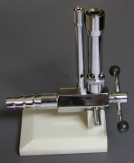
Bunsen Burner 101
A nickel-plated Bunsen burner with an adjustable air intake; for use with natural gas.

4” tall 6088
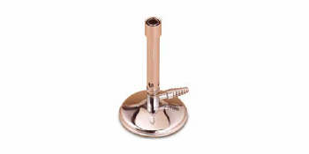

Micro Bunsen Burner 102
A nickel-plated Bunsen burner with an adjustable air intake; for use with natural gas.

2 1/2” tall 6097

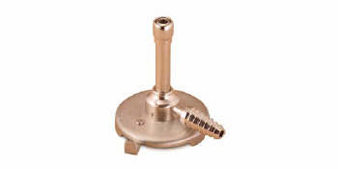

37
BUNSEN BURNERS & ACCESSORIES
___________________________________________________________

Bunsen Burner 2N 6087
Has a needle valve gas control adjustment to provide a very hot brush flame down to a needle flame; artificial or natural gas.
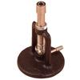
Wax Cup 6583
Fits Bunsen burner 2N

Latex Tubing

¼” Sold by the Foot 9447


Alcohol Torch 6724
Useful for finishing and smoothing wax patterns

Micro-Torch 7409
Self-starting ignitor; easy to operate; may be hand held or fixed in its stand. Variable flame from needle point accuracy to brush Bunsen flame.
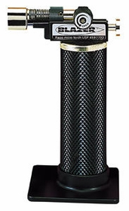

38
BURS
___________________________________________________________

Carbide Burs

Westan carries a Full stock of Komet carbide and diamond burs, disks and polishers,
specially designed for all dental disciplines, including diamond impregnated polishers and stones for Zirconia and Ceramics.
Please visit our website: www.westan.ca and push the KOMET CATALOGUE icon for the full catalogue for your viewing convenience.

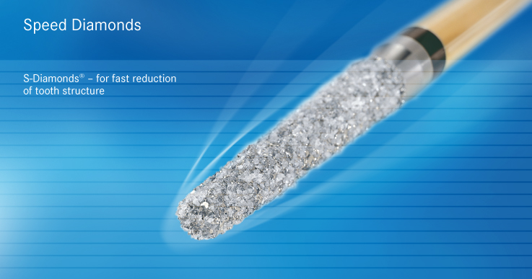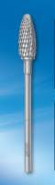

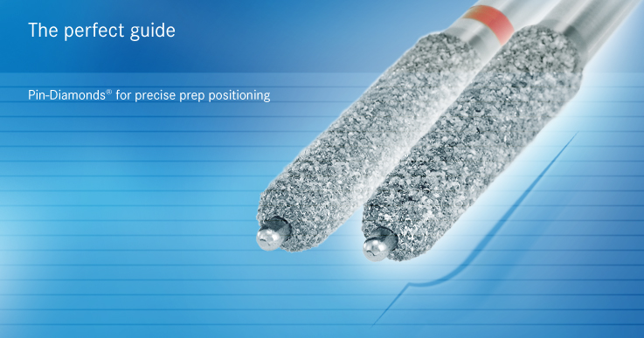
Meister Cones
A paper abrasive material best suited for the polishing of porcelain teeth, resin teeth, and resin denture materials.
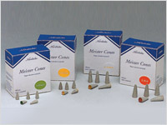
Meister Points
A specially made material designed for carving beautiful anatomy in porcelain crowns.

39
BURS
_______________________________________________________
Lathe Burs

Small Egg 310860
Small Bullet 310520
Large Egg K
Large Bullet K

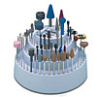
Rotating Bur Holder 17610
By Foredom
Universal rotating bur holder stores and organizes 126 all size accessories, including 1/16”, 3/32”, 1/8”, and 1/4” shanks. Burs not included.
40
BURS
___________________________________________________________

Carbide Burs (Round)

Sold in pkg. of 5

1/4 Round 24446
1/2 Round 24487
1 Round 24644
2 Round 24800
3 Round 24966
4 Round 25120
6 Round 25203
8 Round 25286
11 Round 25471

*Steel Burs also available.*

41
CASTING EQUIPMENT
___________________________________________________________

Kerr Casting Machine (Centrifico) 780506
A dependable broken arm casting machine for all types of dental castings

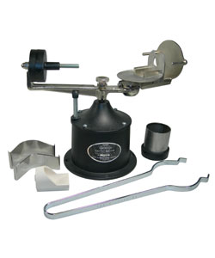
Casting Well 780510
For the Kerr Casting Machine
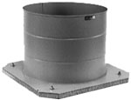

Neo Super Cascom 780488
Clean, easy to use, and reliable vacuum and pressure casting machine, with muffle heating

Carbon Crucibles
For the Neo Super Cascom

Box of 10 780490

Ceramic Crucibles
For the Neo Super Cascom

Box of 10 780489

42
CASTING EQUIPMENT
___________________________________________________________

Carbon Washers
For the Neo Super Cascom

Pkg. of 3 780500

*Thermocouples and muffles available.*

Casting Rings & Formers
By Vaniman
Stainless steel

1 1/4” Ring 69255 1 1/4” Former 70101
1 1/2” Ring 69267 1 1/2” Former 70113
1 3/4” Ring 69280 1 3/4” Former 70125
2” Ring 69302 2” Former 70137

*Oval rings available by special order.*

RINGLESS RINGS
These clear plastic formers are guaranteed to make your investing process easier. They’re strong and durable, yet flexible, to allow for maximum expansion without restriction.

1 1/4” 60 gr. 67064
1 1/2” 90 gr. 67066
2” 67068

For Pressable Ceramics(12mm)

100 gram P10297
200 gram P10293
300 gram

Disposable Plungers

12 mm Box of 50
13 mm.(Emax) Box of 50 202186

43
CASTING EQUIPMENT
___________________________________________________________

Crucibles

Slotted
Quartz 69840
Ceramic 69888

Hooded
Ceramic 69775
Degussa Style 69545
CastPro H10295
Ceramic 69540

Ringliner

2” 50 x 30 M N20010

CASTING TONGS

Broken Arm
Scissor Type H10305
Regular 49373
Has two openings for small or large rings

Tweezers

10” 45056
12” 45058
Serrated Locking Tweezers 44926
Articulating Paper Forceps 45136

44
CHEMICALS
___________________________________________________________

“Super Stripper”
By ADS
Used as a substitute for hydrofluoric acid. Removes soldering flux, investments and oxidation from semi and precious alloys.

1 pt. 86858

ETCHING GEL

Porcelain
Will etch all porcelain veneers and ceramic crowns

Bottle 460244

Metal
For all non-precious alloys

Bottle 460228

Pickle It 86859
By ADS
Non-fuming, safe pickling powder for gold castings. Convenient; dissolves instantly in warm water. Turns solution green when expired.

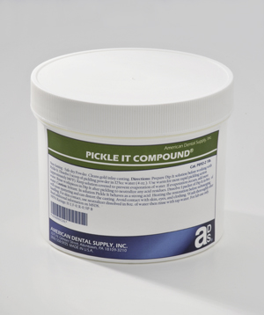

Electro Polish Solution
By CMP

1 gal. 117006

45
DEBUBBLIZERS
___________________________________________________________

Wax Pattern Cleaner
By ADS
Excellent for reducing surface tension on wax patterns to obtain bubble-free, smooth castings

1 gallon

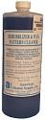

Smoothex
By Whip Mix
Excellent for treating impressions before pouring casts

1 pt. 112811
1 gal. 112878

Surfactant
By Harvest dental
Reduces surface tension when pouring models

1 L 109149

46
SEPARATORS
___________________________________________________________

Separators
Separating Fluid by Ivoclar is one of the leading separating mediums on the market today. As well as separating acrylic from gypsums, it can also be used to separate the two halves of a flask, making deflasking easy and leaving the surface of the resin completely smooth.

Pink 1 L 108336
Pink 5 L 108348

Candulor
Iso-K is an alginate based separating fluid for isolating plaster from acrylic.

Blue 1 L CA1083
Blue 5 L CA1084

Liquifoil
By ADS
Smooth flow on stone and around teeth; rinses off cleanly with water. Stone breaks away clean and easy.
1 gal. 109624

Stone-Sep (by Harvest)
An alcohol based plaster, stone, or investment separating fluid that dries on contact.

32 oz. 109185

Water Glass
Used for separating stone

1 gal. 109037

Wax Solvent
By Justi
Complete wax elimination of acrylic cases; removes wax film from teeth.

1 gal. 90322

Mold Release Spray
An extremely versatile release agent which produces a dry anti-stick surface coating
Dries quickly
11oz can 109166

47
SEPARATORS
___________________________________________________________

Tray Cleaner
By COE
Removes alginates, waxes, and compound from metal trays and instruments in just 15 minutes!

575gram bottle 87260

48
DENTURE SYSTEMS & ACCESSORIES
___________________________________________________________

Ivocap System
By Ivoclar
The Ivocap System is ideal for the following applications:
Full Dentures
Partial Dentures
Occlusal Splints
Ortho Appliances
Relines
Rebases
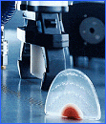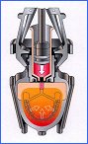
*Call for pricing.*

Success Injection System
By Dentsply
This system combines high pressure injection, closed flask processing, and premium performing Lucitone 199 Denture Resin to help produce the best fitting denture possible.

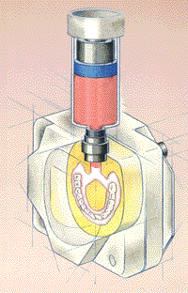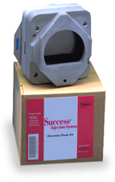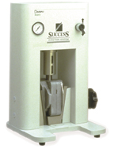

*Call for pricing.*

Ivocap Capsules

Pink (USP) Box of 50 251770
Light Pink (USL) Box of 50 251783
Preference (Matches Shade 199) Box of 50 251839
Clear (Clear) Box of 50 251809

49
DENTURE SYSTEMS & ACCESSORIES
___________________________________________________________

Trubase Base Plates
By Dentsply
These Shellac baseplates can be heated in either hot water or by gas flame. Single thickness plates are used for setting up teeth or as bite blocks. Double thicknesses are used for taking an edentulous impression.

Regular Uppers Box 105926
Regular Lowers Box 105927
Thick Uppers Box 105925
Thick Lowers Box 105924
CURING UNITS

Pressure Pot
Accurate, easy to read air pressure gauge
Safety valve releases pressure between 30 and 35 PSI
Quick release air valve
Standard size; holds three flasks

Each

50
DENTURE SYSTEMS & ACCESSORIES
___________________________________________________________

Aquapres Pressure Pot
By Lang
For denture repairs, relines, rebases and all types of orthodontic appliances

5” Pot 522209

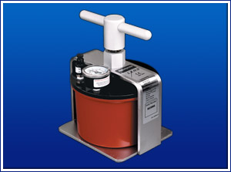

Acrydig
By Manfredi
The Acrydig polymerization units are completely built of stainless steel, then painted. Due to its programmability, the Acrydig will run a polymerization cycle and will automatically switch off, allowing the flasks to cool naturally to avoid resin cracks.

Acrydig 6 Curing Unit

6 – 10 flasks 860770

Acrydig 12 Curing Unit

10 – 18 flasks 860775

51

DENTURE SYSTEMS & ACCESSORIES
___________________________________________________________

Labormat SD 860750
Large boil out unit for up to 12 flasks, as well as for the polymerization of dentures. Features include a hand spray gun, 24 hour time, continuously adjustable temperature from 0 – 95 degrees, individual spraying time adjustment with a six minute timer.

H = 940 W = 635 D = 660

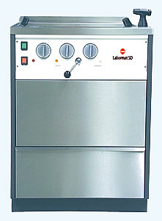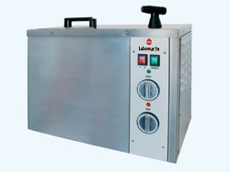

Labormat TH 860762
A compact boil out unit for up to six flasks, as well as for the polymerization of denture resins. Features are the same as the SD above, but in a compact version.

H = 500 W = 570 D = 400

52
DENTURE FLASKS & COMPRESSES
___________________________________________________________

Atlas Flasks
By Handler
Manufactured from forged brass and machine finished, these durable flasks are precisely aligned to prevent mismatches.

Upper Flask (44U) 80463
Lower Flask (44L) 80521
Ejector Disks Each 80539
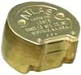
Upper Flask

Generic 80682

Lower Flask

Generic 80670

Compress

Generic 534010

Hydraulic Press 820450

Reline Jigs 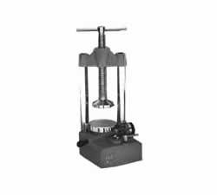 79929

Microwave Flask
By GC
New and improved; one year warranty 80706

53
MODEL FABRICATION
___________________________________________________________

Dowel Pins
Top quality brass dowel pins

#1 Small Pkg. of 1000 9979
#2 Medium Pkg. of 1000 9926

Reverse Dowel Pins

Plastic Pkg. of 1000 9981

Bi-pins
By Renfert

Short 9785
Long 9793
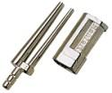
Bi-v-pins
By Renfert 9774
With Plastic Sleeves 9844
Generic 9938

Carbide Drills By Pindex Each 9686
By Renfert Each 9698
By Amann Each G13000

Pindex
Pins with sleeves
Used exclusively with the Pindex system for fabricating precision removable dies and sections from models

Short PX115 9645
Long PX114 9629

54
MODEL FABRICATION
___________________________________________________________

Pindex Machine “Mark II” 840550
The Pindex Machine produces accurate and repeatable drilled parallel channels from the underside of the model. The Mark II is manually operated and is ideally suited for smaller labs and dental offices.
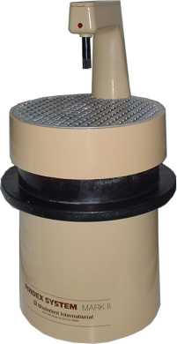

Top Spin 840563
By Renfert
An automatic laser pinhole drilling unit with a 16000 RPM motor
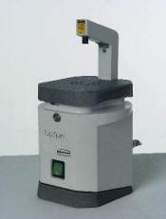

Giroform Pin Drill System (PRODUCTS ONLY)
*We no longer carry this product but we do have parts such as drill bits, sockets, magnets, secondary mounting plates, etc- at great prices.

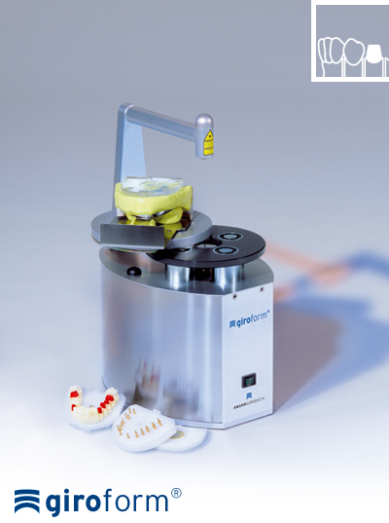

55
MODEL FABRICATION
___________________________________________________________

Die Hardeners

Stone Die & Plaster Hardener
By George Taub
A liquid plastic which is painted on the stone die or model. Impregnates stone and protects margins. Sets and hardens in three to five minutes and will not change dimensions of the die. Seals and waterproofs stone or plaster.

Kit (includes 2 oz. Resin & 2 oz. Thinner) 113801

Margidur
Hardens and protects the plaster die without leaving a deposit
-30ml hardener x 30ml thinner kit 113967
-30ml hardener only 113966

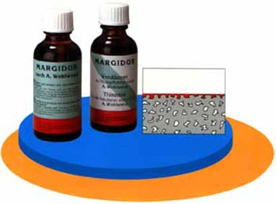

56
MODEL FABRICATION
___________________________________________________________

Margin Liners
By Kerr
These pure wax mechanical pencils create a thin, non-smear, highly visible marking of the marginal periphery without contaminating the pattern.

Blue Pencil 42076 Blue Refills 42043
Red Pencil 42075 Red Refills 42042

Die Spacers
By Kerr
A fast drying, hard, paint-on die coating

Blue 15 ml. 112381
Blue 100 ml. 112270

Die Spacers
By Tak
A paint-on cyanoacrylate re-enforced material that strengthens models and provides uniform cement space. Very hard.

Yellow 1/2 oz. 112231

Tru-Fit
By George Taub
A controlled method for relieving dies before wax-up. Provides better marginal fit and allows castings to seat more completely.

Silver 1oz. 112431
Gold 1 oz. 112423
Thinner 8 oz. 112472

Z-base Brand Accelerator

57
MODEL FABRICATION
___________________________________________________________

Z-Base
By Harvest Dental
Z-Base is used for: Blocking out undercuts
Filling air bubbles
Basing up decay areas and short cusps
Stabilizing dies during finishing procedures
Connecting bridge segments
Placing precision attachment parts for soldering and investing

Z-Base 1/3 oz.
Z-Base Accelerator 2 oz.
Z-Base Accelerator 16 oz.

Picosep 108217
A thin isolating agent designed specifically for separating wax from stone

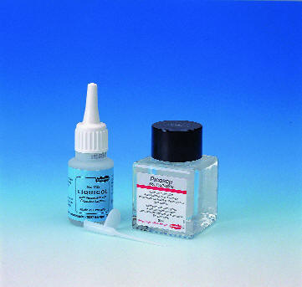

58
MODEL FABRICATION
___________________________________________________________

SAW FRAMES & BLADES

Spiral Sawblades
For cutting in any direction

Extra Fine Pkg. of 12 48361
Coarse Pkg. of 12 48403

Saw Frame - Pinned
Accepts 5” saw blades 47447

Pindex Sawblades

4” x .007 Pkg. of 100 48106
4” x .010 Pkg. of 100 48122

Renfert Sawblades

3” 25 mm. x 3 mm. 48163
3” 20 mm. x 3 mm. 48187
3” 12 mm. x 5 mm. 48173

Keystone Sawblades

5” x .007 Pkg. of 100 48049
5” x .010 Pkg. of 100 48080

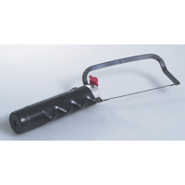

59
SHIPPING SUPPLIES
___________________________________________________________

Work Pans
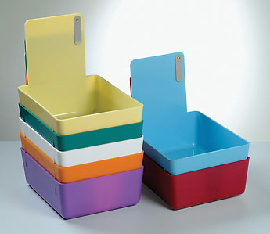
Plastic work pans with metal clip
Standard size
Mix and match

Sold by each or box of 12

Available in: Blue 533976 Red 533974
White 533982 Yellow 533980
Green 533978 Purple 533984
Pink 532500
Generic
Beige base with interchangeable coloured back

Red 533000 Blue 533015
Green 533010 Yellow 533005

Crown & Bridge Boxes
These plastic boxes are hinged with a friction fastener to protect your fine craftsmanship. Available in two sizes, clear top and blue bottom.

1” x 1” Box of 100 or Box of 1000 4323
2 1/8” x 1 5/8” Box of 100 or Box of 1000 4422

Foam Inserts
Sponge inserts designed specially for the crown and bridge boxes; available in blue

1” x 1/ 4” Thick Box of 1000 4414
1” x 1/2” Thick Box of 1000 4400
2 1/8” x 1 5/8” Thick Box of 1000 4455
60
SHIPPING SUPPLIES
___________________________________________________________

Retainer Cups

Made for any ortho or mouthguard appliance(mixed colours)

Sold by case of 120 4562

Denture Brushes

Pkg. of 12 958055

Denture Cups
Holds one set of dentures in mixed colours

Sold by Each or Box of 140 4577

*Imprinting available on request.*

61
SHIPPING SUPPLIES
___________________________________________________________

Laboratory Time Stickers
Colour coded labels, designating the day of the week work is to be completed

Sold by Roll of 1000

Monday Blue 607125
Tuesday Orange 607281
Wednesday Green 607448
Thursday Red 607604
Friday Yellow 607760

Laboratory Work Cards
Colour coded work cards for all your laboratory needs; hard and soft copy

Sold by Pads of 100

Cast Partial White 617124
Combination Denture 617280
& Cast Partial Grey 617447
Crown & Bridge Yellow 617447
Denture Pink 616647
Denture Repair Green 616803
Orthodontics Salmon 616969
Porcelain Blue 617603

Plastic Ziplock Bags

Pkg. of 100

5” x 7” 622327
8” x 10” 622405
8” x 10” With prescription pouch on the side 622425

Kraft Wrapping Paper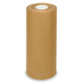

1 Roll Brown 85843
62
EQUIPMENT (MISCELLANEOUS)
___________________________________________________________

Splash Hoods
By Handler
Resin splash hoods come with a light on either the left or the right side.

Left 701146
Right 701186

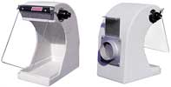

Sta-Kleen Shield Only 701266

Aluminum Splash Hood 701158

Handler 550 Portavac 860490
Compact and practical; bench top dust collector; ideal for any size lab

MICROSCOPES

Renfert Mobiliscopes 535902
A stereo microscope with a swivel arm and built in lighting

Stereo Microscope
Japanese Optics
Has excellent visibility with only regular bench lighting. A 12” flexible neck makes viewing and focusing easy.

Lens Power 8 x 535890
Lens Power 10 x 538590

Plaster Bin 500270
Plaster bin has three compartments and may be hung on the wall or placed on benchtop. Each compartment is individually sealed and built to hold 25 lb. of plaster or investment.

63
EQUIPMENT (MISCELLANEOUS)
___________________________________________________________

Plaster Traps

Disposable

Plastic Bucket with Attachments 3.5 Gallon 517839
5 Gallon 517840
Plastic Bucket Only 3.5 Gallon 517857
5 Gallon 517869

Stainless Steel
This unit is designed to settle out and entrap solids. Durable fittings will meet local plumbing codes and will help keep your drains free of solid waste build-up.

Trap with 6 Liners 517829
Refill Liners 86445

Steam Cleaners 840772
By Reliable
Portable Steam Cleaner requires no plumbing and takes up minimal bench space. It heats rapidly to produce pressurized steam quickly. The capacity is enough to last most labs a full day.

64
EQUIPMENT (MISCELLANEOUS)
___________________________________________________________

BURNOUT FURNACES

5 1/2” W x 5 1/4" D x 5 1/8” H Holds up to 8 1 ¾” rings
(Inside heating chamber dimensions)

9 1/8” W x 5 1/4” D x 5 1/8” H Holds up to 15 1/3/4” rings
(Inside heating chamber dimensions)

PORCELAIN FURNACES

Dr Detox
Furnace Decontaminant
When used on a regular basis, this item keeps your muffles clean and helps to eliminate ion contaminates that can cause problems with your metalwork and ceramics.

Soft Pillows 462596

Firing Trays 912
By BK Medent

65
EQUIPMENT (MISCELLANEOUS)
___________________________________________________________

Firing Pegs

Molar Pkg. of 6 568

Bicuspid Pkg. of 8 594

Anterior Pkg. of 8 570
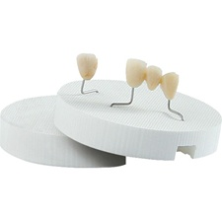
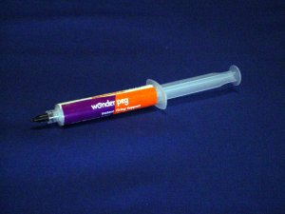

Wonderpeg 113294
Instant firing support; holds crown or porcelain jacket in place while firing in porcelain oven.

Alginate-Mixer by Zhermack
Produces uniform and bubble free mixing for alginates, dental stone, and silicones. Reduces mixing time by 30%.

AmannGirrbach Smart Box Invest G58000
An easy to use measuring device for all investment materials

Integrated cooling system
Preuse measurement technology
Accurate and reproducible mixing results can be obtained at any time of the year
50 user defined programs

66
SUCTION UNITS
___________________________________________________________

GENERAL PURPOSE SUCTION UNITS
All Vanguard units feature:
High speed turbine technology producing high suction
Whisper quiet operation at 55 decibels
Low maintenance design
Unique Pre-Filter/Accumulator captures 99% of all dust
Additional filtration options

VANGUARD 1X
Single Station, single speed

VANGUARD Gold 2X
One or Two Station, multi-speed
High suction for Heavy Duty Use

VANGUARD Platinum 2X
One or Two Station, Variable Speed
Autopilot for Handpiece Synchronization
Optional Air Autopilot add-on for air handpiece control
Automatic “Bag Full” Indicator
Tri-filtration built-in

*Not for use with blasters or abrasives.*

ONE STATION DUST COLLECTORS

Vanguard 1X with Pre-Filter Accumulator

Single Station 10311 860520

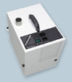

67

SUCTION UNITS
___________________________________________________________

Vanguard Gold 2X

Single Station 10320 860526

Vanguard Gold 2X with Pre-Filter Accumulator

Single Station 10321 860531

Vanguard Platinum 2X

Single Station 10330 860532

Vanguard Platinum 2X with Pre-Filter Accumulator

Single Station 10331 860528

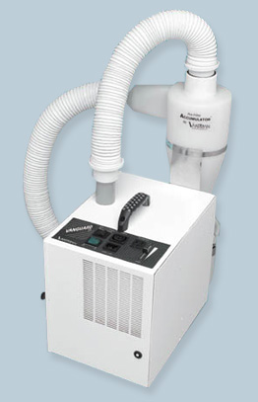

TWO STATION DUST COLLECTORS

Vanguard Gold 2X with Pre-Filter Accumulator

Dual Station 10322 860533

Filter Bags
By Quatro

Pkg. of 5 861039

68

SUCTION UNITS
___________________________________________________________

Jet Stream JS 1200 820225
By Quatro

Hepa Dust Collector
2-Station
Compact design
Contains anti-microbial bag filter
Ultra-quiet performance
Infinite speed control
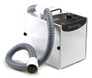

Velocity X1 820385
By Quatro

Brushless Dust Collector
Single station
Premium power
“Slide & Glide” rejuvenating filter cartridge
Maintenance free industrial motor
No brushes or filter bags to change or replace
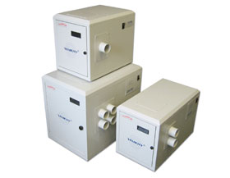

69

STONE & PLASTER
__________________________________________________________

DIE STONES

Die Keen
By Heraeus Kulzer
A very hard die stone that guarantees strength and accuracy. It is recommended for dies as well as crown and bridge models. No hardeners or additives are needed.

Sold in 50 lb. boxes 18000 PSI exp. .18 - .2%

Blue 123392
Green 123388

70

STONE & PLASTER
___________________________________________________________

Super Rock
By Noritake
The flow is superior to conventional products and its thixotropic properties facilitate easy handling. It easily fills and reproduces the finest details of the impression.

Sold in 50 lb. boxes

Golden Brown N11435
Grey N11423

71

STONE & PLASTER
___________________________________________________________

Fujirock
A resin-reinforced die stone that produces remarkably fine and smooth dies and models

18000 PSI exp. .08%

Golden Brown 50lbs 124142
Golden Brown EP 12 kg. 124148

Resin Rock
By Whip Mix
A unique blend of synthetic resin and alpha gypsum, resulting in improved surface smoothness and resistance to abrasion

50 lb. box

White 123630

Green 123438
Grey 123360

ORTHOSTONES

Mounting Stone
By Whip Mix
A very hard, fast setting stone formulated for mounting casts to articulators. Its low setting expansion prevents inaccuracies that result when conventional stone or plaster is used.

50 lb. box 124119

Snow White 067
By Heraeus Kulzer
Snow White has a high surface hardness of 11,000 PSI. Along with its low setting expansion and strength, this stone makes it ideal for creating a working orthodontic model.

50 lb. box 124105

72
STONE & PLASTER
___________________________________________________________

Orthostone
By Whip Mix
A hard, accurate, highly esthetic super white dental stone

50 lb. box 124317

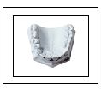

Modelglo
A model soap that leaves finished models with a glossy surface

1 gal. 112854

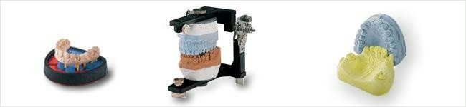

73

STONE & PLASTER
___________________________________________________________

PUMICE

Fine 40 lb. 126316
Medium 40 lb. 126308
Coarse 40 lb. 126324

Resilience
Faster and smoother than pumice promotes easy polishing

Box 20 lb. 123889

74

INVESTMENTS
___________________________________________________________

CROWN & BRIDGE INVESTMENTS

Cerafina
By WM
A carbon free, fine grained phosphate investment. Used for precious, semi-precious, and non-precious alloys
60 gr. Bulk Packets 122212
90 gr. Bulk Packets 122228
1 qt. Liquid 122844

Fastfire 15
A fine grain phosphate investment which requires only a 15 minute bench set before placing into a hot oven for rapid burnout

1 L Liquid 121791

Zubler 144 speed investment
A high performance universal investment that works equally well for all alloys and pressable ceramics

100 gr. x 100 pkg. 122805
Liquid 1 liter 122806

Zubler Conceptvest
Specially formulated for lithium disilicates,
helps to combat the reaction layer.

100 gr. x 50 pkg 122803
Liquid 1 liter 122806

Bellavest SH
By Bego
A shock heat, graphite free, phosphate bound casting investment, applicable for all crown and bridge alloys and pressable ceramics.

90 gr. x 100 pkg w/2 L liquid 121773

75
INVESTMENTS
___________________________________________________________

SOLDERING INVESTMENT

Hi Heat
By Whip Mix
A gypsum soldering investment for high-fusing precious metals

4.5 lb. Jar 120491
25 lb. Box 120483

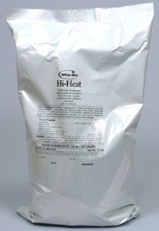

76
INVESTMENTS
___________________________________________________________

CAST PARTIAL INVESTMENTS

Wirovest
By Bego
A phosphate bonded investment material with very high expansion and model hardness characteristics

45 x 400 gr. 120944
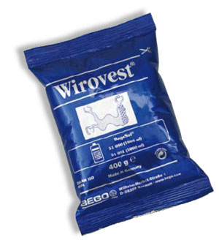
Rema-Exact
A fast-setting partial denture investment for refractory and investing. Creates exact fitting castings.

50 x 400 gr. 117188
1 L Liquid 117190

Remadur 112340
A solvent-free cold model hardener for investment models; environmentally friendly.

Alumina Vest 120801
By Noritake
Alumina Vest is an investment material for casting high noble or noble ceramic alloys. Gypsum bonded; therefore, only requires distilled water.

77
GYPSUM ACCESSORIES
___________________________________________________________

Gypsum Hardener
Replaces water as the gauging liquid when increased hardness and reduced brittleness are desired. It will also improve the flowing quality of the mix.

1 Gallon 125201

Gyp-Strip
A highly effective gypsum remover that keeps your equipment sparkling! Removes plaster, stone, and gypsum investments from mixing bowls, acrylic dentures, denture flasks, casting rings, and non-aluminum articulators.

1 Gallon 87118

Mixing Bowls
These self-cleaning bowls are widely used by dental technicians. Plaster, stone, investments, and alginates will not stick; just flex and wipe with a damp cloth. These bowls are resistant to most chemicals (not suitable for mixing acrylics).

Small 150 cc. 5809
Medium 350 cc. 5825
Large 600 cc. 5841
Extra Large 850 cc. 5866

Plaster Knives

6R 43883 #6 Sloyd 44089
7R 43867 #20 Sloyd 43925
#6 Greenline 43842 #10 Gritman 44113
#12 Gritman 44147
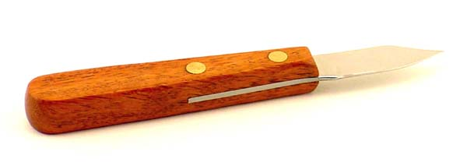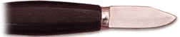

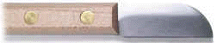

78
GYPSUM ACCESSORIES
___________________________________________________________

Mixing Spatulas

2R 44634
4R 44659 11R 44766
16R 44618
Alginate 44602
Cement #2 41564

79
HANDPIECES
___________________________________________________________

Marathon Handy 700

- Brushless micromotor
- Maximum torque 7.8N cm
- Autocruise speed function
- 50,000 RPM maximum
- variable speed control by hand dial or foot pedal
- vertical and portable

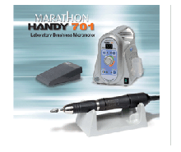

High speed by Marathon
A 300,000 RPM lubricant free handpiece

*Other handpieces available by special order*

80
HANDPIECES
___________________________________________________________

Surveyor/Milling Machine
A precision instrument with exact guidance and movement

Marathon 103 525578

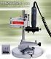

*Please call to check for availability.*
81
IMPRESSION TRAYS
___________________________________________________________

Coe Tray Disposable Impression trays(12 pkg)
By GC

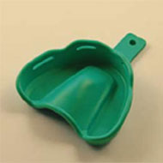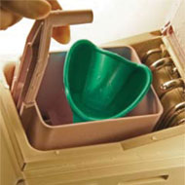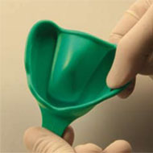

82

ALGINATES
___________________________________________________________

Tropicalgin 106620
By Zhermack
Chromatic alginate lasts 72 hours. Setting time is 2 1/2 minutes.

Neocolloid 106630
High precision alginate. Setting time is 3 1/2 minutes.

Jeltrate
By Dentsply

Regular Set 106560
Fast Set 106545

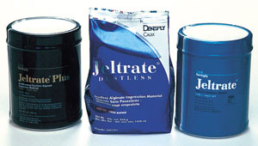

83

ALGINATES
___________________________________________________________

84
IMPRESSION MATERIALS
___________________________________________________________

Coltex(by Coltene)
Specifically developed for functional impressions and is formulated to guarantee the right consistency and setting time. It is an impression system with a catalyst paste that is simple and reliable.

Fine Econo Pack 932011
Medium Econo Pack 932022

Virtual
By Ivoclar
Vinyl polysiloxane materials used to create fine detail impressions of dentition. Available in a variety of viscosities to best suit the individual patient.

Extra Light Fast 935069
Regular 935072
Light Fast 935087
Regular 935091
Medium Fast 935157
Regular 935146
Monophase Fast 935110
Regular 935114
Heavy Fast 935034
Regular 935036

Coe Flex rubber based impression material
By GC 915325
An all purpose polysulfide material for inlays, crowns, bridges, dentures, rebasing and relining.

Virtual Bite Registrations
By Ivoclar 935168

Occlufast
By Zhermack 106700

Ivoclar Accudent XD syringe 940044
Ivoclar Accudent XD tray 940043

85
IMPRESSION MATERIALS
___________________________________________________________

Cartridge Gun

50 ml. 860142

Virtual Mixing Tips
By Ivoclar

Small Yellow Bag of 48 935207
Large Teal Bag of 48 935195

Virtual Intra Oral Tips
By Ivoclar
Small Yellow Bag of 100 935223
Large Clear Bag of 100 935219

86
LAB PUTTY
___________________________________________________________

Lab Putty
By Coltene
Simple handling, multi purpose polysiloxand modeling material

900 ml. With Activator 933012
7.5 kg. Pail 933024
40 ml. Activator 933030

Zetalabor Shore Hardness 85
By Zhermack

2.6 kg. 932879
5 kg. 932875
10 kg. 932878

Titanium Putty Shore Hardness 95
By Zhermack

2.6 kg. 932080
5 kg. 932085

Indurent Gel
Activator for the zetalabor and titanium putty

40 ml. 932090

Coltene Presidents Putty
Intra oral lab putty

2 x 300 ml 933001

Coltene Coltoflax 934114
A putty for use with coltex impression material

Wonderfill
Save as much as 20 minutes and improve model appearance by replacing plaster/stone or alginate with Wonderfill as a tongue filler.

1.1 kg. Pail 117810

87
INSTRUMENTS
___________________________________________________________

Blades & Handles
These lightweight handles have exceptionally sharp replacement blades and are ideal for cutting patterns, waxes, and have thousands of other uses.(Non sterile)

Blades sold per each or box of 100

Stainless Steel Handle #3 42646
#4 42653

Plastic Handle Green #5 42687
Red #6 42661

#10 Blade Fits #3 & #5 Handles 42840
#11 Blade Fits #3 & #5 Handles 42802
#15 Blade Fits #3 & #5 Handles 42869
#21 Blade Fits #4 & #6 Handles 42813
#25 Blade Fits #4 & #6 Handles 42828

CALIPERS & GAUGES

Boley Style Sliding Gauge 46001
Cut out jaws for measuring different shapes, as well as an end that can be used as a depth gauge
Millimetre gauge with vernier reading to 0.1 mm.
Capacity 100 mm.
Locking lever

Metal Calipers 45730
By Renfert

Dial Caliper 45740

88
INSTRUMENTS
___________________________________________________________

CARVERS

Akers Carver
Specially designed precision instrument for wax carving and set up work

Complete Carver 42495

Blade 42323

Handle 42166

Spoon 42489

Porcelain Carving Instruments
By Kerr
For build up and sculpturing of porcelain
Forcibly condenses powder without vibration
Handle is made from light weight aluminum
Blades are available in standard or ultra thin

Handle 32662

Thin Blades Black 32720
White 32803 Red 32886

Ultra Thin Blades Green 33041
Brown 33124

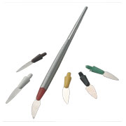
89

INSTRUMENTS
___________________________________________________________

Wax Carvers
Are made of heavy stainless steel and have serrated handles. Most carvers are approximately 7” long.

Hollenbach #3 41804
LeCron #5 42000
Roach #6 41226
Ward #1 41846
Zahle 41697
Vehe 41828
WCI 41856
Beales #7 44820

Haemostats

Straight 44949
Curved 44957

Renfert Keramogrip

Straight 45084
Curved 45068

Renfert Jacketgrip 49459

Wax Spatulas

#4 Fahnstock 40566
#7 Nourstain 41044
#31 Nourstain 41200
#35 Wood Handled Spoon 41366

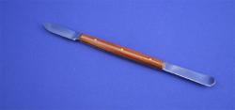

90

INSTRUMENTS
___________________________________________________________

Scrapers

Kingsley style, high grade steel rod set in seasoned hardwood handle.
Can be re-sharpened
6” in length

TWEEZERS

Articulating Paper Forceps 45136

Merriam Serrated
6” long double angle elongated tips, non-pinch, rounded edges 45045

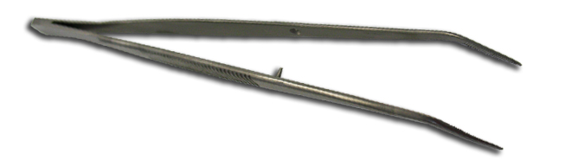

91
INSTRUMENTS
___________________________________________________________

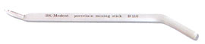
Porcelain Mixing Stick B-110
70731
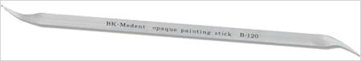
Opaque Painting Stick B-120
70743
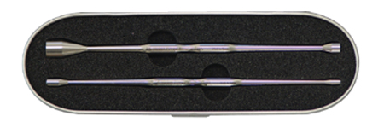
Porcelain Powder Scoop Set B-510
42095
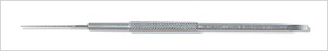 Porcelain Carving Instrument B-160 42012

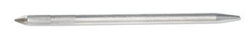
Porcelain Blade Holder B-140
42756
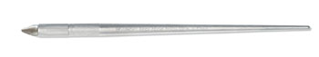
Porcelain Blade Holder B-150
42768

*Please call to inquire about our many additional instruments available.*

92
OPERATORY
___________________________________________________________

GLOVES
Made with only the highest quality latex. Their tactile sensitivity makes them ideal for medical and dental use.

Available in box or case (10 boxes)

Latex Powder Free Small 15169
Medium 15181
Large 15193

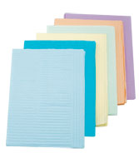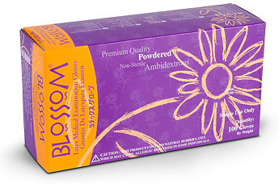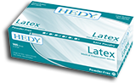

93
OPERATORY
________________________________________________________

94
OPERATORY
___________________________________________________________

MASKS

Earloop Masks

Box of 50 Blue 84665

95
DISINFECTANTS
___________________________________________________________

Cavicide
A broad spectrum disinfectant.
EPA approved Hospital Level cleaner which is safe and effective for all surfaces, immersion, and ultrasonic cleaning.
Tested effective against HIV-1 virus, Hepatitis C, Coronavirus, Mycobacterium, Tuberculosis Var: Bovis.
Ready to use; apply directly to surface and wipe.
For use on inanimate objects and non-critical medical objects.

1 gal. 930048
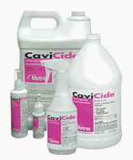
Caviwipes
Non-woven disinfectant towelettes; pre-saturated with Cavicide surface disinfectant; same properties as above.

160 pre-saturated towelettes 6” x 6 3/4” 930042

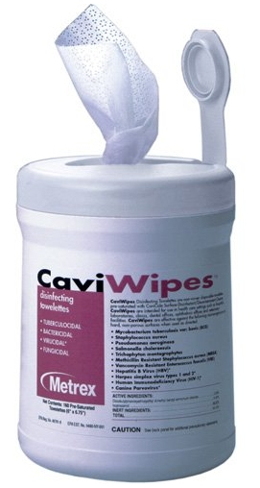

Biomers
May be used as a chairside pre-soak for instruments, dentures, bite wings, and cheek retractors. Reaches highest levels of TB disinfection in one minute.

6 L 921042

96
DISINFECTANTS
___________________________________________________________

Biosurf
One minute high level TB Mycobacterium Bovis, Polio virus, Parvovirus disinfectant; safe to use on all metals, prosthetic, and impression materials. Simply spray, wait one minute, then rinse.

6 L 921007

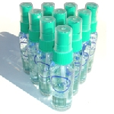
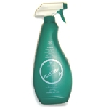

Biotext
Revitalizes leather and vinyl coverings, glass, and plastic. Use as a substitute for water in pumice slurries. Simply spray, wait three minutes, then wipe. Kills TB and Parvovirus in five minutes.

6 L 921039

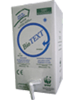

97
CLEANERS
___________________________________________________________

Three- part denture baths

Kleenite Denture Cleaner
Cleans and freshens removeable partials, metal and plastic retainers, sport/mouth guards, night guards, and dental brushes.

6 oz. Bottle 253275

Sonic Denture Cleaner
For individual dentures; can be sold or given to patients. Requires one AA battery.

Sold by each or case of 100 4586

ULTRASONIC CLEANER

VK1
General purpose cleaner

1 gal. 87039

VK3
Plaster and stone remover

1 gal. 87104

VK4
Tartar and stain remover

1 gal. 87088

ULTRASONIC UNIT

EZ Clean 720923
By Renfert
Provides state of the art ultrasonic cleaning technology. Temperature regulated function. Automatic circulation and sweeping function (optimized ultrasonic field distribution). Unit switches off in case of no liquid being present.

98
CLEANERS
___________________________________________________________

Biosonic
By Whaledent
This unit is loaded with features designed to protect you. Its exclusive finger guard basket design virtually eliminates the possibility of accidental finger sticks. The tank lid prevents the escape of aerosol contaminants.

UC 100 3.8L tank capacity 720920
UC 300 14.4L tank capacity S/O

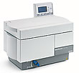

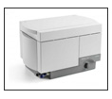

*Available by special order.*

99
SPRUES
___________________________________________________________

Accurate pre-fabricated sprues specifically designed for producing denser, porosity free castings

Indirect

Small 6/8 ga. Box of 250
Large 4/6 ga. Box of 250

Direct

Small 12 ga. Box of 500
Medium 10 ga. Box of 500
Large 8 ga. Box of 500

Wax Buttons

Box of 100 114739

Dentsply(plastic)

Straight 13 ga. Pkg. of 100 114569

WIREWAX
Blue wirewax is extruded to a uniform diameter, proper tackiness and adhesion. Available in round spools.
6 ga. 101889
8 ga. 101921
10 ga. 102085

*Special orders for higher gauges are available.*

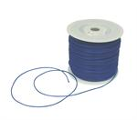

100
SPRUES
__________________________________________________________

INVESTING EQUIPMENT

Combination Unit
By Whip Mix
This space saving unit supplies your power and vacuum for all your mixing and investing needs. The Combination Unit will supply bubble-free investing, improve mixing, and provide versatile power and efficient vacuum. All parts are available separately.

Combination Unit Only 760150
Bench Stand 801560
Lubricant 89845
Tube & Connector 517803
Vac-U-Mixer Bowl 200 cc. 760205
300 cc. 760189
500 cc. 760197
875 cc. 760213
Stainless steel 1200 cc. 760236

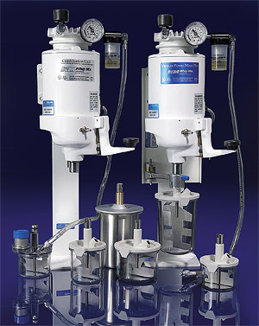

101
LATHES
___________________________________________________________

Red Wing Lathe
By Handler
Full 1/4 HP 700243

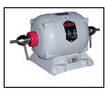
Baldor Lathe

Heavy duty lathe 700250

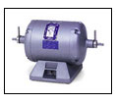

Wells Quick Chuck 700326
Allows the technician to change burs and accessories quickly without any hassle

Wells Adaptor
To affix a Wells Chuck to a Red Wing Lathe 515023

Jacobs Chuck 50169
Manually operated and fits all standard bench lathes. This chuck is completely sealed to prevent dust and grindings from entering any part of the mechanism.

102
LATHES
___________________________________________________________

Tapered Spindles
Steel spindles for use with polishing buffs and wheels

Left Side 50649
Right Side 50482

Arbor Band Chuck 3/4” 51126

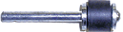

Stone Chuck 50961

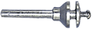

Tapered Buff Chuck 50805

103
MODEL TRIMMERS
___________________________________________________________

By Ray Foster
The Foster 10” and 12” model trimmers are constructed from heavy gauge cast aluminum and feature the unique swinging door design. Unscrewing a single knob allows the door to be swung open wide, permitting easy access for changing a grinding wheel or for cleaning.

The adjustable work table permits a full 20 degree range of vertical adjustment, positive locking, and clean efficient water drainage. Power is delivered by a rugged 1/3 HP motor on the 10” model and a heavy duty 1/2 HP motor on the 12”. Water is delivered to the grinding wheel by a full radius water spray system and is regulated by a manual valve on the front of the model trimmer.

10” Model Trimmer 702223
12” Model Trimmer 702181

Orthodontic Model Trimmer 702165
By Ray Foster
Fitted with the Orthodontic Angulating Work Table, this model allows time saving trimming of models and produces more accurate and attractive results. The 1/2 HP model still features the “swinging door” design, a full radius water spray system, combined with the work table that includes a Verisquare, Angle Guide, and 70 mm Adjustment Gauge.

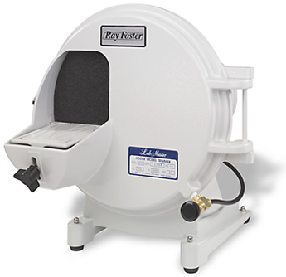

104
MODEL TRIMMERS
___________________________________________________________

MT Plus 702185
By Renfert
Compact, yet very high performance model trimmer
Can be employed for either wet or dry trimming
Available with or without diamond coated disc
2.0 HP motor
10”
Three year warranty

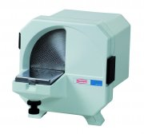

105
ACCESSORIES
___________________________________________________________

10” Carborundum Disc 65621
These high quality carborundum model trimming wheels are reversible.

12” Carborundum Disc 65647

10” Flexi Peel Off Discs 65936
These superior quality abrasive coated discs will cut models three to four times faster and will reduce noise by 75%.

12” Flexi Peel Off Discs 66009

106
ORTHODONTIC SUNDRIES
___________________________________________________________

Ball Clasps
Stainless steel
1 mm Pkg. of 100
.9 mm (.036”) Pkg. of 100
.8 mm (.032”) Pkg. of 100
.7 mm (.028”) Pkg. of 100
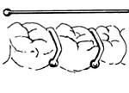
J Clasps (Roach Clasps)
Stainless steel
1 mm Pkg. of 10 230506
.9 mm Pkg. of 10 230472
.8 mm Pkg. of 10 230480
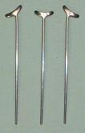

107
ORTHODONTIC SUNDRIES
___________________________________________________________

CLASP WIRE – Gold

18 Ga. Per strip 210326

CLASP WIRE – Stainless Steel
By Dentaurum

17 Ga. .045” 1.15 mm. 210330 18 Ga. .040” 1.02 mm. 210333
19 Ga. .036” .91 mm. 222504
20 Ga. .032” .81 mm. 221828
21 Ga. .028” .72 mm. 221521

CLASP WIRE – Half Round
By Dentaurum

12 Ga. .081” 2.05 mm. 222800
14 Ga. .064” 1.63 mm. 222487
15 Ga. .057” 1.45 mm. 222503
16 Ga. .051” 1.29 mm. 222644

CLASP WIRE – Ticonium
By CMP

18 Ga. 5 pieces 222293 19 Ga. 6 pieces 222231

Strengtheners
By Dentaurum
Palate shaped perforated strengtheners

Gold-plated Pkg. of 10
Stainless steel Pkg. of 10

108

ORTHODONTIC SUNDRIES
___________________________________________________________

Lingual Bars

Pkg. of 12
Small 223121
Medium 223287
Large 223444

PLIERS

Combination Flat and Round

Chrome Plated 5” Long 48908

Contouring

Chrome Plated 5” Long 49047

Three Prong Clasp 4 1/2” Long 49369

Wire Bending 5” Long 48882

109
DUPLICATING MATERIALS
___________________________________________________________

Neoloid
By Dentsply
All purpose duplicating material. With its high degree of flex for duplicating deep undercuts, this material readily rebounds to original shape. Ideal for refractory and stone models.

3.5 Gallon 117895

Niraloid (Concentrate)
Just add water! A remarkably advanced material that lasts longer than regular pre-mixed hydro colloids.

Makes 3 Gallons 117863

Polyflex
A reversible hydrocolloid material to be used for duplicating any model in stone or phosphate investments.

2 Gallon Pail 117521

Castogel
A special duplicating material for demanding partial denture and combination work. Its high elasticity reproduces undercuts easily and removal is made simple.

6 kg. 117800

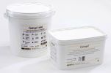

Elite Double
A silicone duplicating material ideal for free expansion duplicating technique with investments.

1 + 1 kg. 117545

110
DUPLICATING MATERIALS
___________________________________________________________

Duplicating Flasks 80650
With its low thermal conductivity, this plastic flask guarantees stress free cooling.

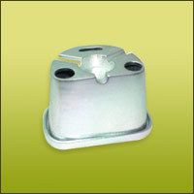

111
MATERIALS
___________________________________________________________

Hot Stop 210086
By Renfert
Prevents acrylic from being burnt; absorbs more than 97% of the heat produced and will not liquefy.

Tackyfier Pattern Adhesive
A tacky material which adheres plastic patterns to the model

4 oz. 115428

112
POLISHING COMPOUNDS
___________________________________________________________

FOR ACRYLIC & METAL

Fabulustre
By Dixon
A white compound formulated to provide high lustre on all types of acrylics, precious metals, and alloys. Greaseless, dry, but not dusty, which means fast and easy clean up.

Stick 1/4 lb. 8654

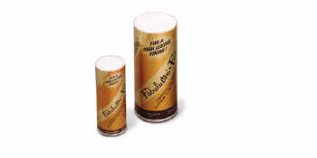
Tripoli
By Dixon
The standard for preparing a smooth finish on metal and acrylic

Bar 1 lb. 8324
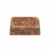

Universal Polishing Paste
By Ivoclar
Leaves a high shine on resin, metal work and resin

Tube 150 ml. 8209

For Chrome Cobalt and Acrylic

Mosher Polishing Compound

Bar 1 lb. 8647

113
POLISHING COMPOUNDS
___________________________________________________________

FOR CROWN & BRIDGE

Buffing Compound
This compound is designed for pre polishing of chrome cobalt.

Red Rouge
By Dixon
For high shine on gold, precious, and non-precious alloys

Bar 1/4 lb. 9124

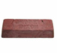

Green Rouge
By Dixon
Produces a mirror-like shine, for use on precious and non-precious alloys

Bar 1/4 lb. 9136

114
PORCELAIN
___________________________________________________________



Noritake Family of Dental Porcelains

Tradition and Innovation in Ceramic Technology
Noritake has over 100 years of successful experience in ceramic technology. It is world famous for its exquisite china. During the past few decades, Noritake has used its expertise in applied ceramic science to become a world leader in ceramic electrical insulators and abrasive materials. In 1987, Noritake brought its knowledge and years of experience to the dental field by developing and introducing NORITAKE SUPER PORCELAIN EX-3, a complete dental porcelain system of the highest quality. Now, Noritake offers many kinds of dental porcelains for available frameworks.

Reproduction of Natural Tooth Colour
Outstanding Resistance to Fractures
Synthetic Material – Stable & High Quality
Natural Fluorescence
Exceptional Handling Characteristics

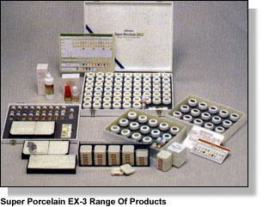

*For more information on this fine porcelain system, please call 1-888-477-9378.*

115
PORCELAIN
___________________________________________________________

Noritake Porcelains

EX-3
For Porcelain bonded to metal; press for press over metal or free standing full porcelain restorations

Cerebien
For Alumina frameworks

CZR
For Zirconia frameworks; press for press over zirconia or free standing full porcelain restorations

Ti22
For Titanium

Magic Former
This is a dry and set type margin porcelain forming liquid. It dries hard and allows for easy removal of the coping from the die without disturbing the margin porcelain.

Magic Separator
This pen-like separator is used to separate porcelain from model material in the margin area, contacts or gingival surface.

Katana Zirconia Blocks
Available in:

UTML-Ultra translucent multi layer
STML-Super translucent multi layer
ML-Multi layered
HT-High translucent

All are available in 14mm , 18mm and 22 mm.

116
PORCELAIN
___________________________________________________________

NORITAKE

*For more information on this fine porcelain system, please call 1-888-477-9378.*

117
PORCELAIN
___________________________________________________________

GC INITIAL , LISI and LISI press porcelain.

Beautifully Natural
GC Initial Ceramic is based on the structural form of nature and is made to the highest quality. This means the optical properties of the restoration such as diffuse reflection, fluorescence, opalescence and translucency mimic those of the natural tooth. Its surface can be easily polished for a realistic mirror reflection and a natural glossy sheen. Whatever the indication or fabrication process employed, it is very simple to make a beautiful, natural-looking restoration.

Naturally Functional
The composition and quality of GC Initial gives you ceramic which is easy to handle and extremely stable. It is simple to contour and very technique tolerant. Ceramic colour and optical properties will not change even after several firings. It has very low ceramic shrinkage, saving time and providing high firing stability for shaping form and creating shadings. The structure of GC Initial ceramic also has excellent physical properties so final restorations are exceedingly durable and fully functional.

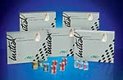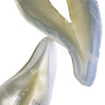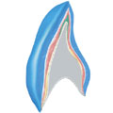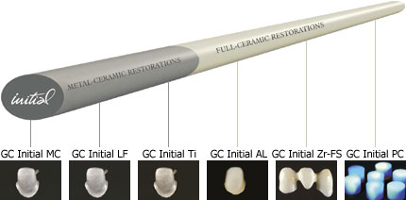

*For more information on this fine porcelain system, please call 1-888-477-9378.*

118
PORCELAIN ACCESSORIES
___________________________________________________________

Cerama Sep 42141
By Kerr
This chemically pure, non-contaminating liquid allows building of porcelain without sticking to margins or stone.

Zhermack Gingifast 931055
For the reproduction of the gingival area for models in fixed prosthesis. Highly elastic and easy to use makes this product a winner!

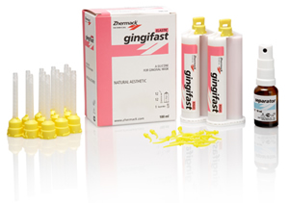
GI Mask
By Coltene
GI mask is a silicone based gingival mask material for the reproduction of gingival contours around prepared margins. It maintains its accuracy for days, till the moment the restoration is finished.

Kit 34038
Separator 30 ml. 34032

Noritake Meister Liquid

This slow-drying liquid allows the ceramist more working time
during porcelain build up(100ml). N11285

119
PORCELAIN ACCESSORIES
___________________________________________________________

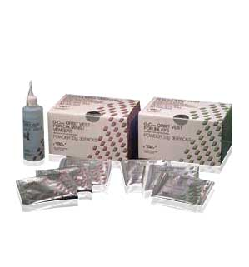

REFRACTORY MATERIAL

G. Cera Vest
Creates laminate veneers of exacting fit. Its thermal expansion is close to that of porcelain, to eliminate cracking. Available in pre-measured packets, plus liquid.

Powder 30 x 33 gr. 122784
Liquid 200 ml. 122786

Norivest
Flows easily to reproduce all the fine details of the impression exactly. Strong, but easily removed after porcelain is fired, reducing the risk of breakage of the inlay or veneer. Available for use with zirconia, alumina, or porcelain bonded to metal porcelains.

120
TEETH
___________________________________________________________

Westan carries the following tooth lines:

Candulor
Physioset TCR
Bonartic TCR
Physiostar NFC
Condyloform II NFC
Bonartic II NFC
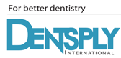
Dentsply
Classic
Bioform
Portrait
Bioblend
Tru-expression
Heraeus Kulzer
Artic
Basic
Mondial


Ivoclar
SR-Vivodent
Orthosit
Orthotyp
Phonares

121
TEETH
___________________________________________________________

Myerson
DP Plus
Cutter Bars

Vita
Physiodens
Vitapan
Vitapan plus
Excell
Cuspiform
Synoform
Lingoform
MFT


*Please call for mould guides.*

122
VACUUM FORMING
___________________________________________________________

The Machine III 840668
The world’s #1 selling vacuum forming machine
Solid design
2 chamber motor
Comes with a five year guarantee.

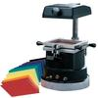

Proform Machine 800143
This vacuum former has a dual-chambered heavy duty vacuum motor.
Construction is all aluminum.
Comes with a five year parts and labour guarantee.

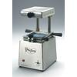

Aluminum Tray Handles

Box of 100 17127

123
VACUUM FORMING
___________________________________________________________

Block Out Compound 106722
To block out remaining teeth on severe or delicate undercuts on models prior to vacuum forming.

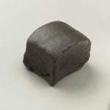

Mouthguard Materials
Soft, clear material for fluoride trays, bleaching and bruxing

Soft EVA .040 Clear Box of 25 241540
Soft EVA .060 Clear Box of 25 241715
Soft EVA .080 Clear Box of 25 241735
Soft EVA .150 Clear Box of 12 241771

Block-Out Material
A low viscosity pigmented, light cure resin in syringe form that is excellent for blocking out models for bleaching laminates.

2 ml. 106734

Proform E-Gaskets
A unique combination of soft and hard material in one sheet, for use on bruxism cases. Acrylic will bond to hard surfaced side.

Box of 12 241916

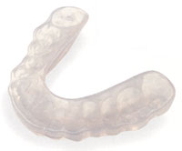
124
VACUUM FORMING
_______________________________________________________________________________

Proform Dual Laminates
Same characteristics as E-Gasket, but in 5 mm. thickness
Box of 12 241966

Bleaching Laminates
This bleaching laminate is very unique due to its foam liner. This liner absorbs the bleach and helps to keep the peroxide right where you want it, on the facial of the teeth.

Box of 50 240792

NuPro

Tooth Whitening Kits
100% carbamide peroxide whitening kit

5 x 2.4 gr. syringes with retainer box 936050

Proform Niteguards
A laminated soft material for night bruxers. Withstands grinding better than traditional soft sheet material.

Box of 12 or each 241943
SPLINT MATERIALS
Stiff, clear material for hard splints, surgical tray, and ortho retainers. Acrylic will adhere to this material.

Surgical Trays

Box of 50 .020 240901
Box of 50 .040 240927
Box of 25 .060 240166
Box of 50 .080 240917

Tray Material

Each Tray 5”x 5”x .150 Blue 240489

125
VACUUM FORMING
___________________________________________________________

Proforms
Coping material; excellent material for temporary bridges

Box of 50 240489
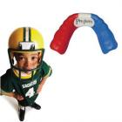
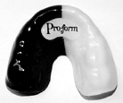

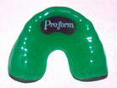
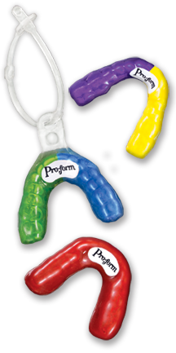

126
VACUUM FORMING
___________________________________________________________

PROFORM COLOURS

SOLID COLOURS DUAL COLOURS TRI-COLOURS

BLACK BLACK/BLUE BLACK/GOLD/BLACK
BLACK/GOLD BLACK/GREEN/WHITE
BLUE BLACK/GREEN BLACK/RED/BLACK
BLACK/ORANGE BLACK/RED/YELLOW
CLEAR BLACK/PINK BLACK/WHITE/BLACK
BLACK/PURPLE BLACK/WHITE/BLUE
GREEN BLACK/RED BLACK/WHITE/ORANGE
BLACK/WHITE BLUE/BLACK/BLUE
ORANGE BLUE/GOLD BLUE/GOLD/BLUE
BLUE/GREEN BLUE/WHITE/BLUE
PINK BLUE/PURPLE BLUE/WHITE/ORANGE
BLUE/RED CANADIAN FLAG
PURPLE BLUE/WHITE GREEN/WHITE/BLACK
GREEN/GOLD GREEN/WHITE/ORANGE
RED PURPLE/GOLD PURPLE/WHITE/PURPLE
WHITE/GOLD RED/BLACK/RED
WHITE WHITE/GREEN RED/WHITE /BLACK
WHITE/ORANGE RED/ WHITE/ BLUE
YELLOW WHITE/PINK RED/WHITE/GREEN WHITE/PURPLE WHITE/BLACK/WHITE
WHITE/RED WHITE/BLUE/WHITE
WHITE/RED/WHITE

*Sold by the dozen; colours can be assorted.*

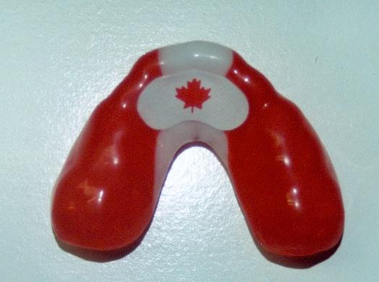

127
VIBRATORS
___________________________________________________________

General Purpose Vibrator
This vaiable speed vibrator provides quiet, efficient performance. It features a shock absorbing base and a removable rubber top to make cleaning easier. 779989

Heavy Duty Table Top Vibrator
This unit is designed to provide an infinite range of vibration, from low to maximum intensity. Features large suction feet for stability and an indicating light to show when power is on.

128
WAXERS
___________________________________________________________

Vario E 780361
With its three heating wells, the Vario E heats modeling waxes to their ideal processing temperature. All three pots’ temperatures can be controlled separately.

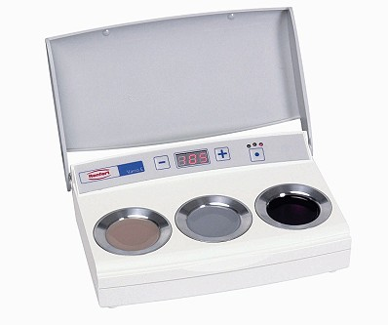

Ultrawaxer(PARTS ONLY)
By Kerr
This exact model is no longer available but we sell the handle and interchangeable tips.

Cord/Handle 780436
Beavertail 780427
Spoon 45870

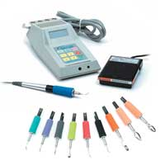
129

WAXERS
___________________________________________________________

Hotty LED 820356
By Renfert
Digital wax dipping pots with a controllable working temperature for gently heating dipping waxes. High grade wax components are heated without impairing the quality.

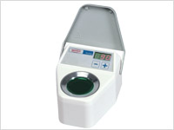

Waxpot 780302
By Ray Foster
A three-well waxpot with adjustable thermostat control and indicator light

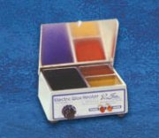

Wax Profi 780374
This unit produces improved prosthetic results more efficiently. Instruments and wax are no longer heated separately, resulting in distortion- free denture bases.
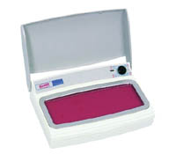
130
WAXERS
___________________________________________________________

Smart Wax Duo(PARTS ONLY)
By Amann Girrbach
*We no longer carry this item but we do have handles and tips available at great pricing.

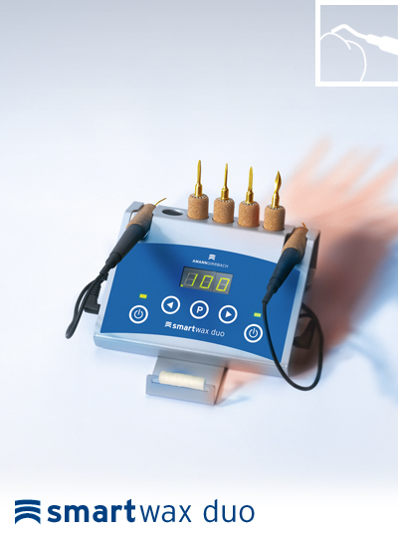
Tips

Small Probe G36000
Large Probe G37000
Beavertail G39000
Needle G38000
Spoon G39500
Knife G40000

WaxLectric I 780218
By Renfert
Wax up is made easy and stress free due to its accurate set and evenly distributed temperature. Three temperatures can be set to each channel and are available at the press of a button. Available with one or two handpieces.

WaxLectric II 780227
By Renfert

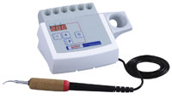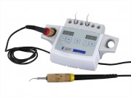

WaxLectric I WaxLectric II

131
WAXERS
___________________________________________________________

Power Pillo 780400
By Renfert
The Power Pillo chisel, with its effortless operation, does not produce high levels of vibration, resulting in comfort to the user.

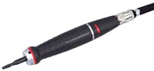

132
WAXES
___________________________________________________________

Adhesive Casting Wax
Used for relief of the saddle areas prior to duplicating. This wax adheres firmly to the stone model. Flexible 4”x4” wax sheets that are coated on one side with a pressure sensitive adhesive.

20 Ga. 32 Sheets per Box 103020
22 Ga. 32 Sheets per Box 103042
24 Ga. 32 Sheets per Box 103208
26 Ga. 32 Sheets per Box 103364
28 Ga. 32 Sheets per Box 103521
30 Ga. 32 Sheets per Box 103687

Baseplate Wax

Neowax 100195
By Dentsply
A popular all season, all purpose, high grade synthetic wax that is tough, pliable, and boils out cleanly.

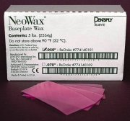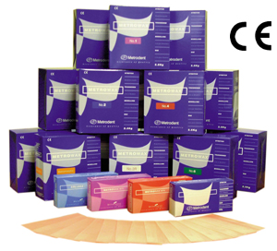

Metrowax
By Metrodent
This high quality baseplate wax is one of our most popular items. Stretch toughened without brittleness, it is static and stays where you put it. Available in a natural pink gum shade.

2.5 kg. Box 100185

Red Refined Wax

5 lb. Box 100568

133
WAXES
___________________________________________________________

Dipping Wax

Dipping Wax
By Kerr
A pure wax formula with micro crystalline structure gives unique elastic feel with memory, clean burn out, and minimal shrinkage.

Yellow 9 oz. Bottle 104396
Green 9 oz. Bottle 104404

High quality dipping wax

Bite Blocks
By Metrodent
Forms easily without heat under normal laboratory conditions. Easily adapted to fit normal ridges.
48 Sticks Box 100220

Blockout Wax
By Renfert
Used for filling in voids and undercuts on the working die

Rose 104978

Undercut Wax
By Renfert
A gentle, flexible coping wax used for small undercuts

Red 104838

134
WAXES
___________________________________________________________

Boxing Wax 100105
Ideal material for boxing in the impression

Utility Wax
Very versatile wax used for boxing alginates, building up impression trays, post damming, and sealing.
White 100024

Casting Wax
By Whip Mix
This wax is easily adaptable without flaking or crumbling and maintains an even degree of workability over a wide temperature range.

Green Sticks Hard 104248
Blue Sticks Hard 104259

Inlay Wax
By Kerr
A superior wax for building up 73degrees melting temperature

Blue Sticks 104321

Sculpturing Wax
By Yeti

Beige 103704 Grey 112396 Blue 103698
Green 103727 Brown 103699 Apricot 103701

Sculpturing Wax
By Renfert

Mint Opaque 497-0300 101445
Universal Beige 495-0100 104460
Grey Opaque 497-0200 104521
Grey Occlusal 492-0200 104469
Beige Opaque 497-0100 104479
Blue Transparent 497-1200 104836
Beige Occlusal 492-0100 104476
Grey Universal 495-0200 104463
Mint Occlusal 492-0300 104465
135
WAXES
___________________________________________________________

DIAGNOSTIC WAX

Life Like Wax
By Whip Mix
A white enamel-like presentation wax, used for aesthetic case presentation

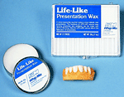
Tin 101558

Geo

Snowhite Transparent (499-0201) 104466
Snowhite Opaque (499-0101) 104464

Periphery Wax
Ideally suited for use with all types of impression materials. Formulated for making wax stops, post damming, and lining the periphery of trays.

Box 60 Sticks 104972

Sticky Wax
A hard, fast setting wax, welds waxes together, repairs wax patterns

Sticks Pkg. of 120 101275

Margin Wax
By Yeti

Cervical Red 103730

136
WAXES
___________________________________________________________

Renfert Red 104486

Stippled Wax
For cast partial; 15 sheets

Fine .4 ml. 137340
Medium .5 ml. 137393
.6 ml. 137349

Wax Clasps

*Please call for sizes and shapes.*

137
VACUUM MIXERS
___________________________________________________________

Twister 840697
By Renfert
The twister produces optimal mixing results with its vacuum pump (15L per minute) and motor speed of 150 – 400 RPM. Mixing time and RPM can be precisely adjusted even during mixing.

Twister Stand 840698
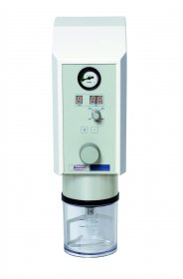

Smart Mix-(BOWLS ONLY)
*We no longer carry this item but we do have bowls available at a great price!
By Amann Girrbach

Bowl 500 ml. G29000
Bowl 750 ml. G30000
Bowl 1000 ml. G31000

138
INDEX
_ ______________________________________________________ __

A
 |  |  |  |  |  |  | Cement Spatula |  | 79
Accelerator | 21 | Blockout Compound |  | 124 |  |  | Cerafina Investment |  | 75
 |  | Blockout Material |  | 124 |  |  | Cerama Sep |  | 119
 |  | Blockout Wax |  | 134 |  |  | Ceramic Crucibles |  | 42
Acrydig 6 Curing Unit | 51 | Boley Gauge |  | 88 |  |  | Ceramicus Brushes |  | 30
Acrydig 12 Curing Unit | 51 | Borax Casting Flux |  | 22 |  |  | Cerebien |  | 116
 |  | Bowls (Mixing) |  | 78 |  |  | Chamois Buffs |  | 31
Adhesive Casting Wax | 133 | Boxes (Plastic) |  | 60 |  |  | Chucks |  | 102
Adhesion Primers | 16 | Boxing Wax |  | 135 |  |  | Clasp Polishers |  | 5
Adjustable Saw Blades | 59 | Braided Strengtheners |  | 108 |  |  | Clasp Wire |  | 108
Aesthetic Denture Base | 13 | Brass Dowel Pins |  | 54 |  |  | Coe Comfort |  | 17
 |  | Bristle Brush |  | 30
Akers Carver | 89 | Broken Arm Casting Tongs |  | 44 |  |  | Coe Flex Impression Material |  | 85
Alcohol Torch | 38 | Brushes |  | 29, 33 |  |  | Coe Soft |  | 17
Alginate-Mixer | 66 | Brush Kits |  | 32 |  |  | Coe Tray Cleaner |  | 48
Alloy | 22 | Brush Tips |  | 33 |  |  | Cold Cure Denture Base Resins |  | 11-19
Alumina Vest | 77 | Brushless Dust Collector |  | 69 |  |  | Cold Cure Monomers |  | 13
Aluminum Oxide | 8 | Buffing Compound |  | 114 |  |  | Coltene Universal Adhesive |  | 21
Aluminum Oxide Wheel | 5 | Buffs |  | 31 |  |  | Coltex |  | 85
Aluminum Tray Handles | 123 | Bunsen Burner 101 |  | 37 |  |  | Coltoflax |  | 87
Aquapress Pressure Pot | 51 | Bunsen Burner 2N |  | 38 |  |  | Combination Unit |  | 101
Arbor Band Chuck | 103 | Burnout Furnaces |  | 65 |  |  | Compress 61 B |  | 53
Arbor Band Chuck & Mandrels | 1 | Bur Rotating Holder |  | 40 |  |  | Compress (generic) |  | 53
Arbor Bands | 1 | Burs |  | 39
Aron Alpha Adhesive | 21 | C |  |  |  |  | Cotton Buffs with Plastic Centre |  | 31
ASA Articulator | 25 |  |  |  |  |  | Cotton Buffs |  | 31
Atlas Flasks | 53 | C Plast Candulor |  | 19 |  |  | Crown & Bridge Boxes |  | 60
 |  | Calipers & Gauges |  | 88 |  |  | Crown & Bridge Investments |  | 75
B |  | Caliper Dial type |  | 88 |  |  | Crown Fit Seating Indicator |  | 24
B |  |  |  |  |  |  | Crucibles |  | 44
Baldor Lathe | 102 | Carbide Burs |  | 39-41 |  |  | Cups |  | 94
Ball Clasps | 107 | Carbide Cutters |  | 41 |  |  | Curing Units |  | 50
Base Plate Wax | 133 | Carbide Drill |  | 54 |  |  | Cut Off Disks |  | 1
Base Plates | 50 | Carbon Crucibles |  | 42 |  |  | Cutter Disks |  | 1
Base Stones | 70 | Carbon Washers |  | 43 |  |  | CZR |  | 116
Bellavest SH | 75 | Carborundum Discs |  | 106 |  |  | D
 |  | Cartridge Gun |  | 86
Bi-pins | 54 | Carvers |  | 89 |  |  | Deluxe Magnetic Articulator |  | 27
Bi-v-pins | 54 | Carving Instruments |  | 88
 |  | Cast Partial Investments |  | 77 |  |  | Dentsply Plastic Sprues |  | 100
Biomers | 96 | Casting Flux |  | 22 |  |  | Denture Base & Repair Acrylics |  | 13
Biosonic Cleaner | 99 | Casting Machine |  | 42 |  |  | Denture Base Resins |  | 13
Biosurf | 97 | Casting Rings & Formers |  | 43 |  |  | Heat Cure |  | 10
Biotext | 97 | Casting Tongs |  | 44 |  |  | Self Cure |  | 12
Bite Blocks | 134 | Casting Wax |  | 135
Bite Registrations | 85 | Casting Well |  | 42 |  |  | Denture Brushes |  | 61
BK Stain Palette | 34 | Castogel |  | 110 |  |  | Denture Cleaner (Kleenite) |  | 98
Blades & Handles | 88 | CaviCide Disinfectant |  | 96 |  |  | Denture Cups |  | 61
Bleaching Laminates | 125 | CaviWipes |  | 96 |  |  | Denture Flasks |  | 53
 |  |  |  |  |  |  | Dial Gauge |  | 88
INDEX
_ ________________________________________________________
 |  |  | F |  |  |  |  | Handpiece Accessories | 80
 |  |  | Fabulustre |  |  | 113 |  | Handler 550 Portavac | 63
Diamond D | 10 |  | Face Masks |  |  | 95 |  | Hard Liners | 14
Die Hardeners | 56 |  | Fastfire 15 |  |  | 75 |  | Hard Reline | 14
Die Keen | 70 |  | Felt Cones |  |  | 2 |  | Hardeners | 56
Die Sealer | 56 |  | Felt Wheels |  |  | 2
Die Spacers | 57 |  | Filter Bags |  |  | 68 |  | Heat Cure Acrylics | 10
Die Stones | 70 |  | Firing Pegs |  |  | 66 |  | Heatless Wheels | 2
Dipping Wax | 134 |  | Firing Trays |  |  | 65 |  | Heavy Duty Table Top Vibrator | 128
Direct Sprues | 100 |  | Flasks (Duplicating) |  |  | 53 |  | Hepa Dust Collector | 69
Discs | 106 |  | Flasks (Generic) |  |  | 53 |  | HeraCeram | 117
Discs (Flexible) | 106 |  | Flasks (Microwave) |  |  | 53 |  | HeraCeram Press | 117
Disinfectants | 96 |  | Flexacryl Hard Liners |  |  | 14 |  | HeraCeram Zirconia | 117
Disposable Articulators | 26 |  | Flexacryl Soft Liners |  |  | 17 |  | Hi Impact Acrylic | 10
 |  |  | Flexible Peel Off Discs |  |  | 106 |  | Hi Impact Monomer | 10
Dowel Pins | 54 |  | Foam Inserts |  |  | 60 |  | Hi Heat Investment | 76
Dry Tips | 82 |  | Formers (Mold) |  |  | 26 |  | Horseshoe Sprues | 100
Dual Pins & Sleeves | 54 |  |  |  |  |  |  | Hot Stop | 112
Duplicating Flasks | 111 |  | Foster EE8 Articulator |  |  | 25 |  | Hotty LED | 130
Duplicating Machine | 111 |  | Frames (Saw) |  |  | 59 |  | Hydent Indicating Paste | 24
Dura Thin Discs | 7 |  | Fujirock |  |  | 72 |  | Hydraulic Press | 53
Dura-Green Points | 4 |  | Furnace Tongs |  |  | 44
Duralay Pattern Resin | 13 |  | Furnaces |  |  | 65 |  | I
Dust Collectors | 67 |  | G |  |  |  |  | I
 |  |  | Galetti Articulator |  |  | 26 |  | Immediate Soft Liner | 17
E |  |  | G. Cera Vest |  |  | 120 |  | Impression Materials & Accessories | 85
 |  |  |  |  |  |  |  | Indicating Pastes & Sprays | 24
Earloop Masks | 95 |  | GC Adhesive |  |  | 21 |  | Indirect Sprues | 100
Econo Cutter Discs | 1 |  | Geo Wax |  |  | 136 |  | Indurent Gel | 87
 |  |  | GI Mask |  |  | 119 |  | Infinity L30 | 65
Edentulous Trays | 82 |  | Gingifast |  |  | 119 |  | Infinity M30 | 65
Electro Polish Solution | 45 |  | Giroform Pin Drill System parts |  |  | 55 |  | Inlay Wax | 135
Elite Duplicating Material | 110 |  | Glass Beads |  |  | 9 |  | Intra Oral Tips | 86
ERA Attachments | 83 |  | Gloves |  |  | 93 |  | Investing Equipment | 101
 |  |  | Gold Clasp Wire |  |  | 108 |  | Investment Materials | 75
Etching Gel | 45 |  | Goldie Burs |  |  | 40 |  | ISO-K | 47
EuroCuring Light | 18 |  | Green Rouge  Grinding Wheels |  |  | 114  1 |  | Ivocap Capsules | 10, 49
EX-3 | 116 |  | Gritman Knives |  |  | 78 |  | Ivocap System | 49
Expansion Screws | 28 |  | Gyp-Strip |  |  | 78 |  | Ivoclar Teeth | 121
EZ-Master Porcelain Mixing Plate | 36 |  | Gypsum Hardener  Gypsum Products & Accessories |  |  | 78  78 |  | Ivolen Tray Material | 18
EZ-Single Porcelain Mixing Plates | 36 |  | H
EZ Clean | 98
 |  |  | Haemostats |  |  | 90
 |  |  | Handles (Bard Parker) |  |  | 88
J |  |  | M
J Clasps | 107 |  | Madame Butterfly Silk Tape |  | 23 |  |  | NM Slims | 7
Jacketgrip | 90 |  | Magnetic Mounting Plates |  |  | 25 |  | Noritake Flux | 22
Jacobs Chuck | 102 |  | Magic Former |  |  | 116
Jeltrate | 83 |  | Magic Separator |  |  | 116
Jet Stream JS 1200 | 69 |  | Mandrels |  |  | 1
Justi Wax Solvent | 47 |  | Margidur |  |  | 56 |  | Norivest | 120
K |  |  | Margin Liner  Margin Wax |  |  | 57  136
Kerr Casting Machine | 42 |  | Marathon Handpiece |  |  | 80 |  | Nupro Tooth Whitening | 125
Keramogrip | 90 |  | Mark II Pindex Machine |  |  | 55
Keyway Attachments Plastic | 28 |  | Masks |  |  | 95
Keyway Attachments Plastic |  |  | Meister Cones |  |  | 39 |  | O
Kraft Wrapping Paper | 62 |  | Meister Points |  |  | 39 |  | Occlufast | 85
 |  |  | Melody Stain Mix Palette |  |  | 34 |  | One Station Dust Collectors  Opaque Painting Stick B-120 | 67  95
 |  |  | Metal Calipers |  |  | 88 |  | Ortho Acrylic | 13
Kleenite Denture Cleaner | 98 |  | Metal Etch Gel |  |  | 45
Knife Edge Wheels | 5 |  | Metrowax  Micro Bunsen Burner |  |  | 133  37 |  | Ortho Stone | 72
Knives | 78 |  | Microscopes |  |  | 63 |  | Ortho Soldering Flux | 22
Kolinsky Brushes | 30 |  | Micro Torch |  |  | 38 |  | Orthodontic Model Trimmer | 104
Kooliner | 14 |  | Microwave Flask |  |  | 53 |  | Orthosit Teeth  Orthotyp Teeth | 121  121
 |  |  | Mixing Bowls |  |  | 78 |  | Oval Casting Rings | 43
L |  |  | Mixing Palettes  Mixing Spatulas  Mixing Tips |  |  | 34  79  86 |  | P
Lab Putty | 87 |  |  |  |  |  |  | Palabond | 16
 |  |  | Model Glo |  |  | 73 |  | Palapress | 12
Laboratory Time Stickers  Laboratory Work Cards | 62  62 |  | Mould Formers  Molloplast B |  |  | 26 |  | Pattern Resin | 13
Labormat SD  Labormat TH | 52  52 |  | Monomers  Mosher Polishing Compound |  |  | 10  113 |  | Periphery Wax | 136
 |  |  | Mounted Points |  |  | 4 |  | Permabond | 21
 |  |  | Mounted Stones |  |  | 3 |  | Permanent Hard Liners | 14
Lang Orthojet | 13 |  | Mounting Plates |  |  | 26 |  | Permanent Soft Liners | 14
Latex Tubing | 38 |  | Mounting Stones |  |  | 72 |  | Permasoft | 14
Lathe Brushes | 29 |  | Mouthguarde Material |  |  | 124 |  | Pickle It Solution | 45
Lathes | 102 |  | MT Plus |  |  | 105 |  | Picosep | 58
Lathes |  |  | Muffles |  |  | 43 |  | Pindex Machine | 55
Life Like Wax | 136 |  | Muslin Buffs |  |  | 31 |  | Pindex Parts and Accessories | 55
Light Cure Ovens | 18 |  |  |  |  |  |  | Pindex Pins | 54
Light Curing Tray Material | 20 |  | N |  |  |  |  | Pinned Saw Blades | 59
Lingual Bars | 109 |  | Nature-Cryl Hi 20ET |  |  | 11 |  | Pinned Saw Frames | 59
Liquifoil | 47 |  | Nature-Cryl MC |  |  | 11 |  | Pins | 54
Long & Short Pindex Pins | 54 |  | Nature-Cryl Pour |  |  | 11
Lucisoft | 14 |  | Neocolloid Alginate |  |  | 83 |  | Plaster Bin | 63
Lucitone 199 | 10 |  | Neoloid Duplicating Material |  |  | 110 |  | Plaster Knives | 78
Lustrol | 16 |  | Neo Super Cascom |  |  | 42 |  | Plaster Nippers
 |  |  | Niraloid |  |  | 110 |  | Plaster Traps | 64
 |  |  | Q |  |  |  |  | Separating Fluid | 47
Plastic Zip Lock Bags | 62 |  | Quick Check |  |  | 24 |  | Silicone Rubber Wheels & Points | 6
 |  |  | R |  |  |  |  | Silicone Spray | 47
Platinum Foil | 22 |  | R- Mixing Plate |  |  | 36 |  | Silk Tape | 23
Pliers | 109 |  | Rapid Wax |  |  | 134 |  | Smart Box | 66
Points ( Mounted) | 4 |  | Rainbow Mixing Palette |  |  | 35 |  | Smart Mix | 138
Points (Rubber) | 5 |  | Ray Foster EE8 Articulator |  |  | 25 |  | Smart Wax Duo | 131
Polishing Brushes | 29 |  | Red Flash Discs |  |  | 7 |  | Smoothex | 46
Polishing Paste | 113 |  | Red Refines Wax |  |  | 133 |  | Snow White 067 | 72
Polyflex | 110 |  | Red Rouge |  |  | 114 |  | SoftLiner “MS” | 15
Pontic Blocks |  |  | Red Wing Lathe |  |  | 102 |  | SoftLiner “S” | 15
Porcelain & Accessories | 119 |  | Refractory Material |  |  | 120 |  | SoftLiner “Tough” | 15
Porcelain Build Up Full Kits | 32 |  | Reline Jig |  |  | 53 |  | Soft Pillows | 65
Porcelain Brushes | 30 |  | Reline Materials |  |  | 14 |  | Soldering Flux | 22
Porcelain Carving Instruments | 89 |  | Rema- Exact |  |  | 77 |  | Soldering Investment | 76
Porcelain Etch It Kits | 45 |  | Remadur |  |  | 77 |  | Solders | 22
Porcelain Furnaces | 65 |  | Renfert Aluminum Oxide |  |  | 8 |  | Sonic Denture Cleaner | 98
Porcelain Mixing Palettes | 36 |  | Renfert Basic Classic Sandblaster |  |  | 8 |  | Spatulas | 79
Porcelain Mixing Stick B-110 | 92 |  | Renfert Margin Wax |  |  | 137 |  | Spindles (for Lathe) | 103
Porcelain Power Scoop B-510 | 92 |  | Renfert Mobiliscopes |  |  | 63 |  | Spiral Saw Blades | 59
Porcelain Blade Holder B-140 | 92 |  | Renfert Variabasic S.B |  |  | 8 |  | Splash Hoods | 63
Porcelain Blade Holder B-150 | 92 |  | Renfert Variojet S.B |  |  | 8 |  | Splint Materials | 125
Porcelain Carving Instrument | 92 |  | Resilience |  |  | 74 |  | Sprue Wax | 100
Power Pillo | 132 |  | Resin Rock |  |  | 72 |  | Sprues | 100
Preformed Clasps | 107 |  | Respirator Masks |  |  | 75 |  | Square Edge Wheels | 5
 |  |  | Retainer Cups |  |  | 61 |  | Staining Palette | 34
Pressure Indicating Paste & Spray | 24 |  | Reverse Dowel Pins |  |  | 54 |  | Sta-Kieen Sheild | 63
Pressure Pot | 51 |  | Ring Liners |  |  | 44 |  | Steam Cleaners | 64
Presidents Putty | 87 |  | Ringless Rings |  |  | 43 |  | Steel Burs | 41
 |  |  | Rotating Bur Holder |  |  | 40 |  | Stereo Microscope | 63
Primo | 16 |  | Rubber Base Impression Material |  |  | 85 |  | Stern Attachments | 28
Probase Cold | 12 |  | Rubber Points |  |  | 5 |  | Sticky Wax | 136
Probase Hot | 10 |  | Rubber Wheels |  |  | 5 |  | Stippled Wax | 137
Pro-Cure 300 | 18 |  | S |  |  |  |  | Stone Chuck | 103
 |  |  | Safety Burner |  |  | 37 |  | Stone Die & Plaster Hardener | 56
 |  |  | Saf-T-Tweezers |  |  | 91 |  | Stones (Mounted) | 3
Proforms | 126 |  | Saw Blades |  |  | 59 |  | Success Injection System | 49
Proforms Colors | 127 |  | Saw Frames |  |  | 59 |  | Super Cal Plus | 71
Proform Dual Laminates | 124 |  | Scotchbrite Wheels |  |  |  |  | Super Porcelain EX-3 | 115
Proform E-Gaskets | 124 |  | Scrapers |  |  | 91 |  | Super Rock | 71
Proform Machine | 123 |  | Screwhead Mandrel |  |  |  |  | Super Sep | 47
Proform Niteguards | 125 |  | Sculpturing Wax |  |  | 135 |  | Super Stripper | 45
Pumice | 74 |  | Sealers & Spacers |  |  | 57
 | 65 |  |  |  |  |  |  | Surfactant | 46
 |  |  | Separating Discs |  |  | 7 |  | Surgical Trays | 125
 |  |  | Separating Sheets |  |  | 16 |  | Surgident Articulating Paper | 23
 |  |  |  |  |  |  |  | Surveyor Milling Machine | 81
T |  |  | U
Tackyfier Pattern Adhesive | 112 |  | UC 100 |  |  | 99 |  | Wheels-Grinding | 1
Takanishi Porcelain Brushes | 30 |  | UC 300 |  |  | 99 |  | Wheels-Heatless | 2
Tak Die Hardener | 57 |  | Ultra Matic Waxer |  |  | 127 |  | Wheels-Rubber | 5
Take 1 Advanced | 86 |  | Ultrasonic Cleaners |  |  | 98 |  | Wire (Clasps) | 108
Tapered Buff Chuck | 103 |  | Ultrasonic Unit |  |  | 98 |  | Wire Bending Pliers | 109
Tapered Mandrel | 1 |  | Ultra Thin Discs |  |  | 7 |  | Wire Wax | 100
Tapered Spindles (for Lathe) | 103 |  | Ultra Tray |  |  | 20 |  | Wironit X-Hard | 22
Teeth | 121  122 |  | Ultravest |  |  | 76 |  | Wirovest | 77
Tempo | 17 |  | Ultra Waxer |  |  | 129 |  | Wonderfill | 87
Temporary Soft Liners & Tissue Conditioners | 17 |  | Undercut Wax |  |  | 134 |  | Wonderpeg | 66
Thermocouples | 43 |  | Universal Polishing Paste |  |  | 113 |  | Work Cards | 62
The Machine III | 123 |  | Utility Wax |  |  | 135 |  | Work Pans | 60
Three Prong Clasp Pliers | 3 |  | V |  |  |  |  | Wrapping Paper | 62
Time Stickers | 62 |  | Vacuum Forming Machines & Accessories |  |  | 67 |  | X-Y-Z
Tips | 131 |  | Vacuum Mixer |  |  | 138
Titanium Putty | 87 |  | Vanguard 1x |  |  | 67 |  | Z-Base Accelerator | 21-58
Ti-22 | 116 |  | Vanguard Gold 2X |  |  | 67 |  | Z-Base Base | 21
Tooth Acrylics | 18 |  | Vanguard Platinum 2X |  |  | 67 |  | Zest Anchor Attachments | 28
Tooth Grinding Wheel | 1 |  | Vaniman Sandstorm Expert |  |  | 8 |  | Zetalabor Shore Hardness | 87
Tooth Whitening Kits | 125 |  | Vario E Waxer |  |  | 129 |  | Zip Lock Bags | 62
Top Spin | 55 |  | Veri Thin Discs |  |  | 7 |  | Zirconia Discs | 116
Touch-O Matic(Bunsen Burner) | 37 |  | Vertex “type” Articulators |  |  | 25
Tokuyama Rebase II | 14 |  | Vertex “type” Mold Formers |  |  | 26
Tray Adhesives | 21
Tray Cleaners | 48 |  | Virtual Polysiloxane Imp Material |  |  | 85
Tray Covers | 94
Tray Material | 18 |  | Vita Pan Teeth |  |  | 122
Tripoli | 113 |  | VK Ultrasonic Cleaners |  |  | 98
Tropical Mixing Palette | 35 |  | W
Tropicana Mixing Palette | 35 |  | Walnut Shells |  |  | 9
Tropicanina Mixing Palette | 35 |  | Wax Lectric II |  |  | 131
Tropicolino | 35 |  | Wax Pattern Clearner |  |  | 46
Tropicalgin | 83 |  | Wax Pot |  |  | 130
Tru-Fit | 57 |  | Wax Profi |  |  | 130
Tru-Soft | 17 |  | Wax Solvent |  |  | 47
Tube Attachments (castable) | 28 |  | Wax Spatulas |  |  | 90
Tweezers | 44, 91 |  | Wax Sprues |  |  | 100
Twister Vacuum Mixer | 138 |  | Wax Units |  |  | 127
Twister Braided Strengthener | 108 |  | Wells Adaptor |  |  | 102
Twister Stand | 138 |  | Wells Quick Chuck |  |  | 102
Two Station Dust Collectors | 68 |  | Westan Margin Wax |  |  | 137
 |  |  | Westan Brand Accelerator |  |  | 57
 |  |  | Wheels-Scotchbrite |  |  | 1

