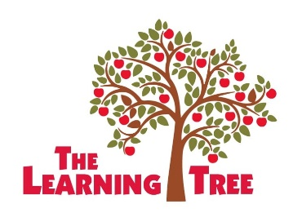

PARENT/GUARDIAN PERMISSION AND RELEASE OF LIABILITY
FOR FIELD TRIP AND COMMUNITY BASED INSTRUCTION PARTICIPATION

I, _______________________________, am the parent/guardian of _______________________________, enrolled child at The Learning Tree located at 17873 Sierra Hwy, Santa Clarita, California 91351, (661) 252-6385.

My permission is indicated below, as represented by my initials, for my child to participate in the field trip/community-based instruction events and activities as outlined on the posted/provided The Learning Tree Summer Program Calendar:

__________ I give my permission for my child

__________ I do not give permission for child

I understand that although the children will be supervised by The Learning Tree staff, I do assume the risk in my child’s participation in the field trip/community-based instruction activities/events. If I choose not to permit my child to participate in this field trip activity, the child will be allowed to remain at the facility on the day of the field trip and will be provided with meaningful alternative activities under the supervision of a staff member.

I acknowledge that I will not seek to have The Learning Tree held liable in the event that any accident, injury, loss of property or any other circumstance or incident occurs during or as a result of my child’s participation in the field trip. This release of liability includes accident, injury, loss, or damages to the student, as well as, to other individuals or property which may result from the child’s participation in the activities/events. I hereby release and agree to hold harmless The Learning Tree, its officials, agents and employees, from any claims arising out of my son’s/daughter’s participation in the activities/events.

I have read and understand and accept all of the statements recited above and accept full responsibility as described.

Parent’s/Guardian’s Signature | Date
Parent’s/Guardian’s Signature | Date

The Learning Tree 17873 Sierra Hwy, Santa Clarita, California 91351 (661) 252-6385

