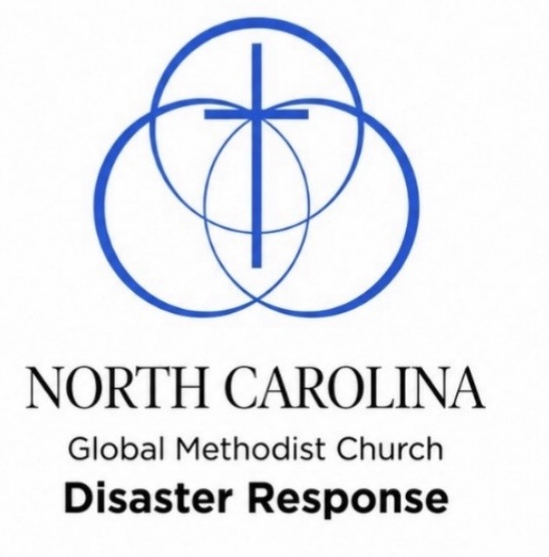
NC GMC DRT PURPOSE

Go where and when God leads, offering a caring Christian presence as His hands and feet – sharing the love of Jesus, especially with those in need. Isaiah 6:8 “Whom Shall I Send?” In all that we do. We exist to bring glory to God – acknowledging that all things are from Him, through Him, and for Him. With every action, word, and purpose,
we seek to honor Christ, that He may be glorified above all.
Romans 11:36

NC GMC DRT GOAL

To make dwellings and properties safe, sanitary and secure while providing a caring Christian ministry of “Listeners” and support.

Our purpose is to be a denomination-wide trained and credentialed group of individuals that responds to the affected communities, being the hands and feet of Jesus Christ, aiding this community with support.

What is a Disaster Response Team

Disaster Response Team is a group of eight or more trained individuals with a common goal to help survivors of a Disaster. It does not matter what stage the Disaster event is in; they are there to show the survivors of this event there is still hope in this world they live in. Anyone over the age of 18 years would be needed from Chainsawing trees to keeping tool trailer in order to cooking meals and making sure workers take breaks to just sitting with the survivors and listening to their story.

NC DRT TRAINING SESSION
18 years old and older

Saturday,
October 24, 2026
9:00 – 4:00

Lake Waccamaw Methodist Church
506 Lakeshore Drive
Lake Waccamaw, NC 28450

COST: $35
This fee covers the cost of your Training Manual, an official
Badge and a T-Shirt to wear when serving on a DRT Mission Trip
(If you don’t plan to go out on DRT Missions, but want to
know how to support DRT Missions from home, you
are welcome to attend this training for free)

REGISTER BY October 21, 2026
Please make sure you mark which session.


or send an email to DRTNCtrainingreg@gmail.com
include name, address, phone number, email and T Shirt size.
You can pay by cash or check at the session.

NOTE: participating in a DRT mission requires a one-time
background check to be performed and paid for by the NC GMC

Please invite anyone that would like to be involved with going out and helping to bring help as well as hope after their lives had been turned upside down by a natural disaster.

