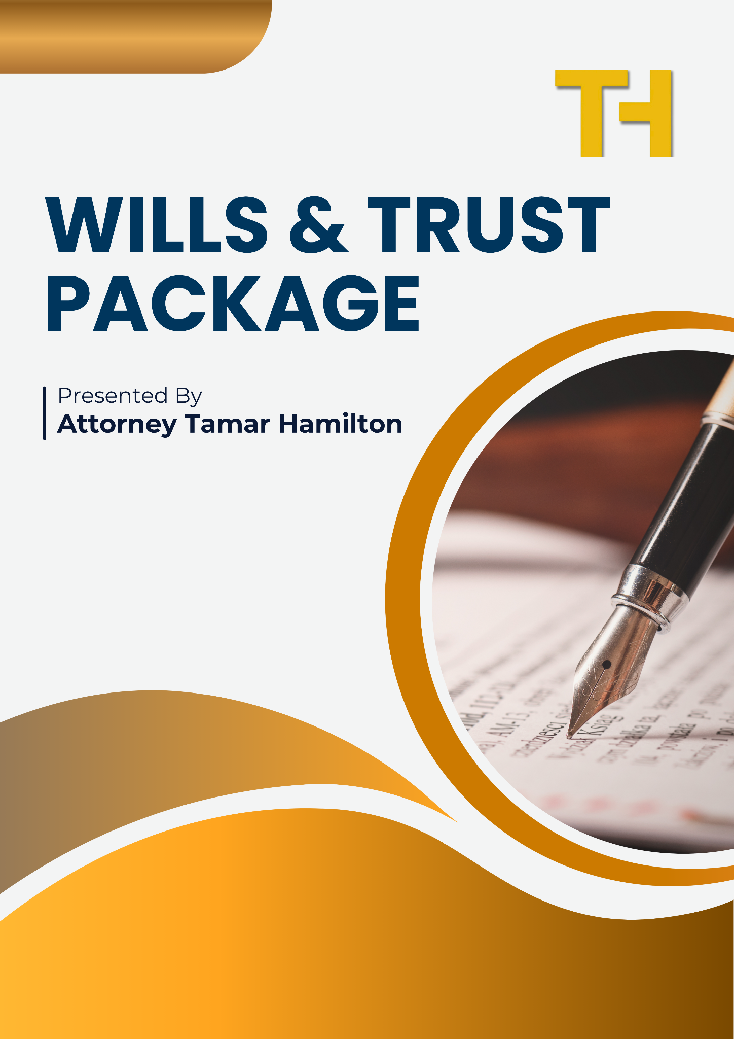
WILLS & TRUST PACKAGE

T A M A R N. H A M I L T O N, P. A .
A T T O R N E Y A T L A W

NOTE
HUSBAND/MALE/SINGLE MALE

WIFE/FEMALE/SINGLE FEMALE
AS APPLICABLE

NOTE: Return this form when completed to tamar@tamarhamiltonlaw.com

Male/Husband’s Name:_________________________________________________________________
Female/Wife’s Name:__________________________________________________________________
Homestead Property:___________________________________________________________________
Additional Real Property:________________________________________________________________

Joint Children:
_____________________________________________________________________________________
_____________________________________________________________________________________
_____________________________________________________________________________________
_____________________________________________________________________________________
_____________________________________________________________________________________
Husband’s Children (if separate):
_____________________________________________________________________________________
_____________________________________________________________________________________
_____________________________________________________________________________________
_____________________________________________________________________________________
_____________________________________________________________________________________

Wife’s Children (if separate):
_____________________________________________________________________________________
_____________________________________________________________________________________
_____________________________________________________________________________________
_____________________________________________________________________________________
_____________________________________________________________________________________

Personal Representative for Husband: (Who would you like to handle your estate administration after your passing? They must be either related to you (this includes a spouse) OR a resident of Florida. It cannot be a non-relative who resides outside of Florida)
First Choice: __________________________________________________________________________
Alternate: ____________________________________________________________________________
Second Alternate: ______________________________________________________________________

Personal Representative for Wife: (Who would you like to handle your estate administration after your passing? They must be either related to you (this includes a spouse) OR a resident of Florida. It cannot be a non-relative who resides outside of Florida)
First Choice: __________________________________________________________________________
Alternate: ____________________________________________________________________________
Second Alternate: ______________________________________________________________________

Attorney-in-Fact for Husband: (Who would you like to handle your financial affairs in the event you are incapacitated, but prior to your passing? This person is not responsible for health care decisions. Financial affairs only. No restrictions on who you can choose.
First Choice: __________________________________________________________________________
Alternate: ____________________________________________________________________________
Second Alternate: ______________________________________________________________________

Attorney-in-Fact for Wife: (Who would you like to handle your financial affairs in the event you are incapacitated, but prior to your passing? This person is not responsible for health care decisions. Financial affairs only. No restrictions on who you can choose.
First Choice: __________________________________________________________________________
Alternate: ____________________________________________________________________________
Second Alternate: ______________________________________________________________________

Health Care Agent for Husband: Must include name, address and phone number (Who would you like to make your medical decisions in the event you are incapacitated and cannot make your own decisions. You should not choose for multiple people to serve together, only one at a time.)
First Choice: __________________________________________________________________________
Address: _____________________________________________________________________________
Phone Number:________________________________________________________________________
Alternate: ____________________________________________________________________________
Address: _____________________________________________________________________________
Phone Number:________________________________________________________________________
Second Alternate: ______________________________________________________________________
Address: _____________________________________________________________________________
Phone Number:________________________________________________________________________

Health Care Agent for Wife: Must include name, address and phone number (Who would you like to make your medical decisions in the event you are incapacitated and cannot make your own decisions. You should not choose for multiple people to serve together, only one at a time.)
First Choice: __________________________________________________________________________
Address: _____________________________________________________________________________
Phone Number:________________________________________________________________________
Alternate: ____________________________________________________________________________
Address: _____________________________________________________________________________
Phone Number:________________________________________________________________________
Second Alternate: ______________________________________________________________________
Address: _____________________________________________________________________________
Phone Number:________________________________________________________________________

Guardian for Minor Children:
First Choice: __________________________________________________________________________
Alternate: ____________________________________________________________________________
Second Alternate: ______________________________________________________________________

Disposition of Assets for Husband:
Specific Distributions: (Specific amounts or assets to go to a specific beneficiary “off the top”; i.e. Boat to John Smith; $25,000 to Jane Doe.)
_____________________________________________________________________________________
_____________________________________________________________________________________
_____________________________________________________________________________________
_____________________________________________________________________________________
_____________________________________________________________________________________

Residuary Estate: (Distribution of everything else in your estate):
☐ Standard – Everything to spouse. If spouse is predeceased or dies in a common accident, then equally to all children.
☐ Other: (Please provide specific instructions on how you want your assets divided upon your passing. Minimum distribution to spouse is 30% per Florida Statute. You cannot provide for less than 30% to your spouse unless you have an executed Prenuptial or Post-Nuptial Agreement. You always provide for more than 30%):
_____________________________________________________________________________________
_____________________________________________________________________________________
_____________________________________________________________________________________
_____________________________________________________________________________________
_____________________________________________________________________________________

Specific Distributions: (Specific amounts or assets to go to a specific beneficiary “off the top”)
_____________________________________________________________________________________
_____________________________________________________________________________________
_____________________________________________________________________________________
_____________________________________________________________________________________
_____________________________________________________________________________________

Assets to be distributed:
☐ Outright (this is distributed directly to the beneficiary. Inherited assets are considered non-marital assets in the event of a divorce but beneficiary has to be extremely careful not to comingle the assets. If the assets are comingled with marital assets, all of the inherited assets become marital assets in the event of a divorce. Assets distributed outright are not creditor protected.)
☐ In trust until age 25 (Assets left in trust can be managed by the beneficiary themselves or by a third party trustee until a certain age chosen by you or indefinitely. Assets left in trust are creditor and divorce protected so long as they remain in trust.)
☐ In trust until age ____
☐ Other: _____________________________________________________________________________
_____________________________________________________________________________________

Disposition of Assets for Wife:
Specific Distributions: (Specific amounts or assets to go to a specific beneficiary “off the top”; i.e. Boat to John Smith; $25,000 to Jane Doe.)
_____________________________________________________________________________________
_____________________________________________________________________________________
_____________________________________________________________________________________
_____________________________________________________________________________________
Residuary Estate: (Distribution of everything else in your estate):
☐ Standard – Everything to spouse. If spouse is predeceased or dies in a common accident, then equally to all children.
☐ Other: (Please provide specific instructions on how you want your assets divided upon your passing. Minimum distribution to spouse is 30% per Florida Statute. You cannot provide for less than 30% to your spouse unless you have an executed Prenuptial or Post-Nuptial Agreement. You always provide for more than 30%):
_____________________________________________________________________________________
_____________________________________________________________________________________
_____________________________________________________________________________________
_____________________________________________________________________________________
_____________________________________________________________________________________

Specific Distributions: (Specific amounts or assets to go to a specific beneficiary “off the top”)
_____________________________________________________________________________________
_____________________________________________________________________________________
_____________________________________________________________________________________
_____________________________________________________________________________________
_____________________________________________________________________________________

Assets to be distributed:
☐ Outright (this is distributed directly to the beneficiary. Inherited assets are considered non-marital assets in the event of a divorce but beneficiary has to be extremely careful not to comingle the assets. If the assets are comingled with marital assets, all of the inherited assets become marital assets in the event of a divorce. Assets distributed outright are not creditor protected.)
☐ In trust until age 25 (Assets left in trust can be managed by the beneficiary themselves or by a third party trustee until a certain age chosen by you or indefinitely. Assets left in trust are creditor and divorce protected so long as they remain in trust.)
☐ In trust until age ____
☐ Other: _____________________________________________________________________________
_____________________________________________________________________________________

