**T**

**Tiny Houses, ADUs, and**

**Other Pint-Size Living Spaces**

**by**

**Deborah Long ©**

**By Deborah Long ©**

**INTRODUCTION TO TINY HOUSES**

Tiny homes have been around since before the days of the early pioneers. These homes emerged from the huts, tents, igloos, wigwams, and grass huts during the early settlers days. The Sioux, Inuits and Samoans were considered the earliest originators of tiny homes.

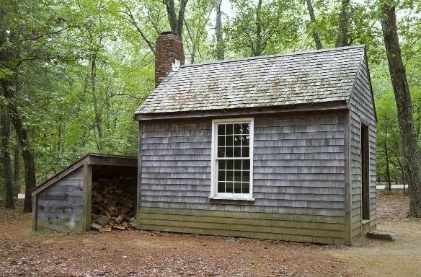The 1854 publication of Henry David Thoreau's book *Walden* highlighted his experience living in a small cabin near Walden Pond. This book and his 150-square foot cottage inspired many people to embrace simpler living and sparked interest in minimalist lifestyles. Thoreau wrote, “A man is rich in proportion to the number of things which he can afford to let alone.” In other words, it’s not about how much you own, but about how content you can be with as little as possible.

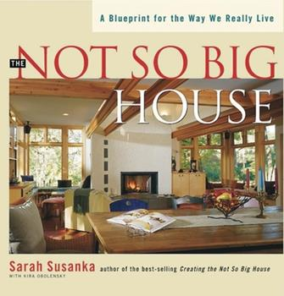In the 1970s, the term "small house movement" began to gain popularity, driven in part by environmental concerns and a desire for more sustainable living. English architect Sarah Susanka's *The Not So Big House: A Blueprint for the Way We Live*.[1] Published in 1998, Susanka further popularized the idea of living in smaller, well-designed spaces that meet individual needs. That year, according to the United States Census Bureau, the average square footage of a home had eclipsed 2,150 square feet for the first time since home sizes were tracked in 1973. Susanka’s book became an influential voice in the conversation about better spaces over bigger spaces, using various architectural principles to make smaller spaces feel bigger.

Two years after Susanka published *The Not So Big House*, University of Iowa professor Jay Shafer became part of the tiny house movement lore when his tiny house became the focus of a front-page feature in the *Des Moines Register*. Titled “Home Sweet Hut,” Shafer gave readers a peek into a life that many of them had probably never even thought of, let alone heard of the tiny house lifestyle. His designs and advocacy for living in tiny houses garnered significant attention and helped popularize the concept. Shafer's work contributed to the growing interest in smaller dwellings and laid the foundation for the modern tiny house movement.

In May 2006, Gregory Johnson was interviewed by National Public Radio around three years after he had moved into his tiny home. Influenced by Susanka, Johnson’s interview got national attention, within days of the segment airing, a publisher called him to work out a book deal. In 2008, his book, *Put Your Life on a Diet: Lessons Learned From Living in Less Than 140 Square Feet*, hit the shelves.[2]

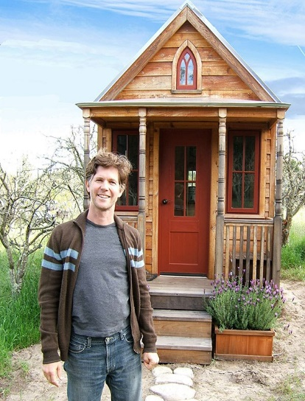The tiny house movement received its biggest break nine months later in 2007 when Oprah decided to highlight Shaefer’s 96-square-foot tiny home. “Jay Shafer’s itty-bitty home is an astounding 96-square-feet,” Oprah narrates in the first few seconds of the segment. “Jay’s commute from home to the office is just inches away.”

Jay Shafer

In the video, Shafer gives the cameras a tour of his home that looks like it could’ve been a part of any one of the wildly popular tiny home shows streaming today. “Aside from not needing anything more than this, I really like the idea of putting what I do have into quality over quantity, ” he said in the video. “Living small is really a luxury, in the sense that I have a lot of time now that I didn’t have before. I can focus now on the other things I want to do in my life, rather than just paying the mortgage and taking care of the house.”[3]

The 2008 financial crisis and the subsequent recession sparked renewed interest in tiny houses as an affordable housing solution. The economic downturn, combined with the desire for financial freedom and a simpler lifestyle, led to increased media coverage and public awareness of tiny houses. In the years following the recession, the tiny house movement gained serious momentum. Even entire towns were ready to invest in tiny homes. Spur, Texas, a small enclave amid rolling prairies, officially declared itself a tiny-house town in 2014, welcoming tiny-home owners and relaxing the typical size and space restrictions on tiny homes.

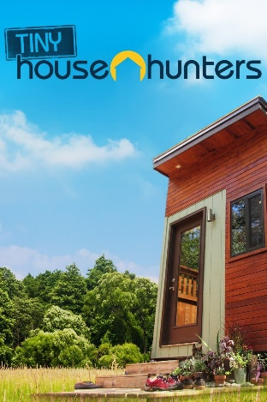The mid-2000s also saw the emergence of television shows like "Tiny House Nation" and "Tiny House Hunters," which highlighted the process of building and living in tiny houses. These shows and the rise of online platforms and social media allowed the tiny house movement to reach a broader audience and generated significant interest and enthusiasm.

Since then, the tiny house movement has continued to grow and evolve, with more individuals embracing the idea of downsizing, sustainable living, and the freedom that comes with living in a smaller space. Today, tiny houses are seen as an alternative housing option and a lifestyle choice for people seeking simplicity, financial freedom, and a smaller ecological footprint.

**Definition and characteristics of tiny houses**

A tiny house is a small and compact dwelling that is typically much smaller than a traditional house. While there is no strict definition of its size, a tiny house is generally considered to be between 100 and 400 square feet (9 to 37 square meters). As a comparison, most American two-car garages are 400 square feet.

Tiny houses are designed to maximize space efficiency and minimize environmental impact. Often built on wheels, tiny houses can be easily transported and provide flexibility in terms of where they can be located. However, some tiny houses are built on a foundation like a traditional house. They can be designed and customized to include all the essential amenities found in a conventional home, such as a living area, kitchen, bathroom, and sleeping quarters. However, due to the limited space, the design and layout need to be cleverly optimized to make the most of every inch.

A tiny house is about the size of the garage pictured here--400 square feet.

____________________________________________________________________________________

**How Much Room Do You Need?[4]**

Use these measurements are a guide.

100 sq ft: It’s the size of a medium-sized bedroom, not including the space inside the closet. If you are renting a 10x10 (100 square feet) bedroom, you will have plenty of space for a bed, side table and dresser… but not much else. Most second bedrooms are between 100 feet and 144 feet (12x12).

200 sq ft: The primary bedroom in the house might be around this size. Another way to look at it is the size of a one car garage. It’s about a 14x14 square foot bedroom.

300 sq ft: A small studio apartment. You might have to sacrifice the couch for a chair, but you will have room for a closet, kitchen, and bathroom. Depending on how it’s laid out you might find it to have all the amenities of a normal apartment.

400 sq ft: A two-car garage is about 400 square feet. Many people are converting garages into granny flats complete with kitchens and bathrooms.

500 sq ft.: This is a generously sized studio.

700 sq ft: Many one-bedroom condominiums or apartments are about 700 square feet.

900 sq ft: You can find many 900 square feet-sized two-bedroom, two-bath, apartments.

1100 sq ft: A large two-bedroom apartment or a small three-bedroom house. Many homes in San Diego are around this size. If it’s three bedrooms it might be tight, or you might not have a dining room.

1400 sq ft: This size home might have a formal dining room or a fourth bedroom. This does not include the garage, which is excluded when calculating the square feet of a home.

_____________________________________________________________________________________________

**Benefits and challenges of tiny house living**

Tiny houses have gained popularity for various reasons. Some people choose to live in tiny houses to reduce their environmental footprint, as these houses typically require fewer resources to build and maintain.

Moreover, the tiny house movement has been driven by a desire for a simpler and more minimalist lifestyle. Many people appreciate the freedom and flexibility that comes with living in a smaller space, allowing them to focus on experiences and relationships rather than material possessions.

Others are attracted to the financial benefits of owning a tiny house, as they are generally more affordable than larger homes, and they often have lower utility and maintenance costs.

In a later discussion, we will look at how tiny houses compare with larger U.S. homes as well as review how tiny houses may help with the affordable housing crisis.

**Different types of tiny houses**

There are several types of tiny houses, each with its own unique characteristics and design features. Here are some common types of tiny houses:

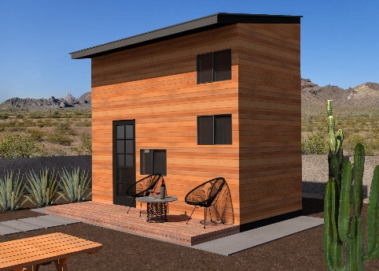

* ***Small Footprint Tiny Houses***: These are tiny houses built on a foundation and designed to have a small physical footprint. They often utilize vertical space and innovative storage solutions to maximize living areas within a compact layout.

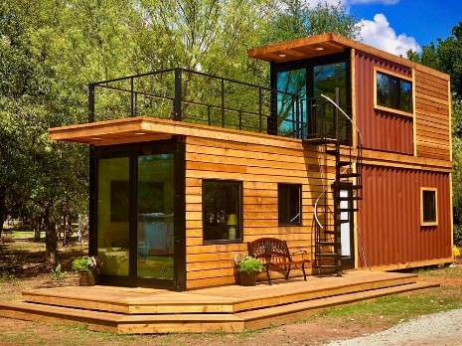

* ***Container Homes***: These tiny houses are constructed using repurposed shipping containers. They offer a unique and modern aesthetic while providing a solid and durable structure.

* ***Treehouses***: Treehouse-inspired tiny houses are built elevated in trees, offering a unique and close-to-nature living experience. These can range from simple, rustic designs to more elaborate and luxurious treehouse dwellings.
* A white tent with a wooden deck and a bench

  Description automatically generated***Yurts***: Yurts are circular, tent-like structures that can be adapted for year-round living. They are typically portable and provide a spacious and open interior with a distinctive design.

* ***Cabin-style Tiny Houses***: These tiny houses draw inspiration from traditional cabins and feature cozy and rustic designs. They often incorporate natural materials, such as wood, and provide a warm and inviting atmosphere.

* ***Floating Tiny Houses***: These tiny houses are designed to float on water, such as lakes or rivers. They can be built on pontoons or other flotation devices, offering a unique and unconventional living experience.

* ***Tiny Houses on Wheels (THOWs)***: These are small homes built on a trailer or chassis, allowing them to be mobile. THOWs offer flexibility and the ability to travel or relocate the home as needed.

NOTE: In North Carolina, a tiny house on wheels can be either personal property or real property. As long as the tiny house is still mobile with its own wheels and chassis, it must have a vehicle identification number (VIN) registered with the North Carolina Department of Motor Vehicles and is considered *personal property.*

A THOW is not considered real property just because the unit was placed on a residential lot. To convert the home into real property, the moving hitch, wheels, and axles must be removed, and the unit must be attached to a permanent foundation on land owned by the owner of the manufactured home. Once the owner files an affidavit confirming that these actions have been taken, the home is considered real property and an improvement to the lot. (See later discussion.)

THOW are considered recreational vehicles (RVs) in North Carolina. The following are characteristics of an RV:

* It is built on a single chassis.
* It is 400 square feet or less in size when measured at the most extensive horizontal projections.
* It is self-propelled or permanently towable by a light-duty truck.
* It is for temporary living only.

The following are the NC rules for this type of tiny house:

* The electrical supply system must be installed and inspected.
* Permanently installed feeder for power supply. Otherwise, the power supply to the park trailer must be a feed assembly with not more than a 30-ampere or 50-ampere power supply cord with a securely attached cap.
* THOWs should not have permanent plumbing or mechanical connections. Instead, they must be anchored temporarily for safety purposes. However, the wheels and axles must always remain on the unit.
* THOWs do not support accessory structures.
* They are not permanent dwellings in North Carolina. So, they must meet electrical code and inspection requirements.[5]

Do brokers or other individuals need a special license to sell THOWs? Most likely, yes. Any person in North Carolina engaged in the business of buying, selling, offering or displaying *three (3) or more manufactured homes* in a twelve-month period will be presumed to be a manufactured housing dealer and must be licensed by the NC Department of Insurance Manufactured Building Division and the NCDOT Division of Motor Vehicles. It will be necessary to contact the Dealer’s Section of the Division of Motor Vehicles to determine the steps necessary to become licensed by the NCDMV.[6]

The terms *selling*" and *sale* include lease-purchase transactions.

***Studio or ADU (Accessory Dwelling Unit)***: An accessory dwelling unit is often—but not always--a tiny house. ADUs are typically between 450-800 square feet.

The type and design of an ADU can vary depending on property size and surrounding structures. (See later discussion.) ADUs have become very popular of late, so let’s go into more detail on this subject.

ADUS are tiny houses designed as self-contained living spaces located on the same property as a primary residence. A DUs can serve as guest houses, rental units, or additional living space for homeowners. An accessory dwelling unit (ADU) is also known as a *granny flat*, *in-law suite*, or s*econdary suite.*

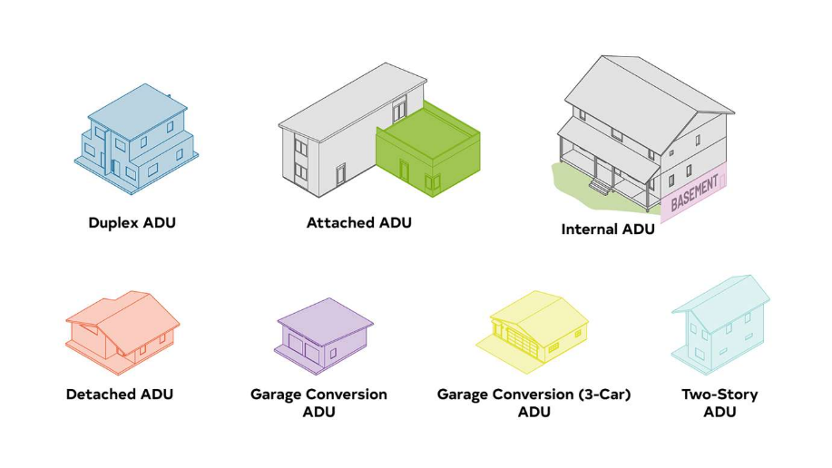ADUs are designed to provide independent living quarters and typically have their own entrance, kitchen, bathroom, and sleeping area. These units are intended to accommodate additional occupants while maintaining the character of the main dwelling.

Examples of ADUs from Raleigh's ADU website

ADUs can take various forms, such as a detached structure, a converted garage, a basement apartment, or an addition to an existing home. They often are tiny homes on foundations, but they can be on wheels. They can be used to house family members, provide rental income, or serve as flexible living spaces.

The benefits of ADUs include:

* Increased housing options: ADUs offer additional housing opportunities within established neighborhoods, allowing for more diverse housing options.
* Rental income potential: Property owners can generate rental income by renting out the ADU, which can help offset housing costs or provide a source of passive income.
* Multigenerational living: ADUs provide a space for extended family members, such as elderly parents or adult children, to live in proximity while maintaining privacy and independence.
* Sustainable land use: ADUs can help maximize the use of existing infrastructure and resources, utilizing underutilized spaces on residential properties.

ADU regulations vary by location, and they are subject to local zoning ordinances, building codes, and other regulatory requirements. These regulations may govern aspects such as the size of the ADU, parking requirements, setback distances, occupancy limits, and permitting processes. It's essential to consult with local planning departments or zoning authorities to understand the specific regulations and requirements for ADUs in a particular area.[7]

An accessory dwelling unit (ADU) and a tiny house are similar in that they both provide additional living space on a property, but there are some key differences between the two:

* Location: ADUs are typically located on the same property as a primary residence, whether it's an attached or detached unit, a converted space, or an addition to an existing home. *They are designed to be secondary to the main dwelling.* On the other hand, a tiny house can be situated on its own property, on wheels for mobility, or on a foundation, offering more flexibility in terms of location.
* Zoning and Regulations: ADUs are subject to local zoning regulations and building codes, which can vary from one jurisdiction to another. These regulations specify where ADUs are allowed, their size, parking requirements, setbacks, and other factors. *Tiny houses, especially those on wheels, may have more complex regulatory considerations as they can be subject to additional regulations governing recreational vehicles (RVs), mobile homes, or travel trailers.*
* Purpose and Design: ADUs are primarily intended to provide independent living quarters and can accommodate various needs, such as housing family members, creating rental income, or supporting multigenerational living. They are typically designed to meet local housing standards and often include full amenities like kitchens and bathrooms. *Tiny houses, on the other hand, can serve as standalone residences or be used for various purposes* beyond additional living space, such as vacation homes, mobile offices, or off-grid living. Their design may be more focused on minimalism, mobility, or customization options.
* Size and Scale: ADUs tend to be larger than tiny houses in terms of square footage. While there is no strict definition of a tiny house, it generally refers to a dwelling that is much smaller than a traditional house, typically ranging from 100 to 400 square feet (9 to 37 square meters). *ADUs can be larger, ranging from a few hundred square feet to several thousand square feet,* depending on local regulations and the property's size.

In 2013, North Carolina’s legislature passed a bill[8] permitting “medical cottages.” The bill, reads in part, that “temporary family health care structures, as defined in G.S. 160A‑383.5,shall be considered dwellings for purposes of this Part, provided that any ordinance provision requiring minimum square footage shall not apply to such structures." Note that this language gives individuals who wish to erect ADUs to take care of, say, aging parents, more latitude from communities with restrictive zoning laws.

It's important to note that the specific definitions and regulations for ADUs and tiny houses can vary depending on the jurisdiction. Local zoning ordinances and building codes ultimately determine how each is classified and regulated in a particular area.

***Summary***

It's important to note that the world of tiny houses is vast and diverse, with numerous variations and customizations available. Each type of tiny house offers its own advantages and appeals to different preferences and lifestyles.

**Market Analysis and Trends**

***Current market trends and demand for tiny houses***

As mentioned earlier, the tiny house movement has gained significant popularity in recent years. The desire for simpler and more sustainable living, as well as the appeal of downsizing and reducing living expenses, has contributed to the increased demand for tiny houses.

Initially, the tiny house movement was associated with younger individuals or couples seeking affordable housing or a minimalist lifestyle. However, the market has expanded to include a broader range of demographics, including families, retirees, and individuals looking for alternative housing options. Tiny houses have gained mainstream recognition through media coverage, television shows, and documentaries. This increased exposure has helped raise awareness and acceptance of tiny houses as a viable housing option.

Regulations and zoning restrictions play a significant role in the market for tiny houses. Many jurisdictions have specific regulations governing the size, classification, and placement of tiny houses. As the popularity of tiny houses has grown, some municipalities have started to revisit and revise their regulations to accommodate this housing option.

____________________________________________________________________________________

North Carolina is considered a somewhat tiny house-friendly state compared to other states. [9] Tiny house regulations and codes may vary by city, town, or county. For example, Wilmington, North Carolina requires at least 150 square feet for first occupant and at least 100 square feet per additional occupant.[10] A tiny house must abide by additional housing ordinances. Winston-Salem has rules about accessory dwelling units ( for example, ADUs are allowed on single-family lots as long as they are occupied by relatives, caretakers, etc.

____________________________________________________________________________________

*Tiny House Communities*: The development of tiny house communities or villages has become more prevalent. These communities often provide a sense of community, shared resources, and opportunities for like-minded individuals to live together in a supportive environment.

*Customization and Design*: The demand for customized and well-designed tiny houses remains strong. People are looking for innovative design solutions that maximize space utilization, incorporate eco-friendly features, and provide functional and comfortable living spaces.

*Sustainability and Eco-Friendly Features*: The emphasis on sustainability and eco-friendly living has influenced the market for tiny houses. Buyers are often interested in features such as solar panels, composting toilets, rainwater collection systems, and energy-efficient appliances.

It's important to note that the market for tiny houses can vary significantly based on geographical location, local regulations, and individual preferences. For the most up-to-date information on current market trends and demand for tiny houses, it is advisable to consult local real estate professionals, builders, or communities that specialize in tiny house living.

***Understanding the target audience and potential buyers***

The target audience for tiny houses can vary depending on several factors, including lifestyle preferences, financial considerations, and personal values. While the target audience is diverse, here are some common groups that are often attracted to the idea of living in tiny houses:

* Minimalists: Individuals who embrace a minimalist lifestyle, value simplicity, and prioritize experiences over material possessions often gravitate towards tiny houses. They appreciate the opportunity to live with less and focus on what truly matters to them.
* Financially Conscious Individuals: Tiny houses can offer a more affordable housing option compared to traditional homes. People who are looking to reduce their housing expenses, lower their mortgage or rental costs, or pay off debts may be attracted to the financial advantages of living in a tiny house.
* Sustainable Living Enthusiasts: Individuals who prioritize sustainability and reducing their environmental footprint are often drawn to tiny houses. The smaller size of these homes means fewer resources are required for construction and maintenance. Eco-friendly features such as solar panels, rainwater harvesting, and composting toilets align with their values.
* Downsizers and Empty Nesters: Empty nesters or individuals looking to downsize after their children have moved out may find tiny houses appealing. These individuals often no longer need or want the space of a larger home, and a tiny house provides a more manageable and efficient living arrangement.
* Adventurers and Nomads: Some people embrace a nomadic or mobile lifestyle, and tiny houses can offer the flexibility to travel and explore different locations. Tiny houses on wheels, in particular, cater to those who enjoy adventure, want the ability to move home, or prefer temporary living arrangements.
* Creative Professionals and Artists: Tiny houses can be customized and designed to suit individual needs and aesthetics. Creative professionals and artists may be attracted to the opportunity to design their own unique living spaces that reflect their artistic sensibilities.
* Aging-in-Place Individuals: Tiny houses can be designed to accommodate accessibility needs, making them suitable for individuals who want to age in place. Features such as single-floor living, wider doorways, and accessible bathrooms can make tiny houses a viable option for older adults.

It's important to note that while these groups are often associated with the target audience for tiny houses, the appeal of tiny houses is not limited to these categories. Different individuals have their own unique reasons for considering tiny house living, and the target audience can vary based on personal circumstances and preferences.

Understanding the target audience and potential buyers for tiny houses can help in tailoring marketing strategies, design choices, and communication efforts to effectively reach and connect with these individuals.

**Zoning and Regulatory Considerations**

***Overview of zoning regulations and building codes related to tiny houses***

Zoning regulations for tiny houses in North Carolina can vary depending on the specific community or municipality. Zoning regulations are typically set at the local level, so it's important to research the specific regulations in the area where consumers intend to place or build a tiny house. However, here are some general considerations and zoning trends that can apply:

Minimum Square Footage: Some communities in North Carolina have minimum square footage requirements for residential dwellings. This means that the size of a tiny house may not meet the minimum square footage threshold, which could restrict its legality in certain areas.

Minimum Lot Size: Zoning regulations may specify a minimum lot size for residential properties. If a tiny house is to be placed on a permanent foundation, it may need to comply with the minimum lot size requirements.

Setbacks and Building Codes: Setbacks refer to the minimum distance a structure must be located from property lines, roads, or other structures. Building codes and zoning regulations may dictate specific setback requirements for tiny houses. It's important to adhere to these guidelines to ensure compliance.

Accessory Dwelling Units (ADUs): Some areas in North Carolina allow for accessory dwelling units (ADUs), which are secondary dwellings located on the same property as a primary residence. In certain cases, a tiny house may qualify as an ADU and be allowed within the zoning regulations pertaining to ADUs.

Mobile/Manufactured Homes: If the tiny house is built on wheels and qualifies as a mobile or manufactured home, it may be subject to regulations specific to those types of dwellings. These regulations can cover issues such as permitting, placement, and construction standards.

To determine the specific zoning regulations for tiny houses in a particular North Carolina community, it is recommended to contact the local planning or zoning department. They can provide consumers with detailed information regarding setbacks, minimum square footage, lot size requirements, and any other zoning restrictions that may apply.

Additionally, keep in mind that zoning regulations can change over time as communities adapt to the growing interest in tiny houses. Therefore, it's essential to stay informed about any updates or amendments to the local zoning ordinances.

____________________________________________________________________________________

The tiny living movement is very popular in North Carolina, but there are more regulations, building codes, and zoning restrictions to adhere to than in some other states.

For example, North Carolina does not allow a house on wheels to be a primary residence, and these can only be occupied for 180 consecutive days per year. Tiny home lovers will need to commit to a foundation to live large in a small home year-round.

Building codes can vary by city, town, or county, but the following specs are relatively standard. Be sure to check local laws for a specific list of requirements.

Tiny homes must be permitted by local jurisdiction, including zoning requirements.

* Plumbing fixtures must be connected to an approved sewage disposal method. North Carolina does not allow storage tanks.
* The home must contain a habitable space, which is a space for living, sleeping, eating, or cooking. A bathroom, closet, hall, or storage area is not considered a habitable space.
* *At least one habitable space must be a minimum of 120 square feet of gross floor area. Additional habitable rooms cannot be less than 70 square feet, and no less than seven feet in any horizontal direction, excluding kitchens, which have no size minimum.*
* Ceiling heights must be a minimum of seven feet in habitable spaces, hallways, and bathrooms.
* The home must contain a toilet, bathtub or shower, kitchen area, and sink.
* The home must have a heating facility compliant with the local code.
* The home must meet code-compliant egress requirements (this refers to windows and fire exits).
* The home must meet requirements regarding energy conservation and foundations.
* Off-grid living is legal in North Carolina. If consumers build in very rural areas, they may not need to meet some of the above requirements. That said, in-depth building restrictions and zoning laws still apply, and it is not always possible to live completely separate from the grid. [11]

___________________________________________________________________________________

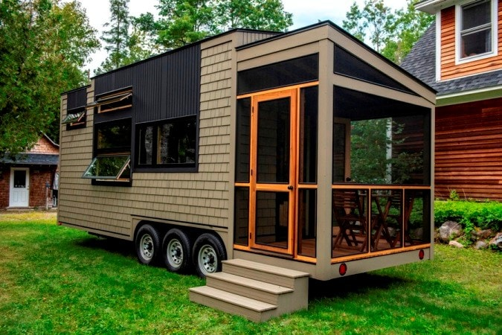In North Carolina, *tiny homes on wheels are considered to be RVs (recreational vehicles)*. Under North Carolina law, the longest continuous time occupants can live in an RV is 180 days—it cannot be used as a legal, permanent home.

So while individuals could live part of the year in a tiny-wheeled abode, they will need a secondary stationary residence.

Again, RVs and campers are only allowed as temporary living quarters, and while they can be temporarily blocked up or anchored, the wheels and axles must not be removed from the unit. Basically, trying to pass off an RV as a permanent dwelling in North Carolina is a violation of the residential code.

_____________________________________________________________________________________________

Manufactured Homes: Real Or Personal Property?[12]

NCREC Bulletin 2002-V33-1

By Blackwell M. Brogden, Jr., Chief Deputy Legal Counsel

Long time readers of the [NCREC] *Bulletin* and those who have reviewed the articles posted on the Commission website (www.ncrec.state.nc.us) will be aware of the article discussing the legal nature of manufactured housing (formerly known as mobile homes) found in the Fall 1992, Vol. 23, #2, issue, and titled Mobile Homes: Real or Personal Property? In essence, manufactured homes begin their existence as items of personal property but can lose that status upon being permanently affixed to real property. Their status can change back upon being severed from the improved real estate to which a manufactured home was once affixed.

….Statutory changes by the General Assembly have introduced reforms into the process of determining whether a particular manufactured home is real or personal property. One of the changes provides for creation and filing of affidavits with the Division of Motor Vehicles and the county Register of Deeds to identify manufactured homes that have been legally classified as real property. Additionally, these changes will provide for uniform treatment of manufactured homes for ad valorem tax purposes.

The legal difference between the treatment of manufactured homes either as real property or personal property is important in real estate transactions. For example, a contract that listed no personal property to be conveyed when at the time of execution there was a manufactured home on the property would not convey title to the home if the unit was personal property. That same contract under the same circumstances would include conveyance of the home if the unit had been permanently affixed so as to become real property. The legal difference also affects the method for obtaining and perfecting liens on units and determining who owns a unit.

The distinction between whether a manufactured home is real or personal property has no bearing on the separate issue of the type of construction of buildings assembled off the property and subsequently transported to a site. Whether real or personal property, a manufactured home is still a manufactured home, and this fact should be disclosed. (If a modular home is constructed to the state building code standard, the home is incorporated into, and becomes part of, the real property upon installation. See the Bulletin, Summer 1995, Vol. 26, #2 issue, article entitled When the Homes Come Rolling In.)

Licensees will not typically review title records or participate in the process of changing personal property to real property. However, completing sales contracts in the proper manner to protect the interests of the parties is important. Thus it is important to know whether a manufactured home is real or personal property.

Practice Tip: If the parties intend that a manufactured home be transferred as part of their sales contract, whether or not the unit is real or personal property, the licensee should include sufficient information in the personal property portion of the sales agreement to cover the specific unit present on the property. If the unit is already classified as real property, no harm is done. If the unit is still personal property, then the intent of the parties will be adequately reflected in the contract.[13]

_____________________________________________________________________________________________

***Navigating legal and permitting requirements for tiny houses***

Navigating legal and permitting requirements for tiny houses can be complex and challenging due to the varying regulations and zoning codes across different jurisdictions. Here are some general steps:

* Start by researching the specific regulations and zoning codes in the area where consumers plan to place or build a tiny house. Check with the local building department, zoning office, or planning department to understand the requirements, restrictions, and permits needed for tiny houses.
* Determine how a tiny house will be classified in the eyes of the local authorities. It can be classified as an RV, an accessory dwelling unit (ADU), a recreational cabin, or something else, depending on its size, features, and intended use. The classification can affect the specific regulations and permits required.
* Engage with professionals who are knowledgeable about local building codes and regulations, such as architects, contractors, or tiny house builders. They can provide guidance and advice based on their experience with local requirements.
* Understand the building codes and standards that apply to tiny houses. These codes may include requirements for electrical systems, plumbing, structural integrity, safety features, and more. Ensure that design and construction plans comply with these codes.
* Become familiar with the permitting process and the specific permits needed. This may include building permits, electrical permits, plumbing permits, and more. Each jurisdiction may have its own application process, fees, and requirements. Work closely with the local building department to understand the necessary permits and their application procedures.
* Engage professionals, such as architects or designers, who have experience with tiny houses. They can help create detailed plans and drawings that meet the local building requirements and can support permit applications.
* Establish a relationship with the local building department and schedule meetings or consultations to discuss a tiny home project. Seek clarification on any regulations or requirements that are uncertain and address any concerns or questions they may have.
* Keep detailed records of all communications, permits, and documentation related to a tiny house project. Maintain a paper trail to demonstrate compliance with regulations and to facilitate the permitting process.

Depending on the complexity of the regulations and permitting requirements in an area, consulting with a lawyer who specializes in real estate or zoning laws may be a valuable step. Attorneys can provide legal advice and guidance specific to a situation.

**Financing and Insurance**

***Financing options for tiny house buyers***

Financing options for tiny house buyers can vary depending on several factors, including the type of tiny house, its classification (whether it's considered a recreational vehicle or a permanent dwelling), and the buyer's financial situation. Here are some common financing options to consider:

* Personal Savings: Using personal savings or funds from the sale of existing assets is a straightforward financing option. If consumers have enough savings, it eliminates the need for external financing and associated interest costs.
* Personal Loans: Securing a personal loan from a bank, credit union, or online lender is a common way to finance a tiny house. These loans are typically unsecured, meaning they don't require collateral, but interest rates and terms will depend on creditworthiness and the lender's criteria.
* RV Loans: If a tiny house is classified as a recreational vehicle (RV), its owner may qualify for RV loans. RV loans are offered by banks, credit unions, and specialized lenders. These loans typically have higher interest rates than traditional mortgages but can provide longer repayment terms.
* Manufactured Home Loans: If a tiny house meets the criteria to be classified as a manufactured home, its owner may be eligible for manufactured home loans. These loans are similar to traditional mortgages and are offered by various lenders, including banks and credit unions.
* Construction Loans: If a consumer is building a custom tiny house or purchasing a tiny house shell to complete the construction, he or she might consider construction loans. These loans provide funds in stages throughout the building process, allowing the owner to finance the construction and then convert the loan to a traditional mortgage once the house is complete.
* Personal Line of Credit: A personal line of credit can provide flexibility for financing a tiny house. It works similar to a credit card, allowing consumers to borrow up to a predetermined limit, and interest is only charged on the amount borrowed. This option can be useful if consumers expect to have ongoing expenses or need funds in phases.
* Seller Financing: In some cases, the seller of the tiny house may offer financing options directly to the buyer. This arrangement allows for negotiation of terms and potentially more flexible payment options. It's essential to clarify all terms and obligations in a formal agreement when considering seller financing.
* Peer-to-Peer Lending: Peer-to-peer lending platforms connect borrowers with individual lenders who are willing to provide loans. These platforms often have less strict criteria than traditional lenders and can be an alternative option for financing a tiny house.

Remember to research and compare the terms, interest rates, repayment periods, and eligibility criteria for each financing option. It's also crucial to consult with lenders or financial advisors to determine the best option based on specific circumstances and financial goals.

**Insurance considerations for tiny houses**

When it comes to insuring tiny houses, there are several considerations to keep in mind. Insurance coverage for tiny houses can differ based on various factors such as the type of tiny house, its classification, location, and usage. Here are some insurance considerations for tiny houses:

* Tiny House Classification: Insurance options may vary depending on how a tiny house is classified. If it is considered a recreational vehicle (RV), its owner may be able to obtain RV insurance. However, if a tiny house is classified as a permanent dwelling, the owner may need to seek homeowners' insurance or a specialty insurance policy for small or alternative dwellings.
* Coverage Types: Consider the coverage types needed for a tiny house. This may include property coverage for the structure itself, personal property coverage for belongings inside, and liability coverage to protect the owner in case of accidents or injuries that occur on the property.
* Location: The location of a tiny house can affect insurance considerations. If a tiny house is on wheels and frequently moved, its owner may need coverage that considers the transportation aspect. Additionally, if a tiny house is located in a tiny house community or on someone else's property, consumers may need to explore coverage options specific to those scenarios.
* Insurance Providers: Reach out to insurance companies that offer coverage for tiny houses and discuss specific needs. Some insurance providers specialize in insuring small or alternative dwellings and may be familiar with the unique requirements and risks associated with tiny houses.
* Customization and Upgrades: If owners have made customizations or added upgrades to their tiny house, make sure they are appropriately accounted for in insurance coverage. Document any changes and ensure they are included in the valuation of the property to ensure adequate coverage.
* Safety Features: Installing safety features in a tiny house can potentially lower insurance premiums. Consider features such as smoke detectors, fire extinguishers, security systems, and sturdy locks to enhance the safety and security of a tiny house.
* Deductibles and Premiums: Understand the deductibles and premiums associated with the insurance policy being considered. Evaluate different options, compare quotes from multiple insurers, and consider factors such as coverage limits, deductibles, and the insurer's reputation and customer service.
* Additional Coverage: Depending on specific needs and concerns, consumers may want to explore additional coverage options such as theft, natural disasters, or specific types of personal property such as valuable items or electronics.

As insurance requirements and options can vary, it's important to communicate directly with insurance providers, discuss specific situations, and ask detailed questions. It's also advisable to consult with an insurance agent or broker who has experience with insuring tiny houses.

**Construction and Design**

***Building and design considerations for tiny houses***

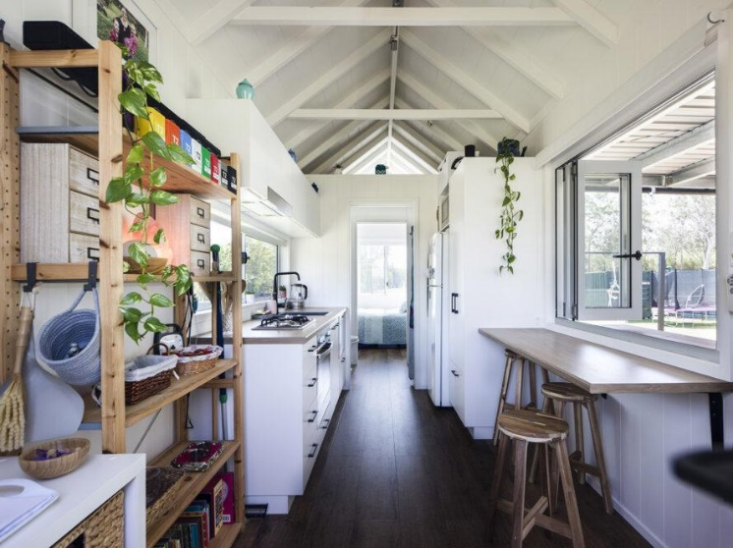When it comes to building and designing tiny houses, there are several key considerations to keep in mind. These considerations help maximize space utilization, ensure structural integrity, create a comfortable living environment, and align with individual needs and preferences. Here are some important building and design considerations for tiny houses:

Space Optimization: Maximize the use of available space by incorporating smart storage solutions, multi-functional furniture, and creative design elements. Consider built-in storage, loft areas, foldable furniture, and wall-mounted fixtures to make the most of limited square footage.[14]

Functional Layout: Carefully plan the layout to optimize functionality and flow within the tiny house. Prioritize essential spaces such as the kitchen, bathroom, and sleeping area, ensuring they are efficiently organized and easily accessible. Open floor plans can help create a sense of spaciousness.

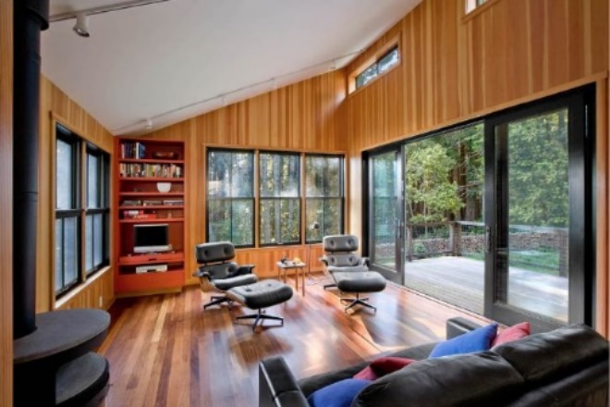Natural Light and Ventilation: Incorporate large windows, skylights, and glass doors to maximize natural light and provide a sense of openness. Proper ventilation is also essential to maintain air quality within a small space.

Energy Efficiency: Implement energy-efficient features to reduce energy consumption and utility costs. Consider insulation, high-efficiency appliances, LED lighting, and renewable energy sources such as solar panels. Properly sealing the tiny house will also contribute to energy efficiency.

Structural Integrity: Ensure the structural integrity of the tiny house by collaborating with experienced professionals or builders. Consider factors such as the weight distribution, appropriate foundation or trailer, proper anchoring, and compliance with local building codes.

Plumbing and Electrical Systems: Carefully plan the plumbing and electrical systems, considering space limitations and the specific needs of the occupants. Efficient use of space for water storage, plumbing fixtures, and electrical outlets is crucial. Consult with professionals to ensure compliance with building codes and safety standards.

Materials and Finishes: Choose durable, lightweight, and space-saving materials for construction, interior finishes, and furnishings. Consider materials that are environmentally friendly, easy to maintain, and aesthetically pleasing. Additionally, consider fire-resistant materials for added safety.

Personalization and Comfort: Customize the tiny house to suit individual needs and preferences. Incorporate personal touches, design elements, and color schemes that create a comfortable and inviting living environment. Balance aesthetics with functionality to achieve a harmonious space.

Safety and Security: Ensure the tiny house is equipped with appropriate safety features, such as smoke detectors, fire extinguishers, and secure entry points. Consider security measures to protect the tiny house from theft or unauthorized access.

Transportability (if applicable): If the tiny house is on wheels, consider the design and construction requirements for transportation. Ensure that the tiny house is structurally designed to withstand movement and that it complies with local transportation regulations.

Remember, building and design considerations for tiny houses can vary based on personal preferences, local regulations, and specific circumstances. It's important to consult professionals, such as architects, builders, or designers, who have experience with tiny house construction, to ensure compliance with regulations and to create a functional and comfortable living space.

***Structural requirements, materials, and construction methods***

Structural requirements, materials, and construction methods for tiny houses are crucial to ensure safety, durability, and compliance with local building codes. Here are some key considerations:

Foundation and Trailer: Tiny houses can be built on a foundation or on a trailer, depending on the mobility desired. If built on a trailer, it is essential to use a sturdy, well-designed trailer that can support the weight of the structure and provide proper towing stability.

Framing: The most common framing methods for tiny houses include traditional stick-built framing, steel framing, or SIPs (Structural Insulated Panels). Stick-built framing using wood is popular due to its 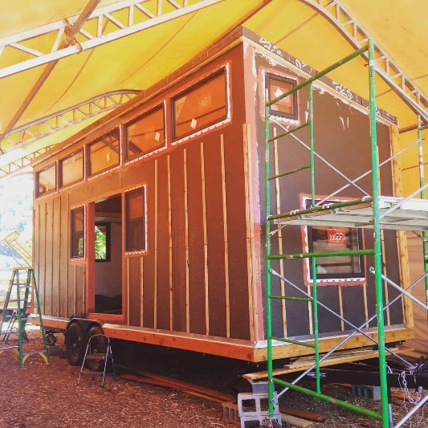affordability, availability, and ease of construction. Steel framing can provide added strength and durability. SIPs are prefabricated panels that offer insulation and structural support.[15]

Structural Insulated Panels and they are essentially a sandwich made of OSB plywood with foam insulation in the middle. They have a number of big advantages, and one is that they result in a tiny house that is highly insulated and efficient.

Insulation: Proper insulation is essential for temperature regulation, energy efficiency, and comfort within a tiny house. Common insulation options include spray foam insulation, rigid foam insulation, or eco-friendly alternatives like recycled denim insulation.

Roofing: Choose a roofing material that is lightweight, durable, and suitable for the climate in which the tiny house will be located. Options include metal roofing, asphalt shingles, or even green roofs with living vegetation.

Wall Materials: Various materials can be used for the walls of a tiny house, including wood siding, metal siding, cement board siding, or even reclaimed materials. Consider factors such as aesthetics, durability, maintenance requirements, and local building code compliance.

Windows and Doors: Install windows and doors that provide adequate natural light, ventilation, and security. Double-pane windows with energy-efficient glass can enhance insulation and reduce energy costs. Consider the size and placement of windows and doors to maximize views and space utilization.

Plumbing and Electrical Systems: Consult with professionals to design and install plumbing and electrical systems that meet local building codes and safety standards. Use appropriate materials and fixtures and consider energy-efficient appliances to reduce water and electricity consumption.

Interior Finishes: Choose interior finishes that are lightweight, space-saving, and easy to maintain. Options include durable flooring materials like laminate, vinyl, or bamboo. Use moisture-resistant materials in areas prone to water exposure, such as the bathroom and kitchen.

Fire Safety: Incorporate fire safety measures, including smoke detectors, fire extinguishers, and proper electrical wiring to reduce fire risks. Ensure that the materials used in construction have appropriate fire ratings.

Accessibility: If considering universal accessibility, incorporate design elements that make the tiny house accessible to people with disabilities. This may include wider doorways, ramps, grab bars, and carefully planned layouts that allow for maneuverability.

Remember, local building codes and regulations may dictate specific structural requirements and materials for tiny houses. It's essential to consult with professionals, such as architects, builders, or local building officials, to ensure compliance with local codes and to address any specific structural considerations for a region.

***Design principles for optimizing space and functionality***

Designing a tiny house requires careful consideration of space utilization and functionality to make the most of the limited square footage. Here are some design principles to optimize space and functionality in tiny houses:

* 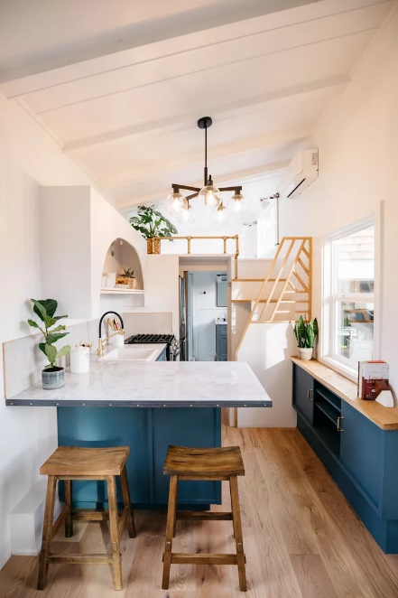Multifunctional furniture: Incorporate furniture that serves multiple purposes to maximize functionality. Examples include sofa beds, dining tables with storage compartments, or built-in seating with hidden storage.[16]
* Open floor plans: Use an open floor plan to create a sense of spaciousness and maximize the flow of movement. Minimize the use of walls and partitions to allow for flexible use of space and create visual continuity.
* Vertical space: Take advantage of vertical space by incorporating tall storage solutions such as shelves, cabinets, or lofts. Use wall-mounted fixtures, hooks, or racks to free up floor space and keep items organized.
* Efficient storage solutions: Design and build custom storage solutions that make the most of every available space. This includes utilizing under-stair storage, built-in closets, and utilizing space under furniture or in unused corners.
* Compact appliances: Choose compact and space-saving appliances without compromising functionality. Consider slimline or stackable washer-dryer units, combination ovens, or drawer-style refrigerators.
* Light colors and natural light: Use light-colored walls, flooring, and furniture to create an illusion of more space. Maximize natural light by incorporating large windows, skylights, and light-filtering window treatments to make the tiny house feel bright and airy.
* Thoughtful kitchen design: Design a functional kitchen with efficient layout and storage. Use innovative solutions like foldable or extendable countertops, magnetic knife strips, or vertical storage for pots and pans.
* Modular design: Consider modular components that can be reconfigured or expanded as needed. This allows for adaptability and customization based on changing needs or preferences.
* Outdoor living space: Extend the living space by creating an outdoor area such as a deck or patio. This provides additional room for activities, relaxation, and entertaining.
* Thoughtful traffic flow: Design the layout to ensure smooth traffic flow and minimize obstructions. Avoid narrow walkways or dead-end spaces that restrict movement within the tiny house.
* Consider visual continuity: Use design elements that create visual continuity throughout the tiny house, such as consistent flooring materials, color palettes, and design themes. This helps create a cohesive and visually appealing space.
* Reflect personal needs and lifestyle: Customize the design to reflect specific needs, preferences, and lifestyle. Consider factors such as hobbies, work requirements, or family dynamics to ensure the tiny house accommodates your individual needs.

Remember, each tiny house design will be unique based on individual preferences and requirements. Prioritize functionality, comfort, and personalization to create a space that optimizes the use of limited square footage while reflecting personal style.

***Cost***

The nationwide average cost of a tiny home is $300 per square foot, double that of a traditional home of $150 per square foot. But tiny houses are still cheaper to build. The average cost to build a tiny home is $45,000, ranging from $30,000 to $60,000. (Of course, the cost of land must be factored in as well.)

In 2023, the average cost of a home in the United States varies depending on factors such as location, size, condition, and market conditions. However, to provide a general idea, the median home price in the U.S. was around $436,800 at that time.[17]

It's important to note that housing prices can vary significantly based on the region. For example, major metropolitan areas and coastal cities tend to have higher home prices compared to rural or less densely populated areas. Additionally, the housing market is subject to fluctuations, and prices can change over time.

During the same year, 2023, the average cost of a home in North Carolina varies depending on factors such as location, size, condition, and market conditions. However, to provide a general idea, the median home price in North Carolina was around $309,681 at that time.[18]

It’s noteworthy that 58% of people who live in tiny houses have about $11,200 more saved in the bank than the average American and 65% of them have no credit card debt. Saving money on a mortgage is one of the biggest draws to living in a tiny house living. A whopping 68% of all tiny house homeowners have no mortgage, compared to 29% of the rest of homeowners. Living in a tiny home may affect spending habits because when you lack storage room, you are less apt to overspend.[19]

The average cost of a tiny house can vary significantly depending on various factors such as location, size, design, materials used, level of customization, and labor costs. However, to provide a rough estimate, the cost of a professionally built, move-in-ready tiny house typically ranges from $40,000 to $100,000 or more. Keep in mind that these figures are just general estimates, and the actual cost can vary widely.

It's important to note that the cost of a tiny house can be influenced by several factors:

* Size: Smaller tiny houses generally have lower construction costs compared to larger ones. The size of a tiny house can range from under 100 square feet to around 400 square feet or more.
* Foundation of house: Foundations for a tiny house can range from $5,000 to $8,000. Tiny houses built on wheels generally do not require a foundation.
* Type of building materials: Materials for a tiny home range from around $14,050 to $54,800. Many tiny houses are van, bus, or shipping container conversions.
* Building permit costs: A tiny house on a trailer typically does not need a permit, since it is considered personal property, not real estate. A tiny house built on a foundation will require a permit, which costs on average $1,350.
* Access to utilities: If a tiny house is in a rural area, its occupants may have to install pre-existing electrical lines that cost $250 to $5,000.
* Type of amenities: More expensive tiny homes typically have more luxurious amenities, such as granite countertops, stainless steel appliances, and other higher-end fixtures.
* Customization: The level of customization and design complexity can affect the cost. Custom features, high-quality materials, and unique design elements may increase the overall expense.
* DIY vs. professional construction: Building a tiny house yourself (DIY) can help reduce costs, but it requires time, skills, and knowledge of construction. Hiring professionals to build a custom tiny house can be more expensive but often ensures higher quality and adherence to building codes.
* Off-grid capabilities: If a tiny house is off-grid or has sustainable features such as solar power, composting toilets, or rainwater collection systems, the cost may increase due to specialized equipment and installation.
* Location: The cost of living and construction labor rates can vary depending on the location. Prices may be higher in certain areas with higher living expenses or where the demand for tiny houses is greater.
* Additional Expenses: In addition to the construction cost, there may be other expenses to consider, such as land acquisition, permits, utility connections, and interior furnishings.
  + Zoning laws: Zoning laws are based on where one lives and can add extra costs.
  + Contractors and other professionals: Depending on where one lives and what work is required, contractors charge different rates.
  + Storage: If a tiny house doesn't fit all of an occupant’s belongings, the occupant may need a storage unit.
  + Mortgages: Traditional lenders typically do not make mortgages on tiny houses. Some tiny house manufacturers partner with finance companies to offer financing.
  + Insurance: Getting tiny home insurance can be difficult and costly.
  + Homeowners’ association fees: Tiny house owners may be in a community that charges one.

It's crucial to carefully budget and consider all potential costs when planning to build or purchase a tiny house. Consulting with tiny house builders, professionals in the construction industry, or individuals with experience in building tiny houses can provide more accurate cost estimates based on specific requirements and location.

**Land Acquisition**

Finding land for a tiny house can be approached in several ways. Here are some suggestions to help you find suitable land:

* Purchase Land: One option is to buy land outright. Consumers can search for available land listings through real estate websites, local classifieds, or by working with a real estate agent specializing in land sales. Consider factors such as location, zoning regulations, access to utilities, and proximity to amenities that are important.
* A picture containing outdoor, grass, aerial photography, house

  Description automatically generatedRent or Lease Land: If purchasing land is not feasible, consumers may explore renting or leasing land for their tiny house. Look for landowners willing to enter into lease agreements or consider options like backyard rentals or joining intentional communities or co-housing projects that offer shared land.
* Tiny House Communities: Some communities are specifically designed for tiny houses. These communities often provide designated plots of land with appropriate zoning and infrastructure for tiny houses. Research tiny house communities or pocket neighborhoods in a desired area to see if they have available lots or spaces. (Pictured above is Acony Bell Community in Brevard, NC.)
* Local Zoning Regulations: Familiarize oneself with local zoning regulations to determine where tiny houses are allowed. Some areas may permit tiny houses on residential lots, while others may require specific zoning designations or participation in ADU programs. Contact local planning departments or consult zoning maps to identify suitable areas.
* Networking and Connections: Engage with local tiny house enthusiasts or communities to tap into their networks. Attend tiny house festivals, workshops, or meetups where consumers can connect with like-minded individuals who may have knowledge of or access to potential land opportunities.
* Online Platforms: Use online platforms and websites dedicated to land listings or tiny house communities. Websites like Tiny House Listings, LandWatch, or Tiny Home Village can help consumers find land specifically suited for tiny houses or connect with landowners interested in hosting tiny homes.

Remember to conduct due diligence when evaluating potential land options. Consider factors such as access to utilities (water, power, sewage), local building codes and regulations, proximity to services, transportation, and any other specific needs for a tiny house lifestyle. Consulting with local planning authorities or professionals can also provide valuable insights and guidance regarding land availability and regulations in a desired area.

Remember that while illustrations can provide inspiration and ideas, they may not always represent real-life construction or feasibility. It's important to consult professional builders, architects, or designers to ensure that your tiny house plans align with local building codes and regulations.

***Infrastructure considerations (utilities, water, sewage) for tiny houses***

When it comes to tiny houses, there are several infrastructure considerations to keep in mind, including utilities, water supply, and sewage management. Here are some key points to consider:

* Electricity: Determine how the tiny house will connect to the electrical grid. Tiny homeowners may need to consult with an electrician to ensure their house meets the necessary requirements and codes. Alternatively, they can consider off-grid options such as solar panels or wind turbines.
* Gas: If a tiny house requires gas for heating, cooking, or other purposes, its occupants will need to plan for a connection to a gas supply or explore alternative options like propane tanks.
* Internet and communication: Depending on location, consumers may have various options, including wired internet, satellite internet, or mobile data plans.
* Water supply:
  + Connection to municipal water: If a tiny house is located in an area with access to a municipal water supply, its occupants can typically connect to the existing water lines. Local regulations may require permits for the connection.
  + Well water: In rural areas without access to municipal water, drilling a well can provide a self-sufficient water supply. Consult with experts to determine the feasibility and requirements for well installation in your specific location.
  + Rainwater Harvesting: Another option is to collect and store rainwater for non-potable uses like irrigation or flushing toilets. Consumers should ensure that they understand local regulations regarding rainwater harvesting.
* Sewage Management:
  + A toilet in a bathroom

    Description automatically generatedMunicipal Sewer Connection: If a tiny house is within reach of a municipal sewer system, its occupants can connect your house to it, similar to a regular home. Check with local authorities and obtain the necessary permits.
  + Septic System: In areas without access to municipal sewer lines, occupants may need to install a septic system. Consult with a professional to assess the soil conditions and determine the appropriate type and size of the system.
  + Composting Toilets: Some tiny house owners opt for composting toilets, which convert waste into usable compost. This option is more environmentally friendly but requires regular maintenance and proper disposal of the compost.[20]

Composting Toilet

Remember, the specific requirements and regulations for utilities, water, and sewage can vary depending on a particular location. It's crucial to research local codes, consult with professionals when needed, and obtain the necessary permits to ensure compliance and a safe living environment.

**Brokerage Issues**

***Addressing buyer concerns and highlighting the unique features of tiny houses***

Addressing buyer concerns and highlighting the unique features of tiny houses can help prospective buyers understand the value and benefits of these compact living spaces. Here are some strategies to consider:

* Energy Efficiency: Emphasize the energy efficiency of tiny houses. Highlight the smaller footprint, which requires less energy for heating, cooling, and lighting. Explain how the well-insulated design and efficient appliances can result in lower utility bills and reduced environmental impact.
* Cost Savings: Discuss the potential cost savings associated with tiny houses. Point out that the smaller size generally means lower purchase and maintenance costs compared to traditional homes. Explain how reduced utility bills, lower property taxes, and less consumption can contribute to long-term financial savings.
* Customization and Personalization: Highlight the unique aspect of tiny houses, which often offer an opportunity for personalized design and customization. Discuss how buyers can tailor their tiny homes to meet their specific needs and preferences, whether it's through clever storage solutions, multi-functional furniture, or unique architectural designs.
* Flexibility and Mobility: Emphasize the flexibility and mobility that tiny houses offer. Discuss how they can be easily moved to different locations, making them suitable for those who enjoy a nomadic lifestyle or want the freedom to explore different areas. Emphasize that tiny houses can be a viable solution for both permanent dwellings and temporary living arrangements.
* 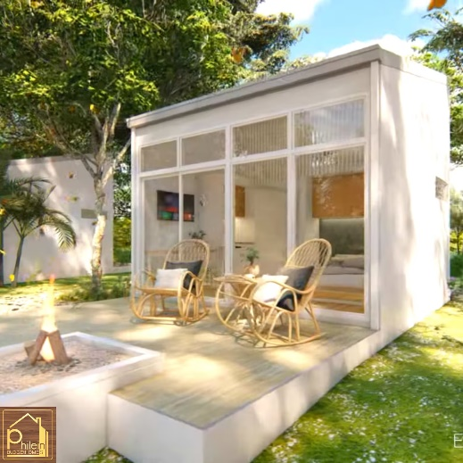Minimalistic Lifestyle: Highlight the appeal of a minimalist lifestyle that comes with tiny houses. Explain how living with less can lead to a more meaningful and clutter-free existence, allowing individuals to focus on experiences, relationships, and personal fulfillment rather than material possessions.
* Environmental Considerations: Highlight the environmental benefits of tiny houses. Discuss how they require fewer resources to build and maintain, produce less waste, and have a smaller carbon footprint compared to traditional homes. Emphasize that living in a tiny house aligns with sustainable and eco-friendly values.
* Community and Social Aspects: Discuss the community and social aspects of tiny house living. Explain how tiny house communities are emerging, providing a sense of belonging, shared resources, and like-minded neighbors. Highlight the opportunities for creating tight-knit communities and fostering meaningful connections.
* Practical Considerations: Address practical concerns that potential buyers may have, such as zoning regulations, financing options, and insurance requirements. Provide information and resources to help buyers navigate these considerations, ensuring they feel confident in their decision-making process.

Remember to tailor one’s approach to address specific buyer concerns and preferences. By effectively highlighting the unique features and benefits of tiny houses, brokers can help potential buyers make informed decisions and appreciate the appeal of this alternative living option.

***Disclosures and contracts specific to tiny house transactions***

The purchase/sale of a NC tiny home is governed by the same statutes and obligations as any other North Carolina real property. (If a THOW is involved, the house itself is considered personal property; if land is involved, the land is considered real property.)

If real estate brokers participate in selling tiny houses that are not mobile homes, the North Carolina Real Estate Commission rules that apply to the brokering real estate apply to these transactions as well.

While tiny home sellers can respond “no representation” regarding any problems noted in the *Real Property Owners and Association Disclosure Statement*, brokers *must* disclose material facts about, for example, items in the residence that may be defective: for example, a malfunctioning electrical system.

NC brokers are not required to measure residential properties, but it is likely that square footage of tiny home structures will be information desired by buyers. If brokers are not comfortable with measuring tiny homes, they should refer consumers to appraisers or other professionals who can competently measure these structures.

Should brokers know about construction and/or safety problems or zoning non-compliance, these matters must be disclosed as well. Any limitations on the use of tiny homes must be disclosed, too.

Contract of Sale: The form commonly used to purchase and sell a residence in North Carolina, The NCAR® 2-T was not designed to handle a tiny home transaction. *There is no universally recognized standard contract specifically designed for buying a tiny house*. Unlike traditional real estate transactions, which often use standardized contracts, the tiny house industry is relatively new and less regulated, leading to a lack of standardized documents.

However, since the tiny house movement has been growing in popularity, there might be some templates or sample contracts available online or through tiny house builders and sellers. These templates can serve as a starting point, but it's essential to remember that they may not cover all the specific details and considerations required of a North Carolina sales contract (the NCREC lists 19 standards for a residential sales contract).[21] Using a generic template can be risky as it might not be legally compliant or may not adequately address the intricacies of a particular purchase. Tiny houses can vary significantly in design, features, and financing arrangements, so having a contract tailored to a consumer's specific situation is crucial.

It's advisable to consult with a qualified real estate attorney who is familiar with the laws and regulations related to tiny house transactions in North Carolina. The attorney can draft a contract that meets legal requirements and addresses the unique aspects of a tiny house purchase. As a reminder, *brokers are not allowed to draft contract language.*

Since tiny houses are unique, having a well-drafted contract is crucial. Below are some key elements that should be included in a contract for a tiny house. These are in addition to or repeat those required by NC law and/or by the NCREC:

* Description of the Tiny House: Provide a detailed description of the tiny house, including its size, features, materials used, and any included appliances or furnishings.
* Inspection and Acceptance: Outline a process for the buyer to inspect the tiny house before finalizing the purchase and establish the criteria for acceptance or any potential remediation if defects are found.
* Warranties: Address any warranties provided by the seller, such as structural warranties or guarantees on appliances, and clearly state their duration and coverage.
* Change Orders: If the buyer requests modifications or customizations to the original design, define the process for documenting and agreeing upon change orders, as well as any associated costs or delays.
* Default and Termination: Outline the circumstances under which either party can terminate the contract and the potential consequences of default, including any penalties or forfeitures.
* Title and Liens: Ensure that the seller has legal ownership of the tiny house and will provide a clear title to the buyer, free of any liens or encumbrances.
* Insurance and Risk of Loss: Determine which party will be responsible for insuring the tiny house until the transfer of ownership and clarify who bears the risk of loss in case of damage or destruction during the construction or delivery process.
* Taxes and Fees: Specify which party will be responsible for any applicable taxes, registration fees, or other costs associated with the sale.
* Dispute Resolution: Establish a method for resolving disputes, whether through mediation, arbitration, or litigation, and specify the jurisdiction where any legal action will take place.

To repeat: It is important to consult with a real estate attorney or legal professional to ensure that *all* necessary disclosures and contracts are properly prepared and comply with local laws and regulations. They can provide guidance and assist in drafting or reviewing the documentation to protect the interests of both the buyer and seller in a tiny house transaction.

**Resale conditions**

Resale considerations for a tiny house can vary depending on various factors, including the market demand for tiny houses in an area, the condition and quality of a tiny house, and the overall appeal of the design and features.[22] Here are some resale considerations to keep in mind:

* Market Demand: Research the local real estate market and evaluate the demand for tiny houses in a specific area. Understanding the market trends, buyer preferences, and potential buyer pool can help gauge the resale potential of a tiny house.
* Location: The location of a tiny house can impact its resale value. Factors such as proximity to amenities, desirable neighborhoods, and accessibility to transportation and services can influence the appeal to potential buyers.
* Quality of Construction: The quality of construction and materials used in a tiny house can affect its resale value. A well-built and structurally sound tiny house is likely to attract more potential buyers and command a higher price compared to one with subpar construction.
* Design and Features: The design and features of a tiny house can play a significant role in its resale value. Consider the layout, functionality, and overall appeal of the design. Features like high-quality appliances, energy-efficient systems, and unique or innovative design elements can enhance the marketability and resale potential.
* Maintenance and Upkeep: Regular maintenance and upkeep of a tiny house can positively impact its resale value. Keeping the property in good condition, addressing any necessary repairs promptly, and properly documenting maintenance records can assure potential buyers that the tiny house has been well cared for.
* Documentation: Keep records of any improvements, upgrades, and renovations made to a tiny house. Having documentation of these enhancements can help demonstrate the value added to the property and can be useful during the resale process.
* Marketing and Presentation: High-quality photographs, detailed descriptions of features and benefits, and highlighting the unique aspects of tiny houses can attract more interest and potentially lead to quicker sales.
* Customization: The level of customization in a tiny house can impact its resale value. While customization can add personal touches and suit specific needs, it's important to strike a balance between customization and broad appeal. Too much customization that limits potential buyers' ability to personalize the space may affect the resale value.

Tiny houses are not guaranteed to appreciate in value in the same way a traditional home does. Tiny homes can actually depreciate in value, especially if it is highly customized. These homes also fall into a niche market, so it may be more difficult to sell a tiny home down the line.

There does not appear to be interest by brokers in marketing and listing tiny homes at the time of this writing. Building contractors and builders have taken an interest in selling tiny homes.

Many buyers and sellers in this market use their own methods for finding tiny homes. See <https://teachers-debbietheteacher.talentlms.com/unit/view/id:4194> as an example.

Remember that the resale value of a tiny house can also be influenced by external factors such as overall housing market conditions, economic factors, and buyer preferences. It's always advisable to consult with local real estate professionals or agents who have experience with tiny house sales in a particular area to get a better understanding of the specific resale considerations in a market.

**Why tiny houses are important, even if we can’t live that way.**

***Bigger houses***

***“****A house is just a place to keep your stuff while you go out and get more stuff. … So now you got a houseful of stuff. And even though you might like your house, you gotta move. Gotta get a bigger house. Why? Too much stuff!” -- George Carlin, 1981*

North Americans are not known for moderation. One very obvious symbol of that is the mushrooming size of our homes. In just two generations, the size of an average North American house has almost tripled, from a modest 983 square feet in the 1950s to today’s 2,349-square-foot homes.

By comparison, Europeans, Southeast Asians, and most of the world have resisted the trend towards sprawling homes – in the UK, for instance, new houses are just one-third as large as new houses in the United States.



From https://dornob.com/how-much-is-enough-average-home-sizes-around-the-world/

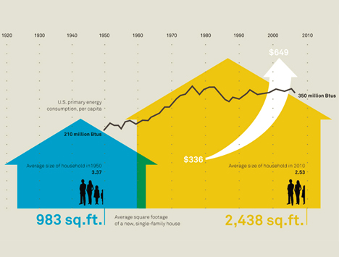What is driving our race for space? For the vast majority of families, it’s definitely not kids: in fact, the North American birth rate has dropped since the ’50s from an average of 3.6 kids per family (think “post-war baby boom”) to just 1.8. It’s also not that we need more room: a study published in a fascinating book called *Life at Home in the 21st Century* showed that only a small portion (40%) of a home’s square footage is used with any regularity by the humans who live there.[23]

1950 house vs 2010 house, compared for size, occupants and energy use. From the Wall Street Journal.

The Center on Everyday Lives of Families at the University of California put together a look at how Americans typically use all that space (and stuff) in their homes. The study examined 32 middle-class families over the course of four years -- 2014, 2015, 2016, and 2017, respectively. A part of this study monitored and collected data on where in the home people spend the majority of their time (represented by the red dots).

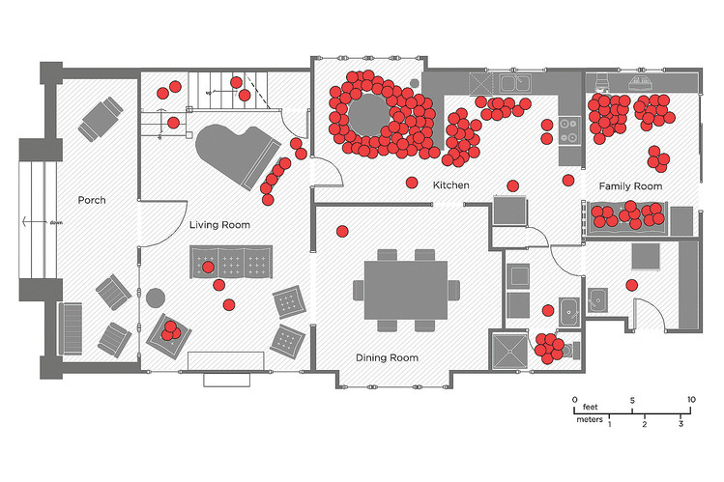The graphic of the floor plan depicts one such family and where they spend time within their home. The house’s total square footage appears to be large and spaced out with a place for a separate living and formal dining room, as well as space for a piano, a laundry room, and a huge front porch.[24][25]

***Affordable housing crisis***

Another reason to look at tiny homes is to consider them a solution to affordable housing crises. An *affordable housing crisis* refers to a situation where a significant portion of the population, particularly low-income individuals and families, face challenges in finding safe, decent, and affordable housing. It occurs when the demand for affordable housing outweighs the available supply, leading to rising housing costs, inadequate housing options, and housing instability for vulnerable populations.

Several factors contribute to an affordable housing crisis:

* High housing costs: Rapidly increasing housing prices, rising rents, and limited affordable housing options make it difficult for individuals and families with lower incomes to find affordable housing within their means.
* Insufficient supply: In some areas, there is a shortage of affordable housing units relative to the demand. This can be due to factors such as limited land availability, zoning restrictions, lack of funding for affordable housing programs, or inadequate investment in affordable housing development.
* Income disparities: Stagnant or slow-growing incomes, coupled with the rising costs of housing, create a widening gap between income levels and housing expenses. This makes it increasingly challenging for low-income households to afford suitable housing without a disproportionate burden on their budgets.
* Gentrification and Displacement: *Gentrification*, which is the process of renovating or revitalizing neighborhoods, can lead to higher property values and rents, displacing lower-income residents who can no longer afford to live in the area.
* Homelessness: The lack of affordable housing options can contribute to homelessness, as individuals and families struggle to secure stable housing and may end up living in temporary shelters or on the streets.

The affordable housing crisis has wide-ranging social and economic impacts. It can exacerbate poverty, increase housing insecurity, hinder economic mobility, strain social services, and contribute to inequality within communities.

Addressing the affordable housing crisis requires a multifaceted approach, including policies and initiatives aimed at increasing the supply of affordable housing, implementing rent control measures, promoting mixed-income developments, providing subsidies and rental assistance programs, and addressing systemic issues that contribute to income inequality and housing disparities. Collaborative efforts among government entities, nonprofit organizations, and private sectors are often necessary to tackle this complex issue and ensure access to affordable housing for all.

North Carolina, like many other states, faces challenges related to the affordable housing crisis. Here are a few examples that highlight some aspects of the issue in North Carolina:

1. 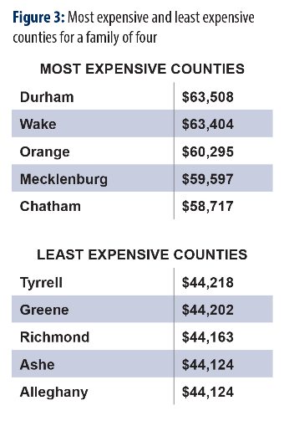Rising Rents in Urban Areas: Cities such as Raleigh, Charlotte, and Asheville have experienced significant population growth and economic development, which has led to an increase in housing costs. Rising rents outpace income growth, making it difficult for low- and moderate-income individuals and families to afford housing in these areas. See chart.[26]
2. Shortage of Affordable Rental Units: There is a shortage of affordable rental units across the state, particularly for extremely low-income households. Many families struggle to find safe and affordable rental housing options, resulting in housing instability, overcrowding, and, in some cases, homelessness.
3. Displacement and gentrification: The revitalization of certain neighborhoods, particularly in urban areas, can lead to increased property values and the displacement of long-time residents. As neighborhoods undergo gentrification, low-income residents may be forced to move to areas with fewer resources and amenities or face homelessness.
4. Rural housing challenges: Affordable housing issues are not limited to urban areas. Many rural communities in North Carolina also face housing challenges, including limited access to quality housing options, inadequate infrastructure, and a lack of affordable rental housing.
5. Affordable homeownership: Access to affordable homeownership is also a concern in North Carolina. High home prices and limited availability of affordable mortgage products can make it challenging for low- and moderate-income households to purchase homes, perpetuating the cycle of renting and limiting wealth-building opportunities.
6. Hurricane and natural disaster effects: North Carolina is prone to hurricanes and other natural disasters, which can exacerbate the affordable housing crisis. Displacement and property damage following these events can lead to a shortage of affordable housing options and further strain on vulnerable populations.

Addressing the affordable housing crisis in North Carolina requires a comprehensive approach involving various stakeholders, including government agencies, nonprofit organizations, developers, and community members. Strategies may include increasing funding for affordable housing programs, promoting mixed-income developments, incentivizing affordable housing construction, and implementing policies to protect tenants and prevent displacement.

Tiny homes can contribute to addressing the affordable housing crisis in several ways:

* Cost-effective housing: Tiny homes are generally more affordable to build or purchase compared to traditional homes. Their smaller size requires fewer materials and less land, which can result in lower construction costs. This affordability makes them more accessible to individuals and families with limited financial resources. (Portland, Oregon has used tiny houses to address its homelessness problem: <https://www.shareable.net/in-a-tiny-house-village-portlands-homeless-find-dignity/?gclid=Cj0KCQjwho-lBhC_ARIsAMpgMof8oI7y0UIMzISyTmYahb_86QVLK2X7yLmX9SpVpaCeOfLg24WJPqMaAolYEALw_wcB>.
* Lower utility costs: Tiny homes are typically designed to be energy-efficient and have smaller footprints, resulting in reduced energy consumption and lower utility costs. This can significantly benefit residents, especially those with limited incomes, by reducing the burden of ongoing expenses.
* Increased housing supply: Tiny homes can help increase the available housing supply, particularly in areas with limited space or high land costs. They can be placed on small plots of land or as infill housing in existing neighborhoods, effectively utilizing underutilized or vacant spaces.
* Flexible and Innovative Housing Solutions: Tiny homes offer flexibility in terms of design and placement. They can be built on wheels, allowing for mobility and the possibility of living in different locations. Additionally, they can be incorporated into mixed-use developments, accessory dwelling units (ADUs), or as part of transitional or supportive housing initiatives.
* Housing for Specific Populations: Tiny homes can be designed to meet the specific needs of vulnerable populations, such as homeless individuals, veterans, or seniors. They can provide temporary or permanent housing solutions and be tailored to accommodate accessibility requirements.
* Sustainable and Minimalist Living: Tiny homes often promote sustainable practices and a minimalist lifestyle. They require fewer resources to build and operate, emphasize efficient use of space, and encourage reduced consumption. This aligns with environmental sustainability goals and can contribute to a more sustainable housing sector.

While tiny homes offer potential solutions to the affordable housing crisis, it's important to note that their impact may be limited in some regions due to zoning regulations, building codes, and infrastructure requirements. Collaborative efforts among policymakers, communities, and housing advocates are essential to create supportive policies, address regulatory barriers, and promote the integration of tiny homes into affordable housing strategies.

**CONCLUSION**

The tiny house is not for everyone, but micro-housing is a growing movement. Tiny houses are the focal point in a broader system to address issues, concerns, and problems of the current day. They offer a path to a smaller environmental footprint, greater financial freedom, and ultimately a self-sufficient life. The tiny home movement enables individuals to live their lives on their own terms.

Anyone who is concerned about life simplification, environmental consciousness, self-sufficiency and a smaller footprint on this planet should consider tiny houses as a viable option for housing.

**ADDITIONAL RESOURCES**

If you're interested in learning more about tiny houses and exploring different aspects of the tiny house movement, here are some resources that you might find helpful:

***Books***

"*The Big Tiny: A Built-It-Myself Memoir*" by Dee Williams: In this memoir, Dee Williams shares her personal journey of downsizing from a three-bedroom house to an 84-square-foot tiny house on wheels. She provides insights into the challenges and joys of living in a tiny house and the lessons she learned along the way.

*Tiny House Design & Construction Guide* by Dan Louche: This comprehensive guidebook covers the process of designing and building a tiny house. It includes information on construction techniques, material selection, building codes, and other practical considerations for creating your own tiny house.

*Tiny House Living: Ideas for Building and Living Well in Less than 400 Square Fee*t by Ryan Mitchell: Ryan Mitchell explores various aspects of tiny house living, from design principles and space optimization to downsizing and simplifying one's lifestyle. The book features real-life stories of individuals who have embraced tiny house living.

*Tiny House Floor Plans: Over 200 Interior Designs for Tiny Houses* by Michael Janzen: This book is a valuable resource for anyone interested in designing their own tiny house. It offers a collection of floor plans and interior designs for different types of tiny houses, providing inspiration and practical ideas for maximizing space.

*The Tiny House Handbook* by Charlie Wing: This comprehensive guide covers a wide range of topics related to tiny houses, including design considerations, construction techniques, energy systems, and legal considerations. It offers practical advice and tips for building and living in a tiny house.

*Tiny Homes: Simple Shelter* by Lloyd Kahn: This book highlights a collection of unique and innovative tiny homes from around the world. It features beautiful photographs and descriptions of various designs, highlighting the creativity and diversity within the tiny house movement.

These books provide different perspectives and insights into the world of tiny houses, and they can serve as valuable resources for inspiration, practical guidance, and understanding the lifestyle associated with tiny house living.

***Websites***

An excellent website on tiny homes covering a lot of information is <https://thetinylife.com/>

Tiny House Design: The website [tinyhousedesign.com](https://d.docs.live.net/2e8f03f2cc863ba9/Documents/COURSES_On%20Demand/TINY%20HOUSES/tinyhousedesign.com) provides a wide range of resources, including illustrations and design concepts for tiny houses.

PAD Tiny houses: Run by Joan Grimms & Dee Williams, Portland Alternative Dwellings has been influential for the tiny house movement for many, many years. <http://padtinyhouses.com>

Tiny House Build: Gabriella and Andrew built their own tiny house, and offer its plans online, as well as loads of resources on their blog and a how-to construction DVD. <http://tinyhousebuild.com>

The Tiny Project: Alek designed and built his tiny house in 2013. His resource page is loaded with books and guides, including the best water heaters, must have tools, the best modern tiny house plans and more. <http://tiny-project.com>

The Tiny Life: Ryan over at the tiny life keeps super busy. He runs the Tiny House Conference each year, regularly blogs about his experience and tests of building and living in a tiny house, as well as writes short ebooks to help get through some of the hurdles with tiny houses. Two of his books are *Cracking the Code* (building codes for tiny houses) and *Shockingly Simple Electrical?* (Guide for electrical for tiny houses). <http://thetinylife.com/>

Life in 120 Square Feet: This site has a large collection of photos (over 300+ online). <http://www.120squarefeet.com/>

Tiny House Design: This site shares interestingly designed tiny houses. <http://www.tinyhousedesign.com/>

Tiny House Blog (tinyhouseblog.com): This website offers a wealth of information on tiny houses, including design ideas, construction tips, and stories from people who have built and lived in tiny homes.

Tiny House Talk (tinyhousetalk.com): It is a popular platform that features news, articles, and discussions about tiny houses. You can find a variety of topics, including tiny house tours, design inspiration, and product reviews.

The Tiny Life (thetinylife.com): This website covers various aspects of living in a tiny home, from downsizing and organization to sustainable living and minimalism. It provides practical advice, resources, and a supportive community.

Tiny House Design (tinyhousedesign.com): This website focuses on architectural and design aspects of tiny homes. It offers free plans, design ideas, and tutorials to help you create your own tiny house.

Tiny House Community (tinyhousecommunity.com): If you're looking for a community-oriented website, Tiny House Community provides a platform for connecting with like-minded individuals, sharing experiences, and finding resources related to tiny homes.

Tiny House Magazine (tinyhousemagazine.co): This online magazine features articles, interviews, and case studies on tiny house living. It offers insights into different aspects of the tiny house movement, including design, construction, and lifestyle.

***Illustrations and Plans***

Books: Many of the books mentioned earlier, such as *Tiny House Floor Plans* by Michael Janzen or *Tiny Homes: Simple Shelter* by Lloyd Kahn, contain illustrations and floor plans of various tiny house designs. These illustrations can give you a visual representation of different layouts and architectural styles.

Tiny House Design: The website tinyhousedesign.com provides a wide range of resources, including illustrations and design concepts for tiny houses.

Pinterest: Pinterest is a popular visual discovery platform where you can find a wealth of tiny house illustrations, photos, and design ideas. You can search for specific terms like "tiny house illustrations" or "tiny house floor plans" to find relevant content.

Instagram: Instagram is another platform where many tiny house enthusiasts and designers share their work. By searching for hashtags like #tinyhouseillustration or #tinyhousedesign, you can discover a variety of illustrations and design concepts.

Online Image Search: Conducting a simple image search using search engines like Google or Bing can yield a range of illustrations and visual representations of tiny houses. You can refine your search by using specific keywords such as "tiny house illustrations" or "tiny house floor plans" to find relevant images.

Architectural Magazines and Publications: Architectural magazines often feature articles and illustrations of unique and innovative housing designs, including tiny houses. Examples of magazines that may highlight tiny house illustrations include *Dwell*, *Tiny House Magazine*, and *Green Builder.*

***Presentation***

Worth reviewing for its NC specific discussion and illustrations. <https://www.orangecountync.gov/DocumentCenter/View/443/Wishbone-Tiny-Homes-PDF>

**AUTHOR**

Deborah H. Long is a licensed real estate instructor in North Carolina. She completed her doctorate in educational leadership in 1994. Her research on the effect of ethics instruction on the ethical reasoning of real estate brokers received national media and industry attention. She has three other college degrees. She has been a teacher for more than 52 years.

In addition to holding a GRI (Graduate Realtor Institute) and CRS (Certified Residential Specialist) designations, Deborah earned the DREI (Distinguished Real Estate Instructor), the most prestigious designation for excellence in teaching offered by the Real Estate Educators Association.

She is the award-winning author of many articles and education programs as well as 25 real estate textbooks. Her real estate ethics program for educators received the "Best Single Education Program" award from the Real Estate Educators Association in 1996 and from the NC Real Estate Educators in 2014. In 2001, the North Carolina Real Estate Educators Association recently recognized Deborah as "Educator of the Year." She was also the editor of the prestigious *REEA Journal* for 10 years.

Deborah's real estate ethics research has been featured in the Wall Street Journal and on numerous radio talk shows. Her research has led her to write *Doing the Right Thing: A Real Estate Practitioner's Guide to Ethical Decision Making*, now available in its 4th edition.

She has been a proponent of online education since it became available and has taught numerous educators about technology. She earned the prestigious Certified Distance Education Instructor designation from ARELLO (Association of Real Estate License Law Officials).

Deborah provides real estate continuing education in Chapel Hill, North Carolina, her home, as well as around the state and country. Deborah was named Tar Heel of the Week in 2017 for her contributions to the community. Deborah can be reached at DebbieTheTeacher@gmail.com.

1. Sarah is now based in Raleigh. See her website: <https://susanka.com/not-so-big-house/>
2. If you are interested, there is a YouTube presentation by Johnson here: https://www.youtube.com/watch?v=QXDfnLvVsn8
3. https://www.oprah.com/own-oprahshow/inside-a-96-square-foot-home-video
4. <https://www.ipasd.com/blog/how-big-is-that-house-how-to-understand-square-footages#:~:text=200%20sq%20ft,a%2014x14%20square%20foot%20bedroom>.
5. <https://www.tinyhouse.com/post/north-carolinas-tiny-home-rules-and-regulations#:~:text=Yes%2C%20tiny%20homes%20are%20legal,even%20for%20a%20whole%20year>.
6. For more information on manufactured housing dealer licensure and requirements, contact the NC Manufactured Building Division of the NCDOI at (919) 647-0058 or visit their website at <https://www.ncosfm.gov/manufactured-bldg/mbd-licensing>.
7. Take a look at Raleigh’s ADU zoning page here: <https://raleighnc.gov/permits/services/building-accessory-dwelling-unit-adu/adu-faqs>
8. See <https://www.ncleg.net/Sessions/2013/Bills/House/HTML/H625v4.html>
9. <https://www.tinysociety.co/articles/tiny-house-laws-united-states/>
10. <https://library.municode.com/nc/wilmington/codes/code_of_ordinances?nodeId=PTIIITECO_CH16BUBURE_ARTVMIHOCO_DIV4MISTEQFA_S16-269EXINSTGE>
11. <https://getjerry.com/home-insurance/north-carolina-tiny-house-laws#what-kinds-of-tiny-houses-are-permitted-in-north-carolina>
12. *NCREC Bulletin* 2002-V33-1 By Blackwell M. Brogden, Jr., Chief Deputy Legal Counsel
13. This article came from the June 2002-Vol33-1 edition of the *NCREC Bulletin*.
14. For ideas on tiny home furniture, go here: <https://www.tinysociety.co/articles/tiny-house-furniture/>
15. To see the assembly of a SIPs tiny house, watch a video here: <https://www.thetinyhouse.net/build-sips-tiny-house/>
16. For furniture ideas, go here: <https://www.tinysociety.co/articles/tiny-house-furniture/>
17. <https://www.fool.com/the-ascent/research/average-house-price-state/> It's important to note that housing prices can vary significantly based on the region. For example, major metropolitan areas and coastal cities tend to have higher home prices compared to rural or less densely populated areas. Additionally, the housing market is subject to fluctuations, and prices can change over time.
18. <https://www.fool.com/the-ascent/research/average-house-price-state/>. It's important to note that housing prices can vary significantly based on the specific city or region within North Carolina. Urban areas and popular coastal cities like Raleigh, Charlotte, and Asheville often have higher home prices compared to rural or less densely populated areas.
19. <https://www.nationaldebtrelief.com/blog/lifestyle/lifestyle-articles/tiny-house-save-money/#:~:text=There%20is%20little%20doubt%20that,have%20no%20credit%20card%20debt>.
20. A composting toilet is typically a waterless system that uses decomposition and evaporation to recycle human waste. It’s not an outhouse or even a port-o-potty, but a physical toilet that can convert solid waste into compost through the composting process. Not only do they compost human waste, but also toilet paper while still remaining odorless. They do this by creating an oxygen-rich environment that enables aerobic bacteria to break down the waste. They come in different sizes, systems, and tank capacities.
21. See <https://www.ncrec.gov/Pdfs/Bicar/Contracts.pdf>
22. An excellent review of statistics regarding tiny home ownership can be found here: <https://www.rubyhome.com/blog/tiny-home-stats/>
23. <https://thinksaveretire.com/think-you-need-a-2000-sqft-house-to-be-comfortable-think-again/>
24. <https://ssgs.ucla.edu/centers/center-on-the-everyday-lives-of-families-celf-2/>
25.
26. <https://www.ncjustice.org/publications/the-2019-living-income-standard-for-100-counties/>