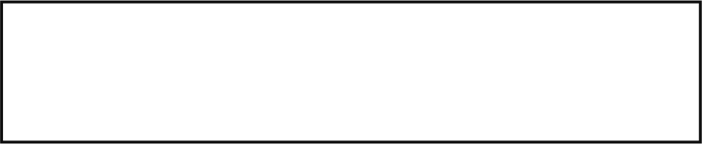
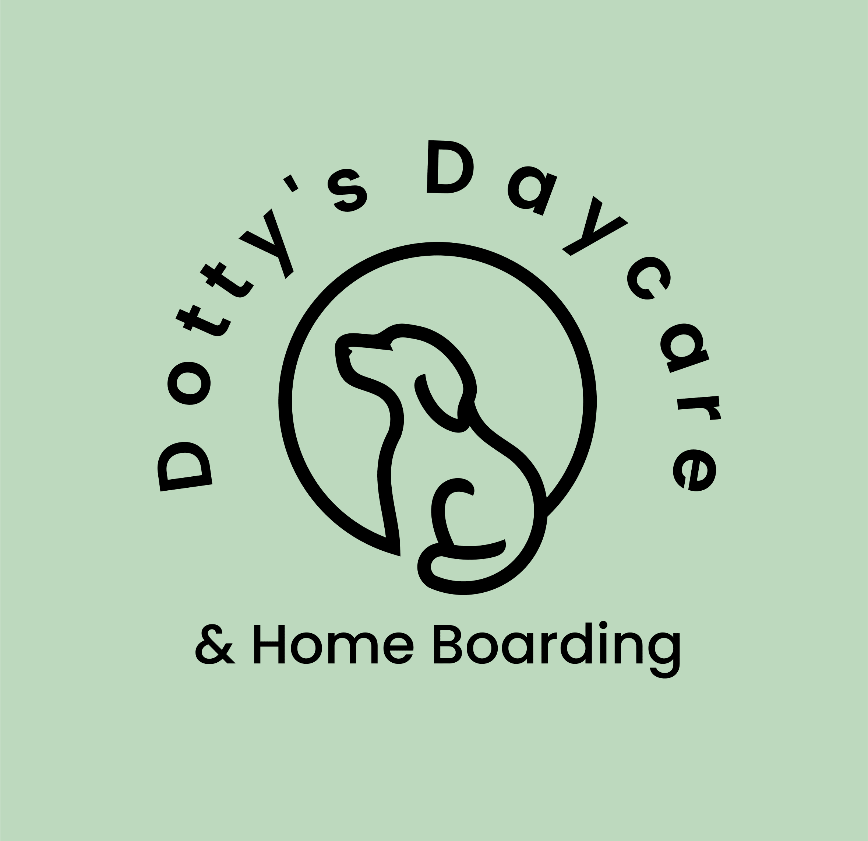
DDHB Terms and Conditions
Name of dog/s –
Date of booking –
Name of Owner’s –

All bookings, either confirmed or pending are subject to DDHB Terms and Conditions. If you have any questions, please don’t hesitate to contact Rachel on 07971260004 or email Dottysdaycare@hotmail.com

Health and Safety (including medical care) -
- 1. You will present the dog for home boarding in a clean and groomed condition with appropriate and clean grooming equipment, an up-to-date vaccinations card and evidence of de-flea and anti-worming treatments given prior to staying.
- 2. All dogs must be treated for fleas and worms no more than 2 weeks prior to arrival for home boarding. In the event of flea infestation your dog will be treated, and any household treatment required will be at your expense. You agree that a flea infestation in our home is a very serious matter and must be avoided at all stays.
- 3. You confirm that you are the legal owner of your dog/s.
- 4. You confirm that your dog has not been ill with any contagious disease or condition within the past 30 days.
- 5. Public Liability Insurance: Dogs accepted are covered for the period of boarding.
- DDHB have public liability insurance with Pet Business Insurance, ref ACE025028 and our date for renewal is April 2025. Our cover includes Dog Walking, Dog Daycare, Pet Home Boarding, Pet Minding, Pet Sitting and Wedding Chaperone.
- 6. Dog Insurance:
- You are encouraged to have up to date dog insurance for your dog/s, which will be kept on your dog/s contact file in case of an emergency. We recommend that as a minimum your dog is insured against sickness, accident, or injury and for third party liability prior to boarding.
- 7. You agree that if you instruct DDHB (see booking form) to exercise your dog off the lead, you are accepting third-party liability for any incidents which may occur. If your dog/s is involved in a fight with another animal or person causing any damage or injury, you agree to be responsible for any expenses incurred (DDHB will supply receipts to evidence expenses) including payment of veterinary fees or any medical treatment required.
- 8. You agree that your dog/s will be exercised outside of our private garden space unless advised differently by owner. Transport via car will take place for your dog as per consent and instructions received on booking form.
- 9. Contact details must be completed on DDHB booking form to ensure that details are provided for your normal Veterinary Practice and an emergency contact other than yourself or someone you are away with who can be contacted (within the UK) if we are unable to get hold of you. The emergency contact needs to be aware that they are your emergency contact and may need to collect dog/s in case of an emergency.
- 10. DDHB will use all care to ensure the happiness, safety and welfare of your dog/s. Reasonable efforts will be made to contact you and your emergency contact if your dog/s become unwell or have an accident during their boarding. However, DDHB reserves the right to make decisions regarding your dog’s health ensuring it is in the best interests of the dog and on the advice of a Veterinary Surgeon. If your dog becomes unwell, has an accident, or injures himself/herself or seems to be in any type of pain, we might need to take him/her to a Veterinary Surgeon, and you agree to be responsible for payment of all the Veterinarian fees incurred.
- 11. DDHB will care for your dog as you would, and every effort will be made to ensure your dog/s is cared for to a high standard however we cannot be liable for loss, injury, or death either inside or outside of our home whilst your dog/s are in our care.
- 12. You understand that under no circumstances will DDHB be liable for consequential damages or damages beyond the replacement value of your dog.
- 13. At our discretion, DDHB may agree to have an unneutered bitch boarded with us. However, this will be discussed and documented separately with the owner. DDHB will add an additional charge of £10 a night for any bitch that does come into season whilst being boarded with us. The owner will also need to cover any additional costs of training pads, additional bedding or cleaning equipment which may be needed to avoid and treat any staining caused by bitch being in season. The additional £10 a night is to cover the cost of additional care needs for your bitch in season including additional separation from our other resident female dog, separation from our children in home and walking your bitch during unsocial hours to avoid attention from other male dogs.
- 14. All reasonable efforts will be made to administer oral, rectal, and topical medication and treatments as directed by the owner, for which there is no charge. However, if veterinary assistance is required or more medication is needed it will be at the owner’s expense.
- 15. You are giving permission to board your dog/s with our resident dog and consent to your dog/s sharing internal and external space with our resident dog. DDHB would not be able to accept any booking form unless a DDHB introductory meeting has taken place at a convenient time for all parties. The potential clients and their dog/s alongside our resident dog and the license holder would need to be in attendance for the DDHB introductory meeting. DDHB also advises that for bookings over 3 nights then a paid overnight trial is recommended.
- 16. You recognise the risks associated with DDHB transporting your dog in our car, e.g., travelling to a vet, going on a walk or on a day out with our family and you expressively relinquish all claims against DDHB.
- 17. DDHB is able to accommodate 3 dogs (plus resident dog) from different households at any one time. Therefore, whilst you have a booking in place with DDHB there may also be other bookings in place at the same time for other dogs (unless additional charge has been paid to secure ‘one household’ booking). It is imperative for DDHB that our focus is the safety of our family and resident dog therefore, for periods where we have more than one booking our main priority is everybody’s safety and ensuring the right environment for the dogs staying with us. A number of factors will be considered e.g. type of breed, size of dog, health and behaviour before another additional bookings are made for the same dates.
- 18. If DDHB decide that your dog/s would not be suitable to board alongside another booking, this is at our discretion and Rachel’s decision is final.
- 19. Regardless of the number of households staying with us, it is still the responsibility of all dog owners to advise us of their dog’s behaviour and ensure they are meeting the terms as stated in the text within this document. Any failure to follow our terms and conditions will result in your booking being terminated, no refund of booking costs, contact made with emergency contact to collect your dog/s and alternative accommodation being found at owner’s expense.
- 20. If your dog/s wear a smart tag on their collar, it is necessary to share the details for this with Rachel to ensure that Rachel can locate the dog during their stay with us, if needed. Otherwise please remove the smart tag and a Dotty’s Daycare & Home Boarding tag will be put on their collar for the duration of their stay with us.

Food and Nutrition
- 1. You will need to supply the necessary dog food and treats for the duration of the dog/s home boarding stay. If additional food must be purchased, then upon presentation of a receipt, this money is owed back to DDHB by dog/s owner.
- 2. All food must be in date and kept in original packaging if possible. If this is not possible then food must be labelled with dog/s name, food type and expiry date.
- 3. Any special dietary requirements or storage of dog food must be declared in the booking form.
- 4. Any changes in your dog’s diet / brand of food needs to be in place at least 4 weeks prior to staying with us at DDHB.

Behaviour
- 1. We are unable to accept bookings for any dogs that have exhibited aggression towards other dogs and/or people as we have children in our family home and a resident dog.
- 2. We are unable to offer boarding to any breeds which are subject to the terms of the Dangerous Dogs Act 1991.
- 3. You agree to make full disclosure of any quality or characteristic which might make your dog not suitable for home boarding with our family, including but not limited to behavioural or health problems, anti-social behaviour including aggression, incontinence/lack of housetraining or excessive loud barking/whining. Failure on your part to disclose any matter which might render the dog unsuitable for home boarding and will be deemed a material omission amounting to a fundamental breach of this agreement. You will also be liable for additional costs if DDHB experiences difficulties due to failure to disclose in the booking form any matter that would be accepted as reasonably unsuitable for home boarding.
Initially DDHB will contact your emergency contact and ask for your dog/s to be collected immediately (no refunds given). If necessary DDHB will endeavour to find boarding kennels for your dog/s, but there will be no refund of the boarding fees you have paid to DDHB and any additional fees charged by the kennel will be payable by you. Every effort will be made to avoid such an event by you providing an honest account of your dog/s and having open discussions during our DDHB introductory meeting and multiple contact methods for DDHB correspondence to understand your dog/s in more detail.
- 4. Any damages caused by your dog/s to our home or possessions other than reasonable wear and tear will be paid for by you directly to the owner of DDHB Ltd upon collection of your dog/s
Bookings
- 1. The booking will only be finalised once the completed booking form and signed terms and conditions document is emailed to DDHB. An email confirmation, relevant consent forms and an invoice will then be sent over to you. A 50% deposit for the booking is required within 48hrs of the owner/s receiving this email confirmation. If this payment is not received within 48hrs, we will not be able to keep bookings open and the dates will be released again.
- 2. The 50% deposit is only refundable if you cancel within 10 days of deposit being paid. On the 11th day onwards, you will not be able to have a refund of this deposit. If the date of your dog/s stay needs to change, there is one transfer option available if the date you request is available. If this revised date becomes unsuitable or the booking needs to be cancelled the deposit will not be refunded.
- 3. Your outstanding balance needs to be paid by 8am on the day your dog/s home boarding starts with us. Payment will need to be made prior to dog being dropped off.
- 4. No refunds/reductions will be given within 2 weeks of your dog/s drop off dates if your holiday dates change and you need less nights / daycare. Owner’s will still need to pay the full amount on their invoice regardless of whether they collect the dog/s earlier than the original dates booked.
- 5. If DDHB is unable to fulfil a booking, we will use all reasonable endeavours to arrange an introduction to another suitable boarding service. If we are not able to recommend an alternative boarding service, we will refund your booking deposit.
- 6. GPDR - The information you provide will be kept on record for a 3-year period from the date noted alongside your signature on the booking form. We will never pass on your details to any other party and will not contact you related to anything other than DDHB related business or perhaps to say hello and see how you & your dogs are getting on!
- 7. If you collect your dog/s before the confirmed end date of your booking, you will not receive a refund.
- 8. By paying your deposit you are confirming your booking and therefore entering a legal contract with Dotty’s Daycare & Home Boarding LTD to these terms and conditions.
- 9. For a booking of 3 nights or more, a paid overnight trial must take place prior to your booking for all dogs staying with us. This is part of our licensing conditions, and it is in the best interest of the dogs to make sure that they are comfortable in our home environment.

Social Media / Photograph usage (please answer either yes or no next to each question)

Yes |  | Are you happy to receive updates on your dog/s whilst they are in our care? This would be in the form of text, photos, or videos.
No

Yes |  | Are you happy for DDHB to take photos or videos of your dog/s for the sole purpose of sending you updates?
No
Yes |  | Are you happy for the license holder to wear a video recorder at times whilst walking your dog/s, to have footage of their walk? This is not for public use.
No
Yes |  | Are you happy for your dog/s to be monitored via a camera whilst they are in our property unattended? This is for the sole purpose of ensuring your dog/s are happy and calm.
No

Yes |  | Are you happy for DDHB to use your dog/s picture and name (no other contact details) on our social media platforms i.e., Facebook and Instagram to highlight the activities we get up to and the service offering provided by DDHB.
No

I confirm that I am the owner of the above-mentioned dog/s. I have understood and agree to the above terms and conditions. I also confirm that the information supplied is correct and that any additional information or changes will be communicated to Dotty Daycare Home Boarding as soon as possible.
Print name -
Signature -
Date -

Future bookings only
Please review this form thoroughly and fill in the relevant boxes below to confirm that you still agree with the terms and conditions for boarding your pet/s at DDHB.
Check in date and time:
Check out date and time:
Signature -
Print name -
Date -

