

Hello PHBA Member,

In an effort to keep you up to date on our Events, I have created a Calendar that can be added to your Current Calendar. If any changes are made / or as I update it – if you add this to your Calendar, then your Calendar will be updated automatically.

If it is a GOOGLE Calendar:
https://calendar.google.com/calendar/u/1?cid=NjQ4NmM3NmYyNjVkZjA5MzgyY2ExZTA0MzhkNDBmOGE4ZDljMjMwZTE5ZTM4ODhmYzE5MTlkYTBjMzc5MTY0MkBncm91cC5jYWxlbmRhci5nb29nbGUuY29t

If it is an OUTLOOK Calendar:
Click ADD CALENDAR
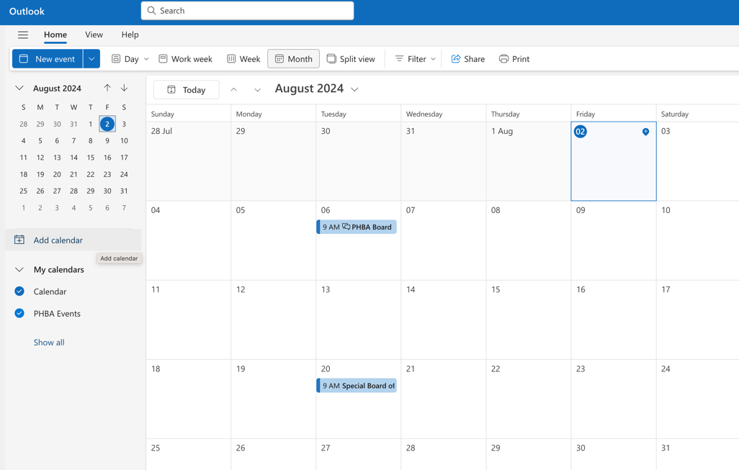

Then Click: SUBSCRIBE FROM WEB
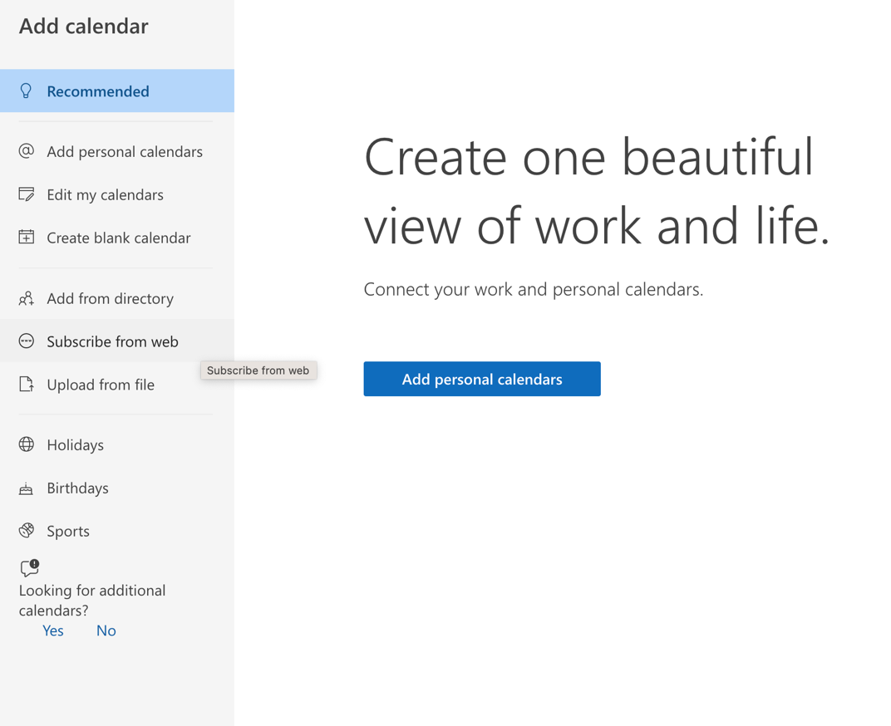

ADD THIS LINK: https://calendar.google.com/calendar/ical/6486c76f265df09382ca1e0438d40f8a8d9c230e19e3888fc1919da0c3791642%40group.calendar.google.com/public/basic.ics

NAME YOUR CALENDAR / ADD A COLOUR CODE
Then Click: IMPORT
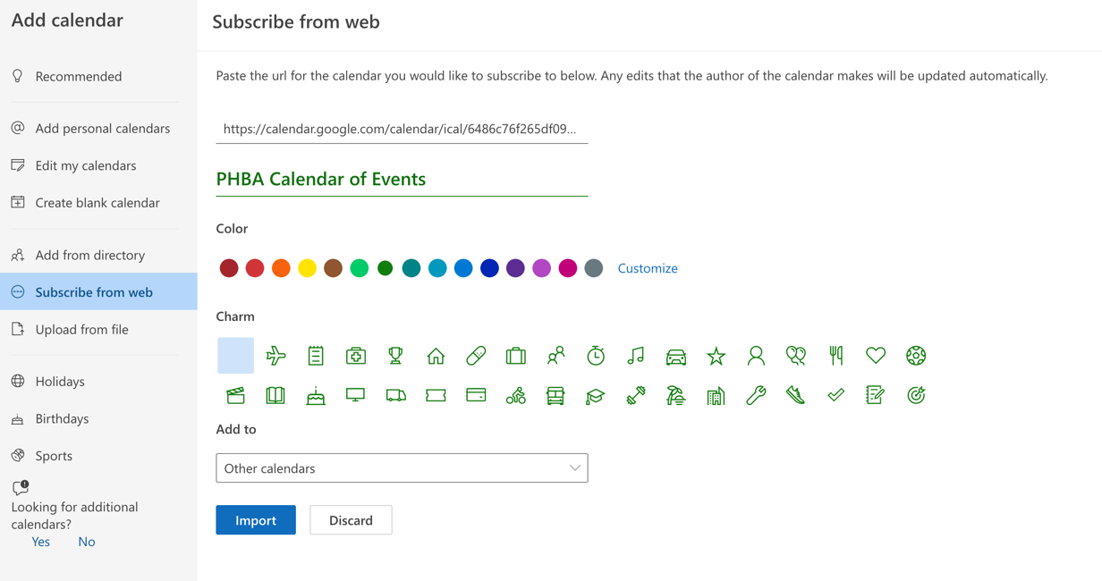

Any questions, please let me know.
Best Regards,

Melissa Schenk
Executive Officer
Cell: (519) 276-0006

MEMBERSHIP MATTERS! CALL A MEMBER FIRST



Perth-Huron Builders Association
P.O. BOX 23024 Station Main, Stratford, ON N5A 7V8

