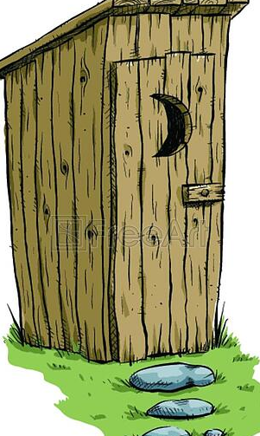
San Juan County Fair
Outhouse Race
Entry Form

Monday, August 10 at 6:30pm (Teams & Outhouse must be present at 6:00pm, for inspection)

ENTRY DEADLINE:August 10th at noon.
OUTHOUSE NAME: ______________________________________________________________
TEAM CAPTIAN: ______________________________________________________________
TEAM MEMBERS: ______________________________________________________________
______________________________________________________________________________
MAILING ADDRESS: ______________________________________________________________
PHONE: _______________________________________________________________________
MAIL entries to: San Juan County Fair
FAX entries to: 505-325-2395
P.O. Box 187
Farmington, NM 87401
PRIZES: Cash Prizes will be awarded according to the number of entries!!

ALL entrants must sign a waiver to hold harmless agreement at registration before they can participate in any events.

www.sanjuancountyfair.net

