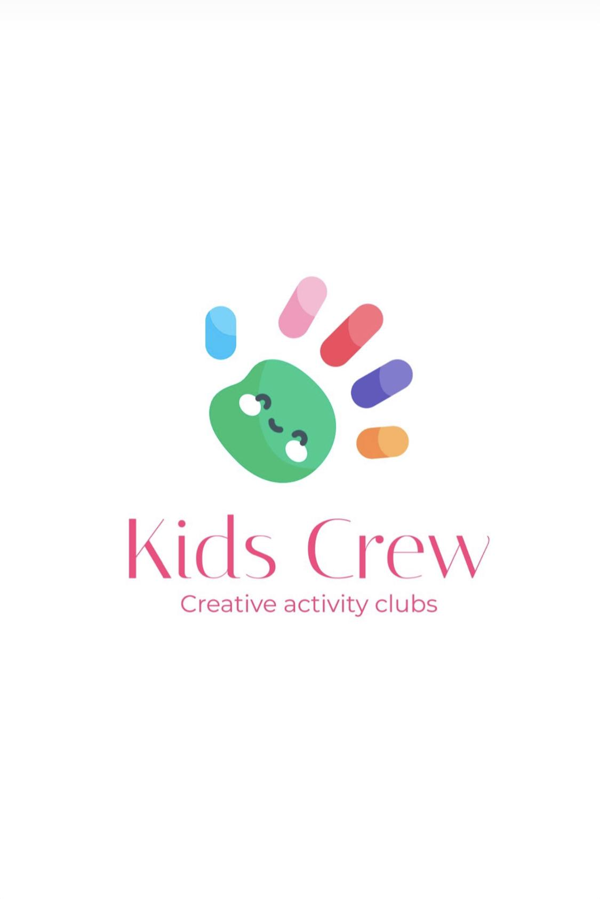Behaviour policy

Kids Crew Activity Club uses effective, positive behaviour management strategies to promote the welfare and enjoyment of children attending the club. Working in partnership with parents, we aim to manage behaviour using clear, consistent and positive strategies. The club rules are discussed in our welcome meetings every day.

Whilst attending Kids Crew we expect children to:
• Use socially acceptable behaviour
• Comply with the club rules, which are agreed by the children attending
• Respect one another, accepting differences of race, gender, ability, age and religion
• Develop their independence by maintaining self-discipline
• Choose and participate in a variety of activities
• Ask for help if needed
• Enjoy their time at the club.

Encouraging positive behaviour
At Kids Crew positive behaviour is encouraged by:
• Staff acting as positive role models
• Older children acting as positive role models/buddies
• Praising appropriate behaviour
• Celebrating achievements verbally
• Informing parents about individual achievements
• Celebrating individuals’ positive behaviour/achievements with a reward at the end of the day
• Offering a variety of play opportunities to meet the needs of children attending the club.

It is inevitable that as children develop and learn, there are times when they need support and guidance to understand that their behaviour is not acceptable. Staff at the camp will try to determine the cause or triggers of the inappropriate behaviour to prevent the situation from recurring. Staff are trained in understanding behavioural difficulties for children with SEN issues eg autism or ADHD. However, as above, inappropriate behaviour cannot be tolerated if it puts other children or staff at risk of harm or takes supervision away from other children.

Dealing with inappropriate behaviour
• Challenging behaviour will be addressed in a calm, firm and positive manner.
• In the first instance, the child will be temporarily removed from the activity in order to have
time out in the chill out area and possibly away from the trigger.
• Staff will explore with the child why the behaviour displayed is deemed inappropriate.
• Staff will give the child an opportunity to explain their behaviour, to help prevent a recurrence.

• Staff will encourage and facilitate mediation between children to try to resolve conflicts through discussion and negotiation/sand timer
• If the inappropriate behaviour appears to be as a result of boredom, staff will consult with the child to find activities that more fully engage them.
• Staff will consult with parents to formulate clear strategies for dealing with persistent inappropriate behaviour.
• We will not threaten any punishment that could adversely affect a child’s well-being (eg withdrawal of food or drink).

If after consultation with parents and the implementation of behaviour management strategies through a behaviour plan, a child continues to display inappropriate behaviour, Kids Crew may decide to exclude the child for a period of time from the club. The reasons and processes involved will be clearly explained to the child and parents.

Physical intervention

Physical intervention will only be used as a last resort, when staff believe that action is necessary to prevent injury to the child or others. If a member of staff has to physically restrain a child, the club leader will be notified and an Incident record will be completed. The incident will be discussed with the parent or carer as soon as possible.
If staff are not confident about their ability to contain a situation, they should call club leader, parents or, in extreme cases, the police.
All serious incidents will be recorded on an Incident record and kept in the child’s file. This may be used to build a pattern of behaviour, which may indicate an underlying cause. If a pattern of incidents indicates possible abuse, we will implement child protection procedures in accordance with our Safeguarding policy.

