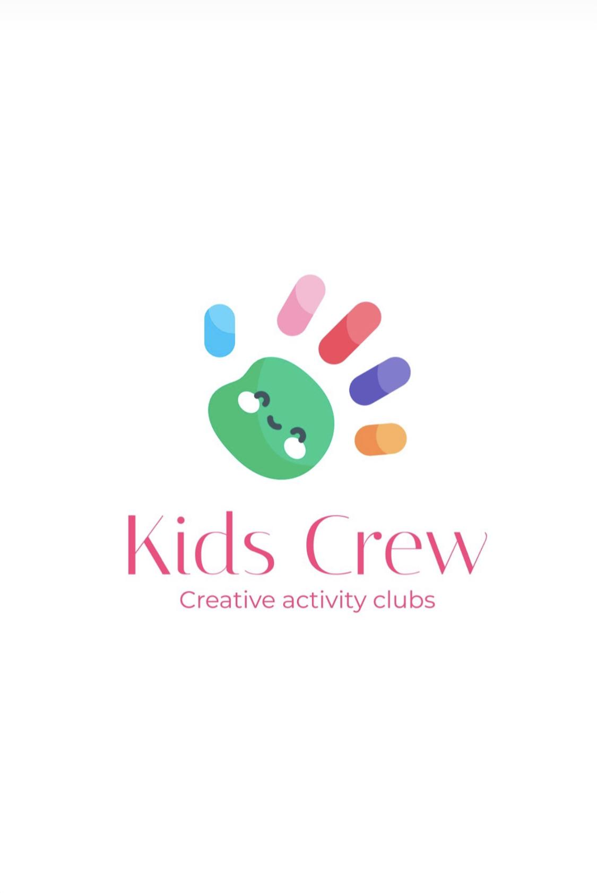Permission to Apply Sunscreen

Sun Protection
Children love to play outside in the sun, but sunburn in childhood increases the risk of developing skin cancer in later life.
Children’s skin is delicate but you can protect their skin by:
• Avoiding the midday sun (between 11am and 3pm)
• Playing in the shade
• Wearing a hat that covers the ears and neck
• Covering up with a T-shirt and wear sunglasses that have UV filters
• Using a minimum of SPF15 sunscreen on exposed skin. Apply sunscreen liberally and reapply regularly.

Kids Crew is concerned about protecting your child from sunburn and skin damage. Please provide a suitable hat, such as a legionnaire’s hat or sunhat. On sunny days, apply sunscreen to any exposed parts.
With your consent we will also help your child apply sunscreen when necessary. Please complete and return the consent form attached below.
" ……………………………………………………………………………………………………………………………………………………
Permission to apply sunscreen
Child’s name: ​
I am happy for my child to have sunscreen applied at Kids Crew activity Club.
Please delete as appropriate:
A. I am happy for my child to use the sunscreen provided by the Club.
or
B. I will provide a bottle of sunscreen labelled with my child’s name for use at the Club.

Signed by parent/carer : ​​ Date: ​
Print name: ​

