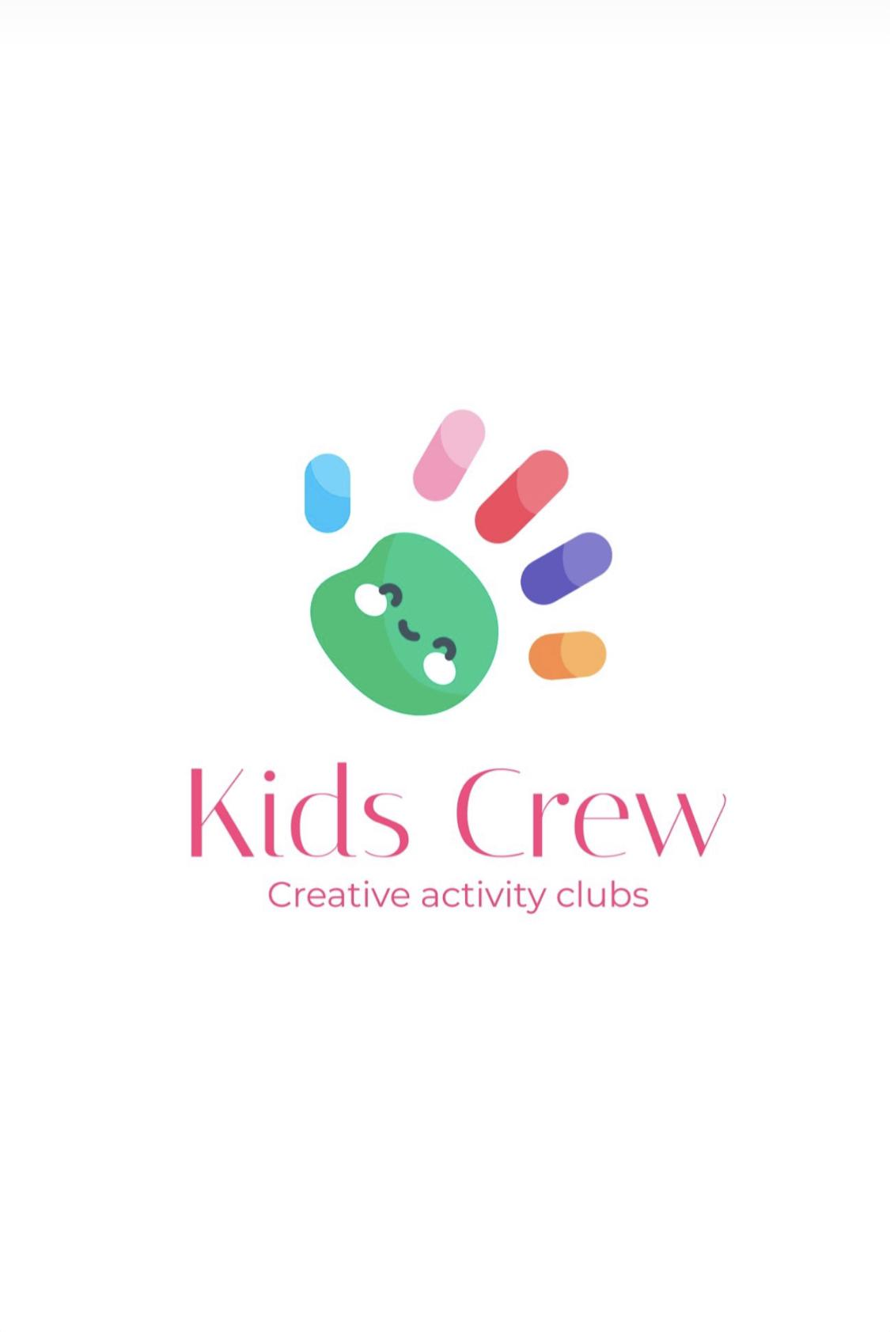Kids Crew aims to provide a safe and enjoyable experience for every child or young person.
To help us do this, please read and complete the following important information.

Name of Child:

• I consent for my child (named above) to attend Kids Crew Activity Club. I understand that the club has policies and procedures (which are available for reference at the club and online), and that there are expectations and obligations relating both to the club and to myself and my child, and I agree to abide by them.
• I understand that Kids Crew Activity Club is a play setting and that whilst my child is there Kids Crew is legally responsible for him/her.
• I will provide my child with a healthy lunch, snack and water bottle.
•Parents and carers must make arrangements for children to be brought to and from the club safely and on time. If a parent or carer is not able to collect their child, they need to let us know in advance who will be doing so to set up a collection password.

• Once my child arrives at Kids Crew he/she will be in the care of Kids Crew until collected and signed out by an authorised person named on their permissions form.
• If my child has a contagious illness I will observe the exclusion period for infection control issued by Public Health England. If I am unsure, I will consult a member of staff.
• It is my responsibility to keep the Club Coordinator informed of any alterations to the information regarding my child (eg contact details, medical conditions, dietary requirements, etc).
• I accept that my child may take part in messy activities while at Kids Crew. I understand that I can provide my child with appropriate or additional clothing to accommodate this if I wish.
• Kids Crew closes at 4.30pm. If, due to unforeseen circumstances, I am going to be late, I will contact the Club Coordinator as soon as possible on 07305455857 .
• If I do not collect my child by 5.30pm, and the club has been unable to reach me or any of my emergency contacts, I understand that Kids Crew will follow its Uncollected Children Policy and contact Social Care.
• Whilst Kids Crew tries to ensure the safety and security of items, I understand that staff cannot be held responsible for loss or damage to my child’s property whilst at the Club.
• I have read the club’s Behaviour Management Policy, agree to its terms, and appreciate that in some circumstances it may be necessary to exclude my child from the club.
• If there are any accidents or incidents at Kids Crew involving my child, I will be informed.
• If my child has an accident at the club, he/she will be treated by a qualified first aider and I will be informed as soon as possible. If my child needs urgent medical treatment and I am unavailable, a member of staff from Kids Crew will sign any consent forms necessary for treatment on my behalf, as stated on the club’s Medical Form.
• Information held by Kids Crew regarding my child will be treated as confidential. However, in certain circumstances, for example if there are child protection concerns, I understand that the club has a legal duty to pass certain information on to other agencies, including Police, Social Care and health care professionals.
• I understand that aggressive and abusive behaviour towards staff will not be tolerated.
• I agree that I will not use a camera, mobile phone or other mobile device on club premises.

I agree to (please tick):
•my child taking part in Kids Crew activity club
• Kids Crew keeping a record of this form and any registration forms for health and safety reasons
• I agree to any medical treatment that my child may need to be given in an emergency
•my child being filmed or photographed during the activity, with the possibility that these photographs/media recordings may be used for advertising purposes on Kids Crew social media pages and website only.
Kids Crew will take all steps to ensure these images are used solely for the purposes for which they are intended.

Note: if consent is not given, Kids Crew will not use any images taken during the activity that contain the names child/young person.

I understand that my child needs to follow the behaviour code and any safety rules so that Kids Crew can keep them and other children safe.

I have read and understood the above terms and conditions and I agree to abide by them.

Signature: ​

Date :

