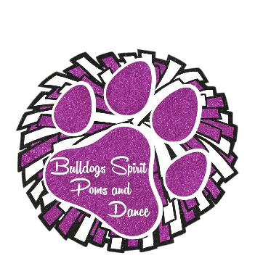

Bulldogsspiritpomsanddance.com
Facebook – Bulldogs Spirit Poms and Dance
“Dance Big, Dream Big, Care Big!”

Registration Form – Fall 2021

Child’s First Name: _____________________________ Child’s Last Name: ________________________
Child’s Birthday: ____________________ Grade Entering as of 8/21 ___________________
Parent(s) First and Last Names: ___________________________________________________________
Address: _____________________________________________________________________________
City: _______________________________________ Zip Code: _________________________________
Parent Cell Phone #1: ________________________________
Parent Cell Phone #2: ________________________________
Parent Email #1: _______________________________________________________________________
Parent Email #2: _______________________________________________________________________
Health Insurance Carrier: ________________________________________________________________
Policy Number/ID Number: ______________________________________________________________
Physician Name: _______________________________________________________________________
Physician Phone Number: ________________________________________________________________
Emergency Contact: ____________________________________________________________________
Emergency Contact Phone Number: _______________________________________________________
Relationship to Dancer: _________________________________________________________________
Allergies, medicines, and any medical conditions we should know about: __________________________________________________________________________________________________________________________________________________________________________
Prior Dance Experience (please circle): Y or N
If so, what kind (please circle)? Ballet Jazz Hip Hop Lyrical Tap Modern Poms Cheer

Please list dance/acrobatic tricks your child knows that you would like us aware of:
_____________________________________________________________________________________
While we CANNOT guarantee we can use all or any of these in our routines, we do our best to highlight skills in routines, depending on the size of the group, choreography, skill levels, etc.

I understand that the IRCA will send a competition waiver to be filled out to the email address I have listed above if we choose to compete with the IRCA. I have no more than one week to complete this waiver, and if the IRCA has to re-send to this, or to another address, I understand there is a $25 fee to have this done, which I, the parent/guardian will have to pay. There will be other competition organizations that we will compete with, who will require a waiver as well. They may be electronic or physical paper copies, as each competition is different and I understand that as soon as they are available all parents must fill them out as soon as possible.

I agree to have my child compete in all competitions our organization has signed up for, for the Fall 2021 Season, barring illness.

Upon signing this document, I am confirming that I have read all 6 documents needed for registration and have agreed to abide by all the rules stated in the documents.

Parent/guardian signature: ______________________________________________________________

T-shirt size (please circle): YS YM YL YXL AS AM AL AXL

How did you hear about us? ______________________________________________________________

------------------------------------------------------------------------------------------------------------------------------------------
Total Paid: Cash_____ Check_____ Paypal _____ $___________
Balance Due: _______________
Signed ___________________________ Date ________________ Relationship to Dancer __________
Parent or Guardian
Signed ______________________________ Date ________________
Bulldogs Spirit Poms and Dance Staff

