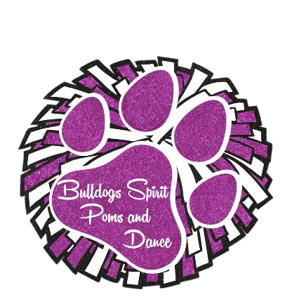

Social Media Contract

Bulldogs Spirit Poms and Dance has engaged in social media as an avenue for families to share specific Bulldogs Spirit Poms and Dance related events, details, organization info and photos. Social media can be defined but not limited to: Facebook, YouTube, group emails or group texts.

As a Bulldogs Spirit Poms and Danceparent, I agree that social media should be used in a positive manner and agree to abide by the following statements.

1. No child, parent, guardian or relative shall use Bulldogs Spirit Poms and Dance social media to communicate negative comments concerning any Bulldogs Spirit Poms and Dance individual (parent, child, coach, volunteer, etc.), competitor, dance or non-dance related issue or Bulldogs Spirit Poms and Dance program in general.
2. Parents of the dancers understand that social media is not an avenue to handle disagreements.
3. The Bulldogs Spirit Poms and Dance organization is NOT responsible for posts on personal pages that are non - Bulldogs Spirit Poms and Dance related. Parent concerns regarding non - Bulldogs Spirit Poms and Dance related issues shall be directed directly to the specific parent or guardian.
4. I, as a parent or guardian, and Bulldogs Spirit Poms and Dance recognize that not all parents are involved in social media (such as Facebook). I, as a parent or guardian, understand that the Bulldogs Spirit Poms and Dance organization will continue to use other avenues as the primary communication, such as email or group texting. I as a parent or guardian, understand that the Bulldogs Spirit Poms and Dance organization is NOT responsible to mass-communicate any post made by a Bulldogs Spirit Poms and Dance parent or guardian regarding a specific/special event or issue.
5. As a parent or guardian, I understand that it is solely my responsibility to monitor my child’s use of social media.
6. I, as a parent or guardian, recognize that any photos personally taken while a team is performing at a competition CANNOT and WILL NOT be posted on ANY social media website. Photos and videos taken are for personal home use only, and may not be placed on social media or the internet. No live streaming or video conferencing is allowed. The IRCA has strict rules pertaining to performance photos and videos being posted and said team will be fined. Any fines received because of photos or videos used will the responsibility of the parent/guardian who posted the picture/video, NOT the Bulldogs Spirit Poms and Dance program.
7. I, as a parent or guardian, understand that any posts or comments made to the Bulldogs Spirit Poms and Dance Facebook page will be monitored by the Bulldogs Spirit Poms and Dance organization.
8. As a Bulldogs Spirit Poms and Dance parent or guardian, I understand that I am ultimately responsible for not only myself, but also my child, and relatives that use Bulldogs Spirit Poms and Dance social media.
9. I, as a parent or guardian, understand that pictures or videos of my child may be taken at practice, competitions or events. I give my permission for any non-competition routine photos or videos to be used for editorial, marketing or advertising purposes, either printed or in electronic form and to be used or posted to the Bulldogs Spirit Poms and Dance organization’s Facebook page or website. For privacy purposes no names of any child, parent or guardian or family member will be posted.
10. The Bulldogs Spirit logo is not be used/replicated in any way, shape or form on print, social media or any form of sharing/marketing except by Bulldogs Spirit.

I, ­­­­­­­­­­­­­­­­­­­­­­­­_____________________________________ (Parent/Guardian) agree to support the Bulldogs Spirit Poms and Dance organization in the goal of a positive use of social media. By signing below, I understand that failure to abide by the above statements will be subject to disciplinary action, which could result in a warning, dismissal from the use of Bulldogs Spirit Poms and Dance social media, and potential suspension/expulsion from the Bulldogs Spirit Poms and Dance program.

____________________________________________ ________________

Parent/Guardian Signature Date

____________________________________________

Bulldogs Spirit Poms and Dance participant name