Integrative Sandplay Therapy Workshops 2021
with Masha Bennett MSc Psych Trauma UKCP Reg Psychotherapist
______________________________________________________
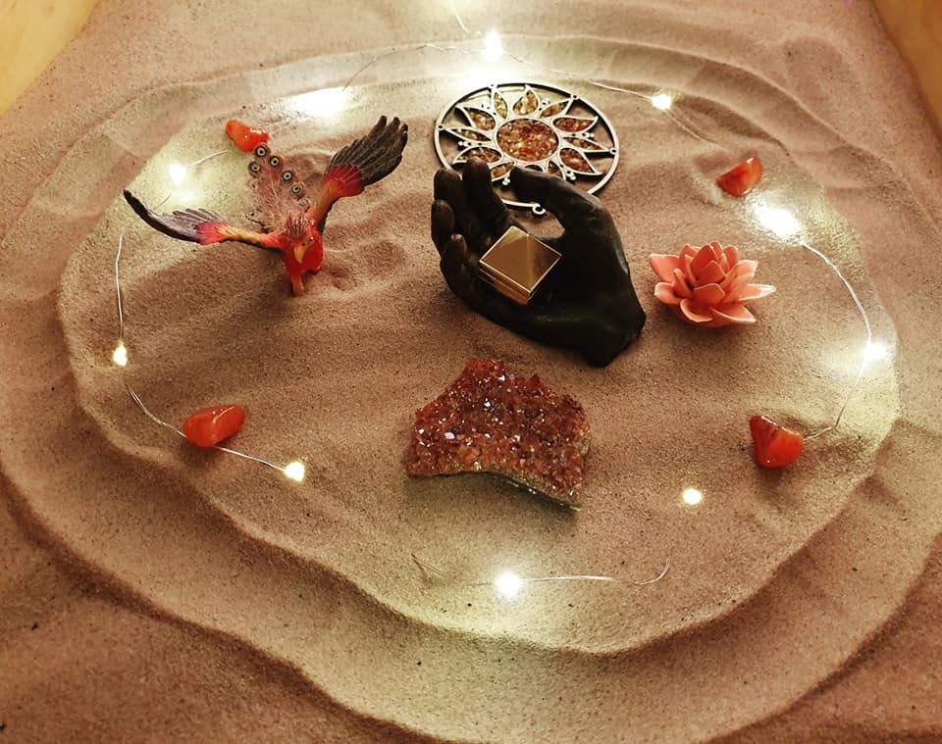
Glossop, Derbyshire (near Manchester)

Workshops available:
* Introduction to Integrative Sandplay Therapy (2 days) - Saturday 7th and Sunday 8th August
- The Four Elements in the Sandtray (1 day) TBC
- Working with Inner Child in the Sandtray (1 day) TBC
- Your Shadow and Light in the Sandtray (1 day) TBC
* Working with Trauma in the Sandtray (2 days) TBC

Workshop costs: £225 for 2 day courses, early bird rate £195
£120 for 1 day courses, early bird rate £105
Early bird rate valid for bookings made with deposit paid (£50) at least one month in advance of the the course.

Included in the cost: Tuition, course materials, the use of the tutor’s extensive sandplay symbol collections, CPD certificate, light refreshments throughout the day. (Lunch is not included).

Location: Glossop is a town in North Derbyshire, approximately 35 minutes on the train from the centre of Manchester (between 30min and 1 hour+ drive depending on traffic), about 45 min drive from Sheffield, 1 hour from Leeds.
The venue address: Wren Nest Business centre, Wren Nest Road, Glossop SK13 8HB
The list of local accommodation can be provided on confirmation of booking/payment.
Please note that if quarantine restrictions do not allow face-to-face delivery of these workshops, they will NOT be moving online but will be postponed till a later date.

Course Eligibility:
The Introduction to Integrative Sandplay Therapy is open to counsellors, therapists, teachers, youth workers, social workers, and others working in a helping capacity in a paid or voluntary position, with adults or children. It may also be suitable as personal development for leaders/managers and creative professionals.

For other workshops, some previous experience of Sand work is required (e.g., our two-day introduction or equivalent, play therapy training, etc).

For the Trauma in the Sandtray workshop, understanding and prior experience of working with trauma is helpful.

If unsure whether the course is suitable for you, you can email the tutor at masha@practicalhappiness.co.uk or text 07887 617558 to arrange a time to talk.

Certificates: CPD Certificate will be issued on behalf of the Association of Integrative Sandplay Therapists, to all attendees who successfully complete the workshop. Please note that attendance on these courses does not confer a qualification.

COVID-19: Please see the relevant section in the Application Form.

Workshop content
Introduction to Integrative Sandplay Therapy (2 days)

This practical workshop will introduce brief history of Sandplay Therapy and the use of Sandplay with adults and children, including non-directive and directive approaches. It will look at considerations of incorporating Sandplay into your existing counselling/therapy practice, and how it differs from other therapeutic approaches. We will discuss the essential elements of a sandplay symbol collection and practicalities of building one up. All participants will have an opportunity to create several of sandtrays, working individually and in pairs, and much of the learning will take place through looking at and evaluating the sandtrays as a group.

The Four Elements in the Sandtray (1 day)
In this workshop we will explore the ancient wisdoms of the Artchetypes of the Four Elements (Earth, Air, Fire Water), how our emotions, cognitions and behaviour may be represented through the Elements, and how they may manifest in the Sandtray. This is an experiential workshop and the participants will be creating their own Sandtrays in both directed and spontaneous exercises.

Your Shadow and Light in the Sandtray (1 day)
In this workshop we will look at the importance of exploring, acknowledging and accepting our Shadow “parts”, and explore how these may manifest in the Sandtray. We will also look at our Light, our Essence and True Self, and how this may manifest in the Sandtray - and how it may interact with the Shadow. We will discuss the significance of Shadow and Light symbols in a sandplay collection and how these can be sourced. This is an experiential workshop and the participants will be creating their own Sandtrays both in directed and spontaneous exercises.

Working With the Inner Child in the Sandtray (1 day)
In this workshop we will look at working with child “parts” or ego-states, and how these may manifest in the Sandtray. We will explore methods to enhance communication and collaboration between the adult self and child parts within the Sandtray safely, and to provide appropriate nurture, protection and support for the inner child parts. This is an experiential workshop and the participants will be creating their own Sandtrays both in directed and spontaneous exercises.

Working with Trauma in the Sandtray (2 days)
In this workshop we will look on the basics of neuroscience of trauma, the three-phase approach to trauma healing and safety consideration when working with traumatised clients. We will explore how trauma may manifest in the Sandtray spontaneously, and the different approaches to help the client process their experience safely in the sand. We will compare and contrast trauma processing in the Sand with a number of talking therapies. This is an experiential workshop and the participants will be creating their own Sandtrays both in directed and spontaneous exercises. If you are experiencing any ongoing trauma symptoms, please speak to the tutor prior to booking.

About the Tutor

Masha Bennett is a UKCP registered psychotherapist, psychotherapy trainer and clinical supervisor, sandplay therapist and tutor for the Association for Integrative Sandplay Therapists, and tutor/gong practitioner with the College of Sound Healing. After her early career in zoology, botany and horticulture, she has been working with adults and young people therapeutically for about 20 years, in prisons, probation service, residential children’s homes, NHS, primary school, charities, and in private practice. Masha is a trauma specialist and has an MSc in Therapeutic Practice for Psychological Trauma from the University of Chester, she is an accredited EMDR Europe Practitioner, trainer in EFT (Emotional Freedom Techniques), and also teachers courses on Trauma Awareness to professionals and general public. In her spare time Masha paints pictures, walks her two border collies and has many cups of tea in her wild woodland garden
Website: www.sandsoundcentre.co.uk
Facebook: https://facebook.com/sand.sound.soul

APPLICATION FORM

The name(s) of the workshop(s) you wish to book on: | Workshop dates:
Full name: | Email:
Address including postcode: | Phone:
Emergency contact details (who do you want to be contacted if you were taken ill during the course?)

Name: Phone:

Relationship to you:
Please describe briefly your experience and qualifications in counselling/ therapy/ related disciplines:
Current occupation / client group:
What is your interest in Sandplay Therapy?
Do you have any special requirements / support needs, that the course tutor will need to be aware of, to enable your full participation in the course?

Please note that all the courses are experiential, and whilst Sandplay Therapy is a safe and gentle way of working, it is also potentially very powerful. If you are currently suffering with mental health issues, feeling emotionally vulnerable, or are going through personal crisis, it is important to be aware that working with Sandplay may connect you to intense feelings, and whilst the tutor will offer you support, you need to be able to manage your emotional state and stay safe during and after the course.

Please type YES below to indicate that you have read and understood the above, and that you are willing to take responsibility for your emotional wellbeing and safety.

COVID-19
The tutor will follow all the appropriate government guidelines to ensure the safety of all course participants as well as her own. This may mean that the course arrangements need to be changed, and some of the workshops may have to be cancelled at short notice - so please bear this in mind when making travel/accommodation arrangements.

The tutor will ensure that:
* The training room and equipment is clean/sanitised as well/as frequently as practicable.
* Each participant will have their own dedicated sandtray with clean sand for the duration of the workshop.
* The room is ventilated with the window and door open before the workshop and during breaks (please note that there is only one smallish window in the room so ventilation may be somewhat limited).
* Seating arrangements will allow adequate social distance between participants.
* Hand-washing facilities/sanitising gel and disinfectant wipes will be available.

You will be asked to take responsibility for your own safety and that of other participants in the following ways:

- Informing the tutor of any COVID-like symptoms you or any of the members of your household have experienced in the week before the course.
- Informing the tutor if you have been in close contact with anyone diagnosed with COVID or with COVID-like symptoms within two weeks before the start of the course.
- Washing your hands/using the sanitising gel frequently during the course.
- Bringing your own flask/mug for hot drinks (which will be provided), and your own bottle of water.
- Using only one sandtray which will be allocated to you for the duration of the course.
- Carrying out any other reasonable requests by the tutor pertaining to health & safety.
- You are welcome to wear a face mask/covering if you wish, but it will not be compulsory (unless government guidelines require it at the time).
- The Sand & Sound Centre is a shoe-free space so you will need to bring slippers or warm socks (we have some slippers available to borrow but in the current circumstances you may prefer to bring your own).

If you are in the vulnerable group/have pre-existing conditions and are not sure whether it is safe for you to attend, please consult with the tutor before booking.

Please type YES below to indicate that you have read and understood the above, and that you are willing to take responsibility for your physical wellbeing and safety, and will be considerate of others’ wellbeing and safety

Any additional information
To sign this form, please type your name and date below:

Payments, refunds and cancellations
Payment is accepted by BACS - payment details will be emailed to you if you are accepted onto the course. If for any reason you need to pay via a different method, please say so in the “Any additional information” section above.
Due to the ongoing quarantine restrictions and possible changes in the official guidelines, only deposits will be accepted in the first instance (not the full fee), in case it is necessary to postpone/cancel the workshop.
In view of current exceptional circumstances, cancellations will be accepted and full refund given up to 7 days before the start of the course. Thereafter, the refund can be given only if another student takes your place - otherwise, your deposit will be transferred towards a future course.
IMPORTANT: Please note that your place will not be confirmed until your application has been accepted and the deposit is received.
_____________________________________________________________________
Please return the completed form by to masha@practicalhappiness.co.uk
For enquiries about course content and suitability, text Masha on 07887 617558 to arrange a time to talk, or contact her by email as above.

