Sound Therapy for Counsellors Workshops 2021
with Masha Bennett MSc Psych Trauma UKCP Reg Psychotherapist
College of Sound Healing Gong Practitioner & Tutor
______________________________________________________
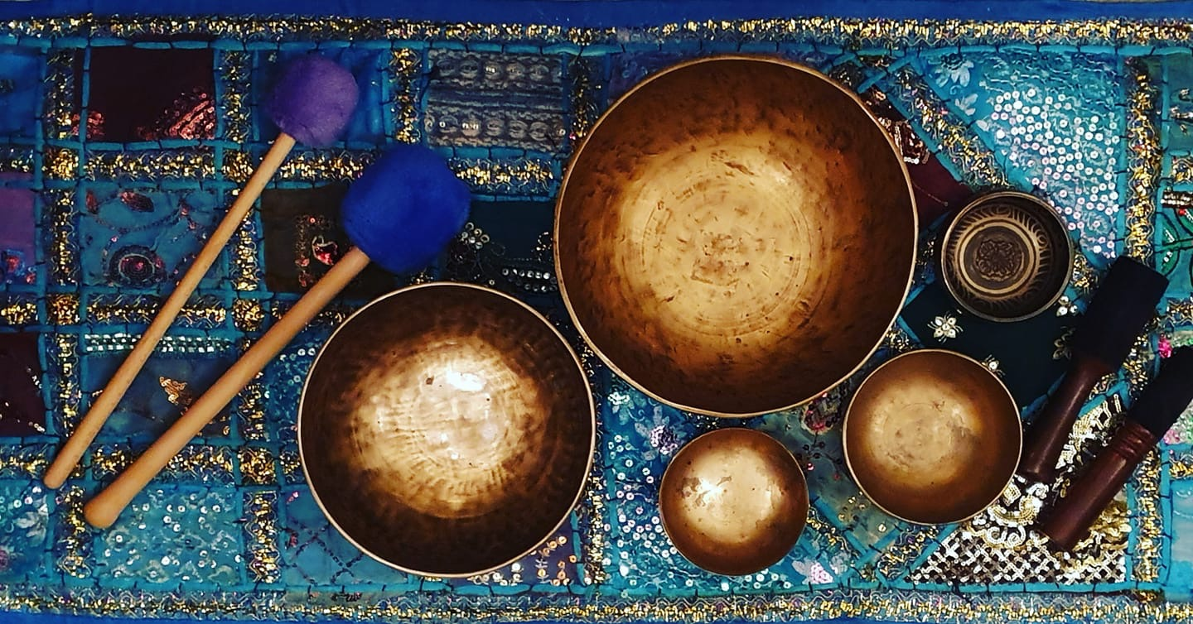
Glossop, Derbyshire (near Manchester)

Workshops available

- Introduction to Sound Therapy for Counsellors 1 day workshop - Saturday 3rd July
Future dates to be scheduled

Also available:

- Sand & Sound Mini Retreat 2.5 days - Friday 25th to Sunday 27th June (FULL), Friday 23rd to Sunday 25th July, OR Saturday 28th to Monday 30 August

Workshop costs: £85 for the 1 day course - £35 deposit secures your place

Included in the cost: Tuition, course materials, CPD certificate, light refreshments throughout the day. (Lunch is not included).

Location: Glossop is a town in North Derbyshire, approximately 35 minutes on the train from the centre of Manchester (between 30min and 1 hour+ drive depending on traffic), about 45 min drive from Sheffield, 1 hour from Leeds.

The venue address: Wren Nest Business centre, Wren Nest Road, Glossop SK13 8HB
The list of local accommodation can be provided on confirmation of booking/payment.
Please note that if quarantine restrictions do not allow face-to-face delivery of these workshops, they will NOT be moving online but will be postponed till a later date.

Workshop times:

- 9.30am arrival for a prompt 10am start
- 5pm finish
- There will be a break for lunch and two short breaks for tea/coffee in the morning and afternoon

Course Eligibility:

Open to counsellors, therapists, psychologists, social workers, play therapists and other helping professionals, who wish to incorporate sound and music into their therapy practice. No prior musical or singing experience necessary. If unsure of course suitability, please contact Masha by emailing masha@practicalhappiness.co.uk or texting 07887 617558 to arrange a time to talk.

Certificates: CPD Certificate will be issued - this does not confer a qualification.
COVID-19: Please see the relevant section in the Application Form.

Workshop content
During the workshop, we will explore the following:
- Effects of sound on our nervous system, physiology and our capacity to heal
- Utilising simple humming, toning and voice exercises in your therapy practice
- Using sound healing instruments (bowls, drums, gongs, chimes etc) with clients
- Healing songs, mantras and chants - and how to create your own
- Combining sound with other therapeutic and creative interventions
- Meditation with sound
Please note as there are still some restrictions on group singing some of the planned exercises may need to be modified but this should not affect your learning experience.
This is an experiential workshop and you will be invited to participate in all exercises, but none of the activities are compulsory.

About the Tutor

Masha Bennett is a UKCP registered psychotherapist, psychotherapy trainer and clinical supervisor, EFTi Master Trainer of Trainers, sandplay therapist / tutor for the Association for Integrative Sandplay Therapists, and tutor/gong practitioner with the College of Sound Healing. After her early career in zoology, botany and horticulture, she has been working with adults and young people therapeutically for about 20 years, in prisons, probation service, residential children’s homes, NHS, primary school, charities, and in private practice. Masha is a trauma specialist and has an MSc in Therapeutic Practice for Psychological Trauma from the University of Chester. In her spare time she paints pictures, walks her two border collies and has many cups of tea in her wild woodland garden
Websites: www.sandsoundcentre.co.uk and www.practicalhappiness.co.uk
Facebook: https://facebook.com/sand.sound.soul

APPLICATION FORM

The name(s) of the workshop(s) you wish to book on: | Workshop dates:
Full name: | Email:
Address including postcode: | Phone:
Emergency contact details (who do you want to be contacted if you were taken ill during the course?)

Name: Phone:

Relationship to you:
Please describe briefly your experience and qualifications in counselling/ therapy/ related disciplines:
Current occupation / client group:
What is your interest in attending this workshop?
Do you have any special requirements / support needs, that the course tutor will need to be aware of, to enable your full participation in the course?

Please note that all the courses are experiential, and whilst EFT is a safe and gentle way of working, it is also potentially very powerful. If you are currently suffering with mental health issues, feeling emotionally vulnerable, or are going through personal crisis, it is important to be aware that working with EFT may connect you to intense feelings, and whilst the tutor will offer you support, you need to be able to manage your emotional state and stay safe during and after the course.

Please type YES below to indicate that you have read and understood the above, and that you are willing to take responsibility for your emotional wellbeing and safety.

COVID-19

The tutor will follow all the appropriate government guidelines to ensure the safety of all course participants as well as her own. This may mean that the course arrangements need to be changed, and some of the workshops may have to be cancelled at short notice - so please bear this in mind when making travel/accommodation arrangements.

The tutor will ensure that:
* The training room and any equipment is clean/sanitised as well/as frequently as practicable.
* The room is ventilated with the window and door open before the workshop and during breaks.
* Seating arrangements will allow adequate social distance between participants.
* Hand-washing facilities/sanitising gel and disinfectant wipes will be available.

You will be asked to take responsibility for your own safety and that of other participants in the following ways:

- Informing the tutor of any COVID-like symptoms you or any of the members of your household have experienced in the week before the course.
- Informing the tutor if you have been in close contact with anyone diagnosed with COVID or with COVID-like symptoms within two weeks before the start of the course.
- You are encouraged to self-test for Covid with a lateral flow test kit (available for free from chemist) the day before the course
- Washing your hands/using the sanitising gel frequently during the course.
- Carrying out any other reasonable requests by the tutor pertaining to health & safety.
- You are welcome to wear a face mask/covering if you wish, but it will not be compulsory (unless government guidelines require it at the time).
- The Sand & Sound Centre is a shoe-free space so you will need to bring slippers or warm socks (we have some slippers available to borrow).

If you are in the vulnerable group/have pre-existing conditions and are not sure whether it is safe for you to attend, please consult with the tutor before booking.

Please type YES below to indicate that you have read and understood the above, and that you are willing to take responsibility for your physical wellbeing and safety, and will be considerate of others’ wellbeing and safety

Any additional information
To sign this form, please type your name and date below:

Payments, refunds and cancellations
Payment is accepted by BACS - payment details will be emailed to you once you are accepted onto the course. If for any reason you need to pay via a different method, please say so in the “Any additional information” section above.
Due to the ongoing quarantine restrictions and possible changes in the official guidelines, only deposits will be accepted in the first instance (not the full fee), in case it is necessary to postpone/cancel the workshop.
In view of current exceptional circumstances, cancellations will be accepted and full refund given up to 7 days before the start of the course. Thereafter, the refund can be given only if another student takes your place - otherwise, your deposit will be transferred towards a future course.
IMPORTANT: Please note that your place will not be confirmed until your application has been accepted and the deposit is received.
_____________________________________________________________________
Please return the completed form by to masha@practicalhappiness.co.uk
For enquiries about course content and suitability, text Masha on 07887 617558 to arrange a time to talk, or contact her by email as above.

